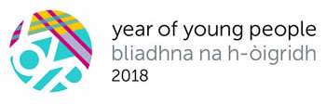
Consultation on the Supporting Disabled Children, Young People and their Families Resource

June 2018

MINISTERIAL LETTER

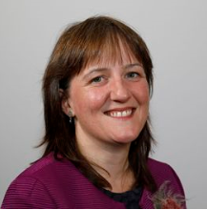

Maree Todd, MSP
Minister for Childcare and Early Years

Scotland is building a fairer society in which: raising or caring for a child with a disability is the rewarding experience we all have the right to expect from family life; a young person with a disability can expect equal treatment and opportunities; we can all expect fairness and compassion in our communities; and national policy is transparently communicated and easily understood.
In December 2016 the Scottish Government launched A Fairer Scotland for Disabled People: Our Action Plan to 2021 for the United Nations Convention on the Rights of Persons with Disabilities. This action plan set out the Government’s overarching ambition to transform the lives of disabled people in Scotland, and represented the culmination of over two years of detailed discussion, negotiation and co-production.

To drive forward such positive change, the plan is centred around five long-term ambitions and a set of ninety-three actions. Many of these actions will impact on individuals of all ages, but a number are specifically aimed at children and young people, including the development of a Supporting Disabled Children, Young People and their Families Resource.

Issues relating to disabled children and young people are incorporated into numerous policies, strategies and legislation at a national level. However, there has not previously been a document or area which draws these strands together. The development of this resource has consciously sought to change that. Furthermore, by providing examples of how our national policies work in real life situations, we hope to spread best practice and drive improvement.

We are committed to helping families navigate through national policy, empowering them with knowledge of their rights and providing clarity on some of the fundamental standards to which everyone may refer.

Key to the overall success of this resource will be recognition that producing a comprehensive policy guide is not an end in itself, but rather a catalyst for genuine change as we identify what works well, and what could improve. We view this consultation as an opportunity to gather the lived experiences of disabled children, young people and their families which will directly impact on how we develop the final resource, following our consultation period.

With the launch of 2018 as the Year of Young People this is an ideal time to increase our direct engagement with disabled children and young people. To guide the development of this resource, we will be hosting a number of events in local communities right across Scotland, to hear views from a diverse range of voices.

With the help of third sector partners, the Scottish Government also supports a permanent Young Disabled People’s Forum which will facilitate conversations with young disabled people on national issues that they feel are important and relevant.

Family members also have a significant role to play within this process. Not only will they typically have the most insightful first-hand experience of any recurring difficulties for their child, but this resource also aims to draw out the practical and emotional support that they require in their own right. We will ensure that families’ and siblings’ voices are heard throughout the consultation.

Launching a public consultation on the content of this resource, which has been developed in collaboration with a number of partners representing parents, young people and practitioners, marks another step in the co-production process. I wish to thank everyone who has been involved in the process so far, and all who contribute to the consultation.

We have high ambitions for the changes we want to see, and disabled children and young people have the right to expect no less. A fairer Scotland can only be realised when we all understand our rights and can seek support when we need it most; your support is invaluable to achieve this goal.

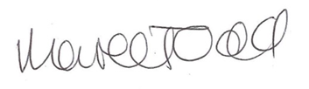

MAREE TODD, MSP

