Culture in Scotland:
what is it and why does it matter?

Easy Read Survey
July 2024

Information
The Scottish Government want to know what culture means to you.

What activities do you enjoy? Does anything stop you from doing what you want to do?

We want to hear from different people to understand what culture means to them.

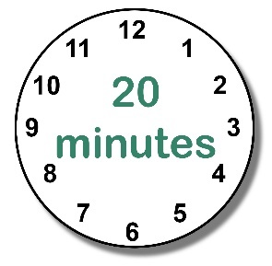

This survey will take about 20 minutes. There are 10 questions for you to answer.

We will then ask you for some information about you, like your age and where you live.

Your answers will only be seen by experts. They will make sure that nobody will know who said what.

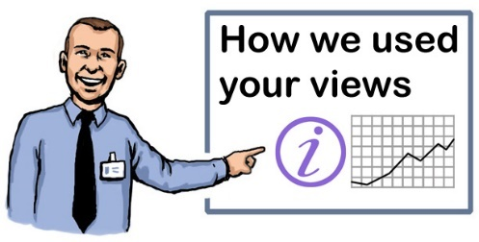
Your views will help the Scottish Government understand more about different views on what culture means to them.

For more information, please see the Easy Read Culture Strategy.

Thank you!
Questions

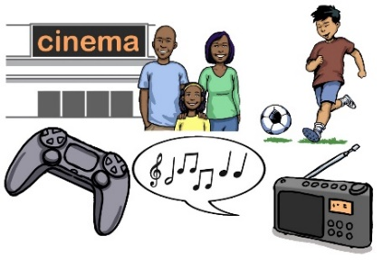

1. What are your favourite things to do in your free time?

Please tell us in the box below:

2. Does anything stop you from doing these things?

Please tell us in the box below:

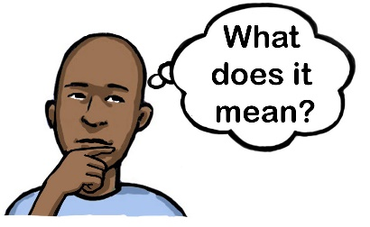
3. Culture means different things to different people. What does culture mean to you?

Please tell us in the box below:

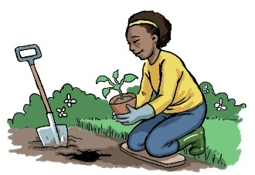
4. Creativity can also mean different things to different people. What does creativity mean to you?

Please tell us in the box below:

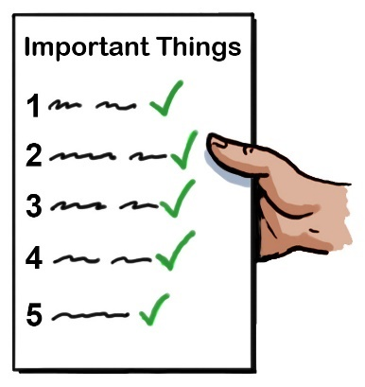
5. Is taking part in cultural or creative activities important to you? If yes, can you explain why?

Please tell us in the box below:

6. How does taking part in cultural and creative activities make you feel?

Please tell us in the box below:

7. Can you tell us how you take part in cultural and creative activities?

In your answer you might want to tell us things like:

Do you take part on your own or with other people?

Where do you take part? At home or at a different place?

Are you a member of a community?

Do you volunteer, or would you like to?

Please tell us in the box below:

8. What do you think about the places where you take part in cultural and creative activities?

In your answer you might want to tell us things like:

Are the places affordable?

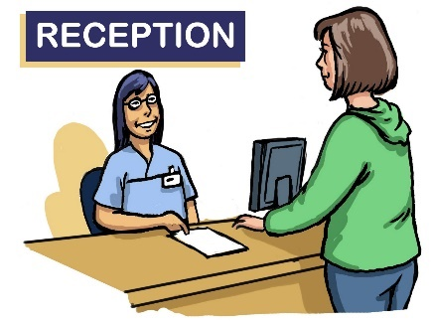

Are the places welcoming?

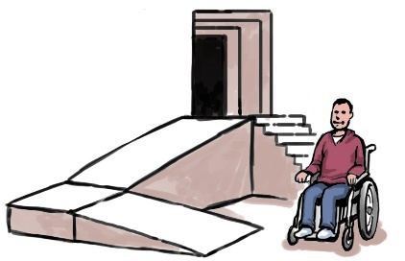

Are the places accessible?

Are the places interesting?

Please tell us in the box below:

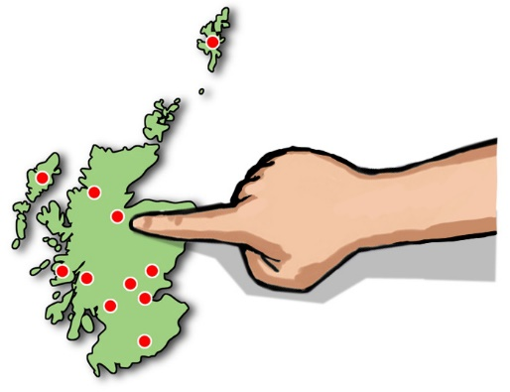
9. What do you think about the cultural and creative opportunities in your local area.

In your answer you might want to tell us things like:

Are there things to do in your local area?

Is there information about what is going on in your local area?

Do the local activities interest you?

Please tell us in the box below:

10. Is there anything else you would like to tell us about what culture or creativity means to you?

Please tell us in the box below:

About You

Please tell is if you are happy for us to publish your answers.

If you say no, we will still listen to your views. But we will keep your answers private and not share them. To see how we use and keep your information safe, please see our Privacy Policy: www.gov.scot/privacy/

The Scottish Government would like to publish your response to this survey. Please tell us what you would like us to do:

Publish response with name

Publish response only, without name

Do not publish response

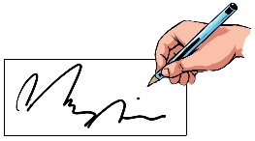
Please tell us your name if you would like to:

What is your email address?

What is your phone number?
(If you do not have an email address)

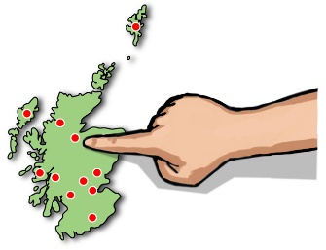

Which local authority do you live in?

What best describes your gender identity?

Female Non-Binary

Male Not listed

Prefer not to say

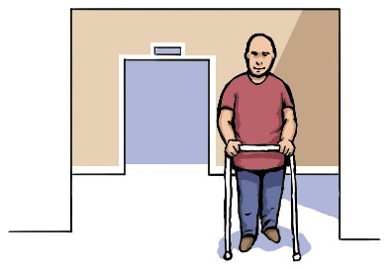
Do you have any long-lasting physical or mental conditions, illnesses or disabilities lasting 12 months or more?

Yes No

Prefer not to say

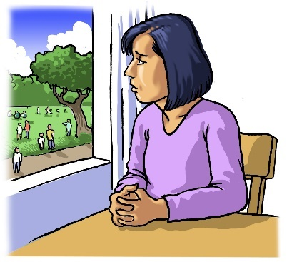
If you answered yes to the above question, does your condition limit your day-to-day activities?

Yes, a lot Yes, a little

Not at all

What is your ethnic group?

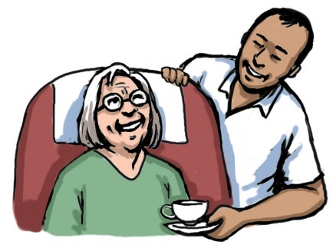

Are you an unpaid carer? This is someone who supports someone else.

Yes No

Prefer not to say

Which of these choices describes you best?

Employed full time, 30 hours or more a week

Employed part time, 8 - 29 hours a week

Self Employed

Unemployed and looking for work

Unemployed and not looking for work

Studying at school, college of university

Looking after the home

Retired

Not working because of long-lasting illness or disability

Other

Prefer not to say

If you have any educational qualifications, please write them here:

How well do you manage with money?

Very well

Quite well

Getting by alright

Not managing very well

Having some money troubles

In deep money trouble

Do not know

Prefer not to say

Sottish Government may wish to contact you again but we need your permission.

Scottish Government may do more research on culture in the future. Are you happy we contact you about future research?

Yes No
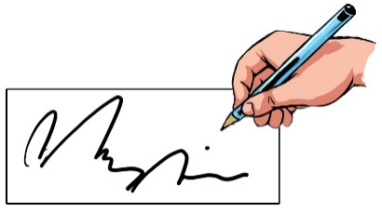

I consent to the data I provide being used.

To give your consent, please sign your name in the box below:

Once you have completed this survey, please email it to: socialresearch@gov.scot

Thank you!

