The Scottish Government’s Draft Delivery Plan
2016-2020

United Nations Convention on the Rights of Persons with Disabilities (UNCRPD)

Summary and Consultation
Easy Read

The Scottish Government’s Draft Delivery Plan
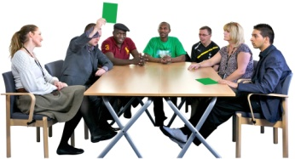 | This is a public consultation document.
 | A consultation is when we ask people what they think about something.
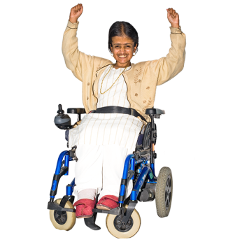 | We are asking people to tell us what they think the Scottish Government can do to improve the lives of disabled people in Scotland.
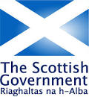 | The consultation has been set up by the Scottish Government.
 | That is who we mean when we say ‘we’ in this document.
 | This is a summary document.  We have left some parts out to make it easier to read.
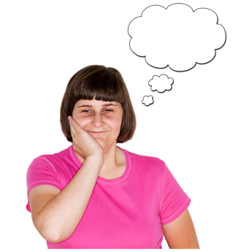 | We would like to know what you think about this draft delivery plan.  All the feedback will help the Scottish Government decide what to do when the draft delivery plan is finalised.

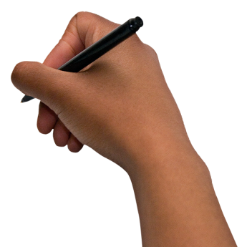 | There are 17 questions in this paper and you can answer as many as you want.  You can send this form back with your comments to:  Cathy Hewit  Scottish Government Equality Unit  Area 3H South  Victoria Quay  Edinburgh  EH6 6QQ
 | Or you can email your comments to  catherine.hewit@scotland.gsi.gov.uk
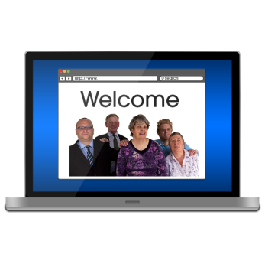 | Or you can tell us what you think on line by going to:  https://consult.scotland.gov.uk/equality-unit/rights-of-persons-with-disabilities
     | You must make sure we get this form by  4 January 2016
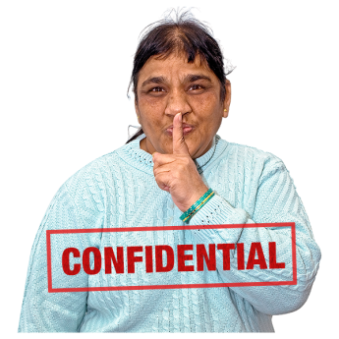 | Please make sure you fill in the form at the back of this paper and send it with your comments.  This is where you can say if you want to tell us what you think in confidence  This means that your name will not be attached to any information you provide for us and will be private.

What we want to do

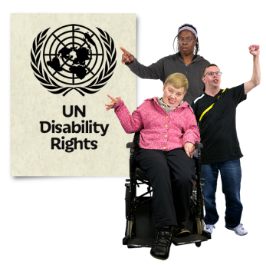 | We know disabled people have the same equality and human rights as non-disabled people.
 | This means disabled people having the same freedom, dignity, choice and control over their lives as everyone else.
 | To make this happen we have been working with Disabled People Organisations (DPOs) and the Convention of Scottish Local Authorities (COSLA) and other organisations.
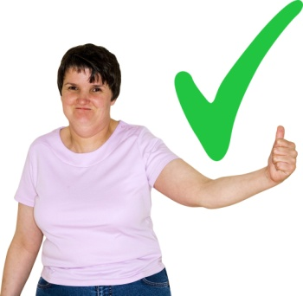 | We now need to take action across all policy areas to make positive changes for disabled people in Scotland.
 | We will be using a framework called the United Nations Convention on the Rights of Persons with Disabilities (UNCRPD).  The Convention is an agreement between different countries.  The Convention says countries will not treat people differently or unfairly because of their disability.

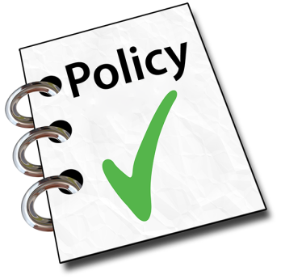 | We are working hard to build stronger relationships between policy makers and disabled people.  This delivery plan explains how we want to make changes from 2016 to 2020.
What we are doing now

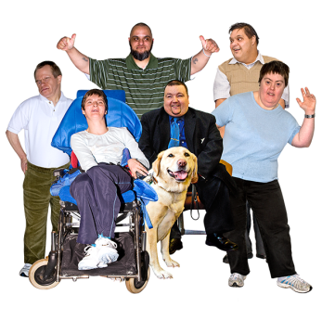 | Making life better for disabled people
 | We want a fairer Scotland.
 | Below is examples of the work we are already doing:
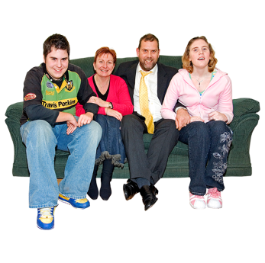 | Disabled children and young people
 | We are supporting disabled children and young people and their families from birth, through school and into work.
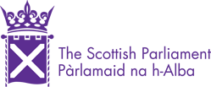 | The Education (Scotland) Bill was introduced to Parliament in March 2015.
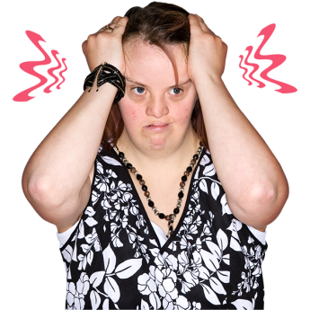 | This Bill will help us get poor children (including disabled children and young people) into education who are not doing well.
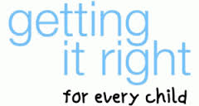 | The Getting it Right for Every Child (GIRFEC) framework makes sure that all services are working together to do this.
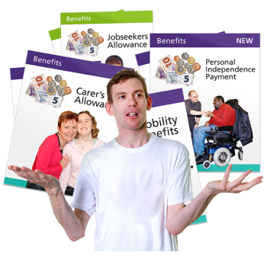 | Social Security  (Benefits)
 | We are working to address how disabled people are affected by welfare changes and cuts.
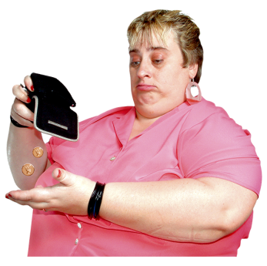 | Disabled people have higher living costs than non-disabled people.  The United Kingdom Government’s welfare cuts and changes are having a negative impact on the lives of disabled people.
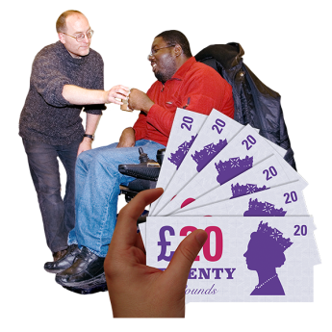 | We are taking action to help disabled people affected by welfare changes by investing £300 million from 2013 to 2016.
 | From April 2013 we have helped more than 150,000 households by giving community care grants to help people live independently.

 | Healthcare and Support
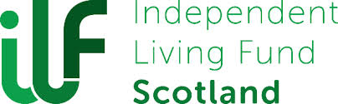 | We are keeping financial support in place for almost 2900 disabled people in Scotland by setting up a new Scottish Independent Living Fund.  We are giving an extra five million pounds to open the scheme to new users from 2015 to 2016.
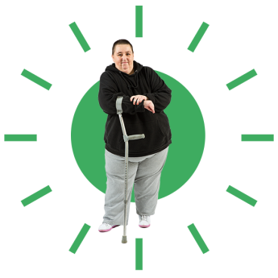 | The following new laws will make a difference to the services disabled people use:
 | The Social Care (Self Directed Support) Scotland Act 2013 gives disabled people more control over the care and support services they use.
 | The Public Bodies (Joint Working) (Scotland) Bill 2014 will join up health and social care services for people, including disabled people, and will make sure that people get the right care, in the right place, at the right time.
 | Carers
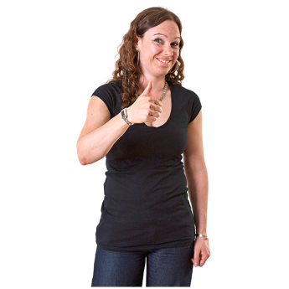 | We want to make sure carers are supported to manage their caring responsibilities with confidence and in good health.  The Carers (Scotland) Bill was introduced to Parliament in March 2015 and it is to provide care in a way which keeps them and those they care for safe and well.

 | Access to transport and housing
 | We are taking action to remove barriers and to improve access to housing and transport.
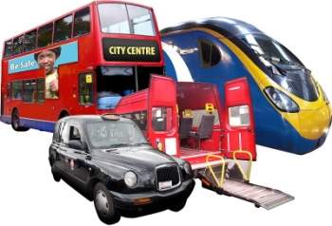 | We are taking action to make sure disabled people have homes suited to their needs.  And also have access to transport.
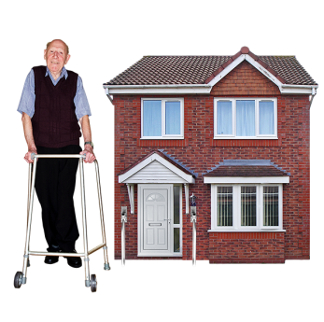 | We have agreed to take on recommendations of the Independent Adaptations working group.  This group is working on making homes suitable for disabled people.
 | We have given money to Glasgow Centre for Inclusive Living to develop a national Register of Accessible Housing.  This is called ‘Home2Fit’. It will help disabled people find accessible housing.
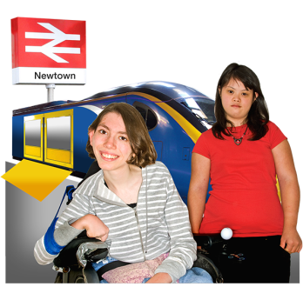 | We are investing in making transport more accessible.

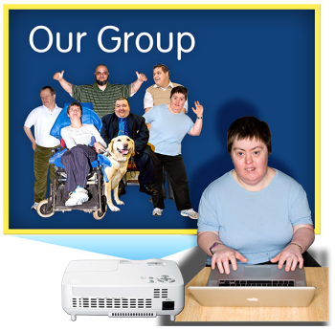 | Transport Scotland hosted a Transport Accessibility Summit with disabled people and transport providers to talk about transport issues affecting disabled people in Scotland.  Disabled people told us we need to work together in partnership to improve journeys for disabled people on public transport.  Transport Scotland will use this information to make changes to improve transport for disabled people.
 | Inclusive Communication
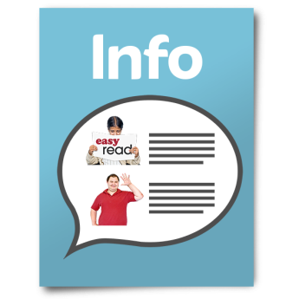 | We are determined to address specific inequalities experienced by particular groups.
Disabled people need to get information and services in a way that they understand.

In April 2013 we set eight equality outcomes to be delivered by April 2017 (as required by The Equality Act 2010 (Specific Duties) (Scotland) Regulations 2012).

One of the outcomes that we’ve set is called “Equality and Diversity Matters”.

This outcome looks at raising awareness to staff about inclusive communication.

 | We are working with Sense Scotland on inclusive communication seminars for staff and appointing Easy Read champions across the organisation.

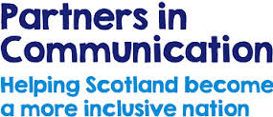 | Partners in Communication is a project delivered by Sense Scotland.  It is working to make sure disabled people with complex communication support needs can have more choice and control over their lives.
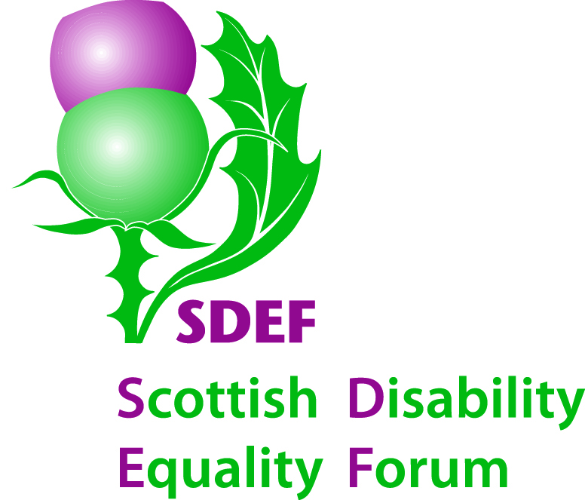 | Creating Connections in Communication  The Scottish Disability Equality Forum (SDEF) is working with Access Panels and public bodies to increase the availability of inclusive communication formats and provide advice on good practice.  SDEF have also introduced an Easy Read version of their consultation briefing responses to encourage greater engagement and understanding of policy issues amongst disabled people.
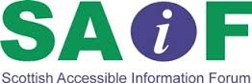 | Inclusive Communication Hub  With Scottish Disability Equality Forum, Scottish Accessible Information Forum (SAIF) are working towards improving their current website to create an online Inclusive Communication Hub.  The online Hub will be a place where everyone can find advice, templates and guidance on how to make their information more accessible.

 | British Sign Language
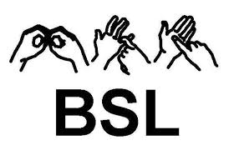 | Deaf BSL users are excluded from many services because they can't get access to information through an interpreter to explain things to them in their own language
We fully support the British Sign Language (Scotland) Bill which was introduced to the Parliament in October 2014.

The Bill needs Scottish Ministers to promote and understand BSL.

The Bill should go through the Scottish Parliament in September 2015.

 | Our commitment to human rights
 | We are implementing the United Nations Convention on the Rights of Persons with Disabilities (UNCRPD)
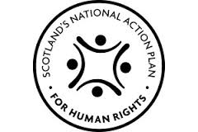 | Human rights are the basic rights and freedoms that we are all entitled to so that we can live with dignity, equality and fairness.  We work closely with disabled people to shape our policies and services, and to raise awareness of UNCRPD across the Scottish Government.  We will keep doing this to improve disabled people’s lives in Scotland.  This draft delivery plan (2016-2020) sets out how we are using the UNCRPD as a framework to improve the lives of disabled people  The draft delivery plan sits within the Scottish National Action Plan on Human Rights (SNAP) and reinforces our commitment as a government to promoting and protecting human rights for all.
What is Disability?

 | The social model of disability
 | The draft delivery plan is based on the social model of disability.  The social model is the preferred model of disability as it states that society - not disability - creates barriers to people living the way they want to.
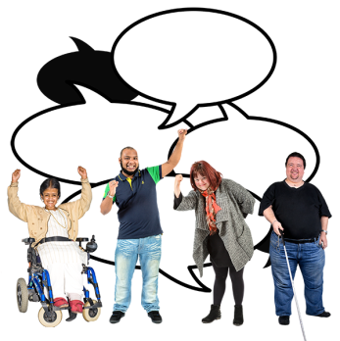 | Disabled People Organisations (DPOs) are run by disabled people for disabled people.  The work they do:  - promotes the rights of disabled people  - highlights disabled people’s needs and priorities, and  - helps to make sure that the voice of disabled people is included in policy development and service delivery.

About UNCRPD and Independent Living

 | Article 19 of the UNCRPD is about the right to live independently and be included in the community.
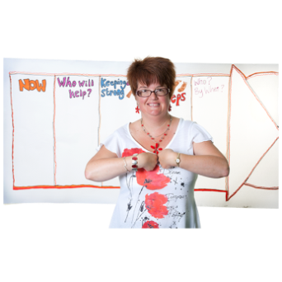 | Independent Living means:  "disabled people of all ages having the same freedom, choice, dignity and control as other citizens at home, at work, and in the community. It does not mean living by yourself, or fending for yourself. It means rights to practical assistance and support to participate in society and live an ordinary life."
Section 2

About the Outcomes and Commitments

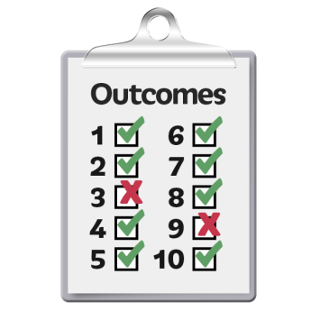 | This draft delivery plan groups the UNCRPD articles into four outcomes we want to work on.

 | The four outcomes
 | We want to live in a Scotland where disabled people have full access to the following:
 | Outcome 1
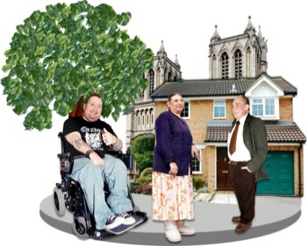 | - The physical and cultural environment  - Transport  - Affordable housing
 | Outcome 2
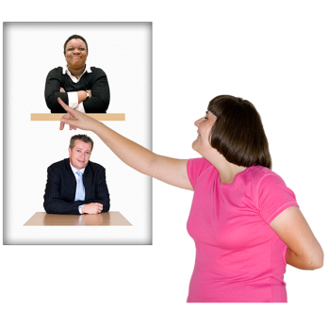 | - Provide healthcare and support for disabled people, including disabled children, to live independently.
 | Outcome 3
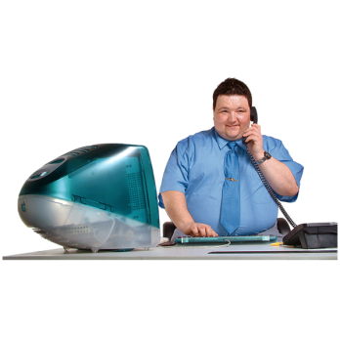 | - Education  - Paid employment  - Income and support if in or out of work

 |  |  | Outcome 4
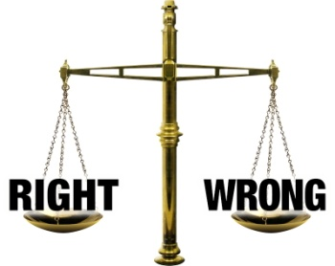 |  |  | - Access to the justice system such as the police, the courts etc without being unfairly judged or punished.  - To have personal and private rights protected.
Consultation Questions

About the Outcomes and Commitments

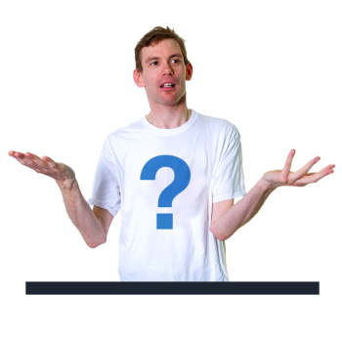 | Question 1
We want the four outcomes to change the lives of disabled people.

Do you think that these four outcomes cover the most important things we need to think about?

Yes I agree   |  | 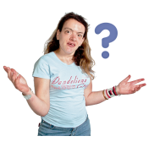  I am not sure |  |   No I do not agree

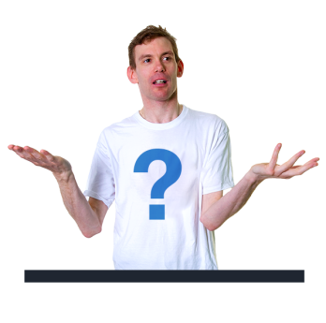 | Question 2  Please tell us what you think about the outcomes.

Information about the commitments
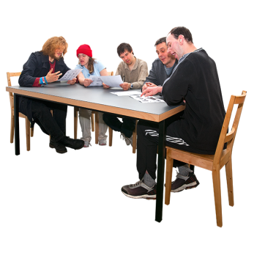 | We hosted a “Disability Symposium” in March 2014.  We talked about how we would develop this draft delivery plan  We held events with other organisations for senior Scottish Government policy officials with responsibility for specific UNCRPD articles.
 | We also funded disability-led organisations to make sure that a wide range of disabled people could have their say on the draft delivery plan.
 | This consultation is about the commitments we have made.  This is an opportunity for disabled people and others to tell us what they think about the commitments.

Section 2.1

Outcome 1: Environment, Transport and Housing

 | This outcome is about equal and inclusive access to the physical and cultural environment, transport and suitable, affordable housing.
 | What we want
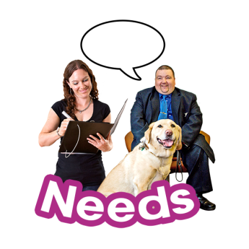 | We want a Scotland to:  - Involve disabled people in designing services  - Increase people’s understanding of disabled people’s needs  - Equal choice over housing, transport, services and facilities  - More disabled people to take part in society

Our commitment to Scotland’s disabled people:

 | Transport
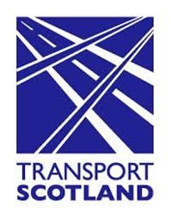 | - Transport Accessibility  Transport Scotland has been talking to Disabled People Organisations about the issues that are important to disabled people.  A group has been set up to look at developing solutions.
 | Planning and Architecture
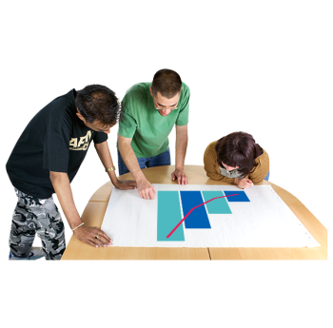 | - Design and Ageing  We will look at research on how the rising numbers of older people will affect planning and design and if this will benefit disabled people too.
 | - Raising Awareness of Accessible Design  The Scottish Awards for Quality in Planning happens every year.  Next year the awards will focus on accessibility for disabled people.

 | Building Standards
- Homes which are more accessible
We will work with house builders and local authorities to make that homes will be built to more recent standards and will be more accessible.

 | Housing and Independent Living
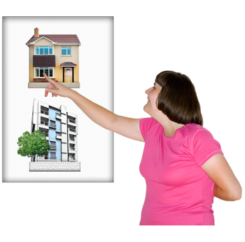 | - Accessible Housing  We will look at the issues raised by Disabled People Organisations about the availability of accessible housing for disabled people.
 | Tourism and Business
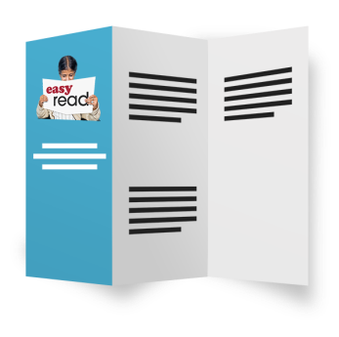 | - A new help guide promoting accessible design will be published  This guide will help architects design accessible buildings which fully meet the needs of disabled people.
- A new help guide to create more accessible websites to assist tourism businesses
This will help businesses show what they can do for disabled visitors.

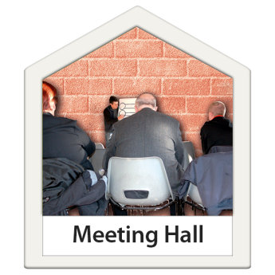 |  | - A new help guide setting out key accessibility  This guide will give hints and tips to meet the needs of disabled people attending events in 2015.
- Access Statement on- line Tool Builder
This is for tourism businesses to update access statements.
 |  | Culture
 |  | - Creative Scotland is increasing opportunities for disabled people to engage in culture and heritage and the arts  They are carrying out a review of how disabled people can get involved in culture and heritage and the arts.
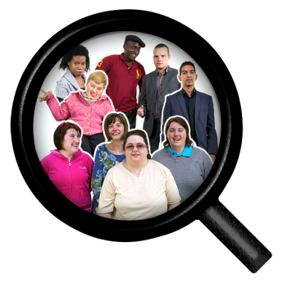 |  | - Recording and reporting of workforce diversity information  This will improve the evidence collected and tell us how well policies are working.
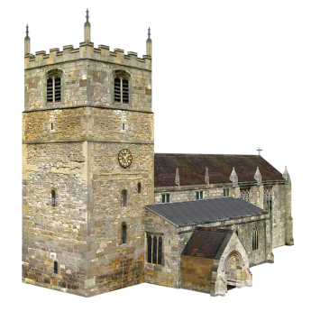 |  | - Improving access to historic buildings, monuments and collections  This includes online access to collections, services and community programmes.
 |  | Sport and Physical Activity
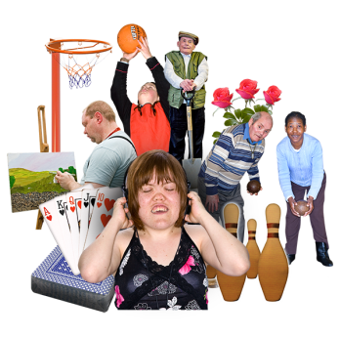 |  | - Disability Inclusion in Sport  Disabled people will have more opportunities to take part in sport as a new parasport centre will be built in Inverclyde.
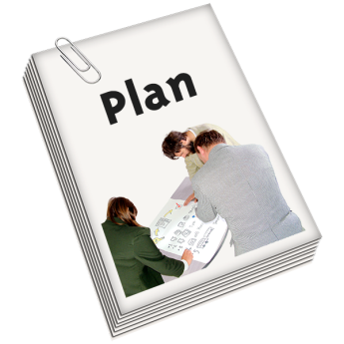 |  | - An Action Plan for disabled people  We will work with SportScotland and disabled people to promote more participation in sports and physical activity.
 |  | - SportScotland  SportScotland will make sure that the needs of disabled people and athletes are met in major national and international sporting events.
 |  | Awareness raising campaign
 |  | - One Scotland Campaign  This campaign will raise awareness of the barriers that disabled people have in society.
Consultation Questions

Outcome 1: Environment, Transport and Housing

Question 3

We want a society where disabled people have equal access to housing, transport and the environment. And we want disabled people to have the same chances to take part in society and culture.

Do you think the commitments above will help us to do this?

Yes I agree | I am not sure |  | No I do not agree

Question 4

If you want to, you can tell us what you think about each commitment.

You do not have to comment on all of them.

If you do not want to comment on any of the commitments, please go to the next question.

 |  | Question 5
 |  | Is there anything we have missed which we can add to the commitments above?
Section 2.2

Outcome 2: Health, Support and Disabled Children

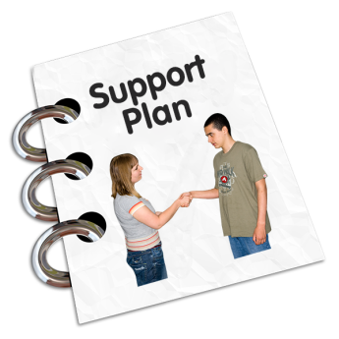 | This is about providing healthcare and support for disabled people, including disabled children and young people, to live independently.
 | What we want
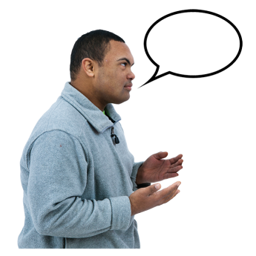 | We want a Scotland which:  - Lets disabled people have a say on how they get support  - Health, social care and other support services to work together to remove the barriers faced by all disabled people  - Lets disabled people get involved in community development and service delivery

Our commitment to Scotland’s disabled people:

 | Health: Care, Support and Rights
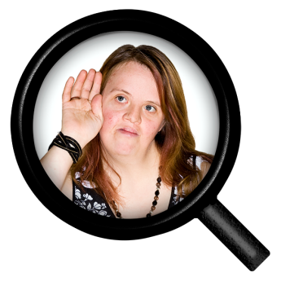 | - Health Inequalities of people with learning disabilities data collection  Research tells us that people with learning disabilities die younger.  This can be avoided, and the research is helping us to understand the support people with learning disabilities need.
- Advocacy
We will make advocacy better to make sure the voice of people with learning disabilities is heard.

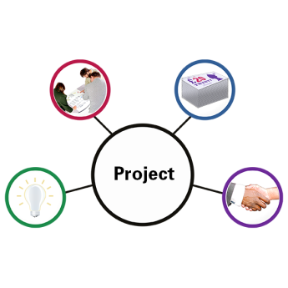 | - The New framework for Hearing the Citizen Voice  We will put in place a new framework so that disabled people can be involved in how the services they use are developed.  The projects are called Tests of Change, Citizen Voice Hub, Gathering Stories and Citizens Panel.

 | Integration of Health and Social Care
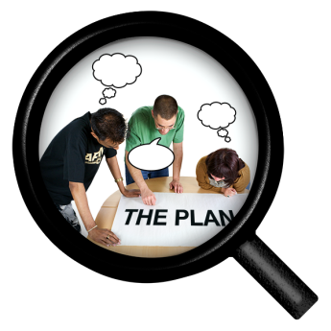 | - Routes to Inclusion – ‘Engaging disabled people and their organisations’  This group will tell us how disabled people can take part in local and strategic planning groups.
 | Allied Health Professionals and Independent Living
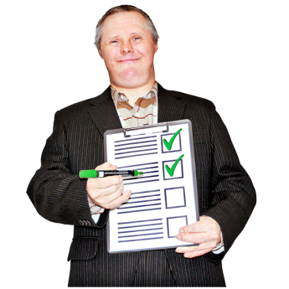 | - Allied Health Professionals and Independent Living – delivery plan  This programme will give us an update plan for Allied Health Professionals (AHP’s).  AHPs are members of health and care teams who help to support care and  treatment that can transform people’s lives, for example, physiotherapists and speech language therapists.  It will find new ways to help people with illness, disability or injury to have healthy lives and stay in their own homes.
 | NHS Disabled Graduates
 | - NHS Disabled Graduates  A two year internship will be developed with the NHS Scotland and the Glasgow Centre for Inclusive Living Equality Academy.
 | Learning Disability Employment Programme
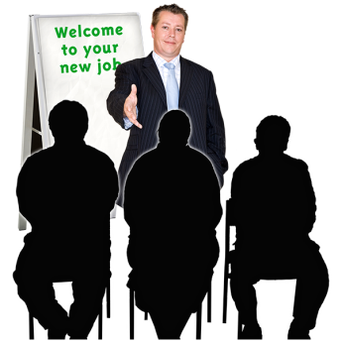 | - NHS Scotland Learning Disability Employment Programme  We will work with NHS Scotland Learning Disability Employment Programme to increase the number of people with learning disabilities employed with them.
 | Disability Inclusion Promotional Campaign
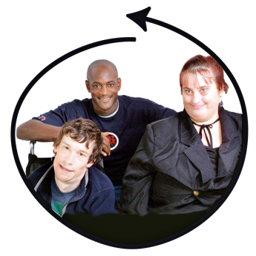 | - Disability Inclusion Promotional Campaign  We will raise awareness of disability inclusion through a promotional campaign with NHS Scotland Human Resource leads, service managers and staff.
 | Equality and Human Rights in NHS Scotland
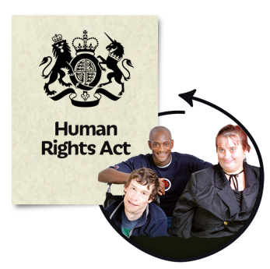 | - Equality and Human Rights in NHS Scotland  We will measure the compliance of NHS Boards on equality diversity and human rights across the NHS in Scotland.

 | Children’s Rights and Wellbeing
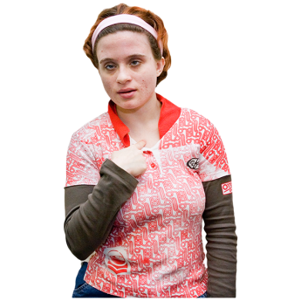 | - The Children and Young People (Scotland) Act 2014  This Act means Scottish Ministers have to think about what they are doing to comply with the UN Convention on the Rights of the Child (UNCRC).  From June 2015, we are using the Child Rights and Wellbeing Impact Assessment (CRWIA) in all policies and services that affect children.  This means that children and young people, including disabled young people can engage more fully to help us develop and deliver services and policies in the right way.
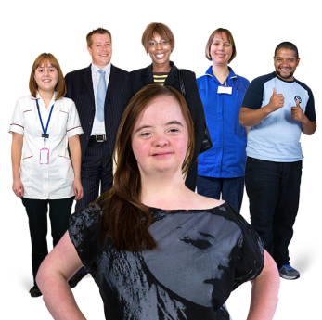 | - Funding for Projects to support disabled children and their families  The Disabled Children and Young People Advisory Group (DCYPAG) will still advise Ministers on the implementation of the Children and Young People (Scotland) Act 2014.
- Information Hub
We will start to make information better for parents and carers of disabled children and young people.

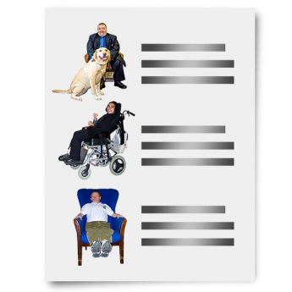 | - Transitions Test of Change Project  This will look at the Getting It Right For Every Child (GIRFEC) principles, including the named person service, into adult services.  This will help us to improve the services we provide for children going into adulthood.
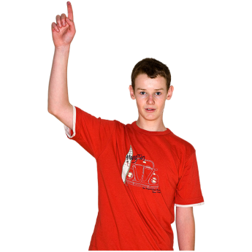 | - Child Internet Safety stakeholder group  This group will consider disabled children’s point of view.
 | Mental Health Legislation
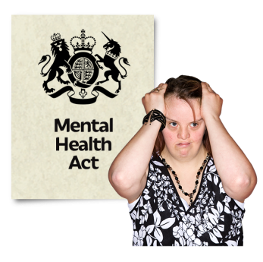 | - Learning disabilities and autism spectrum disorders  We will look at how people with learning disabilities or Autism Spectrum Disorder are included under the Mental Health (Care and Treatment) (Scotland) Act 2003.
 | Adults with Incapacity Act
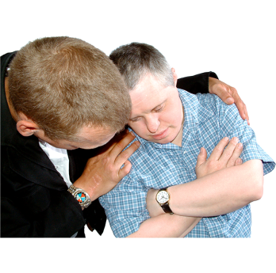 | - Deprivation of Liberty  This is about the way people who care  for you and treat you can stop you  doing the things you want to do.

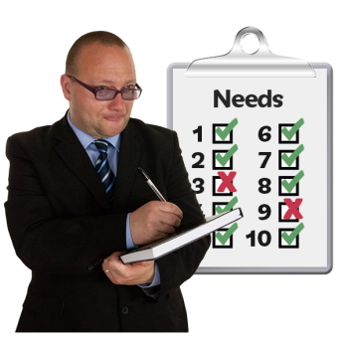 | - Article 12 of UNCRPD  We will review policies on guardianship and think about how supported decision making can be promoted.
 | Care and Justice: Children’s Hearings
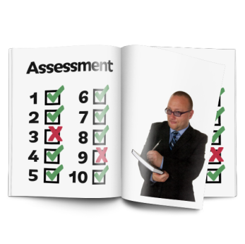 | - An integrated children’s rights and equalities impact assessment for the Scottish Children’s Reporter Administration  This is about how decisions are made within hearing systems.
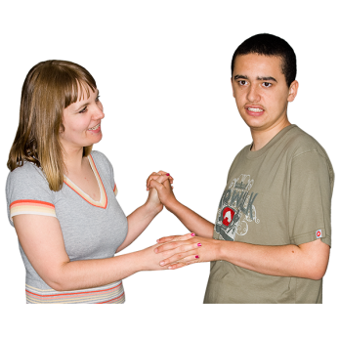 | - Improving the support for “all looked after” children, including disabled children through an improved learning and development framework for foster carers.  Foster carers will have more awareness of learning and development opportunities including support to care for disabled children.

Consultation Questions

Outcome 2: Health, Support and Disabled Children

 | Question 6
We want a Scotland to provide healthcare and support for disabled people, including disabled children, to live independently.

Do you think the commitments above will help us to do this?

Yes I agree | I am not sure | No I do not agree

Question 7

If you want to, you can tell us what you think about each commitment.

You do not have to comment on all of them.

If you do not want to comment on any of the commitments, please go to the next question.

 |  | Question 8
 |  | Is there anything we have missed which we can add to the commitments above?
Section 2.3

Outcome 3: Education, Employment and Income

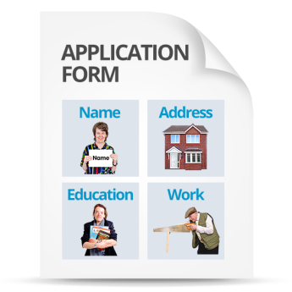 | This outcome is about equal and inclusive access to education, employment and an appropriate income whether in or out of work.
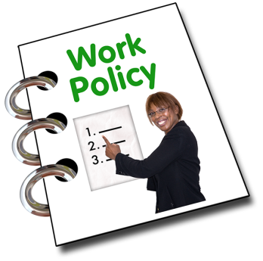 | What we want:  We want a Scotland which has:  - Equal opportunities for disabled people in education and employment.  - More awareness and understanding from employers and educators of barriers faced by disabled people.  - Benefits that meet the additional living and mobility costs for people with an impairment, disability or illness.

Our commitment to Scotland’s disabled people:

 | Additional Support for Learning
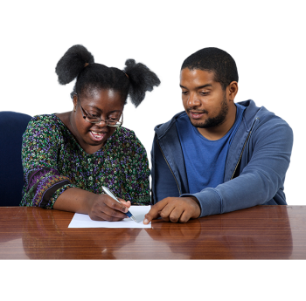 | - Continued commitment to implement additional support for learning  We will work with stakeholders on the Advisory Group for Additional Support for Learning. Children will be able to directly influence the additional support that is provided for them.
 | Strategy and Performance
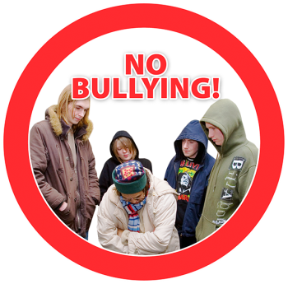 | - Anti-Bullying  We will support Scotland’s national anti-bullying service Respectme.  A priority for this service will be to look at bullying based on the protected characteristics, including disability.
 | Youth and Adult Employability and Skills Development
- Overarching commitment from Fair Work Directorate
We will make sure young disabled people get the opportunities and support they need to get into employment suitable to their needs and skills.

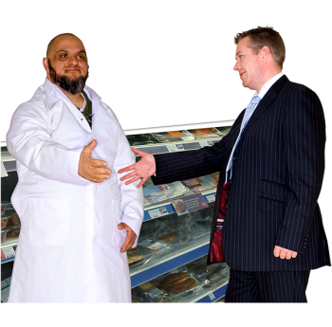 | - Developing the Young Workforce  We will invest £16.6 million and £16.3 million to Scotland’s Youth Employment Strategy.  This will reduce inequality and improve learning options helping young people, including young disabled people, prepare for work and do Modern Apprenticeships.
- Supported Employment Model
We will continue to support and promote this model for disabled people to learn on the job with support from colleagues and a job coach.
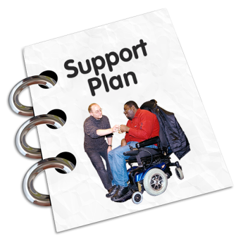 | - Supported Businesses  These are businesses where at least 30% of the staff are disabled.  About 20 of these employ 600 people.  Supported businesses will be offered support for start up and to look at their ability to continue.
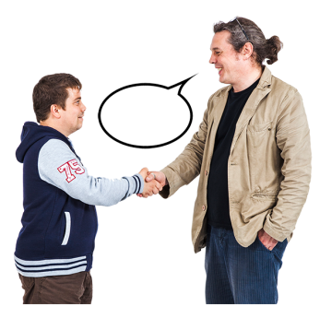 | - Establishment of a Fair Work Convention  This is an independent body supported by us to give advice on how workplaces can be made fairer and more productive.

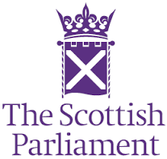 | - Disability Employment Services in Scotland  The Smith Commission says that the support for unemployed people should be overseen by the Scottish Parliament.
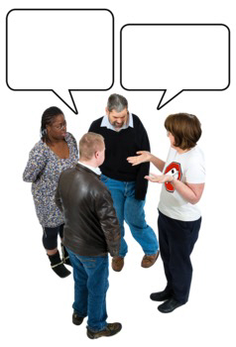 | - The Scottish Government Ministers have promised to make sure that disabled people are supported into work.  A consultation will be launched in July 2017.
 | Employment Tribunals
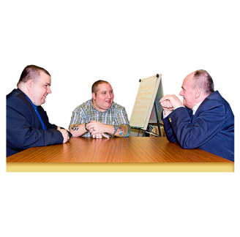 | - We want to remove fees for employment tribunals and will talk to disabled people and their organisations to find out what the barriers are when raising a claim at an Employment Tribunal.
 | Social Justice and Regeneration
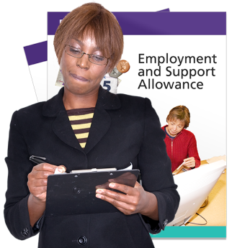 | - Disability Benefits Advocacy Support  We will fund the Health and Social Care Alliance (The ALLIANCE) to co-produce an advocacy project in four pilot areas.  It will focus on disabled people and those with health conditions who are being assessed for welfare benefits including Employment Support Allowance (ESA) and Personal Independence Payment (PIP)
 | Reform of local taxation
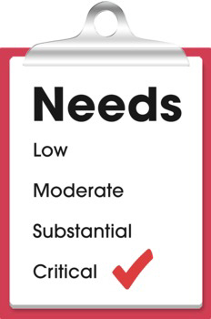 | - Future reform of local taxation will take into account the particular needs of disabled people.
 | Social Security Policy and Delivery
- Social Security for Disabled People
We want to make sure that a social security system treats people with dignity and respect.
We will co-produce policy and delivery options.

Consultation Questions

Outcome 3: Education, Employment and Income

Question 9

We want Scotland to be equal and inclusive in education and employment. And we want a social security system that meets disabled peoples’ needs.

Do you think the commitments above will help us to do this?

Yes I agree | I am not sure | No I do not agree
Question 10

If you want to, you can tell us what you think about each commitment.

You do not have to comment on all of them.

If you do not want to comment on any of the commitments, please go to the next question.

Question 11

Is there anything we have missed which we can add to the commitments above?

Section 2.4

Outcome 4: Justice

 | This outcome is about the justice system and being unfairly judged or punished.
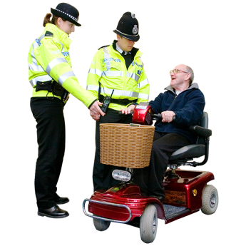 | What we want  We want a Scotland which:  - Lets disabled people report a crime or discrimination without being unfairly judged or punished in any way.  - Treats disabled people as equal citizens within the justice system, whether as the victim or the person who is committing the crime.
 | Civil Law and Legal System
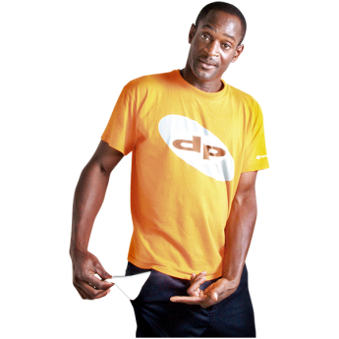 | - Review of legal aid contributions for disabled people  We will work with partners to find out if the current legal aid system which negatively affects disabled people and how this can be changed.

 | Criminal Justice
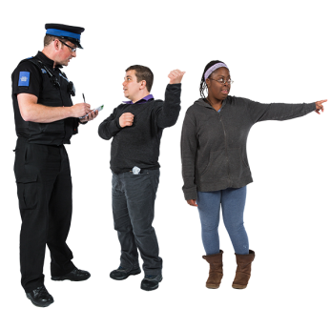 | The seven main criminal organisations will:  - Encourage reporting of hate crimes against disabled people  They have committed to work together for future publicity campaigns and to encourage disabled people to report hate crimes and provide reassurance that these reports will be taken seriously.
- Accessible information
They will publish their most important pieces of information and their publication in alternative formats.
An online secure website will be developed to provide case information for victims and witnesses.
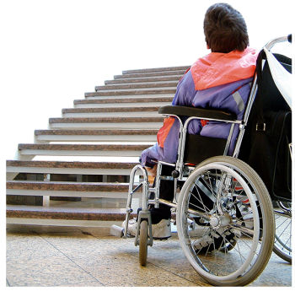 | - Accessibility of sites and services  They will do site audits of their buildings to identify any physical access barriers.  This information will be available on each organisation’s website.
 | Disability Hate Crime
- Disability Hate Crime
We will work with a Local Authority to do a pilot project on preventing and removing disability hate crime from society.

 | Violence against disabled women and girls
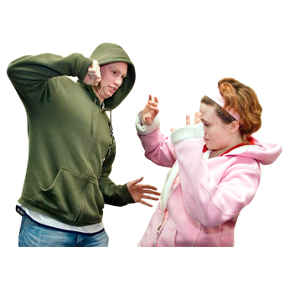 | - Violence against disabled women and girls  We will work with disabled people’s organisations to understand and remove violence against disabled women and girls.

Consultation Questions
Outcome 4: Justice

Question 12

We want a justice system that treats disabled people as equal citizens and does not unfairly judge or punish disabled people.

Do you think the commitments above will help us to do this?
Yes I agree | I am unsure | No I do not agree
Question 13

If you want to, you can tell us what you think about each commitment.

You do not have to comment on all of them.

If you do not want to comment on any of the commitments, please go to the next question.

Question 14

Is there anything we have missed which we can add to the commitments above?

Section 3

Making Changes

To make sure that we change the barriers we have identified, we must change the way that we work and how we engage with communities.

It is important that these three themes are in everything we do:

- Disabled people can take part in our society
- Communication is accessible and inclusive for everyone
- Raising awareness of the issues disabled people have
 | Disabled people can take part in our society
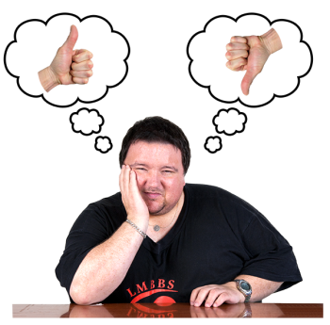 | To make sure disabled people can take parts in all areas of daily and public life:  - Safe, equal access to the physical environment and advice and support is given when it is needed.  - A society where politics, people and service providers support the social model of disability and know the value of removing disabling barriers.  If we achieve these conditions, disabled people will have more choice and control over their own lives.
 | Communication is accessible and inclusive to all
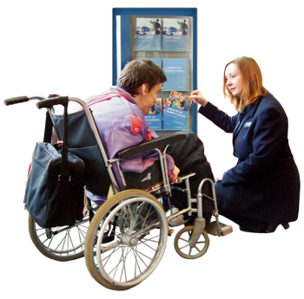 | Accessible communication is just as important as an accessible physical environment.
 | Inclusive communication means that policy makers and service providers need to make sure that views of people with communication support needs are fully heard, understood and valued and used to inform the development of policies and services.
 | Raising awareness
The UNCRPD aims to protect and promote disabled people’s human rights in all areas of life in Scotland.
We will continue to raise awareness of disabled people’s human rights and promote the UNCRPD.

Consultation Questions

Making Changes

 | Question 15
 | Do you think these are the most important three themes we need to think about in everything we do?
Yes I agree | I am not sure | No I do not agree
Question 16

Please comment on your answer above

Section 4

Getting it right and next steps

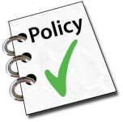 | It is important that we know how well we are doing our work.
 | The draft delivery plan shows how we will move forward to make UNCRPD a reality for disabled people in Scotland.  We are determined to make real, long term progress towards making sure disabled people enjoy the same human rights as other people.  We are committed to working with disabled people and their organisations to meet disabled people’s needs.
   | We will look at all the responses after January 2016.  We will finalise the delivery plan in Spring 2016 taking on board the views of disabled people.  We will keep working with disabled people to look at progress and share good ideas on projects that work.
Consultation Questions

 | Question 17  Tell us anything else you want to about this draft delivery plan.

Have Your Say
Respondent Information Form
You must fill in this form and send it back with your comments

Your name:
Your address:

The Scottish Government wants to let other people know what you think. It can do this by putting your comments on its website or in its library. Is that okay? Please tick one box.
It is okay to show what I said and my name and address.
It is okay to show what I said and my name, but not my
address.
It is okay to show what I said but not my name and address.
It is not okay to share what I said or my name and address.

If you are replying for a group or organisation please write the name here:

If you are replying for a group or organisation, the Scottish Government will put your group’s name and address on its website or in its library. Can it print your comments too?
Yes No, please keep my comments private

We will show your comments to people who work for the Scottish Government. They might want to contact you.
Is that okay?
Yes No

