Strategic Environmental Assessment
Environmental Report
Proposed Pelagic Fisheries Management Plans coordinated by the Marine Directorate of the Scottish Government
Including:
- North Sea Herring Fisheries Management Plan
- Atlanto-Scandian Herring Fisheries Management Plan
- Northern Shelf Mackerel Fisheries Management Plan
- Northern Shelf Blue Whiting Fisheries Management Plan
- West Coast of Scotland and Clyde Herring Fisheries Management Plan

Date: July 2026
Version: public consultation




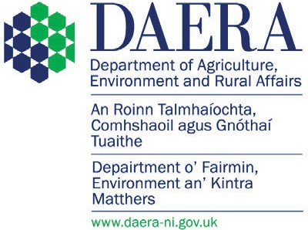
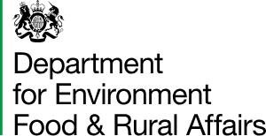



© Crown copyright 2026
This publication is licensed under the terms of the Open Government Licence v3.0 except where otherwise stated. To view this licence, visit nationalarchives.gov.uk/doc/open-government-licence/version/3.
Where we have identified any third-party copyright information you will need to obtain permission from the copyright holders concerned.
Any enquiries regarding this publication should be sent to us at:
FMPs@gov.scot

Contents
Non-technical Summary 6
1. Introduction 8
Fisheries Management Plans – context and background 8
Delivering Sustainable Management of Fisheries and FMPs 9
Scope of the FMP 10
Draft Pelagic FMPs’ Policies and Actions 11
2. Approach to Strategic Environmental Assessment 12
Screening 12
Scoping 13
Scope of the Assessment 14
Assessment Methodology 15
3. Environmental Baseline 17
Summary of the Current State of the UK Marine Environment 17
Existing Environmental Effects of Pelagic Species Fishing 23
4. Relevant Plans, Programmes and Environmental Protection Objectives 32
International 32
Domestic 33
5. Assessment of Environmental Effects 42
Overview of the Potential Positive and Negative Environmental Effects of the Policies and Actions of the draft Pelagic FMPs 43
Overview of Potential Positive Environmental Effects of the FMPs 43
Overview of Potential Negative Environmental Effects of the FMPs 46
In-combination Effects 47
Conclusions 48
6. Proposed Actions to Reduce Significant Negative Effects 49
Existing Negative Effects of Mackerel, Herring andBlue Whiting Fishing 49
Effects identified by this assessment 53
General 54
7. Reasonable Alternatives 54
8. Monitoring and Review 56
Monitoring 56
Review 58
Annex 1: 59
Table 1. Overview of FMPs covered in this Strategic Environmental Assessment, including FMP title, stock, fisheries area (ICES subarea and division), relevant national waters covered, and fishing authorities 59
Table 2. Summary of policies, actions, and relevant Fisheries Act objectives for the five Pelagic FMPs. Policies and actions are mostly applicable to all five Pelagic FMP; Exceptions to this are specified following the relevant actions text. 60
Table 3. Sections of this report and the corresponding paragraph of Schedule 2 of the SEA Regulations 2004 70
Table 4. Results of the scoping exercise to determine those environmental issues likely to be significantly affected by the five draft Pelagic FMPs and thus scoped into the SEA 72
Table 5. High-level assessment of the positive and negative environmental effects of the five draft Pelagic FMPs’ policies and actions 75
Table 6. Assessment of alternatives to proposed policies and actions 99
Appendix A: Eleven Descriptors of the UK MS 109
Appendix B: Additional Baseline Information 110
D1 and D4 – Cetaceans 110
D1 and D4 – Seals 113
D1 and D4 – Birds 115
D1 and D4 – Fish and D3 – Commercially exploited fish and shellfish 118
D1 and D6 – Benthic Habitats 122
D4 – Food webs 125
D10 – Marine Litter 128
D11 – Underwater noise 129
Appendix C: UK MPA designations 132
Appendix D: Marine Plans – Country specific detail 133
Scotland 133
England 133
Northern Ireland 133
Wales 133
Appendix E: Glossary 135
Appendix F: Statutory Consultee Consultation Responses 140
Northern Ireland Environment Agency Response 142
Historic Environment Division Response (Northern Ireland) 152
Historic Environment Scotland Response (Scotland) 155
Historic England Response 159
JNCC Response 167
Natural England Response 171
NatureScot Response 173
NRW Response 176
SEPA Response 183

Non-technical Summary
The draft Atlanto-Scandian Herring FMP, Northern Shelf Blue Whiting FMP, Northern Shelf Mackerel FMP, North Sea Herring FMP and West Coast of Scotland and Clyde Herring FMP, hereafter jointly referred to as “Pelagic FMPs”, have been prepared to meet the requirements of the Fisheries Act 2020, by the relevant authorities for these FMPs - the Department of Agriculture, Environment and Rural Affairs (DAERA), the Department for Environment, Food & Rural Affairs (Defra), the Scottish Government and the Welsh Government – with input from industry, scientists, non-governmental organisations (NGOs) and Statutory Nature Conservation Bodies (SNCB). They set out the policies and proposed actions the fisheries policy authorities (DAERA, Defra, Marine Directorate and Welsh Government) will use to manage mackerel, herring and blue whiting fishing activity, so stocks are harvested within sustainable levels. Alongside these measures, the five draft Pelagic FMPs also set out policies and actions to help support wider social, economic and environmental aspects of the fishery.
This environmental report (ER) has been produced in accordance with the Environmental Assessment of Plans and Programmes Regulations 2004 (SEA Regulations 2004). The following issues (from Schedule 2, paragraph 6 of the SEA Regulations 2004) were scoped into the assessment:
- biodiversity
- fauna
- flora
- water
- climatic factors
- cultural heritage
This assessment focuses on how the policies and actions in the draft Pelagic FMPs could give rise to both significant positive and negative environmental effects. The findings of this assessment have been used to inform the development of the FMPs.
The assessment was conducted against a baseline that primarily used existing evidence on the state of the marine environment set out in the UK Marine Strategy Part 1 published in 2019. Additional sources of evidence were used to establish the status of the environment in relation to issues, such as climatic factors, not covered by the UK Marine Strategy (UK MS). The historical impact of fishing activity on the marine environment has been considered part of the baseline. Our assessment used the best available evidence to reach a suitable judgement on the environmental effects of the draft Pelagic FMPs.
This report sets out those plans, programmes and environmental protection objectives, both international and domestic that the fisheries policy authorities consider relevant to the draft Pelagic FMPs.
This report considers and acknowledges the existing environmental effects of fishing for mackerel, herring and blue whiting on those issues scoped into this assessment, in relation to Marine Protected Areas (MPAs), the UK MS descriptors of good environmental status (GES) for the wider marine environment, Priority Marine Features (PMFs; Scottish waters only), and climatic factors. The potential positive and negative environmental effects of the draft Pelagic FMPs’ policies and proposed actions alone and in-combination have also been assessed.
The Strategic Environmental Assessment (SEA) has concluded that beyond the direct impact on targeted stocks, the fishery has an impact on the marine environment primarily through bycatch of unwanted / protected species and prey reduction. Actions have been proposed to investigate these impacts and use this evidence to develop robust mitigation strategies. The contribution of pelagic fishing to fishing related litter, climate change related issues and cultural heritage were also identified as potential impacts.
The draft Pelagic FMPs have considered these impacts and set out proposals to monitor, and where required, introduce mitigation to address these impacts.
The assessment of the likely negative effects of the policies and actions did not identify any negative effects that posed a significant risk to the environment. The policies and actions, will, where appropriate, be developed to avoid any potential negative effects identified by the assessment process. The environmental effects of implementing the draft Pelagic FMPs’ policies and actions will also be monitored to identify unforeseen adverse effects at an early stage, so appropriate remedial action can be undertaken.
This assessment recommends the draft Pelagic FMPs should consider the following additional points:
- Future iterations of the Pelagic FMPs should consider how they can develop the cultural heritage of each fishery and how fisheries management can contribute to reducing potential negative interactions with marine heritage assets.
- The draft Pelagic FMPs would benefit from providing more specific detail on how the FMPs will interact with Marine Plans. Noting how the FMPs could positively or negatively interact with this programme would improve the in-combination assessment

Introduction

Fisheries Management Plans – context and background
Marine fish stocks are a public resource, a valuable natural asset and important components of marine ecosystems. Managing fishing activity so that we harvest our stocks within sustainable limits will ensure our fishing communities, the seafood supply chain and wider society continue to benefit from our natural assets, now and into the future.
The Joint Fisheries Statement (JFS) as amended, as required by the Fisheries Act 2020, sets out how the UK fisheries authorities (the Department of Agriculture, Environment and Rural Affairs in Northern Ireland, Defra, Scottish Government, and Welsh Government) will prepare and publish 43 Fisheries Management Plans (FMPs) by 2028, to manage fishing activity so the harvesting of fish stocks remains within sustainable levels. The Scottish Government is the coordinating authority for 21 FMPs with a delivery date of end of 2026. Of the 21 FMPs, 8 are for Pelagic stocks.
Sustainable fisheries protect stocks and the wider environment whilst delivering social and economic benefits for present and future generations. Delivering sustainable fisheries will involve balancing the environmental, social and economic aspects of fisheries. Both the short-term and the long-term impacts of decisions to manage fishing activity to protect stocks, the marine environment and on the fishing industry will be considered. Any short-term decisions to favour social or economic benefit should not significantly compromise the long-term health of the stocks and marine environment that underpin these societal and cultural benefits of fishing. These decisions should recognise the cultural importance of fishing through maintaining and, where possible, strengthening coastal communities and livelihoods alongside the requirement for fish stocks to reach and maintain sustainable levels.
UK fisheries policy authorities identified 43 FMPs in the JFS. A timetable for the preparation and publication of the FMPs can be found in Annex A of the JFS and summarised on Gov.UK: see the List of FMPsthe List of FMPs. Following consultation, an updated version of Annex A of the JFS was published in December 2024, introducing changes to the publication dates and technical details of several FMPs.
All FMPs must contain the information set out in section 6 of the Fisheries Act 2020. In summary, an FMP must specify: the relevant authority; stock or stocks, type of fishing, and geographical area to which the plan relates; the status of the stocks; policies and actions to maintain or restore, or contribute to maintaining or restoring, stocks at sustainable limits, or to maintain or increase levels of stock; and the indicators to be used to monitor the effectiveness of the plan.
FMPs must specify whether there is sufficient evidence to enable relevant authorities to assess a stock’s Maximum Sustainable Yield (MSY). Where there is insufficient evidence, the FMP must specify policies for maintaining or increasing levels of the stock, and the steps (if any) that the relevant authority or authorities propose to take to obtain the scientific evidence necessary to enable an assessment of a stock’s MSY. If no steps are proposed, the FMP will explain the reasons for that, and how the precautionary approach to fisheries management will be applied so fish are harvested within sustainable limits.
Through managing fishing activity within sustainable limits, FMPs will contribute to the fisheries objectives set out in section 1 of the Fisheries Act 2020. The scope of an FMP may be extended to consider wider fisheries management issues related to environmental, social or economic matters. How FMPs consider wider fisheries management issues will be determined at the individual FMP level, appropriate to the stock(s), fishery and geographic area within the remit of the FMP.
The Fisheries Act 2020 requires the FMPs to be reported on every three years, as part of the statutory report on the JFS. FMP are also to be reviewed at least every six years. FMPs will evolve as our understanding and evidence base develops through their implementation. Some FMPs will progressively address a wider range of fisheries management issues as they evolve through an iterative approach over time.
FMPs will contain a range of policies and actions whose detail will vary depending on the evidence available to support their implementation. Some policies and actions may only indicate future action and will develop over time as the plan’s evidence progresses through each iteration.
FMPs will adopt an ecosystem-based approach to fisheries management to help deliver environmental, social and economic benefits beyond those accrued from just achieving the sustainable harvesting of stocks.
The policies and actions proposed by an FMP will apply to all vessels (UK and non-UK vessels) fishing relevant stocks in the area covered by the plan.

Delivering Sustainable Management of Fisheries and FMPs
Fisheries rely on the ecosystems in which they operate to support healthy stocks. These ecosystems can be compromised by human-induced pressures, including pollution, marine litter and unsustainable exploitation of marine resources. This pressure includes the impact of fish population levels on the processes and functioning of the wider ecosystem; for example, the removal of prey species impacts the status of top predators.
Long term, sustainable, and profitable fisheries require active management to avoid, reduce or mitigate any adverse impacts of fishing activity on ecosystem functioning, ecosystem resilience, or environmental threats such as climate change.
Available fishery data and advice will help determine the targets and catch limits applied to each stock. Where possible, these limits would include the MSY for data-rich stocks where biomass fluctuations can be tracked. Alternative proxies for harvest limits, the precautionary approach, or a combination of both are required for more data-limited stocks, where it is only possible to detect biomass fluctuations.
Not all stocks currently have sufficient evidence to establish MSY, or proxy, reference points and limits. It is not scientifically feasible or economically viable to collect such evidence for some species. In these cases, FMPs must include the steps, or reasons for not taking steps, national fisheries authorities will take to ensure stocks are harvested within sustainable limits.
FMPs will recognise the importance of the sustainable use and conservation of our marine natural assets and the ecosystem services they provide when setting out policies to manage fishing activity. FMPs will make use of the best available scientific advice, be subject to scientific evaluation, and consider the environmental risks associated with the fishing activity. The plans will use a risk-based approach to identifying appropriate and proportionate mitigation for its environmental impact.
FMPs will contribute to achieving Good Environmental Status (GES) under the UK Marine Strategy (UK MS). In addition to improving or maintaining the status of commercial stocks, plans can include actions focused on reducing the risks and/or pressures from fishing activity to other ecosystem components that may prevent achieving GES.
Managing fishing activity within sustainable limits through FMPs will directly contribute to securing the continued availability of seafood products as an important food source within the UK food supply chain.

Scope of the FMP
The stocks and areas covered by the Pelagic FMPs are summarised in Table 1 of Annex 1. The draft Pelagic FMPs apply to fisheries for the following five species:
- mackerel (Scomber scombrus)
- herring (Clupea harengus)
- blue whiting (Micromesistius poutassou).
The draft Pelagic FMPs will apply to all areas in Scottish waters, English waters, Northern Ireland waters, and Welsh waters where fishing activity for the above given species takes place (fishing areas for each FMP are specified in the Annex A to the JFS). The relevant regions are summarised in Table 1 (Annex 1). A breakdown of the relevant fishing gears for each FMP is also provided in Table 1 (Annex 1).

Draft Pelagic FMPs’ Policies and Actions
The overall vision for the draft Pelagic FMPs is that these fisheries in UK waters are managed sustainably, to help ensure that stocks are maintained above biomass levels capable of producing MSY.
The policies and actions set out in the draft Pelagic FMPs suggest how this could be achieved in a way that is consistent with, and supportive of, the wider achievement of the fisheries objectives set out in the Fisheries Act 2020 (the 2020 Act), and the policies contained within the JFS.
To ensure effective management of the fisheries in UK waters, the draft Pelagic FMPs identify policies focussed on domestic and international management priorities. They were drafted to meet the requirements of policies set out in the JFS and sections 6(3)(a) or 6(3)(b) of the Fisheries Act 2020 (where appropriate).
These policies and actions may change following the public consultation. Any changes will be subject to assessment and reflected in the final Environmental Report. For each policy, the plan sets out:
- a rationale;
- ongoing, short- and longer-term actions; and
- how the actions support delivery of the fisheries objectives.
Table 2 in Annex 1 provides a summary of the policies and actions for the draft Pelagic FMPs.
The six policies for the draft Pelagic FMPs are to:
Policy 1a: Harvest [the stock] sustainably, contributing to maintaining or restoring the biomass above the level capable of producing MSY
Policy 1b: Continue to manage the WoS and Clyde herring stocks using existing tools to maintain stock levels
Policy 2a: Use the best-available scientific evidence to support management decisions relating to the setting of sustainable fishing opportunities
Policy 2b: Improve the evidence base underpinning the stock, in order to support sustainable harvesting of the WoS and Clyde herring stocks, with biomass maintained above the level capable of producing MSY
Policy 3: Monitor catches of [Pelagic FMP stocks] and ensure that where possible all catches are counted against quotas
Policy 4: Identify and support implementation of ecosystem-based fisheries management approaches appropriate for the relevant fisheries
Policy 5: Support fishing businesses to deliver socio-economic and cultural benefits for communities
Policy 6: Reduce the impact of fishing on climate change and support the fishing industry to adapt to the impacts of climate change

There is significant overlap in policies for the five pelagic FMPs, apart from policies 1 and 2 in the West Coast of Scotland and Clyde herring FMP which are different to account for the complexities around these stocks; this is intentional to ensure that there is harmonisation in management approaches and delivery as far as practicable. Area specific considerations, which do not span all five FMPs, are denoted in the individual FMPs.

Approach to Strategic Environmental Assessment

Screening
SEA Regulations 2004 requires that qualifying public plans, programmes, and strategies undergo screening for SEA during their preparation and prior to adoption. Fisheries Management Plans are plans that fall within the definition in Regulation 2.
Marine Directorate, Defra, DAERA and Welsh Government consider that regulation 3(2)(b) of the SEA Regulations 2004 applies to the draft Pelagic FMPs as the plans relate to Scotland, England, Northern Ireland and Wales.
In accordance with the SEA Regulations 2004, Marine Directorate, Defra, DAERA and Welsh Government carried out a screening exercise which determined that the proposed policies in the draft Pelagic FMPs may have likely significant effect (either positive or negative) on a European site or a European offshore marine site and they are not directly connected with or necessary to the management of such sites.
The screening exercise used Defra’s Magic Map Application to identify whether the geographical scope of the FMPs overlap with any European sites or European offshore marine sites. Table 3, page 35 of The updated UK Marine Strategy Part 1 sets out the pressures on the marine environment resulting from anthropogenic activity, which includes fishing. This information was used to identify whether fishing activity for mackerel, herring and blue whiting has the potential to impact these sites and interest features. For example, fishing vessels targeting pelagic stocks have the potential to result in the extraction of, or mortality/injury to wild species.
The screening also judged that actions arising from the draft Pelagic FMPs have the potential to affect multiple European marine sites and the wider marine environment.
Based on the outcome of the screening, the fisheries policy authorities concluded the Pelagic FMPs fall within the description of a plan in regulation 5(3) of the SEA Regulations 2004, and so as a result of regulation 5(1) must be subject to SEA in accordance with Part 3 of the SEA Regulations 2004 during its preparation and prior to its adoption (publication).
Completing this SEA does not remove any other statutory obligation on competent authorities to assess the possible environment impact of a policy or measure ahead of its implementation.

Scoping
Marine Directorate, Defra, DAERA and Welsh Government carried out a scoping exercise to identify the scope and level of detail of the assessment that will be documented in the Environmental Report. Regulation 12(5) requires that when deciding on the scope and level of detail of the information in the Environmental Report, the responsible authority must seek the views of the Consultation Bodies.
A Scoping Report identifying the scope and level of detail of the assessment of the draft Pelagic FMPs was provided to the following Consultation Bodies:
- NatureScot
- Scottish Environment Protection Agency
- Historic Environment Scotland
- Joint Nature Conservation Committee (JNCC)
- Historic England
- Natural England
- Environment Agency
- DAERA
- Natural Resources Wales
- Cadw
See Appendix F for Consultation Body responses on the Scoping Report and how consideration was given to the points raised in each response.
Regulation 12(3) of the SEA Regulations 2004 requires that the Environmental Report shall include the information referred to in Schedule 2, in so far as it is reasonably required. Table 3 in Annex 1 sets out which section of this report corresponds to the relevant paragraphs of Schedule 2.

Scope of the Assessment
Schedule 2 paragraph 6 to the SEA Regulations 2004 lists the issues that must be considered for an assessment of likely significant effect in relation to the proposed FMPs. Based on its initial evaluation of likely significant effects and taking into account the results of the scoping consultation carried out (see Scoping above and Appendix F), the following conclusions were reached regarding the content of the Environmental Report.
Marine Directorate, Defra, DAERA and Welsh Government propose that the Environmental Report will address the effects on the following issues:
- Biodiversity, fauna and flora including the following sub-sections: cetaceans, seals, birds, fish, benthic habitats, commercially exploited fish and shellfish, food webs.
- Water including the following sub-sections: marine litter and underwater noise.
- Climatic factors including the following sub-sections: vessel emissions, blue carbon.
- Cultural Heritage including the following sub-section: interactions between fishing gear and marine heritage assets.
Marine Directorate, Defra, DAERA and Welsh Government scoped the following issues out of the assessment, and therefore they will not be covered in the Environmental Report:
- Population (Human)
- Human health
- Geology and sediments (soil)
- Air
- Material assets
- Landscape and seascape
Fishing activity being managed through the FMPs has the potential to have some level of interaction with all the issues from Schedule 2 paragraph 6. However, the scoping exercise considered and scoped in those environmental issues that would be significantly affected by the draft Pelagic FMPs. Issues such as Population, Human Health, Geology and sediments, Air, Material Assets and Landscape and Seascape were scoped out of this assessment as it was considered that they would not be significantly affected by the draft FMPs. Table 4 in Annex 1 provides the justification behind this decision. Additional rationale behind why sub-sections were considered is set out below:
- To link the issues (from Schedule 2 paragraph 6) that will be addressed by this Environmental Report with the environmental baseline (see section 3), we have attributed a UK Marine Strategy (UK MS) descriptor of Good Environmental Status (GES) to the appropriate corresponding issue(s); see Appendix A for the list of the 11 UK MS descriptors. Achieving GES is about protecting the natural marine environment, preventing its deterioration and restoring it where practical, while allowing sustainable use of marine resources.
- Assessing the status of these descriptors identifies where improvements are required to achieve GES. Knowing the current status will help direct efforts to reduce the impacts of certain human activities. The UK Marine Strategy assessment tool provides further information.
- Under the UK MS, Descriptor 1 – Biodiversity has been split into the following sub-sections; cetaceans, seals, birds, fish, benthic habitats. These sub-sections are all relevant to the biodiversity issue from Schedule 2 paragraph 6 and therefore have been included in this assessment.
- Marine Litter and Underwater Noise have been included as the most relevant sub-sections assessed by the UK MS under the Water issue heading. Fishing activity was considered not to contribute to Eutrophication, Changes in Hydrographical Conditions, and Contaminants; therefore, these sub-sections have not been included.
- Climatic factors are not considered under the UK MS assessment process; therefore, no predetermined sub-sections are available. Vessel emissions and blue carbon were identified as the two most relevant issues related to fishing activity that are associated with climate change.
- Cultural heritage is also not considered under the UK MS assessment process; therefore, no predetermined sub-sections are available. The interaction between fishing gear and marine heritage assets was identified as the most relevant impact related to fishing activity that is associated this issue heading.
Table 4 in Annex 1 shows the results of the scoping exercise on the draft Pelagic FMPs.

Assessment Methodology
This SEA reflects the geographical scope (section 1) and fishing activity covered by the proposed FMPs. It considers the policies and actions of the draft Pelagic FMPs (Table 1 in Annex 1). The assessment reviewed existing evidence on the current state of the marine environment, which included the impact of fishing within the baseline state (section 3).
It assessed the nature and extent of likely effects of the draft Pelagic FMPs (including their policies and actions) on those environmental issues scoped into the assessment and where applicable their associated UK MS descriptors identified in Table 4 (Annex 1). The SEA will assess the actions set out in the FMP to identify and mitigate any likely significant effects of the plan on the environmental issues scoped into the assessment. It is the draft FMPs, as a plan of management that have been assessed, rather than the fishing activities themselves.
As the FMPs are a strategic programme of work, the SEA will consider the potential positive and negative environmental effects of management options in the context of the UK MS descriptors. This SEA will also consider the in-combination effects and interactions of these FMPs with other plans and projects, including other FMPs.
More detailed fisheries assessments which consider current activity are already in progress or have been completed. These assessments may be used to inform the FMPs’ actions as they are delivered, and include:
- The Marine Directorate’s offshore MPA fisheries assessments programme and ongoing inshore MPA and PMF fisheries assessment programmes.
- Defra’s Revised Approach to fisheries management programme (inside twelve nautical miles) in England.
- The Marine Management Organisation’s (MMO) ongoing Fishery Assessment programme (outside twelve nautical miles) in England.
- Assessments required to prepare the Marine Protected Areas (Prohibited Methods of Fishing) Regulations (Northern Ireland) 2022 which came into operation on 1 January 2023. Further fisheries measures are being consulted on currently for 3 offshore MPAs and the outcome of the consultation will be published later this year.
- The Assessing Welsh Fishing Activities Programme is in place in Wales. This work assesses likely impacts to habitats and features from specific gears - it does not assess impacts from current activity, but the generic assessments are used to inform management.
- The annual Habitats Regulation Assessment (HRA) under Regulation 63 of the Conservation of Habitats and Species Regulations 2017 (CHSR) assessing demersal fishing.
- The wider marine environment (UK MS) assessments
Future delivery of the actions specified in the FMPs may give rise to management changes such as new legislation to regulate mackerel, herring and blue whiting fishing. Such changes may have the potential to impact MPAs and their features and will be subject to more detailed Habitats Regulations Assessment before being implemented.
Nevertheless, this Environmental Report acknowledges the potential significant effects associated with fishing activity being managed through the draft Pelagic FMPs and sets out in broad terms how the FMPs will seek to avoid, reduce, or at least mitigate significant negative effects.
During the development of the draft Pelagic FMPs, advice from Statutory Nature Conservation Bodies (SNCBs) (JNCC, Natural England, NatureScot and Natural Resources Wales) on the impacts of fishing activity in relation to MPAs, PMFs, and UK MS descriptors was considered. This Environmental Report will review how this advice has been reflected in the proposed FMPs, and how the proposed policies and actions could change the baseline.
It is important to note the draft Pelagic FMPs contain a range of policies and actions that vary in their stage of development depending upon the evidence available to support their implementation. The level of detail possible for our environmental assessment depends upon the stage of development of the policies and actions of the FMPs at the present time.
This assessment acknowledges the draft Pelagic FMPs set out policies to develop the evidence base for the mackerel, herring and blue whiting fisheries. Our assessment used the best available evidence at the present time to reach a judgement on the environmental effects of the draft Pelagic FMPs.
The detail of the environmental assessment is covered in section 5.

Environmental Baseline

Summary of the Current State of the UK Marine Environment
Section 3 provides a summary of the current state of the UK marine environment for each of the environmental issues screened into this SEA, and where applicable their associated UK MS descriptors (Table 4; Annex 1). The SEA has been conducted against the environmental baseline set out in these sources of existing information. We acknowledge that there are some uncertainties and evidence gaps in the environmental baseline. However, we consider that this environmental baseline provides a comprehensive level of information to undertake an effective assessment and provide informed evidence-based recommendations. Where required, further detailed assessments using additional evidence will be completed ahead of the implementation of FMP actions.
It is likely that without the proposed FMPs, those issues which are contributing to the current state of the marine environment will likely continue to have an influence. The proposed FMPs seek to promote the management of the fisheries in a more coherent and coordinated manner that considers wider environmental issues. The FMPs therefore have the potential to improve the current state of the environment set out below, both where no improvement has been observed, and where positive trends have been identified. Section 6 and 7 considers how the implementation of the FMPs’ proposed policies and actions could change the baseline.

Biodiversity, Flora, and Fauna
The primary source of information on the current state of the UK marine environment came from the UK MS descriptor status assessments: The updated UK Marine Strategy Part 1, published in 2019. The impact of fishing has been considered as part of the assessment on the UK MS descriptors, therefore information on the impact of fishing activity on the marine environment has been included in the sections below as part of the baseline. For further information on the baseline related to UK MS descriptors see Appendix B.

D1 and D4 – Cetaceans
Cetaceans (whales and dolphins) are an important marine ecosystem component that contributes to overall levels of biodiversity (D1). In addition, as top predators, the abundance of cetaceans can also provide some understanding on how the food web is functioning (D4).
The current status of cetaceans for both the North Sea and Celtic Sea is mixed. While there are some aspects that are in line with the achievement of GES, much of the picture is unclear. The impact of various net fisheries is leading to bycatch that, in places, might be impacting long term population viability of harbour porpoise.
Other than for a limited number of coastal bottlenose dolphin populations, it is unclear whether the abundance and range of most cetacean species can be considered in line with GES. Fisheries and the removal of prey species is one of several activities / pressures that have the potential to result in changes in cetacean abundance and distribution.

D1 and D4 – Seals
Seals are an important marine ecosystem component that contributes to overall levels of biodiversity (D1). In addition, as top predators, seal productivity can also provide some understanding and insight as to how the food web is functioning (D4).
Grey seal populations and productivity continues to increase, and targets are being met. Bycatch (largely in tangle / trammel nets) is occurring but not at levels that threaten population viability. For harbour seals, the status is not in line with GES where population declines have occurred in some areas. The cause is unknown. It is not thought to be linked to bycatch as occurrences are rare and there is no indication that it is linked to other pressures associated with fishing.

D1 and D4 – Birds
Seabirds are well monitored species that are an important marine ecosystem component that contributes to overall biodiversity (D1). In addition, as top predators, the abundance of birds can also provide some understanding and insight as to how the wider food web is functioning (D4).
Seabird populations are currently below the level that is considered to meet GES and the situation is deteriorating. Some declines in breeding success have been linked to prey availability caused by climate change and / or past and present fisheries. Invasive predatory mammals are also known to impact breeding success on island colonies. The impact of bycatch will be included in future assessments and current evidence suggests that some longline and static net fisheries could be having possible population level impacts on certain species.

D1 and D4 – Fish and D3 – Commercially exploited fish and shellfish
Fish are an important ecosystem component that contributes to overall levels of biodiversity (D1). In addition, fish of different species have a significant role in marine food webs (D4), acting as both predators and prey. Some fish species are commercially exploited, and only a proportion of these have managed quotas. Over-exploitation can lead to a decline in stocks (D3) which can reduce both future commercial opportunities and have wider ecological impacts.
The current status of fish communities in the UK is primarily shaped by historical over-exploitation by fisheries, while ongoing over-exploitation continues to be a notable contributing factor. Improved fisheries management since the 1990s has resulted in more stocks being fished at or below MSY levels, so although the target is not yet met, there is a positive trend. Improved fisheries management has also resulted in some positive trends in fish communities beyond the targeted stocks.

D4 – Food webs
Food webs (D4) are the network of predator-prey relationships that occur in the marine environment, from phytoplankton to top predators such as birds or seals. Fish communities are a key component of food webs. Knowledge of food webs allow understanding of how changes at one trophic level can impact those above and below it.
Historic fishing activity which has contributed to the current environmental baseline has had a large impact on fish community structure - a key component of marine food webs. With improved fisheries management focusing on stocks, some recovery is occurring. However, the management of fish stocks solely to safeguard future fisheries will not necessarily lead to all food web targets being met. Changes in plankton are likely driven by prevailing environmental conditions, but other impacts cannot be ruled out.

Water Quality

D10 – Marine Litter
Marine litter, including from fishing activities, is a significant pressure on marine ecosystems and water quality. The UK has not yet achieved its aim of GES for litter. Beach litter levels in the Celtic Seas have remained largely stable since the assessment in 2012, whilst beach litter levels in the Greater North Sea have slightly increased. Waste fishing material is a component of beach litter. Both floating litter and seafloor litter remain an issue, with plastic the predominant material. Achieving GES for marine litter requires improved waste management practices, the reduction of lost or discarded fishing gear, and increased awareness and monitoring of the issue.

D11 – Underwater noise
Underwater noise from fisheries, while not the primary source, can still contribute to the overall noise pollution in the marine environment. Fishing vessels will contribute to underwater noise through sonar, engine noise, gear interacting with seabed and deploying and retrieving gear.
The achievement of GES for underwater noise in the UK is uncertain. Research and monitoring programmes established since 2012 have provided an improved understanding of the impacts of sound on marine ecosystems. However, achieving GES for underwater noise will require better understanding and monitoring of the issue, as well as the development and implementation of strategies to manage noise pollution from various sources.

Climatic Factors
Climate change impacts are not part of the UK MS, therefore evidence from other sources were used to provide baseline information in relation to this issue. Statistics from the Department for Energy Security and Net Zero (DESNZ) (formally known as Department for Business, Energy & Industrial Strategy (BEIS), Department for Transport (DFT) and Engelhard et al (2022) report on Carbon emissions in UK fisheries, were used to identify the contribution UK fishing fleets have to the total carbon emissions at sea each year.
Vessel Emissions
The fishing sector contributes to carbon emissions mainly through vessel emissions and use of refrigerants with additional impacts in the processing and wholesale sectors relating to transport of exports (Engelhard et al., 2022). A study of the Scottish pelagic fishing fleet showed 96% of emissions come from fuel use during fishing operations (Sandison et al., 2021). The UK pelagic fleet is comprised of large, modern (and often highly efficient) vessels. Scottish pelagic vessels are significantly larger and more technologically advanced than the rest of the Scottish vessels with an average length of 72 metres and an average engine power of 5800 kW, compared to an average length of fewer than 12 meters and an average engine power of 200 kW for the rest of the Scottish fleet (Metz et al., 2022).
In Scotland, the pelagic fleet was made up of 21 vessels in 2024 which represent only 1% of the Scottish fleet, but account for just over 50% of landings by value of all landings—highlighting their disproportionate contribution to total catch. They target primarily North East Atlantic mackerel, North Sea herring, Atlantic herring (or ASH) and Blue Whiting in the North Sea and Atlantic Ocean. At UK level, fuel use from all fishing activity contributed an estimated 467 kt CO₂e in 2024—representing around 0.12% of total UK territorial emissions (378 Mt CO₂e) and 0.43% of domestic transport emissions (109 Mt CO₂e), and equivalent to about 1.1% of agricultural emissions (41.0 Mt CO₂e). The pelagic fleet has a high daily fuel demand with an annual fuel use of over 35,000 litres. This accounts to around 102 kt CO2e or around 17% of total emissions per fleet segment (Metz et al., 2022). Despite the relatively high fuel use of pelagic vessels, when emissions are assessed per unit of landed output (e.g. edible protein), pelagic species have high catch volumes relative to fuel use and, generally, have comparatively lower emissions than most other seafood (Sandison et al., 2021).
Climate change impacts on Pelagic FMP stocks and fisheries
Pelagic fish stocks (including mackerel, herring and blue whiting) are among the most economically valuable and climatically sensitive fisheries in UK waters and the wider Northeast Atlantic (ICES, 2023; Garrett et al., 2024). The existing evidence shows that climate change is already reshaping pelagic fish distributions, productivity and ecosystem interactions, creating significant challenges for fisheries management systems which are largely based on historical conditions (Baudron et al., 2020; Townhill et al., 2023).
Pelagic species respond to warming seas faster and over greater distances than most demersal fish because they closely track temperature and plankton availability (Baudron et al., 2020; Montero Serra et al., 2015).
Key observed patterns include:
- Strong poleward shifts of both warm affinity and temperate pelagic species (Baudron et al., 2020; Townhill et al., 2023)
- Extreme mobility of Northeast Atlantic mackerel, whose centre of distribution shifted ~1,650 km west and ~400 km north between 2007–2016 (Garrett et al., 2024; Ólafsdóttir et al., 2019)
- Northward re-centring of boreal pelagic stocks (e.g. herring, blue whiting) into Norwegian, Icelandic and Barents Sea waters (Pinnegar et al., 2023; Garrett et al., 2024)
- Altered pelagic fish productivity with sea temperature impacting on spawning and larval survival (Petitgas et al., 2013; Pinnegar et al., 2023)
- Increasing presence of warm water pelagics (e.g. sardine and anchovy like species) in and around the North Sea (Montero Serra et al., 2015; Townhill et al., 2023).
Recent warm years have produced strong year classes for some pelagic species (e.g. mackerel, blue whiting, sprat), but responses are highly variable across species and regions (Garrett et al., 2024).
Pelagic fish play a crucial role by linking lower and upper trophic levels in Northeast Atlantic food webs with fewer species at middle trophic levels compared to lower and upper trophic levels (Bakun, 2006; Engelhard et al., 2014; Lynam et al., 2017). Climate driven changes are already causing ecosystem effects, including shifts in predator–prey dynamics such as increased mackerel predation on herring larvae, alterations in plankton communities that influence migration and feeding behaviour, and growing interactions with expanding pelagic cephalopod populations (Baudron et al., 2020; Garrett et al., 2024).
Single species management risks overlooking climate driven ecosystem feedback. Pelagic fisheries increasingly require ecosystem-based management, particularly for forage species such as herring and sprat (ICES, 2023).
Marine heatwaves and temperature anomalies add short term shocks on top of long-term warming and while these heatwaves may not permanently reduce pelagic biomass, they increase ecological volatility and uncertainty (Smale et al., 2019).

Cultural Heritage
The definition of the ‘marine and aquatic environment’ in the Fisheries Act 2020 (section 52) includes features of ‘archaeological or historic interest in marine or coastal areas’. These features should be regarded as part of the wider marine environment.
Cultural heritage impacts are not part of the UK MS, therefore evidence from other sources were used to provide baseline information in relation to this issue.
The Fishing and the Historic Environment report produced by Historic England was used as the primary source of information on the interactions between commercial fishing and the marine historic environment.
The report identifies several potential and evidenced interactions between commercial fishing and marine heritage assets. Both positive and negative interactions can arise when archaeological material present on the foreshore and seabed is encountered during commercial fishing. Of relevance to the Pelagic FMP fisheries, the report finds that pelagic towed gear, mid‐water trawls and purse seines are unlikely to encounter marine heritage assets and therefore interactions are not anticipated, except for incidental gear loss, and it is anticipated that interactions with cultural heritage assets are not likely to be a significant issue for the Pelagic FMPs. Given the anecdotal nature of many of these interactions a comprehensive assessment of the extent of interactions and their impacts, is currently not available in UK waters.
In Scotland Historic Marine Protected Areas (HMPAs) are marine historic assets of national importance which survive in Scottish territorial waters (out to 12 miles offshore) that are protected by law. Further information and datasets on Scotland’s Marine historic environment and cultural heritage can be found at Historic environment and cultural heritage | Scotland's Marine Assessment 2020.
The historic environment map viewer for Northern Ireland provides an overview of historic sites and landscapes.

Existing Environmental Effects of Pelagic Species Fishing
The draft Pelagic FMPs focus on achieving the sustainable harvesting of stocks. This focus seeks to reduce the environmental risks linked to over-fishing these stocks, thereby giving positive benefit to environmental status.
Nevertheless, fishing within sustainable limits for the target stocks (MSY) may reduce but will not eliminate some of the negative impacts of that fishing activity on the wider marine environment. These impacts are identified in the sections below.
As described in Section 2, this Environmental Report focuses on assessing how the policies and actions in the draft Pelagic FMPs are likely to give rise to both significant positive and negative environmental effects. More detailed fisheries assessments which consider current activity are already in progress or have been completed. These assessments may be used to inform the FMPs’ actions as they are delivered, and include:
- The Marine Directorate’s offshore MPA fisheries assessments programme and ongoing inshore MPA and PMF fisheries assessment programmes.
- Defra’s Revised Approach to fisheries management programme (inside twelve nautical miles) in England.
- The Marine Management Organisation’s (MMO) ongoing Fishery Assessment programme (outside twelve nautical miles) in England.
- Assessments required to prepare the Marine Protected Areas (Prohibited Methods of Fishing) Regulations (Northern Ireland) 2022 which came into operation on 1 January 2023. Further fisheries measures are currently being consulted on for 3 offshore MPAs and the outcome of the consultation will be published later this year.
- The Assessing Welsh Fishing Activities Programme is in place in Wales. This work assesses likely impacts to habitats and features from specific gears - it does not assess impacts from current activity, but the generic assessments are used to inform management.
- The annual Habitats Regulation Assessment (HRA) under Regulation 63 of the Conservation of Habitats and Species Regulations 2017 (CHSR) assessing demersal fishing.
- The wider marine environment (UK MS) assessments
Nevertheless, this ER acknowledges the likely significant effects associated with fishing activity being managed through the draft Pelagic FMPs and sets out in broad terms how the FMP will seek to avoid, reduce, or at least mitigate significant negative effects.

Environmental Effects Associated with MPAs
Advice provided to fisheries policy authorities by Statutory Nature Conservation Bodies (SNCBs) gives more detail on the risks associated with fishing for species covered by the Pelagic FMPs in relation to the designated features of MPAs, Priority Marine Features (PMFs) for Scotland and UK Marine Strategy Descriptors (UK MS). Joint advice from JNCC and NatureScot, commissioned by the Scottish Government's Marine Directorate and covering Scottish waters, was received for Pelagic FMPs in Scottish waters as part of a single assessment. Additional joint advice from Natural England and JNCC, commissioned by Defra and covering English waters, was received for the draft Northern Shelf Blue Whiting FMP, Northern Shelf Mackerel FMP and North Sea Herring FMP, and advice for Welsh waters, developed by Natural Resources Wales (NRW) in collaboration with JNCC, was also received for the draft Northern Shelf Blue Whiting FMP and the draft Northern Shelf Mackerel FMP.
Advice for Welsh waters was reviewed by JNCC and applies to both inshore and offshore waters, with no further advice recommended. This advice takes a different approach to attributing the risk ratings resulting in some apparent divergence across the SNCB advice. However, this divergence is due to this difference in approach rather than a difference in risks across the region. Readers should therefore note that differences in risk ratings between NRW and other administrations predominantly reflect differences in assessment approach rather than substantive differences in the underlying ecological risk; the recommendations across the advice remain consistent
Inside the boundaries of Scottish MPAs, the Marine Directorate assess human activities that could interact with the designated features of MPAs, seek the advice of SNCBs and introduce management where required. Stakeholders have worked closely with regulators to help develop measures to mitigate impacts within inshore and offshore MPAs. Therefore, appropriate management is either in place already (for offshore MPAs) or will be introduced soon to ensure any fishing within MPAs is compatible with the MPA’s conservation objectives. Current management measures already in place related to the use of bottom towed gear is detailed at MPA monitoring strategy - Marine environment.
In England the assessments of the impact of fishing activities inside MPAs are undertaken by the IFCAs within 6nm and the MMO outside 6nm. Stakeholders have worked/will work closely with regulators to help develop measures to mitigate impacts within inshore and offshore MPAs. Appropriate management is or will be in place to ensure any fishing within MPAs is compatible with the MPA’s conservation objectives. Current management measures already in place are detailed on the MMO and Association of IFCAs websites.
In Northern Ireland, current fisheries management measures exist for nine inshore MPAs through The Marine Protected Areas (Prohibited Methods of Fishing) Regulations (Northern Ireland) 2022. Further fisheries measures are being drafted for three offshore MPAs (South Rigg MCZ, Queenie Corner MCZ and Pisces Reef SAC) and will be consulted on later this year.
In Wales, the assessments of the impact of fishing activities for blue whiting and mackerel inside MPAs are undertaken in-house and reviewed by Natural Resources Wales.
Whilst MPA site management considers fishing activity that occurs within the site’s boundaries, there remains the potential for fishing activity occurring outside an MPA to still have impacts on the features protected within the MPA. These impacts can happen when either the pressure exerted by the fishery impacts protected features beyond the spatial footprint of a particular fishing activity (e.g. noise) or when the feature of an MPA is mobile and travels outside the site.
The key risks of fisheries contained within the Pelagic FMPs relating to the designated features of MPAs in Scottish, English and Welsh Waters are summarised below.
Environmental effects associated with designated features of MPAs (Scottish waters)
Fisheries contained in the Pelagic FMPs have the potential to impact the designated features of MPAs in 2 primary ways;
- through the bycatch of designated features of MPAs, and
- the direct (targeted) and indirect (bycatch) removal of prey species on which designated species depend.
Evidence suggests that pelagic trawl and purse seine fisheries pose a relatively low risk to MPA designated marine mammal and fish species features in terms of bycatch, with limited records of bycatch of harbour porpoise, grey seals, basking shark and ‘common’ skate. However, due to low sampling effort, improved evidence is needed to support a low-risk rating for these species. Several MPA designated bird species features are considered sensitive to bycatch in these fisheries; guillemot, razorbill and cormorant have all been recorded as bycatch in pelagic trawls.
While mobile species are typically considered sensitive to bycatch in static and drift net fisheries, there is insufficient resolution to determine the impact of pelagic drift net fisheries specifically. Although the use of pelagic drift nets in the regions covered by the Pelagic FMPs is limited, based on the potential sensitivity to bycatch, expert advice suggests the risk ought to be classed as moderate. This aligns with the assessment from French et al. (2022).
Owing to significant gaps in the available evidence, the risk rating for bycatch in pelagic fisheries is considered moderate. Addressing evidence gaps through ongoing monitoring and research or, where necessary, through enhanced data collection will improve confidence in the assessment of bycatch risks.
All the fish species managed through the pelagic FMPs are considered prey species for a broad range of predators and as such, are an important part of the marine ecosystem around Scotland. There is good evidence to demonstrate that many of the pelagic species covered in the pelagic FMPs are key prey for many of the designated fish, marine mammal, and seabird features in Scottish MPAs. However, the extent to which features rely on specific pelagic prey species is less clear. As such, the risk rating for pelagic fisheries in Scottish waters regarding removal of important prey species that designated species depend on is considered moderate. Work done by the Pelagic FMPs to ensure fisheries meet the precautionary and stock sustainability objectives of the Fisheries Act will help to ensure that exploited stocks are fished sustainably, but additional consideration of predator needs is recommended.
Risks relating to the designated features of MPAs (English waters)
The main impacts of the fisheries incorporated in the relevant Pelagic FMPs on the designated features of MPAs arising from fishing activity outside MPA site boundaries, with an indication of their risk level, are summarised below:
- There is a moderate risk of bycatch of mobile species that are designated features of MPAs in pelagic trawls, demersal trawls, ringnets, and purse seines.
- There is a low risk to the designated features of MPAs through of bycatch of mobile species in handline fisheries.
- There is a moderate risk to the designated species of MPAs from reductions in their prey through the targeted herring, mackerel and blue whiting fisheries.
Risks relating to the designated features of MPAs (Welsh waters)
The risk ratings presented in this advice for Welsh waters reflect NRW’s pressure-feature screening methodology. Risk ratings are assigned where a direct or indirect impact pathway exists between a fishing activity and a protected feature. They are based on the potential for a pressure caused by an activity to be a material consideration for a feature within an HRA when permitting an activity. Natural Resource’s Wales (NRW) approach disaggregates risks by gear type, pressure, and feature group, and by whether the activity occurs inside or outside sites. As a consequence, some pressures may be assigned a High or Medium rating to reflect the sensitivity of the feature; the likelihood of the activity/pressure occurring; and the available evidence to assess impact.
NRW’s approach differs from other published SNCB advice for Scottish, English and Northern Irish waters of the Northern Shelf Mackerel and Northern Shelf Blue Whiting FMPs which incorporate additional considerations such as scale of the fishery, and existing management measures which may mitigate impacts when determining overall risk. Any variation in risk ratings between NRW advice and other administrations is principally a consequence of differing assessment approaches rather than substantive differences in underlying ecological risk.
Summary of NRW’s risk-based nature conservation advice for MPAs in Welsh waters of the Northern Shelf Mackerel and Northern Shelf Blue Whiting FMP areas:
- There is a medium risk inside and outside MPAs from harbour porpoise bycatch in pelagic trawls.
- There is a high risk inside and outside MPAs from harbour porpoise bycatch in pelagic drift nets.
- There is a high risk inside and outside MPAs from harbour porpoise bycatch in pelagic fixed nets.
- There is a high risk inside MPAs from abrasion and penetration to high MarESA sensitivity habitats (e.g. maerl, seagrass beds, modiolus reefs and sea pens) in pelagic fixed nets.
- There is a high risk inside and outside MPAs from the bycatch of herring affecting harbour porpoise prey availability from pelagic fishing.
- There is a high risk inside and outside MPAs from bycatch of Annex II fish species from pelagic fishing.
- There is a medium risk inside the Carmarthen Bay, Northern Cardigan Bay and Liverpool Bay SPAs for the common scoter and red-throated diver features from visual and above water noise disturbance from fishing vessels from pelagic fishing.
- There is a medium risk inside and outside MPAs from diving seabird bycatch from pelagic fishing.
- There is a medium risk inside and outside the Severn Estuary SAC from the bycatch of herring, part of the fish community assemblage of the Severn Estuary SAC estuaries habitat features from pelagic fishing.
NRW advice surrounding the potential risks to sensitive Welsh MPA features from pelagic fisheries and fishing methods in Welsh waters was not provided in the context of feature vulnerability to the low levels of fishing activity associated with Welsh vessels. Any Welsh management measures which may be considered for implementation beyond the publication of this FMP will also consider the very limited type, scale, frequency and duration of recorded Welsh pelagic fishing activity in determining the risks of fishery related impacts.
Environmental effects associated with UK MS Descriptors (Scottish waters)
Advice provided to fisheries policy authorities by the SNCBs gives more detail on the key risks to UK MS descriptors arising from mackerel, herring and blue whiting fishing and their likely impact on achieving Good Environmental Status (GES) (Appendix A). The following potential issues and their associated risk level have been identified for mackerel, herring and blue whiting fishing on UK MS descriptors:
There is a moderate risk to achieving GES for the biological diversity of cetaceans, seals, and birds, due to impacts from Pelagic fishing activities. Bycatch is likely to impact some species populations to the extent that it is contributing to the failure to achieve GES. However, though mobile species are typically considered sensitive to bycatch in static and drift net fisheries, there is insufficient resolution to determine the impact of pelagic drift net fisheries specifically. Although use of pelagic drift nets in the regions covered by the Pelagic FMPs is likely to be limited, the lack of evidence to provide a confident assessment of bycatch risk suggests the risk is likely to be moderate. It is thought that pelagic gears are contributing relatively little to the failure of this indicator in relation to bycatch. However, owing to the importance of pelagic stocks within the Scottish marine ecosystem, the potential to impact prey availability needs further consideration for pelagic fisheries. The Fisheries Management Plan (FMP) process presents an opportunity to further strengthen the ecosystem-based approach to fisheries management. This can help deliver the Ecosystem and Sustainability Objectives, maintaining target fish populations in a favourable condition while also contributing to the achievement of Good Environmental Status.
There is a moderate risk to marine litter. More robust estimates of abandoned, lost, or discarded fishing gear from pelagic fisheries are required.
Risks relating to UK Marine Strategy descriptors (English waters)
Previous work by Natural England investigating the impact of the pressures associated with the fishing industry across all 11 descriptors of Good Environmental Status (GES) in the UK marine environment has highlighted 6 key issues. Of these issues, only a subset will be relevant to any particular fishery / sector.
The main interactions between the draft Pelagic FMPs and UK MS Descriptors that have been identified are summarised below. The high-level assessments flag the potential risk based on the predominant gear types used across a range of fisheries.
- There is a moderate risk to D1, D4 cetaceans, D1, D4 seals, D1, D4 seabirds through bycatch in pelagic trawls, purse seines, and ringnets.
- There is a low risk to D1, D4 cetaceans, D1, D4 seals, D1, D4 seabirds through bycatch in handline fisheries.
- There is a moderate risk to D1, D4 cetaceans, D1, D4 seals and D1, D4 seabirds through targeted removal of herring, mackerel and blue whiting, as important prey species.
- There is a moderate risk to D10 marine litter from pelagic trawls, purse seines, and ringnets.
Risks relating to UK Marine Strategy descriptors (Welsh waters)
To develop our GES advice for Welsh waters, we have considered the 31 January 2024 advice produced by Natural England and JNCC for the Northern Shelf Mackerel and the Northern Shelf Blue Whiting FMPs. While the Natural England and JNCC GES advice for both FMPs applies to English waters, the analysis and assessment are also applicable to Welsh waters.
Some of the risk ratings for GES may be different than those summarised above in our advice for the designated features of Welsh MPAs or to the GES risk ratings produced by Natural England and JNCC for English waters due to the status of the descriptors in Wales or the likelihood of the pressure occurring. GES assessments often consider activities that cause pressures across a larger geographic scale than MPAs and FMPs, can include fishing activities not occurring in Wales, comprise additional activities other than fishing, and include additional receptors within groupings e.g. all cetaceans and not just bottlenose dolphin and harbour porpoise.
Summary of NRW’s risk-based nature conservation advice for GES in Welsh waters of the Northern Shelf Mackerel and Northern Shelf Blue Whiting FMPs
- There is a moderate risk to achieving GES for cetaceans, seals, and seabirds (D1 & D4) through bycatch in pelagic trawls;
- There is a high risk to achieving GES for harbour porpoise (D1 & D4) and a moderate risk to achieving GES for all other cetaceans (D1 & D4) through bycatch in fixed nets and drift nets;
- There is a moderate risk to achieving GES for seals and seabirds (D1 & D4) through bycatch in fixed nets and drift nets;
- There is a moderate risk to achieving GES for fish (D1 & D4) through bycatch in pelagic trawls, fixed nets, and drift nets;
- There is a high risk to achieving GES for harbour porpoise (D1 & D4) through bycatch of herring, an important prey species, in pelagic trawls, fixed nets, and drift nets; and
- There is a moderate risk of achieving GES for marine litter (D10) from pelagic trawls, fixed nets, and drift nets.
Environmental effects associated with Scottish Priority Marine Features (Scottish waters only)
Priority Marine Features (PMFs) in Scotland represent a selection of habitats and species identified for their conservation importance. These eighty-one features are acknowledged for their national significance and the role they play in supporting marine biodiversity. The list includes highly mobile marine mammals and fish (but not seabirds), as well as habitats and benthic species of conservation interest. The purpose behind identifying PMFs is to focus conservation efforts, guide management actions, and ensure the protection and enhancement of marine biodiversity within Scottish waters.
The primary impact pathways for PMFs are the same as those listed above for MPA features: (i) bycatch, and (ii) prey reduction. As with the MPA risk assessment, physical impacts have been screened out as pelagic gears are considered low risk with respect to this impact pathway.
There is a moderate risk of bycatch for PMFs (marine mammal and fish) from pelagic fisheries in Scottish waters. As discussed above for MPA features, pelagic fisheries are not expected to pose a substantial risk of bycatch; however, evidence gaps remain resulting in a precautionary rating. Addressing evidence gaps through ongoing monitoring and research or, where necessary, through enhanced data collection will improve confidence in the assessment of bycatch risks.
Several marine mammal and fish PMFs, in addition to those species designated as MPA features, are likely to utilise pelagic species at various life stages as a prey resource. Though they exhibit a variety of foraging strategies, many killer whale groups, including those that visit Scottish waters, are fish-eating specialists, feeding almost exclusively on schooling pelagic fish species such as herring and mackerel. Fin whale feed on small schooling fish species such as herring and sprat. Herring and mackerel are also important prey species for adult porbeagle. Though substantial evidence gaps exist, many of the species targeted by fisheries listed under the Pelagic FMPs are important prey species for a variety of cetaceans and fishes, including species of conservation interest which are not listed as PMFs, such as the humpback whale; thus, a moderate risk to PMFs (fish, marine mammals) through removal of key prey species in pelagic fisheries is concluded.
Work done by the FMP to ensure fisheries eventually meet the precautionary and sustainability objectives of the Fisheries Act will help to ensure the stocks are fished sustainably, but additional consideration of predator needs is recommended. For forage fish stocks, additional steps should be considered so that stocks are managed in such a way as to enable them to perform their key role in marine food webs and ecosystems. This would be an important step in implementing an Ecosystem Based Approach to Fisheries Management.

Climatic Factors
Vessels fishing for mackerel, herring and blue whiting contribute to the total carbon emissions at sea each year by the UK’s fishing fleets. While the estimated emissions by the UK fishing fleet represents a small proportion of the overall emissions in the UK, decarbonising the fleet and moving towards net zero will help reduce the contribution of fisheries activities to climate change.
No conclusive evidence is currently available on the impact of fishing activity for mackerel, herring and blue whiting fishing on organic carbon stocks and the impacts will depend on the gears used to target these pelagic stocks now and in the future.

Cultural Heritage
Fishing activity can have both positive and negative effects on marine heritage assets. The positive effects relate to the discovery of marine heritage assets during fishing activity, with both past and future discoveries or findspots often reliant on fishing gear interactions. Negative effects can be caused by physical disturbance to cultural heritage on and within the seabed. Specific effects include: impeded access and interpretation of assets by fishing gear (for example nets, lines and ropes) collecting around physical structures; direct damage of assets by gear, usually towed gear, causing irreparable alteration to physical structures; burial of archaeological material by sediment during fishing practices; removal of the archaeological material from the seabed during fishing practices; and transferal of archaeological material from its original place on the seabed during fishing practices. Avoiding negative interactions with marine heritage assets will help conserve them for their enjoyment by future generations.
The marine historic environment also plays an important role in providing ecosystem services in relation to nature conservation, sea angling, recreational diving and commercial fishing. Marine heritage assets, particularly ship and plane wrecks can provide habitats for marine life, with fish often aggregating around them for refuge or to feed. Avoiding negative interactions with marine heritage assets that act as habitats can positively contribute to the conservation of the wider marine environment.

Relevant Plans, Programmes and Environmental Protection Objectives
The draft Pelagic FMPs have broad application since they cover an activity that occurs across Scottish, English, Northern Irish and Welsh waters. Consequently, the plans will interact with a range of established national legislation, plans and programmes, and international agreements and declarations signed by the UK.
The draft Pelagic FMPs apply to Scottish, English, Northern Irish and Welsh waters, therefore, when preparing FMPs, the relevant fisheries policy authorities are required to have regard to this existing regulatory structure.
The sections below set out those plans, programmes and environmental protection objectives that the fisheries policy authorities consider relevant to the implementation of the draft Pelagic FMPs. The draft Pelagic FMPs could interact with other relevant plans and projects. Any cumulative impacts will also be considered in any future assessments ahead of implementing actions.

International
The draft Pelagic FMPs have had regard to the commitments the UK has made under the following international agreements and declarations during its preparation:
- Trade and Cooperation Agreement (TCA) between the EU and the UK
- UN Fish Stocks Agreement 1995
- UN Convention on the Law of the Sea (UNCLOS)
- UN Sustainable Development Goals
- UN Convention on Biological Diversity (CBD)
- Convention on the Conservation of Migratory Species of Wild Animals (CMS)
- RAMSAR Convention
- Convention on International Trade in Endangered Species of Wild Fauna and Flora (CITES)
- Convention for the Protection of the Marine Environment of the Northeast Atlantic (OSPAR)
  - The OSPAR Quality Status Report is a key resource when looking at the environmental impact of fisheries in the Northeast Atlantic.
- Regional Fisheries Management Organisations (RFMOs): The UK is an independent Contracting Party to the following RFMOs relevant to stocks being managed through the FMP Programme:
  - NEAFC – North East Atlantic Fisheries Commission
  - ICCAT – International Commission for the Conservation of Atlantic Tunas
  - NAFO – Northwest Atlantic Fisheries Organisation
- Convention for the Protection of the Archaeological Heritage of Europe

Domestic
The draft Pelagic FMPs have had regard to the following national legislation, plans and programmes during preparation:

Marine Protected Areas
FMPs are required by law to consider the implications of the fishing activities they manage for designated Marine Protected Areas (MPAs). In Scotland, Special Areas of Conservation (SACs) and Special Protection Areas (SPAs) are protected under the Conservation (Natural Habitats, &c.) Regulations 1994 (as amended). Scotland also designates Nature Conservation Marine Protected Areas (NCMPAs) in inshore waters under the Marine (Scotland) Act 2010, and for offshore Scottish waters under the Marine and Coastal Access Act 2009. In England and Wales, SACs and SPAs are protected under the Conservation of Habitats and Species Regulations 2017 (as amended), and Marine Conservation Zones (MCZs) are designated under the Marine and Coastal Access Act 2009. Northern Ireland protects SACs and SPAs through the Conservation (Natural Habitats, etc.) Regulations (Northern Ireland) 1995 and designates MCZs under the Marine Act (Northern Ireland) 2013. Offshore SACs and SPAs (beyond 12 nautical miles) are designated and protected under the Conservation of Offshore Marine Habitats and Species Regulations 2017. Collectively, these frameworks require FMPs to assess potential impacts on MPA conservation objectives and ensure that proposed management measures do not adversely affect the integrity of protected sites.
The MPA network covers 38% of UK waters. Relevant or public authorities, (including fisheries regulators), assess human activities that could interact with the designated features of MPAs, seek the advice of the Statutory Nature Conservation Bodies (SNCBs) and introduce management where required. The draft Pelagic FMPs will support the management of fishing activity in MPAs. When implementing any actions arising from the FMPs that overlap with European Marine Sites and MCZs or their designated features, an assessment will be undertaken prior to implementation, to assess the likely effects of the action on the conservation objectives of the site.
Marine regulators also have responsibilities relating to Sites of Special Scientific Interest (SSSIs) under the Wildlife & Countryside Act 1981 and Natural Environment & Rural Communities Act 2006. Ramsar sites, (wetlands of international importance), designated under the Ramsar Convention, are often underpinned by SSSIs but are afforded the same protection at a policy level as Special Areas of Conservation and Special Protection Areas. Appendix C lists the different types of MPA and relevant designations in the UK.

Highly Protected Marine Areas - England
Highly Protected Marine Areas (HPMAs) are areas of the sea (including the shoreline) that allow the protection and full recovery of marine ecosystems. By setting aside some areas of sea with high levels of protection, HPMAs will allow nature to fully recover to a more natural state, allowing the ecosystem to thrive.
HPMAs will protect all species and habitats and associated ecosystem processes within the site boundary, including the seabed and water column. For large HPMAs, resultant displacement may lead to the intensification of fisheries pressure that will require assessing and potentially addressing if unduly exacerbating existing pressures.
The first three Highly Protected Marine Areas (HPMAs) designations in English waters came into force on 5 July 2023.
The three sites are:
- Allonby Bay
- North East of Farnes Deep
- Dolphin Head
Any actions arising from the FMPs that overlap with HPMAs will comply with the conservation objectives for designated features.

Conservation (Natural Habitats, &c.) Regulations 1994, Conservation of Habitats and Species Regulations 2017 and Conservation of Habitats and Species (Amendment) (EU Exit) Regulations 2019
The Conservation (Natural Habitats, &c.) Regulations 1994 and the Conservation of Habitats and Species Regulations 2017 include provisions for: protecting sites that are internationally important for threatened habitats and species (European marine sites) and provide a legal framework for species requiring protection (European protected species). The Conservation of Habitats and Species (Amendment) (EU Exit) Regulations 2019 sets out changes to made to the 2017 Regulations to ensure the regulations operate effectively in English waters. The draft Pelagic FMPs will support the protection of protected sites and species.

The Conservation of Offshore Marine Habitats and Species Regulations 2017
The Conservation of Offshore Marine Habitats and Species Regulations 2017 include provisions for the designation and protection of areas that host important habitats and species in the offshore marine area. The draft Pelagic FMPs will seek to support the protection of offshore marine habitats and species.

Marine Strategy Regulations 2010 – UK wide
The Marine Strategy Regulations 2010 requires Administrations in the UK to take action to achieve or maintain GES in UK waters. The UK Marine Strategy (UK MS) is a key pillar of marine policy in the UK. There is a clear link between the UK MS and the ‘ecosystem objective’ of the Fisheries Act 2020 – sections 1(4) and 1(10).
The UK Marine Strategy Part Three: Programme of Measures identifies FMPs as a tool to support the delivery of GES for commercial fisheries (Descriptor 3). It also recognises FMPs could, where appropriate include ‘measures/actions to mitigate the impact of fishing activity on the wider environment, including the seabed’ to support other the delivery of GES for other descriptors.

Marine Plans – UK wide
The Marine and Coastal Access Act 2009 (MCAA) makes provision for the UK Marine Policy Statement (MPS), published 2011, and sets requirements, (together with the Marine Act (Northern Ireland) 2013 (the 2013), The Marine (Scotland) Act 2010 (the 2010 Act)), for the production of marine plans. The MPS provides the framework for marine plans around the UK and sets the high-level policy context for marine planning, including setting high-level marine objectives. Requirements for how decisions relating to the marine area should take account of marine plans are specified in section 58 of MCAA, section 8 of the 2013 Act and section 15 of the 2010 Act. The draft Pelagic FMPs consider the relationship between marine spatial planning and fishing activity being managed through FMPs, and how these policies can work in a joined-up way to ensure more effective use of the marine space and resources. Further information on the marine plans in Scotland, England, Wales and Northern Ireland is provided in Appendix D.

The Environment Act 2021
The Environment Act 2021 sets out England’s commitment to protect and enhance our environment for future generations. The act seeks to improve air and water quality, protect wildlife, increase recycling and reduce plastic waste. A central pillar is an obligation for policy makers to have due regard to five environmental principles, (integration principle, prevention principle, rectification at source principle, polluter pays principle, precautionary principle), during the development of policy. Policies developed through the draft Pelagic FMPs will have due regard to these principles. Further details of the environmental principles can be found at Environmental Principles Gov.uk page.
The Environment Act 2021 also requires the government to publish an Environmental Improvement Plan (EIP) for England. The EIP published in 2023 builds on the 25 Year Environment Plan by setting out how the government in England will work with landowners, communities and businesses to deliver goals for improving the environment. FMP policy supports the EIP by enabling the development of fisheries management tools that will contribute to securing clean, healthy, productive and biologically diverse oceans and seas. Through implementing a sustainable domestic fisheries policy, the draft Pelagic FMPs will deliver actions to secure healthy stocks that will be fished in an environmentally sustainable manner.
The Environment Act 2021 also makes provision for legally binding targets of which the targets for biodiversity and Marine Protected Areas will relate to FMPs. In addition, public authorities who operate in England must consider what actions they can take to conserve and enhance biodiversity in England. This obligation is the strengthened ‘biodiversity duty’ that the Environment Act 2021 introduced. The draft Pelagic FMPs will comply with the biodiversity duty.

The Environmental Targets (Biodiversity) (England) Regulations 2023
The Environmental Targets (Biodiversity) Regulations 2023 set long-term targets in respect of three matters within the priority area of biodiversity under section 1 of the Environment Act 2021 (c. 30). These Regulations also set a target in relation to the abundance of species in accordance with section 3 of the Environment Act 2021. The Regulations specify the standard to be achieved in respect of each target and the date by which it must be achieved. The draft Pelagic FMPs will support achieving the targets set out in the regulations as appropriate.

The Environmental Targets (Marine Protected Areas) Regulations 2023 – England
The Environmental Targets (Marine Protected Areas) Regulations 2023 set a long-term environmental target under section 1 of the Environment Act 2021 (c. 30). The target set by regulation 3 is in respect of the condition of protected features in MPAs. These Regulations specify the standard to be achieved in respect of the target and the date by which it must be achieved. The draft Pelagic FMPs will support achieving the targets set out in the regulations.
Environment (Principles, Governance and Biodiversity Targets) (Wales) Act 2026
The Act establishes a framework for environmental governance in Wales, aimed at addressing three core challenges: tackling the combined impacts of the climate and nature emergencies, protecting the environment from harm, and responding to changes in environmental governance following the UK’s departure from the EU. The draft Pelagic FMPs will contribute, where relevant, to addressing these challenges.

Climate Change Act 2008 – UK Wide
The Climate Change Act 2008 is the basis for the UK’s approach to tackling and responding to climate change. It requires that emissions of carbon dioxide and other greenhouse gases are reduced and that climate change risks are adapted to. The Act also establishes the framework to deliver on these requirements. The draft Pelagic FMPs will support policies to meet targets to achieve net zero by 2050 as set out in the legislation.

Marine wildlife bycatch mitigation initiative
The Marine wildlife bycatch mitigation initiative outlines how the UK will achieve its ambitions to minimise and, where possible, eliminate the bycatch of sensitive marine species. This initiative brings together, and builds on, existing work such as the UK Bycatch Monitoring Programme and Clean Catch UK, recognising that further actions need to be taken if we are to achieve our objectives. The draft Pelagic FMPs will support this initiative by contributing to mitigating the negative impacts of fishing activity as appropriate.

Water Environment Regulations (Water Framework Directive)
The Water Environment, (Water Framework Directive) (England & Wales), Regulations 2017 (referred to as the WFD Regulations) provide a framework for assessing and managing the water environment, which includes estuaries and coastal waters in England. The draft Pelagic FMPs will support achieving the targets for water quality set out in the regulations.
River Basin Management Plans (RBMPs) produced under the Water Environment Regulations, provide the overarching framework for water management to help protect and improve our water environment. RBMPs extend out to 1 nautical mile from the baseline into the marine environment and seek to maintain or restore Good Ecological Status within the area they cover. The draft Pelagic FMPs will support the objectives in the relevant RBMPs to meet Good Ecological Status.

Biodiversity Strategy - Scotland
By managing fishing activity so our stocks are harvested within sustainable limits, FMPs will have a positive impact on fish stocks and consequently a positive impact on biodiversity and the wider ecosystem. Fisheries Management Plans will contribute to achieving the aims of the Biodiversity Strategy by supporting a healthy marine environment; connecting people with the natural world; involving stakeholders more in the decision-making process; and maximising the benefits of a diverse natural environment and the services it provides, whilst contributing to sustainable economic growth for Scotland.

Future fisheries: management strategy - 2020 to 2030 - Scotland
Scotland's Fisheries Management Strategy sets the overall strategic framework for fisheries management in Scotland. It contains a 12-point action plan intended to deliver a range of policies and improvements to support responsible and sustainable fisheries management in Scotland. These actions will be delivered over the course of the ten-year timeframe for the Strategy. Supporting policies such as the Future Catching Policy (FCP) and introduction of Remote Electronic Monitoring (REM) to key parts of the fishing fleet, will deliver the outcomes contained within the Strategy. The FMPs will be another element in delivering the Strategy in Scotland.

UK Withdrawal from the European Union (Continuity) (Scotland) Act 2021
The UK Withdrawal from the European Union (Continuity) (Scotland) Act 2021 (‘the Continuity Act’) provides Scottish Ministers with a power to help meet the Scottish Government’s commitment to align with future developments in EU law, where appropriate.
It introduces new duties on Ministers and other public authorities to have due regard to five guiding principles on the environment. These principles are set out at section 13(1) of the Continuity Act, and are the principle of integration, the precautionary principle, the preventative principle, the rectification at source principle and the polluter pays principle. These duties will ensure that consideration of protection and improvement of our environment is embedded in decision-making across different policies and sectors. In effect, this will keep Scotland aligned with the environmental principles that guide policy development in the EU and will contribute to sustainable development.

Climate Change (Scotland) Act 2009 – Scotland
The Climate Change (Scotland) Act 2009 creates a legally binding framework to reduce greenhouse gas emissions, originally setting a 42% reduction target by 2020 and 80% by 2050 against a 1990 baseline. It mandates annual emissions targets, requires adaptation plans, and imposes climate duties on public bodies to ensure sustainable, low-carbon action. The 2009 Act was significantly strengthened by the Climate Change (Emissions Reduction Targets) (Scotland) Act 2019, which amended the 2050 target to a net-zero emissions target by 2045. The 2019 Act also introduced 75% reduction targets by 2030 and 90% by 2040. The draft Pelagic FMPs will support policies to meet targets to achieve net zero by 2045 as set out in the legislation.

Climate Change Act (Northern Ireland) 2022 – Northern Ireland
The Climate Change Act (Northern Ireland) 2022 sets the targets for the reduction of greenhouse gas emissions in Northern Ireland. Sectoral plans must be developed and published by Northern Ireland departments, setting out how greenhouse gas emission reduction targets will be achieved. This includes sectoral plans for fisheries, which must include plans for the fisheries sector, including proposals and policies for sea fisheries and the inland fisheries industry.
The draft Pelagic FMPs will support policies to meet targets to achieve net zero by 2050 as set out in the legislation.

Wildlife and Natural Environment Act (NI) 2011 – Northern Ireland
This Act amends the Wildlife (Northern Ireland) Order 1985 and the Environment (Northern Ireland) Order 2002, introducing new provisions to protect a broader range of plants, animals, and birds, as well as enhancing protection for Areas of Special Scientific Interest.
By managing fishing activities to ensure that stocks are harvested within sustainable limits, the FMPs will positively impact fish stocks, which in turn will benefit biodiversity and the wider ecosystem. This aligns with the Fisheries Act 2020’s ecosystem and sustainability objectives.

The Environment (NI) Order 2002 – Northern Ireland
The Environment (Northern Ireland) Order 2002 is the primary environmental legislation in Northern Ireland, encompassing provisions for pollution prevention, conservation, waste management, and other environmental matters.
By managing fishing activities to ensure that stocks are harvested within sustainable limits, the FMPs will positively impact fish stocks, which in turn will benefit biodiversity and the wider ecosystem. This aligns with the Fisheries Act 2020’s ecosystem and sustainability objectives.

Biodiversity Strategy for NI to 2020 – Northern Ireland
By managing fishing activity so our stocks are harvested within sustainable limits, FMPs will have a positive impact on fish stocks and consequently a positive impact on biodiversity and the wider ecosystem. Fisheries Management Plans will contribute to achieving the aims of the Biodiversity Strategy for NI by supporting a healthy marine environment; connecting people with the natural world; involving stakeholders more in the decision-making process; and maximising the benefits of a diverse natural environment and the services it provides, whilst contributing to sustainable economic growth for Northern Ireland.

The Northern Ireland Marine Protected Areas Strategy
The Northern Ireland Marine Protected Areas Strategy (2014) outlines the Department of Agriculture, Environment and Rural Affairs’ (DAERA) approach to conserving marine biodiversity within the inshore region. It aims to establish an ecologically coherent network of well-managed MPAs that contributes to both national and international conservation goals. The strategy emphasises the importance of protecting designated features, restoring degraded habitats, and ensuring sustainable use of marine resources through effective management and stakeholder engagement. The draft FMPs will support this initiative by aligning fisheries practices with conservation objectives.

Well-being of Future Generations (Wales) Act 2015 – Wales
All activities undertaken as part of the development of the Pelagic FMPs have been in line with the Well-being of Future Generations (Wales) Act 2015. Under the Act, Welsh Ministers, as a public body, must carry out sustainable development. Sustainable development means the process of improving the economic, social, environmental and cultural well-being of Wales by taking action, in accordance with the sustainable development principle, aimed at achieving the well-being goals.
Section 5 defines the sustainable development principle as acting in a manner which seeks to ensure that the needs of the present are met without compromising the ability of future generations to meet their own needs considering the five ways of working. Section 4 of the Act describes the 7 well-being goals which public bodies must work towards.

Environment (Wales) Act 2016 – Wales
This Act sets out the principles of the ‘sustainable management of natural resources’ in Wales. The Pelagic FMPs will support the policies set out in the Act to manage natural resources sustainably, considering the effect of the Pelagic FMPs on ecosystem services and ecosystem resilience.
All activities undertaken as part of the development of the Pelagic FMPs are intended to be in line with the Environment (Wales) Act 2016.
Section 6 of the Environment (Wales) Act 2016 requires that public authorities must seek to maintain and enhance biodiversity [of the Section 7 habitats and species] so far as consistent with the proper exercise of their functions and in so doing promote the resilience of ecosystems. The Pelagic FMPs seek to support the requirements of this Act.

Historic Environment (Wales) Act 2023

The Act provides effective protection and management of our unique historic environment so that it can continue to contribute to the well-being of Wales and its people. The Act contains the law regarding monuments, archaeology, buildings, conservation areas, parks and gardens of special historic interest.

Assessing Welsh Fishing Activities (AWFA) – Wales
Assessing Welsh Fishing Activities (AWFA) - Welsh Government are working in partnership with NRW, its statutory nature conservation advisor, to undertake a structured evaluation of fishing activity interactions with features of Welsh MPAs

Welsh National Marine plan 2019 – Wales

Welsh National Marine plan 2019 provides a statutory policy framework to help guide the development of the Welsh Marine area includes cross-cutting socio-economic environmental policies under specific areas of the Marine and Coastal Access Act.

The Marine Wildlife Bycatch Mitigation Initiative
The Marine Wildlife Bycatch Mitigation Initiative outlines how the UK will achieve its ambitions to minimise and, where possible, eliminate the bycatch of sensitive marine species. This initiative brings together, and builds on, existing work such as the UK Bycatch Monitoring Programme and Clean Catch UK, recognising that further action needed to achieve our objectives. The draft FMPs will support this initiative by contributing to mitigating the negative impacts of fishing activity as appropriate.

Seabird Bycatch Plan of Action
The Seabird Plan of Action (PoA) develops an approach to understand and where necessary reduce seabird bycatch in UK fisheries, through engagement and dialogue with all interested parties and the implementation of subsequent recommendation. The draft Pelagic FMPs will support this initiative by contributing to mitigating the negative impacts of fishing activity as appropriate.

Other FMPs
The fisheries policy authorities considered the interaction between the published FMPs and this tranche of plans whilst drafting the Pelagic FMPs. The draft Pelagic FMPs are expected to interact with the following FMPs covering pelagic species; Celtic Sea and Western Channel Pelagic FMP, Irish Sea Pelagic FMP, and North Sea and Channel Sprat FMP.
The five draft Pelagic FMPs propose management for mackerel, herring and blue whiting, whereby stock mixing, interconnectivity and migration of pelagic stocks will likely mean management in one FMP will influence the other.
The interaction between other FMPs will be further considered when monitoring the effectiveness of plans. Any necessary adaptations would be built into the plan’s ongoing implementation and adjusted in future revisions of the FMPs.

Other Localised Plans
Explore Marine Plans (EMP) is an online interactive tool developed by the Marine Management Organisation (MMO) to allow a user find and view spatial marine activity data for the English marine area, information on marine planning licences relating to a specific area, and marine plan policy information.
The draft Pelagic FMPs will use this tool to identify where the plan could interact with other relevant marine activities, plans or projects. Any necessary adaptations would be built into the plan’s ongoing implementation and contribute to future revisions of the FMPs.

Assessment of Environmental Effects
The environmental baseline information (section 3) shows that the marine environment is subject to a range of pressures from human activities. Fishing-related activities form only part of the contribution of these pressures to the current state of our marine environment.
The present assessment acknowledges the evidence that shows those pressures that are largely derived from fishing activity and can impact the environmental effects when considered in-combination with other processes and activities.
Section 5 assesses the environmental effects of the policies and actions of the draft Pelagic FMPs in relation to the environmental issues screened into this SEA, and where applicable their associated UK MS descriptors (Annex 1: Table 4).

Overview of the Potential Positive and Negative Environmental Effects of the Policies and Actions of the draft Pelagic FMPs
The potential positive and negative environmental effects of implementing the policies and actions set out in the five draft Pelagic FMPs have been identified in Table 5 (Annex 1).

Overview of Potential Positive Environmental Effects of the FMPs

Biodiversity, Flora, Fauna, and Water quality
The draft Pelagic FMPs seek to effectively manage the harvesting of the relevant Pelagic stocks within sustainable limits while focussing on improving the sustainability of the fisheries over the long-term, ensure that stocks are maintained above biomass levels capable of producing MSY.
The five draft Pelagic FMPs cover the mackerel, herring and blue whiting stocks which are shared with Coastal State partners. Fishing opportunities are managed by total allowable catches (TACs). These, and other joint management actions, are set through international negotiations guided by the best available scientific advice, balancing environmental, social, and economic factors.
There is sufficient available scientific evidence for the relevant fisheries policy authorities to make annual MSY assessments for most Pelagic stocks covered by these FMPs in UK waters, and these stocks are currently being fished within an MSY approach. Therefore, the draft Pelagic FMPs describe a vision with policies and proposed actions which set out how management can continue to maintain an MSY approach for the relevant pelagic fisheries and highlight research areas that could lead to refinements to management approaches in the future. In particular, there is potential to refine and adapt the long-term management strategies for these stocks through the benchmarking process, with an action to progress this under policy 1.
The relevant fisheries policy authorities do not have sufficient evidence to estimate MSY reference points for the West Coast of Scotland and Clyde herring fisheries covered by the West Coast of Scotland and Clyde Herring FMP. While the advice and management approach for the West Coast stock follows the ICES MSY approach under their framework for Category 3 stocks, there is no analytical assessment of the Clyde herring stock. Therefore, this FMP sets out a path to improve the overall management approach by considering how the evidence base can be strengthened, with any subsequent action focussed on restoring (if required) and then maintaining the stock at sustainable levels.
The overall vision for the draft Pelagic FMPs is that these fisheries are managed to ensure long-term sustainability, which includes supporting the economic profitability of dependent fisheries, minimising environmental impact, and maintaining the social and cultural value this important resource contributes to the UK.
The policies and actions set out in the FMPs suggest how this could be achieved in a way that is consistent with, and supportive of, the wider achievement of the fisheries objectives set out in the 2020 Act and the policies contained within the JFS.
Policies 1 and 2, and associated actions, relate to sustainable stock management with regard to maintaining stocks at levels that can consistently produce Maximum Sustainable Yield (MSY). Continuation of current data collection and analysis and where necessary, improving data gaps to ensure the availability of high-quality data for stock assessments, will allow for more informed management decisions in the future that could result in improvements across a range of receptors and ultimately contribute to the sustainable management of targeted stocks. This may have indirect benefits for wider environment, for example food webs and biodiversity.
As well as improving the status of the stocks themselves and contributing to improvements against UK MS commercial fish descriptor targets (D3), the benefits of these actions to fish biodiversity and food webs will contribute to improvements in UK MS targets under D1 and D4.
Similarly, policy 3 outlines a suite of actions to address discarding, proposing actions to continue and enhance current monitoring efforts. Improved understanding and accounting of discards will support management and the development of appropriate technical measures to reduce unwanted catch. Such actions are likely to have a positive effect on biodiversity and food webs, contributing to improvements in UK MS targets under D1 and D4.
Actions under policy 4 address bycatch of sensitive marine species in the fisheries and the role of these pelagic stocks in wider food webs. Improved understanding of bycatch will allow for appropriate mitigation measures to be designed where required. Actions under these policies also champion best practice and support existing programmes of work to reduce and mitigate impacts of sensitive species bycatch. If implemented, mitigation measures would be expected to have a positive effect on biodiversity. Actions for further research to support delivery of an ecosystem-based approach to management of these stocks would also address current knowledge gaps around the importance of these FMP stocks in wider food webs.
Implementing appropriate bycatch mitigation measures in the fishery is expected to contribute to the recruitment of sensitive marine species. Continued and improved monitoring through REM will build the evidence base on bycatch of sensitive species, allowing for more refined assessments of risk and development of appropriate mitigations which, if adopted, should deliver benefits with respect to foodwebs and biodiversity.
The draft Pelagic FMPs do not include specific actions on water quality issues such as marine litter at this time. In Scotland a range of actions are underway to address issues with marine litter, as set out in the Marine Litter Strategy for Scotland and these actions will continue to be delivered as part of a separate programme of work.

Climatic Factors
The draft Pelagic FMPs acknowledge that the UK seafood sector will need to consider how it will reduce emissions to contribute to meeting the Net Zero target. The draft FMPs have not proposed any actions to reduce emissions at this stage. However, where applicable the FMPs will support actions to transition to low carbon fishing.
Policy 6 and associated actions relating to supporting research and collaboration to assess climate change impacts and environmental effects of Pelagic fisheries, including CO₂ emissions, are not expected to have immediate positive effects on the environment or contributing to the net zero target. However, the increased understanding and enhanced collaboration can lead to more coordinated efforts and foster the development and implementation of innovative solutions which will help achieve sustainability actions.

Cultural Heritage
While the FMPs are not intended to focus on mitigating the impacts of fishing on marine heritage assets, fisheries management could contribute to safeguarding these assets and their locations.
Actions to reduce adverse effects on the environment, for example through gear design, spatial management or reducing fishing related marine litter, could indirectly help to conserve both known and unknown marine heritage assets.
Policy 5 and associated actions are intended to support fishing businesses to deliver socio-economic and cultural benefits. Managing stocks so they are harvested in a sustainable way can have environmental, social, and economic benefits. Ensuring a fishery is environmentally, socially, and economically sustainable over the long term could help promote the cultural importance of fishing and preserve the cultural heritage of fishing itself including wrecks of fishing vessels, historic harbours and infrastructure, and fishing communities.
The SEA process will highlight to fisheries policy authorities how fisheries management policies and actions could support measures that protect the historic marine environment and improve early reporting of previously unknown sites.

Overview of Potential Negative Environmental Effects of the FMPs

Biodiversity, Flora, Fauna, Water quality, Climatic factors, Cultural heritage
Acknowledging that the proposed policies and actions are at the beginning stages of their development, the assessment of likely negative effects identified a low risk of significant adverse effects on the environment from implementing individual policies and actions. However, we do not yet know the potential environmental effects of implementing the actions set out in the draft Pelagic FMPs.
Nevertheless, the policies and actions should deliver improved environmental protection, so although it is difficult at this stage to anticipate all the potential significant negative effects on the environment in the short term, the overall ambition is to have a positive effect on the environment over the long term through the implementation of the ecosystem-based approach to fisheries management. From an MPA perspective, any changes in management will be subject to MPA assessments which will ensure MPA features are protected inside and outside sites.
There is the potential for factors such as the spatial footprint, intensity, type of gear and fishing methods of the Pelagic fisheries to alter through publishing the Pelagic FMPs and implementing their policies and actions. We recognise that management interventions brought in through FMPs may solve one issue, but unintended and unpredictable issues could arise because of the actions being implemented. For example, it is acknowledged that some of the proposed actions to support the FMPs’ policies may, through interventions intended to have a positive effect, lead to displacement of fishing activities to other locations or into other fisheries. This may result in negative environmental effects that fall outside the scope (area or species) of these FMPs. Where an FMP cannot solve an issue, it may be appropriate for other FMPs to consider this issue. Or, if areas beyond UK waters are affected, it may be appropriate for this issue to be considered through wider UK or international fisheries management fora.
This section has identified potential negative effects that could arise from the implementation of the FMP’s policies and actions. Due to the policies and actions being at an early stage of development it is difficult to systematically set out their magnitude and significance, without further detail on the nature, timing, duration, scale or location of the proposed. Changes to fishing activity resulting from the implementation of the FMP policies and actions should be monitored as part of the process of evaluating the effectiveness of FMPs. Tools such as REM, inshore Vessel Monitoring Systems (iVMS) and VMS greatly improve, or could improve, our ability to monitor spatial and temporal changes in fishing effort. Such monitoring would help identify any unintended consequences on the environment and indicate whether the implementation of these actions could lead to any significant environmental effects if unmanaged. Mitigating action could then be considered where any significant negative effects are identified that are related to those issues scoped into this assessment.

In-combination Effects
The draft Pelagic FMPs could potentially have positive (or negative) in-combination effects with other programmes to deliver sustainable fisheries (see section 4). Whilst these other programmes focus on different topics, there are common themes that positively link them together. For example, FMPs and the Marine Plans share the common principles of managing marine resources sustainably and reducing the impact of anthropogenic pressure on the marine environment. Having due regard to the Environmental Principles and Biodiversity Strategy (for Scotland), the Environmental Principles (for England) and the Northern Ireland Biodiversity Strategy during the development of policy will further ensure that the environment will be appropriately considered throughout the FMP process. More broadly, we anticipate the cumulative positive effect of these programmes will result in helping to meet sustainability objectives and achieving long-term improvements to the marine environment.
Conducting the in-combination assessment at this stage in the production cycle of the FMPs proved difficult due to the high-level nature of the policies and actions at this early stage of development. From the analysis of the potential environmental effects (section 5) of the policies and actions set out in the draft Pelagic FMPs, the potential negative effects are not considered significant enough at this stage to require the policies and actions to be amended. When considering other potential policies, we are not aware at this stage that any other regimes/activities are going to change that position.
The FMPs could facilitate the in-combination assessment with Marine Plans by providing more specific detail on how the FMP could positively or negatively interact with them. However, a Marine Plan assessment will be undertaken on the finalised FMPs’ policies and actions prior to publication, to assess how they will interact with Marine Plan policies. The assessment will identify whether an FMP policy will be compliant, potentially conflict, or not be compliant with Marine Plan policies. The interaction between FMPs and Marine Plans will be further considered when monitoring the effectiveness of plans. Any necessary adaptations, to ensure FMPs and Marine Plans interact positively, would be built into the plan’s ongoing implementation and adjusted in future revisions of the FMPs as required.
Before there are any changes to fisheries management as a result of the draft Pelagic FMPs, where necessary, all new actions will be subject to Habitats Regulations Assessments, Marine Conservation Zone assessments, National Marine Plan assessments and MPAs impact assessments. Such assessments will consider the potential in-combination effects with other plans and projects that are occurring or will occur within an MPA. These assessments will also identify where any specific interactions exist.
The combined effect of implementing the polices and actions of all FMPs will be considered through the mandatory FMP monitoring process once the plan is published and could form part of the longer-term JFS or FMP review cycles (section 8).

Conclusions
Fishing for mackerel, herring and blue whiting is an ongoing activity that poses some risks to the quality status of the marine environment. The draft Pelagic FMPs focus on achieving the sustainable harvesting of stocks and therefore will reduce the risks to the future status of stocks in the long term thus giving positive benefit to the environment.
Together, these actions will have the positive benefit of ensuring stock sustainability and contributing to improving the status of UK MS commercial fish stocks (D3) in the UK. In doing this there may also be improvements in overall fish biodiversity (D1) and the marine food webs (D4).
Nevertheless, we acknowledge that fishing for these pelagic stocks within sustainable limits may not remove all the associated negative effects of that fishing on the wider marine environment.
The fisheries objectives (in the Fisheries Act 2020) require FMPs to integrate environmental, social, and economic aspects of a fishery when introducing interventions to control fishing activity within sustainable levels. Achieving the balance between these three elements will be a central component of making a contribution to the sustainability objective.
The draft Pelagic FMPs takes a precautionary approach to fisheries management and adopts a balanced and proportionate approach towards delivering the fisheries objectives. The policies and actions set out in the draft Pelagic FMPs may result in positive and negative effects on the environment in the short term, with the overall ambition to have a positive effect on the environment over the long term through the implementation of the ecosystem-based approach to fisheries management.
As well as impacting the commercial fish stocks themselves, the fishery is likely to be impacting the wider environment. Bycatch of certain species, and reduction in prey availability, have been highlighted as a risk.
Actions have been proposed to investigate the impact of both unwanted / protected species bycatch. While these will not result in immediate positive environmental benefits or environmental improvements, they should help determine what mitigation may be required. The FMP recommends using additional evidence to develop robust mitigation strategies and be used to support the national bycatch strategies.
Before there are any changes to fisheries management as a result of the draft Pelagic FMPs, where necessary, all new actions will be subject to Habitats Regulations Assessments and Marine Conservation Zone assessments. Such assessments will consider the potential in-combination effects with other plans and projects that are occurring or will occur within in an MPA. These assessments will also identify where any specific interactions exist.
The draft Pelagic FMPs do not specifically consider the impacts of fishing on marine heritage assets. However, any future fisheries management aimed at reducing wider environmental effects could indirectly help to conserve both known and unknown marine heritage assets. This iteration of the FMP focuses on setting out measures to achieve sustainable harvesting of targeted stocks but there is scope for future iterations of the FMP to address this wider issue.

Proposed Actions to Reduce Significant Negative Effects

Existing Negative Effects of Mackerel, Herring and Blue Whiting Fishing
This ER has acknowledged the existing negative environmental effects associated with the fishing activity which will be managed through the draft Pelagic FMPs. The actions proposed by the FMPs to reduce negative effects are set out below.
The known impacts of mackerel, herring and blue whiting fishing include bycatch of sensitive and/or non-target species, prey reduction, litter/ghost gear affecting habitats and species, vessel emissions on climate, and the impact on cultural heritage sites.

Biodiversity, Flora, Fauna, Water quality
The stocks covered by the five draft Pelagic FMPs are shared with coastal State partners. Fishing opportunities are managed by total allowable catches (TACs). These, and other joint management measures, are set through international negotiations guided by the best available scientific advice, balancing environmental, social, and economic factors. There is sufficient available scientific evidence for the relevant fisheries policy authorities to make annual MSY assessments for most pelagic stocks covered by these FMPs in UK waters. The relevant fisheries policy authorities do not have sufficient evidence to estimate MSY reference points for the West Coast of Scotland and Clyde herring fisheries covered by the West Coast of Scotland and Clyde Herring FMP, but advice and management follows the ICES MSY approach under their framework for Category 3 stocks. Therefore, this FMP sets out a path to improve the overall management approach by considering how the evidence base can be strengthened, with any subsequent action focussed on restoring (if required) and then maintaining the stock at sustainable levels. The policies and actions listed in the draft Pelagic FMPs will be part of the overall stock management strategy and are expected to contribute to the conservation of stocks and the wider environment.
The five draft Pelagic FMPs have considered advice from Statutory Nature Conservation Bodies (SNCBs) with respect to the impacts from mackerel, herring and blue whiting fishing activity on MPA features, the wider marine environment in relation to UK MS descriptors, as well as PMFs (Scottish waters).
The draft Pelagic FMPs have set out the following proposed actions to reduce those known negative effects as follows:

Impacts within MPAs
The MPA network (Appendix C) is protected through the existing MPA management process and HRA assessments by managing human activities such as fishing, to avoid likely significant effects on the environment. These activities are mainly controlled through the powers vested in the Scottish Ministers, IFCAs, the MMO, Welsh Government and DAERA.
The Scottish Government, Defra, the MMO, the Welsh Government and DAERA were involved in the development of the FMPs to ensure actions proposed through the FMPs are compatible with existing MPA management.
Before the Scottish Government/the Scottish Ministers, Defra, Welsh Ministers and DAERA implement any new management interventions proposed in the draft Pelagic FMPs, those interventions will be screened for likely significant effects on any European sites or European offshore marine sites that overlap with the geographical scope of the measure and, where necessary, a further appropriate assessment will be completed in accordance with the Conservation (Natural Habitats, & c.) Regulations 1994, the Conservation of Habitats and Species Regulations 2017 or the Conservation of Offshore Habitats and Species Regulations 2017. In accordance with the Marine and Coastal Access Act 2009 (MaCAA), a Marine Conservation Zone (MCZ) Assessment, National Marine Plan assessment and MPAs impact assessments will also be completed before any new management measure is implemented that may significantly hinder the conservation objectives of an MCZ.
Additionally, Nature Conservation Marine Protected Areas (NCMPAs) are designated and protected by the Marine (Scotland) Act 2010 and Marine and Coastal Access Act 2009. An MPA assessment will be completed as required, to ensure impacts from any actions or measures are appropriately assessed and mitigated where necessary before being implemented.
The points above will make sure the impacts of mackerel, herring and blue whiting fishing activity, and the FMPs’ policies and actions, do not prevent our ability to meet the conservation objectives for MPA features. Thereby enabling us to achieve the legally binding target for MPA condition set out in the Environmental Targets (Marine Protected Areas) Regulations 2022.

Environmental effects associated with designated features of MPAs
The marine environment outside of MPAs but within the spatial boundaries of these FMPs may potentially be negatively impacted by fishing activities. SNCB advice commissioned by the Scottish Government’s Marine Directorate covering Scottish waters highlighted the risk of bycatch of mobile species (e.g. birds, mammals and fish) that are designated features of MPAs where they occur out with sites. While the risk to mobile species through bycatch from mobile pelagic gear is generally considered low, given the scale of these fisheries and significant gaps in the available evidence, the risk rating for bycatch in the pelagic fisheries was assessed as moderate. There is insufficient evidence for some fisheries regarding the extent of bycatch, highlighting the need to both enhance our understanding and take appropriate action.
The advice also identified a moderate risk of prey depletion to designated features of MPAs from these pelagic fisheries. Many of the pelagic species covered in the five pelagic FMPs are considered key prey for many of the designated fish, marine mammal, and seabird features in UK MPAs. However, the extent to which features rely on specific pelagic prey species is less clear.
SNCB advice covering English waters also identified moderate risk to the conservation status of designated mobile species from pelagic fishing due to bycatch and prey reduction. NRW’s advice, covering Welsh waters also identified high risks of bycatch of harbour porpoise in fixed and drift nets.
The advice acknowledged the lack of high-quality bycatch data. This severely restricts both the ability to draw firm conclusions on mobile bycatch risks on MPA features beyond site boundaries, and the ability to identify specific mitigation. Policy 4 specifically addresses bycatch of sensitive marine species in the fisheries. The actions set out as part of this policy aim to build our understanding whilst also taking appropriate action. Actions focus on improving fisheries data accuracy, continuing and improving current programs for mitigation and best practice, and supporting ongoing research and innovation to develop Ecosystem-based Approaches to management of these fisheries where required. If then implemented, these actions would be expected to have a positive effect on biodiversity and food webs.
The introduction and rollout of REM to UK pelagic fishing vessels will enhance the evidence base and could lead to a downgrading of the risk in the future.

UK MS Descriptors Impacts
The five draft Pelagic FMPs focus on achieving sustainable harvesting of mackerel, herring and blue whiting. This will support the achievement of GES for UK MS Descriptor 3 – Commercial fish and shellfish stocks. This will also benefit the wider marine environment and support improvements in the status of fish biodiversity (Descriptor 1) and marine food webs (Descriptor 4).
The risks identified in the SNCB advice largely mirror the risks associated with designated features of MPAs. While the risk from Pelagic fishing to achieving GES for marine mammals, seals and seabirds (D1 & D4) is generally considered low in relation to bycatch, there are still significant gaps in the available evidence, and prey reduction is identified as a moderate risk. As a result, the FMP risk rating is moderate, taking a precautionary approach into account.
The draft Pelagic FMPs propose to investigate the impact of both unwanted and protected species bycatch under Policy 4, and lists actions to continue and enhance monitoring of catch under Policy 3, which will help build the evidence base around prey reduction.

Priority Marine features (PMFs) impacts (Scottish waters)
The risk rating for PMF bycatch and prey reduction in Pelagic fisheries is considered moderate
The draft Pelagic FMPs, under Policies 3 and 4, proposes actions aimed at improving data collection and understanding of bycatch, continuing and enhancing catch data collection, and supporting research on integrating Ecosystem-Based Approaches to Management of these stocks. These policies are expected to support management measures that will reduce the impact of these fisheries on Priority Marine Features (PMFs).

Climate Change
Vessel Emissions
The draft Pelagic FMPs acknowledge that more work is needed to fully understand how carbon emissions can be reduced in a sustainable way. The FMPs propose 2 actions as part of policy 6 aimed at collaboration for reducing environmental impacts of the fisheries (including CO₂ emissions) and improving the evidence base. This will be done by collaborating across Government, with industry and academic organisations to understand the current evidence gaps and latest innovations, to support the development of pathways towards Net Zero for the UK fishing fleet. The FMPs will support the fishery through national transition to low carbon fishing, contributing to UK Government commitments to Net Zero.
Climate change impacts on mackerel, herring and blue whiting stocks and fisheries
The five draft Pelagic FMP propose an action under Policy 6 to “Collaborate across the UK and internationally on further evidence and analysis to understand the impact of climate change on Pelagic FMP stocks and develop options for how the Pelagic FMP fisheries may adapt to climate change impacts in the future”. This action would build the evidence base for the relevant pelagic stocks, ensuring appropriate options for adaptive management can be identified. This evidence can be integrated into future iterations of the Pelagic FMPs.

Cultural Heritage
The draft Pelagic FMPs do not explicitly consider the potential impacts of fishing activity on marine cultural heritage.
Historic England have developed a range of options designed to manage negative interactions between commercial fishing and the historic marine environment. Marine Directorate, Defra, Welsh Government, and DAERA should work with agencies such as Historic Environment Scotland, Historic England, CADW and DfC Historic Environment Division to consider how measures that could protect the marine historic environment could be incorporated into fisheries management for future iterations. Considering appropriate measures to reduce negative interactions with marine heritage assets could strengthen the positive interactions between FMPs and cultural heritage and has the potential for the FMPs to contribute to having a positive effect on the current baseline.

Effects identified by this assessment
The assessment of the likely negative effects of the individual policies, measures and actions in section 5 identified a low risk of significant adverse effects on the environment from implementing individual policies and actions. Therefore, no changes to the proposed policies and actions are needed ahead of publishing the FMPs. Where appropriate, the policies and actions will be developed and implemented to mitigate any potential negative effects identified by the current assessment.
The likely negative effects will also be considered when developing monitoring activities as part of the implementation process (see section 8), to ensure that any negative effects of the FMP’s policies and actions individually or combined can be further reduced. Given the uncertainty as to the negative effects of implementing the individual policies and actions, monitoring changes to fishing activity resulting from the implementation of the FMPs will help identify any unintended consequences on the environment that could lead to significant negative environmental effects. Where likely unintended environmental consequences are identified, appropriate changes to management or mitigation can be implemented to reduce to any negative environmental effects developing.

General
The UK is committed to using marine resources sustainably and reducing the impacts of fishing on the marine environment to comply with its international and domestic obligations. The draft Pelagic FMPs seek to support these commitments by providing the tools (FMP policies and actions) to deliver the sustainable harvesting of stocks.
The range of environmental issues identified through this assessment have been considered by the draft Pelagic FMPs. The FMPs acknowledge that the evidence base is not sufficiently comprehensive at present to fully address many of the issues and therefore proposes a multi-step, iterative approach to deliver long-term sustainability through improving the evidence base. The FMPs should remain flexible to adapt their policies and actions as new evidence on potential impacts of mackerel, herring and blue whiting fishing emerge, particular in relation to climate change.
This ER considers that the FMPs have proposed all necessary actions to address existing issues and have appropriately considered how they will address potential issues arising from the implementation of the FMPs’ policies and actions. This ER has therefore not proposed any mitigations in addition to those already set out in the FMPs.

Reasonable Alternatives
Regulation 12(2)(b) of the SEA Regulations 2004 requires the fisheries policy authorities to consider reasonable alternatives to the draft Pelagic FMPs. A reasonable alternative has been defined as ‘an activity that could feasibly attain or approximate the FMP’s actions at a lower environmental cost or decreased level of environmental degradation’.
Section 2 of the Fisheries Act 2020 requires the fisheries policy authorities to publish a JFS setting out how they will use FMPs to achieve, or contribute to achieving, the fisheries objectives. Annex A of the JFS lists the planned FMPs, including the draft Pelagic FMPs. Section 6 of the Fisheries Act 2020 requires the fisheries policy authorities to prepare and publish listed FMPs, including the eight specified Pelagic FMPs.
The draft Pelagic FMPs, alongside the other 35 FMPs were agreed by the fisheries policy authorities through the JFS publication. Engagement across administrations took place via the processes outlined in the Fisheries Framework. Regular scrutiny of the emerging list of FMPs was built into every step of the JFS policy formation, and through this process credible alternatives to managing stocks without an FMP were considered. The draft list of proposed FMPs, that included the draft Pelagic FMPs, was part of the public consultation on the draft Joint Fisheries Statement in early 2022.
Fishing for mackerel, herring and blue whiting is an ongoing activity and management already exists which is considered broadly appropriate. The draft Pelagic FMPs cover Pelagic stocks which are shared with Coastal State partners. Fishing opportunities are managed by total allowable catches (TACs). These, and other joint management measures, are set through international negotiations guided by the best available scientific advice, balancing environmental, social, and economic factors.
There is sufficient available scientific evidence for the relevant fisheries policy authorities to make annual MSY assessments for most pelagic stocks covered by these FMPs in UK waters. The relevant fisheries policy authorities do not have sufficient evidence to estimate MSY reference points for the West Coast of Scotland and Clyde herring fisheries covered by the West Coast of Scotland and Clyde Herring FMP, but advice and management follows the ICES MSY approach under their framework for Category 3 stocks.
The Fisheries Policy Authorities manage these Pelagic fisheries on an overarching basis, and actions to ensure overall sustainable management across the FMP regions are in place. This is generally achieved through the setting of a TAC alongside appropriate technical management measures. These FMPs therefore describe a vision with policies and actions which set out how management can continue to support an MSY approach for the mackerel, herring and blue fisheries, and highlights areas that could lead to refinements to management approaches in the future. Areas for action include those which support the wider delivery of policies within the JFS, and which contribute to the delivery of the fisheries objectives in the 2020 Act.
A range of environmental issues (e.g., through SNCB advice, evidence relating to climate change impacts, etc.) have been considered during the development of the current proposed policies and actions to ensure they have minimal negative environmental effects and where applicable maximum positive environmental gain. Stakeholder input, including that from the environmental sector has been considered during the development of policies and actions. These processes have been employed to ensure the most appropriate actions have been proposed for this stage in the life cycle of the FMPs. An assessment of the potential alternatives is provided in Table 5 (Annex 1).
On this basis, the FMPs will likely deliver greater environmental gain and will have a more significant positive impact on improving the current environmental baseline, compared to a ‘business as usual’ approach that only continues with existing fisheries management. The proposed policies and actions set out in the FMPs are therefore considered to be the most appropriate for this stage in the FMPs’ development.
The draft Pelagic FMPs will develop through future iterations as the evidence base improves. Policies and actions will be adapted to ensure the most appropriate and effective management interventions are used to address contemporary issues. Where appropriate, additional actions will be developed as options for more targeted management become available to tackle a wider range of fisheries management issues over the longer-term.
The public will be consulted on the draft Pelagic FMPs, alongside the consultation of this ER. These consultations will provide stakeholders with the opportunity to review proposed policies and actions and present alternatives if available.

Monitoring and Review

Monitoring
Regulation 17 of the SEA Regulations 2004 requires the responsible authorities to monitor the significant environmental effects of the implementation of the draft Pelagic FMPs’ policies and actions to identify unforeseen adverse effects at an early stage, ensuring appropriate remedial action can be undertaken. Paragraph 9 of Schedule 2 to the 2004 Regulations requires the Environmental Report to include a description of the measures envisaged concerning monitoring in accordance with regulation 17.
The types of relevant monitoring already undertaken or proposed by the FMPs fall into the following categories:
- Monitoring the effectiveness of FMP policies and actions
- Environmental impacts monitoring
- Monitoring changes in fishing activity

Monitoring effectiveness of the FMPs
Section 6 of the Fisheries Act 2020 requires the FMPs to specify indicators to be used for monitoring the effectiveness of the draft Pelagic FMPs.
The draft Pelagic FMPs’ policies and actions are intended to ensure that the fisheries covered by these FMPs are fished sustainably with respect to an MSY approach and also to support improvements in the overall management approach.
The section on Implementation and Monitoring (section 12) of the FMPs provides details on the indicators to be used for monitoring the effectiveness of the plans. This includes:
- ICES stock assessments assess how fish populations have changed over time and the effect that fishing pressure is having on stocks. Key biological indicators are provided as reference points, which give indication towards their MSY, fishing pressure and spawning stock biomass. Fisheries policy authorities undertake a review of ICES stock assessments on an annual basis, to determine how stocks are performing against these reference points, and any other reference points provided within the advice.
- The health of the stock will continue to be reviewed in this way as part of the ongoing negotiations cycle, utilising the ICES stock assessment process, and will also be reviewed on a more in-depth basis as part of the ICES benchmark process (which varies from stock to stock). The health of the stock will be the indicator used to monitor the effectiveness of these FMPs in managing the FMP stocks sustainably.
Individual policies and actions will be monitored and reported on. As part of the three-year review cycle for the JFS, as set out under section 11 of the Fisheries Act (2020), each policy and action contained within the FMPs will be considered and reported on in relation to a) whether it has been implemented and b) any known interactions between the actions and health of the stock. The responsible authorities will report on levels of biomass, primarily using ICES reference points, to provide an indication of the overall health of the stock.

Environmental Impacts

MPAs
The conservation status of conservation sites, including SACs, SPAs, MPAs and MCZs is monitored by the SNCBs, and is reported under the Habitats Regulations, the Marine and Coastal Access Act 2009 and the Marine (Scotland) Act 2010. Findings from these monitoring activities could be used to help indicate where potential risks or impacts associated with fishing activity being managed through the FMPs are occurring. FMPs could act on this evidence to amend their policies and actions to reduce or avoid these risks or impacts. Findings from these monitoring activities could also be used to indicate where FMP policies and actions are having a positive effect. The draft Pelagic FMPs include an action on supporting fisheries management measures being introduced to existing Marine Protected Areas (MPAs), where these are not already in place.

UK Marine Strategy
The UK MS monitors and assesses the state of the marine environment against 11 descriptors. See section above for details on how monitoring the FMPs will link into future assessments under the UK MS.
PMFs (Scottish waters)
In July 2014, Scottish Ministers adopted a list of 81 Priority Marine Features (PMFs), which may also be protected under various legislations or other designations. As many benthic species and habitat PMFs are represented within the Scottish MPA network, it is assumed these features will receive protection through the MPA management process.

Atmospheric emissions
The Climate Change Committee (CCC) was set up under the Climate Change Act 2008 to support the strategic aims of Defra and the devolved administrations and to independently assess how the UK can optimally achieve its emissions reductions goals. The Committee advises on the level of carbon budgets and submits annual reports to Parliament on the UK’s progress towards targets and budgets. Evidence on the contribution of the UK Pelagic fishing fleet has been considered in this SEA and would continue to be reviewed against the FMPs’ actions as part of monitoring.

Review
The Fisheries Act 2020 requires the Pelagic FMPs to be reviewed at least every six years; the 2020 Act requires a report on the FMP’s progress to be included in the report on the JFS every three years. The formal review will assess how the FMPs have contributed to the Pelagic fisheries harvesting within sustainable limits and the Fisheries Act objectives. An earlier review may be triggered in light of a change to relevant evidence, international obligations, or wider events. The decision to review earlier will be taken by the fisheries policy authorities.
The results of monitoring the effectiveness of the Pelagic FMPs will also contribute to the legally required process to review the JFS. The JFS report will set out the extent to which each FMP has been implemented and has affected stock levels in the UK.
Additional reviews can be conducted at any point within these time scales if relevant evidence, international obligations, or wider events require a change in the policies set out in the FMPs.
The findings of these reviews will inform the development of subsequent iterations of the Pelagic FMPs. As part of the reporting and wider review processes, alternatives to management can be identified to ensure the Pelagic FMPs deliver on their policies and wider environmental obligations.
The SEA Environmental Report will be periodically updated to reflect how the implementation of proposed FMPs’ policies and actions affect the environment. Such updating will ensure that the SEA remains up to date throughout the ongoing FMP process into the future.

Annex 1:

Table 1. Overview of FMPs covered in this Strategic Environmental Assessment, including FMP title, stock, fisheries area (ICES subarea and division), relevant national waters covered, and fishing authorities
FMP Title | Stock | Fishing area  (ICES subarea and division) | Relevant UK waters covered by the FMP | Authorities
Atlanto Scandian Herring FMP | Herring | North Sea and Arctic (4a; UK waters of 2a) | Scottish | Marine Directorate, DAERA, Defra.
Northern Shelf Blue Whiting FMP | Blue Whiting | Northern Shelf (UK waters of 2a, 4, 5b, 6, 7a 7d, 7e, 7f, 7g, 7h, 7j, UK waters of 12b) | Scottish, English, Welsh, Northern Ireland | Marine Directorate, DAERA, Welsh Government, Defra.
Northern Shelf Mackerel FMP | Mackerel | Northern Shelf (UK waters of 2a, 4, 5b, 6, 7a 7d, 7e, 7f, 7g, 7h, 7j, UK waters of 12b) | Scottish, English, Welsh, Northern Ireland | Marine Directorate, DAERA, Welsh Government, Defra.
North Sea Herring FMP | Herring | North Sea and Eastern Channel (4, 7d) | Scottish, English | Marine Directorate, DAERA, Defra.
West Coast of Scotland and Clyde Herring FMP | Herring | West Coast of Scotland (5b, 6) | Scottish, Northern Irish | Marine Directorate, DAERA, Defra.

Table 2. Summary of policies, actions, and relevant Fisheries Act objectives for the five Pelagic FMPs. Policies and actions are mostly applicable to all five Pelagic FMP; Exceptions to this are specified following the relevant actions text.
Policy | Action | Timeframe | Relevant Fisheries Act Objectives
Policy 1a: Harvest [the stock] sustainably, contributing to maintaining or restoring the biomass above the level capable of producing MSY | Continue to take an approach to TAC setting informed by the best available scientific advice, following the LTMS and in line with an MSY approach. (Applies to North Sea herring FMP only)  Continue to work with trilateral partners to support the sustainable harvesting of the stock through international negotiations. (Applies to North Sea herring FMP only)  Continue to support the trilateral request to ICES to identify the exceptional circumstances under which the LTMS should be reviewed and/or suspended, and work with trilateral partners to agree appropriate next steps if defined exceptional circumstances are triggered in the future. (Applies to North Sea herring FMP only)  Continue to take an approach to TAC setting informed by the best available scientific advice and in line with the LTMS. (Applies to Atlanto-Scandian herring FMP only)  Continue to work with coastal States partners and fishing parties with the aim of improving the sustainable harvesting of the stock. This will include working collectively to agree a comprehensive sharing arrangement for the stock, which in turn will help reduce fishing pressure. (Applies to Atlanto-Scandian herring FMP only)  Contain to maintain the UK TAC share at 1.95% to help manage fishing pressure in lieu of comprehensive sharing arrangements being put in place. (Applies to Atlanto-Scandian herring FMP only)  Continue to take an approach to TAC setting informed by the best available scientific advice and in line with an MSY approach, and in line with a LTMS when in place. (Applies to North-East Atlantic mackerel FMP only)  Continue to work with coastal State partners with the aim of improving the sustainable harvesting of the stock. This will include working collectively to make progress towards a comprehensive quota sharing arrangement for the stock, which in turn will help reduce fishing pressure. (Applies to North-East Atlantic mackerel FMP only)  Continue to take an approach to TAC setting informed by the best available scientific advice and following MSY principles. (Applies to Northern Shelf blue whiting FMP only)  Continue to work with coastal States to improve sustainable harvesting of the stock. This includes working collectively to make progress on a comprehensive sharing arrangement for the stock, which would reduce fishing pressure. (Applies to Northern Shelf blue whiting FMP only) | Ongoing | - Sustainability Objective  - Precautionary Objective  - Scientific Evidence Objective  - Ecosystem Objective
 | Following the ICES benchmark for the stock in 2025, progress coastal State discussions to refine and update the current LTMS. (Applies to Atlanto-Scandian herring FMP only)  Following the planned ICES benchmark for the stock in 2027, progress Coastal State discussions to refine and update the current LTMS. (Applies to Northern Shelf blue whiting FMP only) | Short Term (1-2 years)
Policy 1b: Continue to manage the WoS and Clyde herring stocks using existing tools to maintain stock levels | Continue to take a precautionary approach to TAC setting, following the principles set out in the JFS until sufficient evidence is in place to make a robust assessment. (Applies to West Coast of Scotland and Clyde Herring FMP only)  For WoS herring, continue to work with the EU with the aim of maintaining the sustainable harvesting of the stock through international negotiations. (Applies to West Coast of Scotland and Clyde Herring FMP only) | Ongoing | - Sustainability Objective  - Precautionary Objective  - Scientific Evidence Objective  - Ecosystem Objective
Policy 2a: Use the best-available scientific evidence to support management decisions relating to the setting of sustainable fishing opportunities. | Continue to participate in ICES working groups to support ongoing data collection and maintenance of the international scientific evidence base which supports the setting of fishing opportunities at sustainable levels. (Applies to all Pelagic FMPs except the West Coast of Scotland and Clyde Herring FMPs)  Continue to undertake scientific surveys, participate in international stock assessments and contribute to the international advice process. (Applies to North Sea herring and Atlanto-Scandian herring FMPs only)  Continue to undertake existing scientific surveys and , working collaboratively with other scientific institutes and the pelagic fishing industry, investigate options to improve the current knowledge gap of juvenile mackerel through additional new surveys. Participate in international stock assessments and contribute to the international advice process (North-East Atlantic mackerel FMP only)  Continue to identify possible improvements to available evidence base for NSAS herring (Applies to North Sea herring FMP only)  Continue to work collaboratively with the UK pelagic/fishing industry in the [co-sampling programme/including schemes such as the Scottish Pelagic Industry-Science Data Collection Programme (SPISDCP)] allowing data to be gathered on a haul-to-haul basis ensuring [that] high quality, and representative, data are gathered and submitted to ICES. (Applies to all Pelagic FMPs except the West Coast of Scotland and Clyde Herring FMPs)  Continue to use the best available data/ evidence to underpin management decisions (implementing the precautionary approach when robust data is not yet available). (Applies to all Pelagic FMPs except the West Coast of Scotland and Clyde Herring FMP)  Continue to participate in international stock assessments and contribute to the international advice process. (Applies to the Northern Shelf Blue Whiting FMP only) | Ongoing | - Sustainability Objective  - Precautionary Objective  - Scientific Evidence Objective
 | Utilise additional and new data streams, including (the use of biological data from the self-sampling scheme of the SPISDCP, and scientific) data derived from new technology such as REM. (Applies to all five Pelagic FMPs)  Actively work in conjunction with partners in the UK-Norway Science/Industry mackerel collaboration project to determine the feasibility of undertaking a survey of 2-year-old mackerel NW of Scotland, fulfilling a current knowledge gap identified by ICES. (Applies to the Northern Shelf Mackerel FMP only) | Short Term (1-2 years)
Policy 2b: Improve the evidence base underpinning the stock, in order to support sustainable harvesting of the WoS and Clyde herring stocks, with biomass maintained above the level capable of producing MSY. | Continue to undertake scientific surveys and participate in ICES working groups to support ongoing data collection and maintenance of the international scientific evidence base which supports the setting of fishing opportunities at sustainable levels. (Applies to West Coast of Scotland and Clyde Herring FMP only)  Continue to participate in international stock assessments and contribute to the international advice process. (Applies to West Coast of Scotland and Clyde Herring FMP only)  Continue to use the best available data to underpin management decisions and refine the management approach as additional information becomes available. (Applies to West Coast of Scotland and Clyde Herring FMP only)  Continue to participate in international stock assessments for WoS herring and contribute to the international advice process. (Applies to West Coast of Scotland and Clyde Herring FMP only)  Continue to seek relevant additional evidence and data from academics, researchers and the fishing industry as part of the review of the Clyde herring stock and take relevant information into account when setting the TAC. (Applies to West Coast of Scotland and Clyde Herring FMP only) | Ongoing | - Sustainability Objective  - Precautionary Objective  - Scientific Evidence Objective  - Ecosystem Objective
 | Consider options to improve data gaps in assessments, including through the use of REM. (Applies to West Coast of Scotland and Clyde Herring FMP only) | Medium to Long Term (3-5 years)
Policy 3: Monitor catches of [Pelagic FMP stocks] and ensure that where possible all catches are counted against quotas | Continue to monitor pelagic fishing activity using REM (where available) and other tools and take appropriate action to tackle non-compliance as needed. (Applies to all five Pelagic FMPs)  Continue to monitor levels of fish bycatch within pelagic fisheries and take appropriate management action if required. (Applies to all five Pelagic FMPs) | Ongoing | - Sustainability Objective  - Scientific Evidence Objective  - Bycatch Objective
Policy 4: Identify and support implementation of ecosystem-based fisheries management approaches appropriate for the relevant fisheries. | Continue to monitor levels of bycatch in pelagic trawl fisheries through REM, to improve understanding of risk and to support appropriate management if required. (Applies to all five Pelagic FMPs)  Continue to promote existing good practice within the fishing industry in relation to handling of sensitive marine species and returning them to the sea unharmed, where practical to do so. (Applies to all five Pelagic FMPs) | Ongoing | - Bycatch Objective  - Sustainability Objective  - Equal Access Objective
 | Work with UK experts to consider the ecological role of pelagic species in the North Sea and West of Scotland, and how an ecosystem-based approach could be integrated into fisheries management [especially in relation to our goals for commercially important fish species which interact with West of Scotland herring]. (Applies to all five Pelagic FMPs) | Short Term (1-2 years)
 | Work with ICES to consider further developing ecosystem-informed assessments and ecosystem modelling approaches in the future. (Applies to all five Pelagic FMPs)  Explore avenues to protect and enable recovery of habitats that have been identified as important for herring from the pressures that pose risks to them. (Applies to West Coast of Scotland and Clyde herring FMP only) | Medium to Long Term (3-5 years)
Policy 5: Support fishing businesses to deliver socio-economic and cultural benefits for communities | Continue to take account of socio-economic considerations [for both catching sector and on-going processors] as part of international negotiations and as part of the process to determine [fair] fishing opportunities [across the UK]. (Applies to all five Pelagic FMPs)  Continue to gather and use evidence on economic aspects of the fishery to ensure management decisions are informed by the best available evidence. (Applies to all five Pelagic FMPs)  Encourage and support initiatives to promote the consumption and value of [the Pelagic FMP species]. (Applies to the North Sea Herring and the Atlanto-Scandian herring FMPs only)  Raise awareness of actions being taken by UK for the sustainable management of this fishery. (Applies to the North-East Atlantic Mackerel FMP only) | Ongoing and Short Term (1-2 years) | - Sustainability Objective  - Equal Access Objective  - National Benefit Objective
Policy 6: Reduce the impact of fishing on climate change and support the fishing industry to adapt to the impacts of climate change | Collaborate with partners across government, industry, and academic sectors on initiatives to reduce environmental impacts of the [Pelagic FMP] fishery (including CO2 emissions). (Applies to all five Pelagic FMPs)  Collaborate across the UK and internationally on further evidence and analysis to understand the impact of climate change on [Pelagic FMP stocks] and develop options for how the [Pelagic FMP] fishery may adapt to climate change impacts in the future. (Applies to all five Pelagic FMPs)  As additional information becomes available in relation to climate change, explore the implications for this. (Applies to all five Pelagic FMPs) | Medium to Long Term (3-5 years) | - Sustainability Objective  - Climate Change Objective

Table 3. Sections of this report and the corresponding paragraph of Schedule 2 of the SEA Regulations 2004
Section(s) of this Report | Corresponding Paragraph in Schedule 2
Sections: 1 and 4 | Paragraph 1: An outline of the contents and main goals of the plan or programme, and of its relationship with other relevant plans and programmes.
Sections: 3 and 7 | Paragraph 2: The relevant aspects of the current state of the environment and the likely evolution thereof without implementation of the plan or programme.
Section: 3 | Paragraph 3: The environmental characteristics of areas likely to be significantly affected.
Section: 3 | Paragraph 4: Any existing environmental problems which are relevant to the plan or programme including those relating to any areas of a particular environmental importance, [such as a European site (within the meaning of regulation 8 of the Conservation of Habitats and Species Regulations 2017)].
Section: 4 | Paragraph 5: The environmental protection objectives, established at international, [European Union] or national level, which are relevant to the plan or programme and the way those objectives and any environmental considerations have been taken into account during its preparation.
Section: 5 | Paragraph 6: The likely significant effects on the environment, including short, medium and long-term effects, permanent and temporary effects, positive and negative effects and secondary, cumulative and synergistic effects, on issues such as (a) biodiversity; (b) population; (c) human health; (d) fauna; (e) flora; (f) soil; (g) water; (h) air; (i) climatic factors; (j) material assets; (k) cultural heritage, including architectural and archaeological heritage; (l) landscape; and (m) the inter-relationship between the issues referred to in sub-paragraphs (a) to (l).
Section: 6 | Paragraph 7: The measures envisaged to prevent, reduce and as fully as possible offset any significant adverse effects on the environment of implementing the plan or programme.
Section: 7 | Paragraph 8: An outline of the reasons for selecting the alternatives dealt with, and a description of how the assessment was undertaken including any difficulties (such as technical deficiencies or lack of know-how) encountered in compiling the required information.
Sections: 8 | Paragraph 9: A description of the measures envisaged concerning monitoring in accordance with regulation 17.
Non-technical summary | Paragraph 10: A non-technical summary of the information provided under paragraphs 1 to 9.

Table 4. Results of the scoping exercise to determine those environmental issues likely to be significantly affected by the five draft Pelagic FMPs and thus scoped into the SEA
Issue | Potential to cause impacts | Justification
Biodiversity, fauna and flora, geology and sediments (UK MS descriptors D1, D3, D4, D6) | Yes | Fishing activity for mackerel, herring and blue whiting has the potential to cause extraction of/the mortality of/injury to/ disturbance to, wild species for both target and non-target species.  These issues are within the scope of this SEA.
Population  (Human) | No | The proposed FMPs are not likely to result in significant increases or decreases in human population numbers, or changes to in-migration or out-migration.  This issue is beyond the scope of this SEA.
Human health | No | The proposed FMPs would not result in any significant human health issues. Whilst fishing remains a dangerous vocation and the proposed FMPs will promote safe operations, the regulation of the safety of fishing operations falls elsewhere.  This issue is beyond the scope of this SEA.
Geology and sediments (soil)  (UK MS descriptor D6) | No | Fishing activity for mackerel, herring and blue whiting is unlikely to result in physical disturbance to the seabed and substrates, due to the pelagic (mid-water) nature of the fisheries.  This issue is beyond the scope of this SEA.
Water  (UK MS descriptors D10, D11) | Yes | The proposed FMPs aim to make fishing practices more environmentally sustainable so there is scope to reduce the impact of fisheries on water quality. However, the actions proposed are unlikely to affect eutrophication, hydrographical conditions or contaminant levels (descriptors 7-9).  This issue is within the scope of this SEA.
Air | No | The proposed FMPs are unlikely to result in significant additional vessel emissions and associated air pollution. Reducing vessel emissions from a carbon footprint perspective will be considered by the Climatic factors issue.  This issue is beyond the scope of this SEA.
Climatic factors | Yes | The proposed FMPs will make an appropriate contribution to the climate change objective of the Fisheries Act 2020, seeking to ensure it develops relevant policies to both mitigate impact on and adapt to climate change.  This issue is within the scope of this SEA.
Material assets | No | The proposed FMPs will not impact material assets related to; ports and shipping; fisheries and aquaculture; leisure or recreation; tourism; marine manufacturing; defence; aggregate extraction; energy generation and infrastructure development; seabed assets.  This issue is beyond the scope of this SEA.
Cultural heritage | Yes | Fishing activity for mackerel, herring, and blue whiting has the potential to interact with marine heritage assets. While the FMPs are not intended to focus on mitigating the impacts of fishing on the marine historic environment, there is potential for fisheries management to have a positive effect on safeguarding cultural heritage features.  This issue is within the scope of this SEA.
Landscape and Seascape | No | The Pelagic FMPs are unlikely to significantly alter the current effects of fishing practices on the landscape and or seascape.  This issue is beyond the scope of this SEA.

Table 5. High-level assessment of the positive and negative environmental effects of the five draft Pelagic FMPs’ policies and actions
Action | Time frame | Positive effects | Negative effects
Policy 1a: Harvest [the stock] sustainably, contributing to maintaining or restoring the biomass above the level capable of producing MSY
North Sea herring FMP:  Continue to take an approach to TAC setting informed by the best available scientific advice, following the LTMS and in line with an MSY approach.  Atlanto-Scandian herring FMP:  Continue to take an approach to TAC setting informed by the best available scientific advice and in line with the LTMS  North- East Atlantic mackerel FMP:  Continue to take an approach to TAC setting informed by the best available scientific advice and in line with an MSY approach, and in line with a LTMS when in place  Norther Shelf blue whiting FMP:  Continue to take an approach to TAC setting informed by the best available scientific advice and following MSY principles. | Ongoing | This action is expected to contribute towards the sustainability of targeted stocks. This may also have indirect benefits for the wider environment, for example food webs and biodiversity.  Relevant SEA Issues:  - Biodiversity, fauna, flora (UK MS - D1, D3, D4, D6) | If this leads to management that reduces opportunities, that may lead to spatial changes in fishing effort that increases fishing pressure outside the scope of the relevant FMP (area and/or species). If this leads to management that increases opportunities within the plan area, the increase in pressure could have a negative impact on the wider environment.  Relevant SEA Issues:  - Biodiversity, fauna, flora (UK MS - D1, D3, D4, D6)
North Sea herring FMP:  Continue to work with trilateral partners to support the sustainable harvesting of the stock through international negotiations.  Atlanto-Scandian herring FMP:  Continue to work with coastal States partners and fishing parties with the aim of improving the sustainable harvesting of the stock. This will include working collectively to agree a comprehensive sharing arrangement for the stock, which in turn will help reduce fishing pressure.  North- East Atlantic mackerel FMP:  Continue to work with coastal State partners with the aim of improving the sustainable harvesting of the stock. This will include working collectively to make progress towards a comprehensive quota sharing arrangement for the stock, which in turn will help reduce fishing pressure.  Norther Shelf blue whiting FMP:  Continue to work with coastal States to improve sustainable harvesting of the stock. This includes working collectively to make progress on a comprehensive sharing arrangement for the stock, which would reduce fishing pressure. | Ongoing | This action is expected to contribute towards the sustainability of targeted stocks. This may also have indirect benefits for the wider environment, for example food webs and biodiversity.  Relevant SEA Issues:  - Biodiversity, fauna, flora (UK MS - D1, D3, D4, D6)  - Water (UK MS descriptors D10, D11)  - Climatic factors | If this leads to management that reduces opportunities, that may lead to spatial changes in fishing effort that increases fishing pressure outside the scope of the relevant FMP (area and/or species). If this leads to management that increases opportunities within the plan area, the increase in pressure could have a negative impact on the wider environment.  Relevant SEA Issues:  - Biodiversity, fauna, flora (UK MS - D1, D3, D4, D6)  - Water (UK MS descriptors D10, D11)  - Climatic factors
North Sea herring FMP:  Continue to support the trilateral request to ICES to identify the exceptional circumstances under which the LTMS should be reviewed and/or suspended, and work with trilateral partners to agree appropriate next steps if defined exceptional circumstances are triggered in the future.  Atlanto-Scandian herring FMP:  Contain to maintain the UK TAC share at 1.95% to help manage fishing pressure in lieu of comprehensive sharing arrangements being put in place. | Ongoing | This action is expected to contribute towards the sustainability of targeted stocks. This may also have indirect benefits for the wider environment, for example food webs and biodiversity.  Relevant SEA Issues:  - Biodiversity, fauna, flora (UK MS - D1, D3, D4, D6)  - Water (UK MS descriptors D10, D11)  - Climatic factors | If this leads to management that reduces opportunities, that may lead to spatial changes in fishing effort that increases fishing pressure outside the scope of the relevant FMP (area and/or species). If this leads to management that increases opportunities within the plan area, the increase in pressure could have a negative impact on the wider environment.  Relevant SEA Issues:  - Biodiversity, fauna, flora (UK MS - D1, D3, D4, D6)  - Water (UK MS descriptors D10, D11)  - Climatic factors
Atlanto-Scandian herring FMP:  Following the ICES benchmark for the stock in 2025, progress coastal State discussions to refine and update the current LTMS.  Norther Shelf blue whiting FMP:  Following the planned ICES benchmark for the stock in 2027, progress Coastal State discussions to refine and update the current LTMS. | Short Term (1-2 years) | This action is expected to contribute towards the sustainability of targeted stocks. This may also have indirect benefits for the wider environment, for example food webs and biodiversity.  Relevant SEA Issues:  - Biodiversity, fauna, flora (UK MS - D1, D3, D4, D6)  - Water (UK MS descriptors D10, D11)  - Climatic factors | If this leads to management that reduces opportunities, that may lead to spatial changes in fishing effort that increases fishing pressure outside the scope of the relevant FMP (area and/or species). If this leads to management that increases opportunities within the plan area, the increase in pressure could have a negative impact on the wider environment.  Relevant SEA Issues:  - Biodiversity, fauna, flora (UK MS - D1, D3, D4, D6)  - Water (UK MS descriptors D10, D11)  - Climatic factors
Policy 1b: Continue to manage the West Coast of Scotland and Clyde herring stocks using existing tools to maintain stock levels
West Coast of Scotland and Clyde Herring FMP:  Continue to take a precautionary approach to TAC setting, following the principles set out in the JFS until sufficient evidence is in place to make a robust assessment. | Ongoing | This action is expected to contribute towards the sustainability of targeted stocks. This may also have indirect benefits for the wider environment, for example food webs and biodiversity.  Relevant SEA Issues:  - Biodiversity, fauna, flora (UK MS - D1, D3, D4, D6)  - Water (UK MS descriptors D10, D11)  - Climatic factors | If this leads to management that reduces opportunities, that may lead to spatial changes in fishing effort that increases fishing pressure outside the scope of the relevant FMP (area and/or species). If this leads to management that increases opportunities within the plan area, the increase in pressure could have a negative impact on the wider environment.  Relevant SEA Issues:  - Biodiversity, fauna, flora (UK MS - D1, D3, D4, D6)  - Water (UK MS descriptors D10, D11)  - Climatic factors
West Coast of Scotland and Clyde Herring FMP:  For WoS herring, continue to work with the EU with the aim of maintaining the sustainable harvesting of the stock through international negotiations. | Ongoing | This action is expected to contribute towards the sustainability of targeted stocks. This may also have indirect benefits for the wider environment, for example food webs and biodiversity.  Relevant SEA Issues:  - Biodiversity, fauna, flora (UK MS - D1, D3, D4, D6)  - Water (UK MS descriptors D10, D11)  - Climatic factors | If this leads to management that reduces opportunities, that may lead to spatial changes in fishing effort that increases fishing pressure outside the scope of the relevant FMP (area and/or species). If this leads to management that increases opportunities within the plan area, the increase in pressure could have a negative impact on the wider environment.  Relevant SEA Issues:  - Biodiversity, fauna, flora (UK MS - D1, D3, D4, D6)  - Water (UK MS descriptors D10, D11)  - Climatic factors
Policy 2a: Use the best-available scientific evidence to support management decisions relating to the setting of sustainable fishing opportunities.
Continue to participate in ICES working groups to support ongoing data collection and maintenance of the international scientific evidence base which supports the setting of fishing opportunities at sustainable levels | Ongoing | This action is expected to contribute towards the sustainability of targeted stocks. This may also have indirect benefits for the wider environment, for example food webs and biodiversity.  Relevant SEA Issues:  - Biodiversity, fauna, flora (UK MS - D1, D3, D4, D6)  - Water (UK MS descriptors D10, D11)  - Climatic factors | No immediate negative effects are anticipated. If this eventually leads to management that reduces opportunities, this action may result in spatial changes in fishing effort that increases the fishing pressure elsewhere.  Relevant SEA Issues:  - Biodiversity, fauna, flora (UK MS - D1, D3, D4, D6)  - Water (UK MS descriptors D10, D11)  - Climatic factors
Continue to undertake scientific surveys, participate in international stock assessments and contribute to the international advice process. | Ongoing | This action, while important, will not by itself have a positive effect on the environment. However, it will allow for more informed management decisions in the future that could result in improvements across a range of receptors.  Relevant SEA Issues:  - Biodiversity, fauna, flora (UK MS - D1, D3, D4, D6)  - Climatic factors | Field surveys could result in negative effects on the environment if impacts are not adequately considered during the planning stage.  Data collection needs to be considered alongside proposed management actions as it will not prevent the associated fisheries from declining further if overfishing is taking place.  Relevant SEA Issues:  - Biodiversity, fauna, flora (UK MS - D1, D3, D4, D6)  - Water (UK MS descriptors D10, D11)  - Climatic factors
Continue to undertake existing scientific surveys and , working collaboratively with other scientific institutes and the pelagic fishing industry, investigate options to improve the current knowledge gap of juvenile mackerel through additional new surveys. Participate in international stock assessments and contribute to the international advice process | Ongoing | This action, while important, will not by itself have a positive effect on the environment. However, it will allow for more informed management decisions in the future that could result in improvements across a range of receptors.  Relevant SEA Issues:  - Biodiversity, fauna, flora (UK MS - D1, D3, D4, D6)  Climatic factors | Field surveys could result in negative effects on the environment if impacts are not adequately considered during the planning stage.  Data collection needs to be considered alongside proposed management actions as it will not prevent the associated fisheries from declining further if overfishing is taking place.  Relevant SEA Issues:  - Biodiversity, fauna, flora (UK MS - D1, D3, D4, D6)  - Water (UK MS descriptors D10, D11)  Climatic factors
Continue to identify possible improvements to available evidence base for NSAS herring | Ongoing | This action, while important, will not by itself have a positive effect on the environment. However, it will allow for more informed management decisions in the future that could result in improvements across a range of receptors.  Relevant SEA Issues:  - Biodiversity, fauna, flora (UK MS - D1, D3, D4, D6)  Climatic factors | No immediate negative effects are anticipated  Relevant SEA Issues:  - Biodiversity, fauna, flora (UK MS - D1, D3, D4, D6)  - Water (UK MS descriptors D10, D11)  Climatic factors
Continue to work collaboratively with the UK pelagic/fishing industry in the [co-sampling programme/ {including schemes such as the} Scottish Pelagic Industry-Science Data Collection Programme (SPISDCP)] allowing data to be gathered on a haul to haul basis ensuring [that] high quality, and representative, data are gathered and submitted to ICES. | Ongoing | This action, while important, will not by itself have a positive effect on the environment. However, it will allow for more informed management decisions in the future that could result in improvements across a range of receptors.  Relevant SEA Issues:  - Biodiversity, fauna, flora (UK MS - D1, D3, D4, D6)  - Climatic factors | No negative effects are anticipated; therefore this action is considered to pose a low risk.  Data collection needs to be considered alongside proposed management actions as it will not prevent the associated fisheries from declining further if overfishing is taking place.
Continue to use the best available data/ evidence to underpin management decisions (implementing the precautionary approach when robust data is not yet available). | Ongoing | This action is expected to contribute towards the sustainability of targeted stocks. This may also have indirect benefits for the wider environment, for example food webs and biodiversity.  Relevant SEA Issues:  - Biodiversity, fauna, flora (UK MS - D1, D3, D4, D6)  - Water (UK MS descriptors D10, D11)  - Climatic factors | No immediate negative effects are anticipated. If this eventually leads to management that reduces opportunities, this action may result in spatial changes in fishing effort that increases the fishing pressure elsewhere.  Relevant SEA Issues:  - Biodiversity, fauna, flora (UK MS - D1, D3, D4, D6)  - Water (UK MS descriptors D10, D11)  - Climatic factors
Continue to participate in international stock assessments and contribute to the international advice process. | Ongoing | This action is expected to contribute towards the sustainability of targeted stocks. This may also have indirect benefits for the wider environment, for example food webs and biodiversity.  Relevant SEA Issues:  - Biodiversity, fauna, flora (UK MS - D1, D3, D4, D6)  - Water (UK MS descriptors D10, D11)  - Climatic factors | No immediate negative effects are anticipated. If this eventually leads to management that reduces opportunities, this action may result in spatial changes in fishing effort that increases the fishing pressure elsewhere.  Relevant SEA Issues:  - Biodiversity, fauna, flora (UK MS - D1, D3, D4, D6)  - Water (UK MS descriptors D10, D11)  - Climatic factors
Utilise additional and new data streams, including (the use of biological data from the self-sampling scheme of the SPISDCP, and scientific) data derived from new technology such as REM. | Short Term (1-2 years) | This action is expected to contribute towards the sustainability of targeted stocks. This may also have indirect benefits for the wider environment, for example food webs and biodiversity.  Relevant SEA Issues:  - Biodiversity, fauna, flora (UK MS - D1, D3, D4, D6)  - Water (UK MS descriptors D10, D11)  - Climatic factors | No immediate negative effects are anticipated. If this eventually leads to management that reduces opportunities, this action may result in spatial changes in fishing effort that increases the fishing pressure elsewhere.  Data collection needs to be considered alongside proposed management actions as it will not prevent the associated fisheries from declining further if overfishing is taking place.  Relevant SEA Issues:  - Biodiversity, fauna, flora (UK MS - D1, D3, D4, D6)  - Water (UK MS descriptors D10, D11)  - Climatic factors
Actively work in conjunction with partners in the UK-Norway Science/Industry mackerel collaboration project to determine the feasibility of undertaking a survey of 2 year old mackerel NW of Scotland and fulfilling fulfilling a current knowledge gap identified by ICES.. | Short Term (1-2 years) | This action, while important, will not by itself have a positive effect on the environment. However, it will allow for more informed management decisions in the future that could result in improvements across a range of receptors.  Relevant SEA Issues:  - Biodiversity, fauna, flora (UK MS - D1, D3, D4, D6)  - Climatic factors | Field surveys could result in negative effects on the environment if impacts are not adequately considered during the planning stage.  Data collection needs to be considered alongside proposed management actions as it will not prevent the associated fisheries from declining further if overfishing is taking place.  Relevant SEA Issues:  - Biodiversity, fauna, flora (UK MS - D1, D3, D4, D6)  - Water (UK MS descriptors D10, D11)  - Climatic factors
Policy 2b: Improve the evidence base underpinning the stock, in order to support sustainable harvesting of the WoS and Clyde herring stocks, with biomass maintained above the level capable of producing MSY.
Continue to undertake scientific surveys and participate in ICES working groups to support ongoing data collection and maintenance of the international scientific evidence base which supports the setting of fishing opportunities at sustainable levels. | Ongoing | This action, while important, will not by itself have a positive effect on the environment. However, it will allow for more informed management decisions in the future that could result in improvements across a range of receptors.  Relevant SEA Issues:  - Biodiversity, fauna, flora (UK MS - D1, D3, D4, D6)  - Climatic factors | No immediate negative effects are anticipated. If this eventually leads to management that reduces opportunities, this action may result in spatial changes in fishing effort that increases the fishing pressure elsewhere.  Field surveys could result in negative effects on the environment if impacts are not adequately considered during the planning stage.  Data collection needs to be considered alongside proposed management actions as it will not prevent the associated fisheries from declining further if overfishing is taking place.  Relevant SEA Issues:  - Biodiversity, fauna, flora (UK MS - D1, D3, D4, D6)  - Water (UK MS descriptors D10, D11)  - Climatic factors
Continue to participate in international stock assessments and contribute to the international advice process. | Ongoing | This action is expected to contribute towards the sustainability of targeted stocks. This may also have indirect benefits for the wider environment, for example food webs and biodiversity.  Relevant SEA Issues:  - Biodiversity, fauna, flora (UK MS - D1, D3, D4, D6)  - Water (UK MS descriptors D10, D11)  - Climatic factors | No immediate negative effects are anticipated. If this eventually leads to management that reduces opportunities, this action may result in spatial changes in fishing effort that increases the fishing pressure elsewhere.  Relevant SEA Issues:  - Biodiversity, fauna, flora (UK MS - D1, D3, D4, D6)  - Water (UK MS descriptors D10, D11)  - Climatic factors
Continue to use the best available data to underpin management decisions and refine the management approach as additional information becomes available. | Ongoing | This action is expected to contribute towards the sustainability of targeted stocks. This may also have indirect benefits for the wider environment, for example food webs and biodiversity.  Relevant SEA Issues:  - Biodiversity, fauna, flora (UK MS - D1, D3, D4, D6)  - Water (UK MS descriptors D10, D11)  - Climatic factors | No immediate negative effects are anticipated. If this eventually leads to management that reduces opportunities, this action may result in spatial changes in fishing effort that increases the fishing pressure elsewhere.  Relevant SEA Issues:  - Biodiversity, fauna, flora (UK MS - D1, D3, D4, D6)  - Water (UK MS descriptors D10, D11)  - Climatic factors
Continue to participate in international stock assessments for WoS herring and contribute to the international advice process. | Ongoing | This action is expected to contribute towards the sustainability of targeted stocks. This may also have indirect benefits for the wider environment, for example food webs and biodiversity.  Relevant SEA Issues:  - Biodiversity, fauna, flora (UK MS - D1, D3, D4, D6)  - Water (UK MS descriptors D10, D11)  Climatic factors | No immediate negative effects are anticipated. If this eventually leads to management that reduces opportunities, this action may result in spatial changes in fishing effort that increases the fishing pressure elsewhere.  Relevant SEA Issues:  - Biodiversity, fauna, flora (UK MS - D1, D3, D4, D6)  - Water (UK MS descriptors D10, D11)  Climatic factors
Continue to seek relevant additional evidence and data from academics, researchers and the fishing industry as part of the review of the Clyde herring stock and take relevant information into account when setting the TAC. | Ongoing | This action is expected to contribute towards the sustainability of targeted stocks. This may also have indirect benefits for the wider environment, for example food webs and biodiversity.  Relevant SEA Issues:  - Biodiversity, fauna, flora (UK MS - D1, D3, D4, D6)  - Water (UK MS descriptors D10, D11)  - Climatic factors | No immediate negative effects are anticipated. If this eventually leads to management that reduces opportunities, this action may result in spatial changes in fishing effort that increases the fishing pressure elsewhere.  Data collection needs to be considered alongside proposed management actions as it will not prevent the associated fisheries from declining further if overfishing is taking place.  Relevant SEA Issues:  - Biodiversity, fauna, flora (UK MS - D1, D3, D4, D6)  - Water (UK MS descriptors D10, D11)  - Climatic factors
Consider options to improve data gaps in assessments, including through the use of REM. | Medium to Long Term (3-5 years) | This action, while important, will not by itself have a positive effect on the environment. However, it will allow for more informed management decisions in the future that could result in improvements across a range of receptors and ultimately contribute to the sustainable management of targeted stocks. This may have indirect benefits for wider environment, for example food webs and biodiversity.  Relevant SEA Issues:  - Biodiversity, fauna, flora (UK MS - D1, D3, D4, D6)  - Water (UK MS descriptors D10, D11)  - Climatic factors | This action, while important, will not by itself have an effect on the environment. However, it will allow for more informed management decisions. The intention of these would be to have a positive impact, but there could be unintended negative effects, resulting from spatial changes in fishing effort.  Data collection needs to be considered alongside proposed management actions as it will not prevent the associated fisheries from declining further if overfishing is taking place.  Relevant SEA Issues:  - Biodiversity, fauna, flora (UK MS - D1, D3, D4, D6)  - Water (UK MS descriptors D10, D11)  - Climatic factors
Policy 3: Monitor catches of [Pelagic FMP stocks] and ensure that where possible all catches are counted against quotas
Continue to monitor pelagic fishing activity using REM (where available) and other tools, and take appropriate action to tackle non-compliance as needed. | Ongoing | Although this action will have no immediate positive effects on the environment, it should ultimately support the move towards harvest control rules that contribute to the sustainability of targeted stocks and reducing unwanted catches. Additionally, by reducing discards, the action may have indirect benefits for the broader marine environment, such as supporting food webs and preserving biodiversity.  Relevant SEA Issues:  - Biodiversity, fauna, flora (UK MS - D1, D3, D4, D6) | No immediate negative effects are anticipated. If this leads to management that reduces opportunities, that may lead to spatial changes in fishing effort that increases fishing pressure outside the scope of the FMPs (area and/or species). If this leads to management that increases opportunities within the plan area, the increase in pressure could have a negative impact on the wider environment.  Relevant SEA Issues:  - Biodiversity, fauna, flora (UK MS - D1, D3, D4, D6)  - Climatic factors
Continue to monitor levels of fish bycatch within pelagic fisheries and take appropriate management action if required. | Ongoing | Although this action will have no immediate positive effects on the environment, it should ultimately support the move towards harvest control rules that contribute to the sustainability of targeted stocks and reducing unwanted catches. Additionally, by reducing discards, the action may have indirect benefits for the broader marine environment, such as supporting food webs and preserving biodiversity.  Relevant SEA Issues:  - Biodiversity, fauna, flora (UK MS - D1, D3, D4, D6) | No immediate negative effects are anticipated. If this leads to management that reduces opportunities, that may lead to spatial changes in fishing effort that increases fishing pressure outside the scope of the FMPs (area and/or species). If this leads to management that increases opportunities within the plan area, the increase in pressure could have a negative impact on the wider environment.  Relevant SEA Issues:  - Biodiversity, fauna, flora (UK MS - D1, D3, D4, D6)  - Climatic factors
Policy 4: Identify and support implementation of ecosystem-based fisheries management approaches appropriate for the relevant fisheries.
Continue to monitor levels of bycatch in pelagic trawl fisheries through REM, to improve understanding of risk and to support appropriate management if required. | Ongoing | Although this action will have no immediate positive effects on the environment, it should ultimately support the move towards harvest control rules that contribute to the sustainability of targeted stocks and reducing unwanted catches. Additionally, by reducing discards, the action may have indirect benefits for the broader marine environment, such as supporting food webs and preserving biodiversity.  Relevant SEA Issues:  - Biodiversity, fauna, flora (UK MS - D1, D3, D4, D6) | No immediate negative effects are anticipated. If this leads to management that reduces opportunities, that may lead to spatial changes in fishing effort that increases fishing pressure outside the scope of the FMPs (area and/or species). If this leads to management that increases opportunities within the plan area, the increase in pressure could have a negative impact on the wider environment.  Relevant SEA Issues:  - Biodiversity, fauna, flora (UK MS - D1, D3, D4, D6)  - Climatic factors
Continue to promote existing good practice within the fishing industry in relation to handling of sensitive marine species and returning them to the sea unharmed, where practical to do so. | Ongoing | This action is expected to deliver broader environmental benefits, for example for food webs and biodiversity. Implementing appropriate bycatch mitigation measures in the fishery is expected to contribute to the recruitment of sensitive marine species If then implemented, this will have a positive effect on biodiversity and, in some cases, MPA condition.  Relevant SEA Issues:  - Biodiversity, fauna, flora (UK MS - D1, D3, D4, D6) | No immediate negative effects are anticipated. If this eventually leads to management that reduces opportunities, this action may result in spatial changes in fishing effort that increases the fishing pressure elsewhere or technical alterations (such as gear switching) that may change the risk profile of the fishery with respect to bycatch and benthic impacts.  Relevant SEA Issues:  - Biodiversity, fauna, flora (UK MS - D1, D3, D4, D6)
Work with UK experts to consider the ecological role of pelagic species in the North Sea and West of Scotland, and how an ecosystem-based approach could be integrated into fisheries management [especially in relation to our goals for commercially important fish species which interact with West of Scotland herring]. | Short Term (1-2 years) | Although this action will have no immediate positive effects on the environment, developing practical options to integrate and adopt ecosystem-based approaches should ultimately reduce the impact that pelagic fisheries have on the marine environment.  Relevant SEA Issues:  - Biodiversity, fauna, flora (UK MS - D1, D3, D4, D6)  - Climatic factors | Any unintended reduction in fishing opportunities could lead to spatial changes in fishing effort and increased fishing pressure elsewhere. Any change in fishing practices through mitigation could introduce a different set of pressures that may have negative effects.  Relevant SEA Issues:  - Biodiversity, fauna, flora (UK MS - D1, D3, D4, D6)  - Climatic factors
Work with ICES to consider further developing ecosystem-informed assessments and ecosystem modelling approaches in the future. | Medium to Long Term (3-5 years) | Although this action will have no immediate positive effects on the environment, developing practical options to integrate and adopt ecosystem-based approaches should ultimately reduce the impact that pelagic fisheries have on the marine environment.  Relevant SEA Issues:  - Biodiversity, fauna, flora (UK MS - D1, D3, D4, D6)  - Climatic factors | Any unintended reduction in fishing opportunities could lead to spatial changes in fishing effort and increased fishing pressure elsewhere. Any change in fishing practices through mitigation could introduce a different set of pressures that may have negative effects.  Relevant SEA Issues:  - Biodiversity, fauna, flora (UK MS - D1, D3, D4, D6)  - Climatic factors
Explore avenues to protect and enable recovery of habitats that have been identified as important for herring from the pressures that pose risks to them. | Medium to Long Term (3-5 years) | Although this action will have no immediate positive effects on the environment, developing practical options to integrate and adopt ecosystem-based approaches should ultimately reduce the impact that pelagic fisheries have on the marine environment.  Relevant SEA Issues:  - Biodiversity, fauna, flora (UK MS - D1, D3, D4, D6)  Climatic factors | Any unintended reduction in fishing opportunities could lead to spatial changes in fishing effort and increased fishing pressure elsewhere. Any change in fishing practices through mitigation could introduce a different set of pressures that may have negative effects.  Relevant SEA Issues:  - Biodiversity, fauna, flora (UK MS - D1, D3, D4, D6)  Climatic factors
Policy 5: Support fishing businesses to deliver socio-economic and cultural benefits for communities
Continue to take account of socio-economic considerations [for both catching sector and on-going processors] as part of international negotiations and as part of the process to determine [fair] fishing opportunities [across the UK | Ongoing and Short Term (1-2 years) | Including social, economic and cultural importance in fisheries management is consistent with ecosystem-based approaches and can lead to improved governance and environmental outcomes.  Relevant SEA Issues:  - Biodiversity, fauna, flora (UK MS - D1, D3, D4, D6)  - Water (UK MS descriptors D10, D11)  - Climatic factors | If stock negotiations lead to agreed management or quotas that reduce opportunities, that may lead to spatial changes in fishing effort that increases fishing pressure outside the scope of the relevant FMP (area and/or species). If this leads to management that increases opportunities within the plan area, the increase in pressure could have a negative impact on the wider environment.  If social, economic and cultural importance are considered in isolation, fisheries management approaches may have negative environmental consequences.  Relevant SEA Issues:  - Biodiversity, fauna, flora (UK MS - D1, D3, D4, D6)  - Water (UK MS descriptors D10, D11)  - Climatic factors
Continue to gather and use evidence on economic aspects of the fishery to ensure management decisions are informed by the best available evidence. | Ongoing and Short Term (1-2 years) | Including social, economic and cultural importance in fisheries management is consistent with ecosystem-based approaches and can lead to improved governance and environmental outcomes.  Relevant SEA Issues:  - Biodiversity, fauna, flora (UK MS - D1, D3, D4, D6)  - Water (UK MS descriptors D10, D11)  - Climatic factors | If stock negotiations lead to agreed management or quotas that reduce opportunities, that may lead to spatial changes in fishing effort that increases fishing pressure outside the scope of the relevant FMP (area and/or species). If this leads to management that increases opportunities within the plan area, the increase in pressure could have a negative impact on the wider environment.  If social, economic and cultural importance are considered in isolation, fisheries management approaches may have negative environmental consequences.  Relevant SEA Issues:  - Biodiversity, fauna, flora (UK MS - D1, D3, D4, D6)  - Water (UK MS descriptors D10, D11)  - Climatic factors
Encourage and support initiatives to promote the consumption and value of [the North Sea Herring, Atlanto-Scandian herring species]. | Ongoing and Short Term (1-2 years) | Including social, economic and cultural importance in fisheries management is consistent with ecosystem-based approaches and can lead to improved governance and environmental outcomes.  Relevant SEA Issues:  - Biodiversity, fauna, flora (UK MS - D1, D3, D4, D6)  - Water (UK MS descriptors D10, D11)  - Climatic factors | If stock negotiations lead to agreed management or quotas that reduce opportunities, that may lead to spatial changes in fishing effort that increases fishing pressure outside the scope of the relevant FMP (area and/or species). If this leads to management that increases opportunities within the plan area, the increase in pressure could have a negative impact on the wider environment.  If social, economic and cultural importance are considered in isolation, fisheries management approaches may have negative environmental consequences.  Relevant SEA Issues:  - Biodiversity, fauna, flora (UK MS - D1, D3, D4, D6)  - Water (UK MS descriptors D10, D11)  - Climatic factors
Raise awareness of actions being taken by UK for the sustainable management of this fishery. | Ongoing and Short Term (1-2 years) | Including social, economic and cultural importance in fisheries management is consistent with ecosystem-based approaches and can lead to improved governance and environmental outcomes.  Relevant SEA Issues:  - Biodiversity, fauna, flora (UK MS - D1, D3, D4, D6)  - Water (UK MS descriptors D10, D11)  - Climatic factors | If stock negotiations lead to agreed management or quotas that reduce opportunities, that may lead to spatial changes in fishing effort that increases fishing pressure outside the scope of the relevant FMP (area and/or species). If this leads to management that increases opportunities within the plan area, the increase in pressure could have a negative impact on the wider environment.  If social, economic and cultural importance are considered in isolation, fisheries management approaches may have negative environmental consequences.  Relevant SEA Issues:  - Biodiversity, fauna, flora (UK MS - D1, D3, D4, D6)  - Water (UK MS descriptors D10, D11)  - Climatic factors
Policy 6: Reduce the impact of fishing on climate change and support the fishing industry to adapt to the impacts of climate change
Collaborate with partners across government, industry, and academic sectors on initiatives to reduce environmental impacts of the [Pelagic FMP] fishery (including CO2 emissions). | Medium to Long Term (3-5 years) | Although this action will have no immediate positive effects on the environment, developing practical options to reduce carbon emissions will support the development of climate change mitigation and adaptation actions for the pelagic fisheries. This should ultimately reduce the impact that pelagic fisheries have on the marine environment.  Relevant SEA Issues:  - Biodiversity, fauna, flora (UK MS - D1, D3, D4, D6)  - Climatic factors | Any unintended reduction in fishing opportunities could lead to spatial changes in fishing effort and increased fishing pressure elsewhere. Any change in fishing practices through mitigation could introduce a different set of pressures that may have negative effects.  Relevant SEA Issues:  - Biodiversity, fauna, flora (UK MS - D1, D3, D4, D6)  - Climatic factors
Collaborate across the UK and internationally on further evidence and analysis to understand the impact of climate change on [Pelagic FMP stocks] and develop options for how the [Pelagic FMP] fishery may adapt to climate change impacts in the future. | Medium to Long Term (3-5 years) | Although this action will have no immediate positive effects on the environment, the increased understanding will ultimately support better management which will help achieve sustainability actions.  Relevant SEA Issues:  - Biodiversity, fauna, flora (UK MS - D1, D3, D4, D6)  - Climatic factors | No negative effects are anticipated; therefore, this action is considered to pose a low risk.
As additional information becomes available in relation to climate change, explore the implications for this. | Medium to Long Term (3-5 years) | Although this action will have no immediate positive effects on the environment, the increased understanding will ultimately support better management which will help achieve sustainability actions.  Relevant SEA Issues:  - Biodiversity, fauna, flora (UK MS - D1, D3, D4, D6)  - Climatic factors | No negative effects are anticipated; therefore, this action is considered to pose a low risk.

Table 6. Assessment of alternatives to proposed policies and actions
Policy | Actions | Alternative to proposed actions
Policy 1a: Harvest [the stock] sustainably, contributing to maintaining or restoring the biomass above the level capable of producing MSY &  Policy 1b: Continue to manage the WoS and Clyde herring stocks using existing tools to maintain stock levels | North Sea herring FMP:  Continue to take an approach to TAC setting informed by the best available scientific advice, following the LTMS and in line with an MSY approach.  Continue to work with trilateral partners to support the sustainable harvesting of the stock through international negotiations.  Continue to support the trilateral request to ICES to identify the exceptional circumstances under which the LTMS should be reviewed and/or suspended, and work with trilateral partners to agree appropriate next steps if defined exceptional circumstances are triggered in the future.  Atlanto-Scandian herring FMP:  Continue to take an approach to TAC setting informed by the best available scientific advice and in line with the LTMS  Continue to work with coastal States partners and fishing parties with the aim of improving the sustainable harvesting of the stock. This will include working collectively to agree a comprehensive sharing arrangement for the stock, which in turn will help reduce fishing pressure.  Contain to maintain the UK TAC share at 1.95% to help manage fishing pressure in lieu of comprehensive sharing arrangements being put in place.  Following the ICES benchmark for the stock in 2025, progress coastal State discussions to refine and update the current LTMS.  North- East Atlantic mackerel FMP:  Continue to take an approach to TAC setting informed by the best available scientific advice and in line with an MSY approach, and in line with a LTMS when in place  Continue to work with coastal State partners with the aim of improving the sustainable harvesting of the stock. This will include working collectively to make progress towards a comprehensive quota sharing arrangement for the stock, which in turn will help reduce fishing pressure.  Norther Shelf blue whiting FMP:  Continue to take an approach to TAC setting informed by the best available scientific advice and following MSY principles.  Continue to work with coastal States to improve sustainable harvesting of the stock. This includes working collectively to make progress on a comprehensive sharing arrangement for the stock, which would reduce fishing pressure.  Following the planned ICES benchmark for the stock in 2027, progress Coastal State discussions to refine and update the current LTMS.  West Coast of Scotland and Clyde Herring FMP:  Continue to take a precautionary approach to TAC setting, following the principles set out in the JFS until sufficient evidence is in place to make a robust assessment.  For WoS herring, continue to work with the EU with the aim of maintaining the sustainable harvesting of the stock through international negotiations. | This group of actions sets out how management can develop or maintain an MSY approach for the fisheries, and highlights areas that could lead to refined management approaches in the future.  No reasonable alternatives have been identified at this stage.
Policy 2a: Use the best-available scientific evidence to support management decisions relating to the setting of sustainable fishing opportunities.  &  Policy 2b: Improve the evidence base underpinning the stock, in order to support sustainable harvesting of the WoS and Clyde herring stocks, with biomass maintained above the level capable of producing MSY. | Continue to participate in ICES working groups to support ongoing data collection and maintenance of the international scientific evidence base which supports the setting of fishing opportunities at sustainable levels. Continue to undertake scientific surveys, participate in international stock assessments and contribute to the international advice process. Continue to undertake existing scientific surveys and , working collaboratively with other scientific institutes and the pelagic fishing industry, investigate options to improve the current knowledge gap of juvenile mackerel through additional new surveys. Participate in international stock assessments and contribute to the international advice process.  Continue to identify possible improvements to available evidence base for NSAS herring.  Continue to work collaboratively with the UK pelagic/fishing industry in the [co-sampling programme/including schemes such as the Scottish Pelagic Industry-Science Data Collection Programme (SPISDCP)] allowing data to be gathered on a haul to haul basis ensuring [that] high quality, and representative, data are gathered and submitted to ICES.  Continue to use the best available data/ evidence to underpin management decisions (implementing the precautionary approach when robust data is not yet available).  Continue to participate in international stock assessments and contribute to the international advice process.  Utilise additional and new data streams, including (the use of biological data from the self-sampling scheme of the SPISDCP, and scientific) data derived from new technology such as REM.  Actively work in conjunction with partners in the UK-Norway Science/Industry mackerel collaboration project to determine the feasibility of undertaking a survey of 2 year old mackerel NW of Scotland, fulfilling a current knowledge gap identified by ICES.  West Coast of Scotland and Clyde herring FMP only:  Continue to undertake scientific surveys and participate in ICES working groups to support ongoing data collection and maintenance of the international scientific evidence base which supports the setting of fishing opportunities at sustainable levels.  Continue to participate in international stock assessments and contribute to the international advice process.  Continue to use the best available data to underpin management decisions and refine the management approach as additional information becomes available.  Continue to use the best available data to underpin management decisions and refine the management approach as additional information becomes available.  Continue to seek relevant additional evidence and data from academics, researchers and the fishing industry as part of the review of the Clyde herring stock and take relevant information into account when setting the TAC.  Consider options to improve data gaps in assessments, including through the use of REM. | This group of actions sets out how management can develop or maintain an MSY approach for the fisheries, and highlights areas that could lead to refined management approaches in the future.  No reasonable alternatives have been identified at this stage.
Policy 3: Monitor catches of [Pelagic FMP stocks] and ensure that where possible all catches are counted against quotas | Continue to monitor pelagic fishing activity using REM (where available) and other tools, and take appropriate action to tackle non-compliance as needed.  Continue to monitor levels of fish bycatch within pelagic fisheries and take appropriate management action if required. | Monitoring unwanted catches is crucial for making informed, evidence-based management decisions.  Better information is required to understand the detailed nature of bycatch to adequately mitigate impacts.  Without this, it is not possible to design effective mitigation actions.  No reasonable alternatives have been identified at this stage.  Alternative options can be considered as detailed actions are drafted.
Policy 4: Identify and support implementation of ecosystem-based fisheries management approaches appropriate for the relevant fisheries. | Continue to monitor levels of bycatch in pelagic trawl fisheries through REM, to improve understanding of risk and to support appropriate management if required.  Continue to promote existing good practice within the fishing industry in relation to handling of sensitive marine species and returning them to the sea unharmed, where practical to do so.  Work with UK experts to consider the ecological role of pelagic species in the North Sea and West of Scotland, and how an ecosystem-based approach could be integrated into fisheries management [especially in relation to our goals for commercially important fish species which interact with West of Scotland herring].  Work with ICES to consider further developing ecosystem-informed assessments and ecosystem modelling approaches in the future.  Explore avenues to protect and enable recovery of habitats that have been identified as important for herring from the pressures that pose risks to them. | Understanding and minimising the impacts fisheries have on the marine environment and marine ecosystems is an important part of delivering an ecosystem-based approach.  Better information is required to understand the detailed nature of bycatch to adequately mitigate impacts.  Without this, it is not possible to design effective mitigation actions.  No reasonable alternatives have been identified at this stage.
Policy 5: Support fishing businesses to deliver socio-economic and cultural benefits for communities | Continue to take account of socio-economic considerations [for both catching sector and on-going processors] as part of international negotiations and as part of the process to determine [fair] fishing opportunities [across the UK]. Continue to gather and use evidence on economic aspects of the fishery to ensure management decisions are informed by the best available evidence.  Encourage and support initiatives to promote the consumption and value of [the Pelagic FMP species].  Encourage and support initiatives to promote the consumption and value of [the North Sea Herring, Atlanto-Scandian herring] species.  Raise awareness of actions being taken by UK for the sustainable management of the fishery. | This is considered a requirement for making appropriate management decisions.  It allows management measures to be developed in partnership by those that will be impacted.  This will allow for alternative management measures to be discussed and agreed upon in the future.
Policy 6: Reduce the impact of fishing on climate change and support the fishing industry to adapt to the impacts of climate change | Collaborate with partners across government, industry, and academic sectors on initiatives to reduce environmental impacts of the [Pelagic FMP] fishery (including CO2 emissions).  Collaborate across the UK and internationally on further evidence and analysis to understand the impact of climate change on [Pelagic FMP stocks] and develop options for how the [Pelagic FMP] fishery may adapt to climate change impacts in the future.  As additional information becomes available in relation to climate change, explore the implications for this. | Improving the evidence-base on the impact of fishing on climate change, along with maintaining and enhancing cross-sector collaboration, is crucial for making informed, evidence-based management decisions.  No reasonable alternatives have been identified at this stage.  Alternative options can be considered as detailed actions are drafted.

Appendix A: Eleven Descriptors of the UK MS
D1 – Biological diversity (cetaceans, seals, birds, fish, and pelagic habitats)
D2 – Non-indigenous species
D3 – Commercially exploited fish and shellfish
D4 – Food webs (cetaceans, seals, birds, and fish)
D5 – Eutrophication
D6 – Sea-floor integrity (benthic habitats)
D7 – Hydrographical conditions
D8 – Contaminants
D9 – Contaminants in fish and other seafood for human consumption
D10 – Litter
D11 – Introduction of energy, including underwater noise

Appendix B: Additional Baseline Information

D1 and D4 – Cetaceans
Cetaceans (whales and dolphins) are an important marine ecosystem component that contributes to overall levels of biodiversity (D1). In addition, as top predators, the abundance of cetaceans can also provide some understanding on how the food web is functioning (D4).
To meet Good Environmental Status, the high-level objective is that ’the population abundance of cetaceans indicates health populations that are not significantly affected by human activities’. However, according to the 2019 UKMS updated part 1 assessment, the overall status of cetaceans in the North Sea and Celtic Seas is currently uncertain. The baseline environmental condition with respect to cetaceans is therefore one where some degree of recovery is potentially required to meet GES. For more information, see report on Abundance and Distribution of Cetaceans.
A summary of the status is shown in Table A1. When considering the detailed targets and indicators used to make the assessment, the data suggests some are in line with GES in some geographic areas. But for many others, the results are either unclear or insufficient data is available to make an assessment. It should be noted that the indicators used do not always cover the entire breadth of what is set out in the target. For instance, the bycatch assessment is currently primarily driven by looking at harbour porpoise. The indicators can be developed in the future as more evidence is available.
Table A1. Detail from the 2019 UKMS assessment on descriptor D1; D4: Cetaceans. Taken from 2019 UKMS updated part 1 assessment and the UKMS Marine Online Assessment Tool.
Target | Indicator | North Sea | Celtic Seas
The long-term viability of cetacean populations is not threatened by incidental bycatch | Harbour porpoise bycatch | GES achieved | GES status uncertain
There should be no significant decrease in abundance caused by human activities | Abundance and distribution of coastal bottlenose dolphins | GES achieved | GES status uncertain
There should be no significant decrease in abundance caused by human activities | Abundance and distribution of cetaceans other than coastal bottlenose dolphins | GES partially achieved | GES status uncertain
Population range is not significantly lower than the favourable reference value for the species | Abundance and distribution of coastal bottlenose dolphins | GES achieved | GES status uncertain
Population range is not significantly lower than the favourable reference value for the species | Abundance and distribution of cetaceans other than coastal bottlenose dolphins | GES partially achieved | GES status uncertain

Current impact of fisheries on the baseline condition
Fishing is one of several anthropogenic activities that are considered relevant to this ecosystem component. Other pressures include noise impacts from offshore infrastructure such as renewable energy and pollution from a range of sources. More information on relevant pressures is provided in section 2.6.1 of the Marine Strategy Part One: UK updated assessment and Good Environmental Status.

Cetacean bycatch
There is a specific target associated with the impact of bycatch from fisheries on the viability of cetacean populations. In the 2019 UKMS assessment, only data on the bycatch of Harbour Porpoise was used. This estimated that bycatch in the North Sea was below the precautionary threshold of 1% of the population estimate (and therefore meeting the indicator target), but above this threshold for the Celtic Seas. It was, however, below the less precautionary 1.7% of population estimate. Whether the target was being met in the Celtic Seas was therefore uncertain.
More recent analysis for the 2023 OSPAR quality status report (which uses the same indicator as the UKMS) shows that bycatch of harbour porpoise in the Greater North Sea and Irish & Celtic seas are exceeding the threshold. Bycatch of common dolphin is also exceeding the threshold. For more details, see OSPAR Marine Mammal By-catch assessment. As this is a common indicator for both OSPAR and UKMS, that suggests that an updated UKMS assessment would no longer be seen as meeting this target.
Using the latest evidence from the UK Bycatch Monitoring Programme by Kingston et al (2021), it is specifically net fisheries (for example, gill nets, tangle nets etc) that are largely responsible for both harbour porpoise and common dolphin bycatch.
Cetacean abundance and range targets
For coastal bottlenose dolphins, the indicator target of ‘no statistically significant decrease in abundance’ was met in the Greater North Sea and for the largest group in the Celtic Seas (in the Coastal Wales assessment unit). No assessment has been possible for the other two smaller Celtic Seas Groups (in the West Coast assessment unit and Coastal Southwest assessment unit). For more information, see OSPAR assessment - Abundance and Distribution of Cetaceans
For species other than coastal bottlenose dolphins, the indicator target of ‘no significant decline’ was met for some species in some areas (minke whale in the Greater North Sea), but for most species and all of the Celtic Seas, there was insufficient evidence to make an assessment. For more information, see Abundance and distribution of cetaceans other than coastal bottlenose dolphins - Marine online assessment tool.
Without this information, it is difficult to understand the potential impact fisheries could currently be having (alongside impacts from other industries or factors such as pollution) and if fisheries impacts are a scale of concern. Aside from bycatch (which is considered separately), the mechanism by which certain fisheries could theoretically be impacting on abundance and distribution would be through the removal of prey species important to cetacean species. At high levels, this could potentially lead to population-level impacts.
Cetacean summary
The status of cetaceans with both the North Sea and Celtic Sea is mixed. While there are some aspects that are in line with the achievement of GES, much of the picture is unclear. The impact of various net fisheries is leading to bycatch that, in places, might be impacting long term population viability of harbour porpoise.
Other than for a limited number of coastal bottlenose dolphin populations, it is unclear whether the abundance and range of most cetacean species can be considered in line with GES. Fisheries and the removal of prey species is one of several activities / pressures that have the potential to result in changes in cetacean abundance and distribution.

D1 and D4 – Seals
The UK has achieved its aim of GES for grey seals in the Greater North Sea and Celtic Seas. There was a significant increase in the abundance of harbour seals in West Scotland where most harbour seals are located, but their status in other parts of the Celtic Seas is uncertain. Harbour seals in the Greater North Sea have not yet achieved GES.
Seals are an important marine ecosystem component that contributes to overall levels of biodiversity (D1). In addition, as top predators, seal productivity can also provide some understanding and insight as to how the food web is functioning (D4).
To meet Good Environmental Status, the high-level objective is that ’the population abundance and demography of seals indicate healthy populations that are not significantly affected by human activities’. According to the 2019 UKMS updated part 1 assessment, the UK has achieved its aim for GES for grey seals in the Greater North Sea and Celtic Seas. For harbour seals, there has been a significant increase in abundance in West Scotland where most harbour seals are located but their status is uncertain in other parts of the Celtic Seas and below what is required for GES in the Greater North Seas. For more information, see Assessment of progress towards the achievement of Good Environmental Status for seal biodiversity -Marine online assessment tool
A summary of the current status is shown in Table A2. It should be noted that the current indicators used do not always cover the entire breadth of what is set out in the targets. For instance, there was no indicator developed or used as part of the 2019 assessment for bycatch.
Table A2. Detail from the 2019 UKMS assessment on descriptor D1; D4: Seals. Taken from: UK updated assessment and Good Environmental Status (available at Marine Strategy Part One and the UKMS Marine Online Assessment Tool . *For this indicator, an assessment of seal bycatch be found on the at OSPAR 2023 quality status report website.
Target | Indicator | North Sea | Celtic Seas
The long-term viability of seal populations is not threatened by incidental bycatch. | Marine mammal bycatch (OSPAR)* | - | -
Population abundance and distribution are consistent with favourable conservation status. | Grey seal abundance and distribution | GES achieved | GES achieved
 | Harbour seal abundance and distribution | GES not achieved | GES status uncertain
Grey seal pup production does not decline substantially in the short or long-term. | Grey Seal Pup Production (OSPAR) | GES achieved | GES achieved

Current impact of fisheries on the baseline condition
Fishing is one of several anthropogenic activities that are considered relevant to marine mammals. Other pressures include noise impacts from offshore infrastructure such as renewable energy and pollution from a range of sources. More information on relevant pressures is provided in section 2.6.1 of the Marine Strategy Part One: UK updated assessment and Good Environmental Status.
Seal bycatch
The 2019 UKMS assessment suggests a new target on bycatch mortality will be used in the future. Seal bycatch was not considered within the 2019 assessment. Grey seals are one of the three marine mammal species regularly recorded during the UK Bycatch Monitoring programme. Figures for seals (grey and harbour) are combined but the majority are thought to be greys. In the 2018 report the authors were fairly confident that all seals observed in gillnets were greys. Harbour seals (referred to as common seals in the report) are rarely caught and numbers are too low to generate a useful bycatch estimate separately. The gears that pose the most risk to grey seals appears to be tangle and trammel nets, which was estimated to account for over 90% of seal bycatch in 2019.
The most recent OSPAR quality status reports assessment on marine mammal bycatch (which is likely to feed into the next round of UKMS assessments), concludes that although grey seal bycatch is high, bycatch in 2020 was below the threshold value set and therefore not thought to be demographically significant. This suggests that in an updated UKMS assessment, seal bycatch is not likely to be threatening the long-term viability of the population and the bycatch target will be met.
Seal abundance and production
The 2019 UKMS assessment reports that grey seal numbers have continued to increase. Increases in grey seal pup production has slowed since the rapid increase following the end of culling in the 1970s, but still shows a positive trend. This is line with GES. Harbour seal abundance has increased over both the short and long term in the English Channel and along the East Coast of England. But there have been short-term and long-term declines in parts of Scotland. The cause of the declines is not currently known. For more information, see Assessment of progress towards the achievement of Good Environmental Status for seal biodiversity -Marine online assessment tool .
Seals summary
Grey seals populations and productivity continues to increase, and targets are being met. Bycatch (largely in tangle and trammel nets) is occurring but not at levels that threaten population viability. For harbour seals, the status is not in line with GES where population declines have occurred in some areas. The cause is unknown. It is not thought to be linked to bycatch as occurrences are rare and there is no indication that it is linked to other pressures associated with fishing.

D1 and D4 – Birds
The UK has achieved its aim of GES for non-breeding waterbirds in the Greater North Sea but not in the Celtic Seas. Breeding seabirds have not achieved GES.
Seabirds are well monitored species that are an important marine ecosystem component that contributes to overall biodiversity (D1). In addition, as top predators, the abundance of birds can also provide some understanding and insight as to how the wider food web is functioning (D4).
To meet Good Environmental Status, the high-level objective is that ‘the abundance and demography of marine bird species indicate healthy populations that are not significantly affected by human activities. According to the (available at 2019 UKMS updated part 1 assessment , GES has not been achieved for seabirds in the Greater North Sea and the Celtic Seas and the situation is declining, evidenced by increasing breeding failure rates. The baseline environmental condition with respect to birds is therefore one where some recovery is required to meet GES. For more information, see report on Marine Birds - Marine online assessment tool.
A summary of the current status is shown in Table A3. It should be noted that the current indicators used do not always cover the entire breadth of what is set out in the targets. For instance, although there are plans for target about bycatch, there was no indicator developed or used as part of the 2019 assessment.
Table A3. Detail from the 2019 UKMS assessment on descriptor D1; D4: Birds. Taken from Marine Strategy Part One: UK updated assessment and Good Environmental Status and the UKMS Marine Online Assessment Tool. *For this indicator, detail of a pilot assessment can be found at OSPAR 2023 quality status report website.

Target | Indicator | North Sea | Celtic Seas
The long-term viability of marine bird populations is not threatened by deaths caused by incidental bycatch catch in mobile and static fishing gear. | Under development* | - | -
The population size of species has not declined substantially since 1992 as a result of human activities. | Marine Bird Abundance | GES not achieved | GES not achieved
Widespread lack of breeding success in marine birds caused by human activities should occur in no more than three years in six. | Marine bird breeding success/failure | GES not achieved | GES partially achieved
 | Kittiwake breeding success | GES achieved | Not assessed
There is no significant change or reduction in population distribution caused by human activities. | Distribution of breeding and non-breeding marine birds | Not assessed | Not assessed
There is no significant change or reduction in population distribution caused by human activities. | Invasive mammal presence on island seabird colonies | Not assessed | Not assessed

Current impact of fisheries on the baseline condition
Fishing is one of several anthropogenic activities that are considered relevant to this ecosystem component, including incidental bycatch and competition for resources (for example, sandeel fishing). Other pressures include mortality due to renewables, disturbance from a range of activities, oil pollution, and transfer of non-indigenous species to islands from ships. More information on relevant pressures is provided in section 2.6.1 of the Marine Strategy Part One: UK updated assessment and Good Environmental Status.
Bird populations size and breeding success
In the 2019 UKMS assessment, population targets were met for non-breeding water birds in the Greater North Sea but not in the Celtic Seas. Population targets for breeding seabirds were not met for breeding seabirds in either sub-region. In both sub-regions, a quarter or more species showed frequent and widespread breeding failures. Surface-feeding species that predominantly prey on small fish are often subject to greater ecological pressures compared to others. This would suggest that the surface feeding availability of small forage fish species including lesser sandeel and sprat is limiting the breeding success of surface-feeding species such as black-legged kittiwake. Reductions in food availability could be a result of climate change or due to past and present fisheries, or a combination of both. For more information, see Marine Birds - Marine online assessment tool.
The recent avian influenza outbreak Is likely to have had a strong negative effect on seabird population sizes for some species. It is not yet clear what the extent of the impact is, but it has the potential to move the baseline further away from meeting GES targets.
Bird bycatch
The 2019 UKMS assessment suggests a new target on bycatch mortality that will be used in the future. It is well recognised that certain fishing gears can pose a high bycatch risk to seabirds. Anderson et al (2022) identifies the UK offshore demersal longline fishery and the <10m static net fishery as the fleets that pose the highest risk to birds.
Mortality estimates are not produced routinely for birds using data available from the UK Bycatch Monitoring Programme. Preliminary estimates using the available data suggests that UK vessels in longline, gillnet and midwater trawls may account for thousands of seabird mortalities each year covering several species, with fulmar and cormorant being the most affected species in terms of possible population impacts with a further five species (great northern diver, gannet, shag, guillemot and razorbill) having an estimated bycatch mortality that exceeded 1% of total adult mortality (Northridge et al 2020 and Miles et al 2020). However, these estimates have high uncertainty in part because sample sizes are low and possibly unrepresentative of the fleet.
Bird summary
Seabird populations are currently below the level that is considered to meet GES and the situation is deteriorating. Some declines in breeding success have been linked to prey availability caused by climate change and / or past and present fisheries. Invasive predatory mammals are also known to impact breeding success on island colonies. The impact of bycatch will be included in future assessments and current evidence suggests that some longline and static net fisheries could be having possible population level impacts on certain species.

D1 and D4 – Fish and D3 – Commercially exploited fish and shellfish
Demersal fish biodiversity is recovering from a history of over-exploitation, but GES has not yet been achieved in either the Greater North Sea or the Celtic Seas. A partial assessment of pelagic shelf fish status did not provide a clear result.
The UK has achieved its aim of GES for some commercially exploited fish. Most national shellfish stocks have either not yet achieved GES or their status is uncertain. The percentage of quota stocks fished below MSY and the proportion of marine fish spawning stock biomasses capable of producing MSY have increased significantly since 1990.
Fish are an important ecosystem component that contributes to overall levels of biodiversity (D1). In addition, fish of different species have a significant role in marine food webs (D4), acting as both predators and prey. Some fish species are commercially exploited, and only a proportion of these have managed quotas. Over exploitation can lead to a decline in stocks (D3) which can reduce both future commercial opportunities and have wider ecological impacts.
In order to meet Good Environmental Status, the high-level objective for fish is that ‘the abundance and demography of fish indicate healthy populations that are not significantly affected by human activities. For stocks of commercial fish, the high-level objective is that ’Populations of all commercially exploited fish and shellfish are within safe biological limits, exhibiting a population age and size distribution that is indicative of a healthy stock’.
According to the 2019 UKMS updated part 1 assessment, neither of these objectives are currently being met, although there are signs of improvement. The baseline environmental condition with respect to fish is therefore one where recovery is required to meet GES. For more information, see the report on Fish and Commercial fish and shellfish.
The 2019 assessment used a limited number of indicators. More indictors are being included in future assessments. A summary of the current status and indicators is shown in Table A4a and A4b.
Table A4a. Detail from the 2019 UKMS assessment on fish D1; D4: Fish. Taken from the Marine Strategy Part One: UK updated assessment and Good Environmental Status and the UKMS Marine Online Assessment Tool.
Target | Indicator | North Sea | Celtic Seas
The size structure of fish communities is indicative of a healthy marine food web. | Size Composition in Fish Communities | GES not achieved | GES not achieved
The size structure of fish communities is indicative of a healthy marine food web. | Proportion of large fish (Large Fish Index). | GES not achieved | GES partially achieved
The size structure of fish communities is indicative of a healthy marine food web. | Mean maximum length of fish. | GES not achieved | GES not achieved
Incidental bycatch is below levels which threaten long-term viability and recovery of fish populations. | Under development. | Not assessed | Not assessed
The population abundance of sensitive species is not decreasing due to anthropogenic activities and long-term viability is ensured. | Recovery in the population abundance of sensitive fish species. | GES not achieved | GES achieved
For fish species in the Habitats and Birds Directive population abundance and geographic distribution meets established favourable reference values. | UK assessments of listed fish species. | Not assessed | Not assessed
For listed fish species, the area and the quality of the habitat is sufficient. | UK assessments of listed fish species. | Not assessed | Not assessed

Table A4b. Detail from the 2019 UKMS assessment D3: commercial fish and shellfish. Taken from the Marine Strategy Part One: UK updated assessment and Good Environmental Status and the UKMS Marine Online Assessment Tool.
Target | Indicator | North Sea | Celtic Seas
The Fishing mortality rate of populations of commercially exploited species is at or below levels which can produce the maximum sustainable yield. | Commercial fishing pressure for stocks of UK interest. | GES partially achieved | GES partially achieved
The Spawning Stock Biomass of populations of commercially exploited species are above biomass levels capable of producing the maximum sustainable yield. | Reproductive capacity of commercially exploited stocks of UK interest. | GES partially achieved | GES partially achieved

Current impact of fisheries on the baseline condition
The status of commercial fish stocks (D3) primarily relates to exploitation rates so is predominantly influenced by fishing activities. For commercial fish some (53% of quota stocks) were being exploited at or below MSY in 2015, but this was not the case for all stocks. Out of a suite of 79 TACs which can be reported across multiple years, 32 of the 79 baseline TACs were consistent with ICES’ advice (40%) in 2023 compared to 27 TACs (34%) in 2022 (Bell et al.2023). Most non-quota stocks are unassessed, and do not have MSY or a suitable proxy in place despite being a significant proportion of UK landings. Most shellfish stocks have either not met the requirement or their status is uncertain. For more information, see report on Commercial fish and shellfish.
Fish as part of the ecosystem (D1 and D4) encompasses a much wider range of species, including those not commercially targeted. Both the removal of targeted species and bycatch of non-targeted / non-commercial fish species is relevant. While fishing is considered the main anthropogenic activity that is relevant to this ecosystem component, other pressures such as noise from renewable infrastructure and hydrodynamic changes brought about from coastal defence are also relevant in some instances. More information on relevant pressures is provided in section 2.6.1 of the Marine Strategy Part One: UK updated assessment and Good Environmental Status.
Recovery from past over-exploitation by fisheries does appear to be occurring in some areas. Demersal fish biodiversity is recovering from a history of over-exploitation, but GES has not been achieved in either the Greater North Sea or the Celtic Sea. A partial assessment of pelagic shelf fish status did not provide a clear result.
Fish summary
The current status of fish communities in the UK is primarily shaped by historical over-exploitation by fisheries, while ongoing over-exploitation continues to be a notable contributing factor. Improved fisheries management since the 1990s has resulted in more stocks being fished at or below MSY levels so, although the target is not yet met, there is a positive trend. Improved fisheries management has also resulted in some positive trend in fish communities beyond the targeted stocks.

D1 and D6 – Benthic Habitats
The levels of physical damage to soft sediment habitats are consistent with the achievement of GES in UK waters to the west of the Celtic Seas, but not in the Celtic Seas or in the Greater North Sea. For sublittoral rock and biogenic habitats GES has not yet been achieved. Descriptor also relevant to Geodiversity (geology and sediments).
Benthic habitats are an important ecosystem component that contributes to overall levels of biodiversity (D1). It is also important to ensure the structure and function of the benthic ecosystems is adequately safeguarded by considering seafloor integrity (D6).
To meet Good Environmental Status, the high-level objective is that ’the health of seabed habitats is not significantly adversely affected by human activities’. However, according to the 2019 UKMS updated part 1 assessment, GES has not been achieved. This states that the main problem is caused by physical disruption of the seabed from fishing gear (demersal towed gear). The baseline environmental condition with respect to benthic habitats is therefore one which is required to meet GES. For more information, see Benthic habitats - Marine online assessment tool.
A summary of the current status is shown in Table A5. Most indicators focussing on intertidal benthic habitat are consistent with GES (except for saltmarsh in the North Sea), but subtidal habitats are not consistent with GES.
Table A5. Detail from the 2019 UKMS assessment on D1; D6: Benthic habitats. Taken from Marine Strategy Part One: UK updated assessment and Good Environmental Status and the UKMS Marine Online Assessment Tool. *The benthic communities’ indicator (OSPAR BH2) is currently in the pilot stage of development.
Target | Indicator | North Sea | Celtic Seas
The physical loss of each seabed habitat type caused by human activities is minimised and where possible reversed. | Physical loss of predicted habitats | GES not achieved | GES not achieved
The extent of habitat types adversely affected by physical disturbance caused by human activity should be minimised. | Extent of Physical damage indicator to predominant and special habitats | GES not achieved | GES not achieved
The extent of habitat types adversely affected by physical disturbance caused by human activity should be minimised. | Benthic communities’ indicator* | Not assessed | Not assessed
Habitat loss of sensitive, fragile, or important habitats caused by human activities is prevented, and where feasible reversed. | Physical loss of predicted habitats indicator | GES not achieved | GES not achieved
The extent of adverse effects caused by human activities on the condition, function and ecosystem processes of habitats is minimised. | Benthic communities’ indicator | Not assessed | Not assessed
The extent of adverse effects caused by human activities on the condition, function and ecosystem processes of habitats is minimised. | Aggregated Infaunal Quality Index | GES not achieved | GES partially achieved
The extent of adverse effects caused by human activities on the condition, function and ecosystem processes of habitats is minimised. | Aggregated Saltmarsh Tool | GES not achieved | GES achieved
The extent of adverse effects caused by human activities on the condition, function and ecosystem processes of habitats is minimised. | Aggregated Rocky Shore Macroalgal Index | GES achieved | GES achieved
The extent of adverse effects caused by human activities on the condition, function and ecosystem processes of habitats is minimised. | Aggregated Intertidal Seagrass Tool | GES achieved | GES achieved
The extent of adverse effects caused by human activities on the condition, function and ecosystem processes of habitats is minimised. | Intertidal rock community change indicator (MarClim) | GES status uncertain | GES status uncertain

Current impact of fisheries on the baseline condition
Fishing is one of several anthropogenic activities that are considered relevant to this ecosystem component. Other pressures include physical loss from renewable energy generation and oil extraction, coastal defence and the input and spread on invasive non-native species. But the main barrier to the achievement of GES is caused by physical disruption of the seabed from fishing. More information on relevant pressures is provided in section 2.6.1 of the Marine Strategy Part One: UK updated assessment and Good Environmental Status.
Physical disturbance of seabed
Fishing is considered to be the main driver of physical disturbance and occurs when gear is towed across the seafloor. The degree of disturbance depends on factors such as the size of the gear, the activity level (for example, number of tows per year) how fragile the benthic species present are and how quickly they can recover. The use of demersal towed gears is widely distributed. Using available VMS data and benthic habitat data available, the 2019 UKMS assessment concluded that seabed disturbance targets were not being met within the Greater North Sea and Celtic Seas. As the analysis combined the VMS of all towed gear metiers together, it is not yet possible to determine the relative contribution of different gear types to the current levels of seabed disturbance. Other activities, such as aggregate extraction, have yet to be included within the analysis, but the spatial extents of these are considerably smaller than fishing activity. For more information and detail of the analysis, see report on the Extent of Physical Disturbance to Benthic Habitats: Fishing mobile gears and Extent of Physical Damage to Predominant and Special Habitats.
Habitat loss
UKMS assessments on a limited range of highly sensitive habitats (seagrass beds and horse mussel reefs), suggest that a loss of areas of potential habitat has occurred up to 2016. This was based on modelled data. The main causes were not thought to be due to fishing as these impacts are generally considered reversable. Irreversible loss has been predicted to have come about from aquaculture, navigational dredging / dredge spoil disposal, recreational activity, and coastal development. For more information, see report on Potential Physical Loss of Predicted Biogenic Habitats. There are instances where fishing can result in permanent habitat loss (for instance, heavy bottom towed gear over softer, rocky reef habitats), but fishing is generally considered to lead to habitat disturbance / degradation rather than loss.
Benthic habitat summary
There is widespread disturbance of seabed habitats by demersal towed gear that is contributing to the failure to achieve GES. Other impacts from non-fisheries activities may also be having an influence, but to a much lesser degree.

D4 – Food webs
Food webs (D4) are the network of predator-prey relationships that occur in the marine environment, from phytoplankton to top predators such as birds or seals. Fish communities are a key component of food webs. Knowledge of food webs allow understanding of how changes at one trophic level can impact those above and below it.
To meet Good Environmental Status, the high-level objective for food webs is that ’the health of the marine food web is not significantly affected by human activities’. According to the 2019 UKMS updated part 1 assessment, the extent to which good environmental status has been achieved is uncertain. Plankton communities are changing, some fish communities are recovering from past overexploitation, but others are not, breeding seabirds are in decline, and grey seal numbers are increasing. It is known that the components of the marine food webs are changing but it is not always clear how they are affecting each other. For more information, see report on Food webs. A summary of the current status is shown in Table A6.
Table A6. Detail from the 2019 UKMS assessment on D4: food webs. Taken from the Marine Strategy Part One: UK updated assessment and Good Environmental Status) and the UKMS Marine Online Assessment Tool.

Target | Indicator | North Sea | Celtic Seas
The species composition and relative abundance of representative feeding guilds are indicative of a healthy marine food web. | Maximum Length of Fish | GES not achieved | GES not achieved
The species composition and relative abundance of representative feeding guilds are indicative of a healthy marine food web. | Changes in plankton communities - Marine online assessment tool | GES status uncertain | GES status uncertain
The species composition and relative abundance of representative feeding guilds are indicative of a healthy marine food web. | Abundance and distribution of coastal bottlenose dolphins. | GES achieved | GES status uncertain
The species composition and relative abundance of representative feeding guilds are indicative of a healthy marine food web. | Abundance and distribution of cetaceans other than coastal bottlenose dolphins | GES partially achieved | GES status uncertain
The species composition and relative abundance of representative feeding guilds are indicative of a healthy marine food web. | Marine Bird Abundance | GES not achieved | GES not achieved
The balance of abundance between representative feeding guilds is indicative of a healthy marine food web. | TBC | Not assessed | Not assessed
The size structure of fish communities is indicative of a healthy marine food web. | Size Composition in Fish Communities | GES not achieved | GES partially achieved
Productivity of the representative feeding guilds, characterised by key species, is indicative of a healthy marine food web. | Grey Seal Pup Production | GES achieved | GES achieved
Productivity of the representative feeding guilds, characterised by key species, is indicative of a healthy marine food web. | Marine bird breeding success/failure. | GES not achieved | GES partially achieved
Productivity of the representative feeding guilds, characterised by key species, is indicative of a healthy marine food web. | Kittiwake breeding success | GES achieved | Not assessed

Current impact of fisheries on the baseline condition
Anthropogenic impacts on the marine food web are multiple and complex. As fish communities are a key component of food webs, pressure from fisheries can have a significant impact. The removal of forage fish (i.e., species at a low trophic level that contribute significantly to the diets of other fish, marine mammals, or seabirds) has the potential to impact higher tropic levels. For instance, reduction in the availability of small forage fish is likely to be contributing to the breeding success of some marine birds. Climatically driven changes in plankton will also have a strong influence on the rest of the food web. More detail is given under the individual faunal group sections.
Food webs summary
Historic fishing activity has had a large impact on fish community structure which is a key component of marine food webs. With improved fisheries management focusing on stocks, some recovery is occurring. However, the management of fish stocks solely to safeguard future fisheries will not necessarily lead to all food web targets being met. Changes in plankton are likely driven by prevailing environmental conditions, but other impacts cannot be ruled out.

D10 – Marine Litter
To achieve Good Environmental Status for marine litter, the high-level objective is that ‘the amount of litter and its degradation products on coastlines and in the marine environment is reducing and levels do not pose a significant risk to the environment and marine life.’ According to the 2019 UKMS updated part 1 assessment, GES has not been achieved for marine litter, and it remains a significant pressure on marine ecosystems. The baseline environmental condition with respect to marine litter is therefore one where improvement is required to meet GES. A summary of the current status is shown in Table A7.
Table A7. Detail from the 2019 UKMS assessment on D10 Marine Litter . Taken from Marine Strategy Part One: UK updated assessment and Good Environmental Status) and the UKMS Marine Online Assessment Tool.
Target | Indicator | North Sea | Celtic Seas
A decrease in the total amount of the most common categories of litter found on surveyed beaches. | Presence of litter (beaches). | GES not achieved | GES not achieved
A decrease in the number of items of litter on the seabed. | Presence of litter (seabed) | GES status uncertain | GES status uncertain
A downward trend in the number of northern fulmars with more than 0.1g of plastic particles in their stomach. | Presence of floating litter | GES status uncertain | GES status uncertain
Develop an appropriate indicator to measure micro-litter in the marine environment. | In development. | Not assessed | Not assessed

Current impact of fisheries on the baseline condition
Fishing activities can contribute to marine litter through discarded or lost fishing gear, including nets, lines, and traps. This type of litter, also known as "ghost gear", can persist in the environment, entangling marine life, smothering benthic habitats, and introducing microplastics into the marine food chain. In addition, waste generated onboard fishing vessels, such as packaging materials and food waste, can also contribute to marine litter when not disposed of properly.
Marine litter summary
Marine litter, including from fishing activities, is a significant pressure on marine ecosystems and water quality. The UK has not yet achieved its aim of GES for litter. Beach litter levels in the Celtic Seas have remained largely stable since the assessment in 2012, whilst beach litter levels in the Greater North Sea have slightly increased. Waste fishing material is a component of beach litter. Both floating litter and seafloor litter remain an issue, with plastic the predominant material. Achieving GES for marine litter requires improved waste management practices, the reduction of lost or discarded fishing gear, and increased awareness and monitoring of the issue.

D11 – Underwater noise
To achieve Good Environmental Status for underwater noise, the high-level objective is that ‘loud, low and mid frequency impulsive sounds and continuous low frequency sounds introduced into the marine environment through human activities are managed to the extent that they do not have adverse effects on marine ecosystems and animals at the population level.’ The 2019 UKMS updated part 1 assessment, indicates that data on underwater noise is limited, making it difficult to determine whether GES has been achieved. However, increasing awareness of the issue has led to further research and monitoring efforts. For more information, see Underwater noise Report. A summary of the current status is shown in Table A8.
Table A8. Detail from the 2019 UKMS assessment on D11 Underwater noise. Taken from Marine Strategy Part One: UK updated assessment and Good Environmental Status and the UKMS Marine Online Assessment Tool.
Target 2019 | Indicator | North Sea | Celtic Seas
Levels of anthropogenic impulsive sound sources do not exceed levels that adversely affect populations of marine animals. |  | GES status uncertain | GES status uncertain
Levels of anthropogenic continuous low-frequency sound do not exceed the levels that adversely affect populations of marine animals | Safe levels of low anthropogenic continuous low frequency sound. | GES status uncertain | GES status uncertain
Current impact of fisheries on the baseline condition
Fishing activities can generate underwater noise through the use of engines, sonar, and other equipment. Although fisheries are not the primary source of anthropogenic underwater noise (shipping, construction, and energy production are major contributors), they can still contribute to the overall noise pollution in the marine environment. This noise can impact marine species that rely on sound for communication, navigation, and foraging, leading to changes in behaviour, stress, and potential displacement from preferred habitats.
Summary
Underwater noise from fisheries, while not the primary source, can still contribute to the overall noise pollution in the marine environment. Fishing vessels will contribute to underwater noise through sonar, engine noise, gear interacting with seabed and deploying and retrieving gear. The achievement of GES for underwater noise in the UK is uncertain. Research and monitoring programmes established since 2012 have provided an improved understanding of the impacts of sound on marine ecosystems. However, achieving GES for underwater noise will require better understanding and monitoring of the issue, as well as the development and implementation of strategies to manage noise pollution from various sources.

Appendix C: UK MPA designations
- Conservation of Habitats and Species Regulations 2017 and The Conservation of Offshore Marine Habitats and Species Regulations 2017
  - Special Protection Areas (SPAs)–- England, Scotland, Wales
  - Special Areas of Conservation (SACs)–- England, Scotland, Wales
- Conservation (Natural Habitats, etc.) Regulations (Northern Ireland) 1995 (as amended)
- Special Protection Areas (SPAs) – Northern Ireland
- Special Areas of Conservation (SACs) – Northern Ireland
- Marine and Coastal Access Act 2009
  - Marine Conservation Zones (MCZs) – England, Wales
  - Nature Conservation Marine Protected Areas (NCMPAs), offshore waters – Scotland
- Marine (Scotland) Act 2010
  - Nature Conservation Marine Protected Areas (NCMPAs), inshore waters – Scotland
- Marine Act (Northern Ireland) 2013
  - Marine Conservation Zones (MCZs) – Northern Ireland
- Natural Environment and Rural Communities Act 2006 (Part 4)
  - Sites of Special Scientific Interest (SSSI) – England, Scotland, Wales
- The Environment (Northern Ireland) Order 2002
  - Coastal Areas of Special Scientific Interest (ASSIs)–- Northern Ireland
- Convention on Wetlands of International Importance
  - Ramsar Sites (Wetland of International Importance under the Convention on Wetlands of International Importance Especially as Waterfowl Habitat)

Appendix D: Marine Plans – Country specific detail

Scotland
Scotland’s first National Marine Plan was adopted in 2015 and provides a statutory policy framework to guide the sustainable development and management of marine activities and resources in Scotland’s marine area. The plan was developed and adopted in accordance with the requirements set out in the Marine and Coastal Access Act (MCAA) 2009 and Marine (Scotland) Act 2010 (the ‘Marine Acts’) and in conformity with the UK Marine Policy Statement. Under the MCAA, Scottish Ministers are the marine plan authority, and the plan covers both Scottish inshore and offshore waters and applies to the exercise of both reserved and devolved functions. The plan sets out specific national and regional policies and objectives relating to commercial fisheries, alongside cross-cutting general policies on environment and ecosystem conservation, sustainable development and climate change mitigation and adaptation.

England
Marine plans put into practice the objectives for the marine environment that are identified in the MPS alongside the National Planning Policy Framework (NPPF) and the Localism Act 2011. The Marine Management Organisation (MMO) is responsible for preparing marine plans in England, and published the North East, North West, South West, South East marine plans by 2021. The marine plans include policies to support a sustainable fishing industry and a healthy marine environment.

Northern Ireland
The Marine and Coastal Access Act 2009 (MCAA) and the Marine Act (Northern Ireland) 2013 (The Marine Act), require the Department of Agriculture, Environment and Rural Affairs (DAERA) as the Marine Plan Authority (MPA), to prepare marine plans. The draft Marine Plan has been developed within the framework of the UK Marine Policy Statement (UK MPS). This will facilitate the sustainable development of the marine area.

Wales

Welsh National Marine plan 2019 provides a statutory policy framework to help guide the development of the Welsh Marine area includes cross-cutting socio-economic environmental policies under specific areas of the Marine and Coastal Access Act.

Appendix E: Glossary
Biodiversity: The variety of all life on earth, including the diversity within and between all plant and animal species and the diversity of ecosystems.
Blue carbon: Carbon captured by the world’s oceans and coastal ecosystems. Blue carbon habitats are the habitats where it is stored.
Bycatch: Defined in section 52 of the Fisheries Act 2020 means (a) fish that are caught while fishing for fish of a different description, or (b) animals other than fish that are caught in the course of fishing.
Climate change: Referring to human-induced climate change driven by greenhouse gas emissions. It includes global warming, warming oceans, greater risks of flooding, droughts, and heat waves.
Convention on International Trade in Endangered Species of Wild Fauna and Flora (CITES): CITES is an international agreement between governments. Its aim is to ensure that international trade in specimens of wild animals and plants does not threaten the survival of the species.
Convention on the Conservation of Migratory Species of Wild Animals (CMS): The Convention on the Conservation of Migratory Species of Wild Animals, also known as the Convention on Migratory Species (CMS) is an international agreement that aims to conserve migratory species throughout their ranges. The agreement was signed under the auspices of the United Nations Environment Programme and is concerned with conservation of wildlife and habitats on a global scale.
Descriptors (UK Marine Strategy): Descriptors are elements within the environment that provide the means to assess general status or condition of that environment. This can be done through the establishment of indicators or targets for each descriptor.
Ecosystem: A biological community which consists of all the organisms and the physical environment with which they interact.
Ecosystem-based approach: Defined in section 1(10) of the Fisheries Act 2020 as an approach which (a) ensures that the collective pressure of human activities is kept within levels compatible with the achievement of good environmental status (within the meaning of the Marine Strategy Regulations 2010 (S.I. 2010/1627)), and (b) does not compromise the capacity of marine ecosystems to respond to human-induced changes.
Findspots: The place where one or more artefacts have been found. May prove to be associated with a site, other finds, natural features etc., or isolated (no apparent relationship).
Fish: Marine and estuarine finfish and shellfish, including migratory species such as European eel and salmon.
Fisheries: The commercial or recreational capture of wild marine organisms (fish and shellfish); commercial fishing can use a variety of mobile and static gear, vessels and locations.
Fisheries Framework (Fisheries Management and Support Framework): outlines the legislation and policies for the sustainable management of fisheries and the wider seafood sector. It covers the catching, processing and supply industries, including access to fishing opportunities, licensing, stock recovery, enforcement, data collection, aquaculture, recreational sea angling, and areas of collaboration and common principles. It includes governance structures and ways of working.
Fisheries Management Plan (FMP): A document, prepared and published under the Fisheries Act 2020, that sets out policies designed to restore one or more stocks of sea fish to, or maintain them at, sustainable levels.
Fisheries policy authorities: As defined by section 52 of the Fisheries Act 2020, “fisheries policy authorities” means (a) the Secretary of State, (b) the Scottish Ministers, (c) the Welsh Ministers, and (d) the Northern Ireland department.
Fishermen’s fasteners: Places where fishermen have snagged their fishing gear.
Food webs: The natural interconnection of food chains and a graphical representation of what-eats what in an ecological community.
Good Environmental Status (GES): A qualitative description of the state of the seas that the Marine Strategy Regulations 2010 requires authorities to achieve or maintain by the year 2020. Achieving GES is about protecting the marine environment, preventing its deterioration, and restoring it where practical, while allowing sustainable use of marine resources.
Inshore: 0 to 12 nautical miles from the UK’s territorial sea baselines.
Inshore Fisheries and Conservation Authorities (IFCAs): IFCAs are responsible for the management of fishing activities in English coastal waters out to six nautical miles from territorial sea baselines. The 10 IFCAs have a shared 'vision' to lead, champion and manage a sustainable marine environment and inshore fisheries.
International Council for the Exploration of the Sea (ICES): Coordinates and promotes marine research on oceanography, the marine environment, the marine ecosystem, and on living marine resources in the North Atlantic.
Joint Fisheries Statement (JFS): As defined by section 2(1) of the Fisheries Act 2020, a document which sets out the policies of the fisheries policy authorities for achieving, or contributing to the achievement of, the fisheries objectives in the Fisheries Act 2020.
Marine environment: Includes (a) the natural beauty or amenity of marine or coastal areas, or of inland waters or waterside areas, (b) features of archaeological or historic interest in those areas, and c) flora and fauna which are dependent on, or associated with, a marine or coastal, or aquatic or waterside, environment.
Marine litter: Any solid material which has been deliberately discarded or unintentionally lost on beaches, on shores or at sea. It includes any persistent, manufactured or processed solid material.
Marine Management Organisation (MMO): An executive non-departmental public body in the United Kingdom established under the Marine and Coastal Access Act 2009, with responsibility for planning and licensing of activities in English waters from 0-200nm, save fisheries activities within 0-6nm which are the responsibility of the IFCAs. The MMO also has some UK responsibilities.
Marine Protected Areas (MPA): Areas of the sea protected by law for nature conservation purposes.
Marine Plans: A marine plan is a document which has been prepared and adopted for a marine plan area by the appropriate marine plan authority in accordance with Schedule 6 of the Marine and Coastal Access Act 2009, and which states the authority's policies for and in connection with the sustainable development of the area.
Maximum Sustainable Yield (MSY): Defined in the Fisheries Act 2020 as the highest theoretical equilibrium yield that can be continuously taken on average from a marine stock under existing environmental conditions without significantly affecting recruitment.
National fisheries authorities: As defined by section 25(4) of the Fisheries Act 2020, these are (a) the Secretary of State, (b) the Marine Management Organisation, (c) the Scottish Ministers, (d) the Welsh Ministers, and (e) the Northern Ireland department. The term ‘national fisheries authorities’ differs from ‘fisheries policies authorities’ in including the MMO.
Non-quota stocks (NQS): Species that are not managed through TACs (quota limits). They include some finfish, most commercial shellfish species, and various other species.
Offshore: 12 to 200 nautical miles from the UK’s territorial sea baselines.
Precautionary approach to fisheries management: Defined in section 1(10) of the Fisheries Act 2020 as an approach in which the absence of sufficient scientific information is not used to justify postponing or failing to take management measures to conserve target species, associated or dependent species, non-target species or their environment.
Processing: As defined by section 52 of the Fisheries Act 2020: in relation to fish or any other aquatic organism, includes preserving or preparing the organism, or producing any substance or article from it, by any method for human or animal consumption.
RAMSAR Convention: The convention emphasises the special value of wetland, particularly as a key habitat for waterfowl. The Convention resulted in the designation of sites known as Ramsar Sites for management and conservation at an international level.
Recreational sea fishing: An umbrella term for a variety of recreational activities including recreational sea angling recreational netters and charter boats.
Regional Fisheries Management Organisation (RFMO): A multilateral international body or agreement set up to manage and conserve fish stocks in a particular region.
Remote Electronic Monitoring (REM): Integrated on-board systems that may include cameras, gear sensors, video storage, and Global Positioning System units, which capture comprehensive videos and are used to monitor fishing activity with associated sensor and positional information.
Resilience: The ability of an ecosystem, species, habitat, or industry to respond, recover or adapt to either changes or disturbances within a reasonable timeframe without permanent loss or damage.
Sensitive species: As defined in section 52 of the Fisheries Act 2020, sensitive species means: (a) any species of animal or plant listed in Annex II or IV of Directive 92/43/EEC of the Council of the European Communities on the conservation of natural habitats and of wild flora and fauna (as amended from time to time), (b) any other species of animal or plant, other than a species of fish, whose habitat, distribution, population size or population condition is adversely affected by pressures arising from fishing or other human activities, or (c) any species of bird.
Shellfish: As defined in section 52 of the Fisheries Act 2020, shellfish includes molluscs and crustaceans of any kind found in the sea or inland waters.
Statutory Nature Conservation Bodies (SNCBs): The Statutory Nature Conservation Bodies' (SNCBs) are Natural England, Natural Resources Wales, NatureScot, the Northern Ireland Environment Agency, the Joint Nature Conservation Committee, and DAERA's statutory advisory body, the Council for Nature Conservation and the Countryside.
Sustainable Development: As defined by the Brundtland report (1987), sustainable development is development that meets the needs of the present without compromising the ability of future generations to meet their own needs.
Sustainable fishing: Sustainable fisheries protect their stocks and the wider environment whilst delivering social and economic prosperity. Fisheries management decisions should balance environmental, economic and social considerations to create sustainable fisheries that benefit present and future generations. It means ensuring that fish stocks can be fished commercially and recreationally, both now and in the future. Both the short term and the long term impacts of decisions managing fishing activity to protect stocks and on the fishing industry should be considered, while any short term decisions to give social or economic benefit should not significantly compromise the long term health of the marine environment. These decisions should recognise the cultural importance of fishing through maintaining and, where possible, strengthening coastal communities and livelihoods alongside the requirement for fish stocks to reach and maintain sustainable levels.
Territorial sea: The waters under the jurisdiction of a state, defined by UNCLOS as up to 12 nautical miles from the baseline or low-water line along the coast.
The Convention for the Protection of the Marine Environment of the North-East Atlantic (OSPAR): An international agreement for cooperation for the protection of the marine environment of the North-East Atlantic. Work under the Convention is managed by the OSPAR Commission, made up of representatives of the Governments of 15 Contracting Parties and the European Commission, representing the European Union. Work to implement the OSPAR Convention is taken forward through the adoption of decisions, which are legally binding on the Contracting Parties, recommendations, and other agreements.
Total Allowable Catch (TAC): The total allowable catch (TAC) is a catch limit set for a particular fishery or stock, generally for a year or a fishing season. TACs are usually expressed in tonnes of live weight equivalent but are sometimes set in terms of numbers of fish.
Trade and Cooperation Agreement (TCA): The Trade and Cooperation Agreement between the United Kingdom of Great Britain and Northern Ireland, of the one part, and the European Union and the European Atomic Energy Community of the other part. This agreement governs the relationship between the UK and the EU. It was signed in December 2020, applied from 1 January 2021 and was ratified (in a slightly amended form) in April 2021.
UK Marine Policy Statement (UKMPS): The UK policy framework for preparing marine plans and taking decisions that affect the marine environment in the UK.
UK Marine Strategy (UK MS): The UK Marine Strategy provides the framework for delivering marine policy at the UK level and sets out how we will achieve the vision of clean, healthy, safe, productive, and biologically diverse oceans and seas.
UN Convention on Biological Diversity (CBD): The international legal instrument for the conservation of biological diversity, the sustainable use of its components, and the fair and equitable sharing of the benefits arising out of the utilisation of genetic resources. The post-2020 global biodiversity framework, containing the latest set of global goals and targets, is currently under negotiation and is due to be agreed and adopted at the fifteenth Conference of Parties (COP15) to the CBD in December 2022.
UN Convention on the Law of the Sea (UNCLOS): A multilateral international agreement that lays down a comprehensive regime of law and order in the world's oceans and seas, establishing rules governing all uses of the oceans and their resources. It was signed in 1982 and came into force in 1994.
UN Sustainable Development Goals: 17 United Nations goals ‘to transform our world’ and promote prosperity whilst protecting the planet. Goal 14 is to conserve and sustainably use the oceans, seas and marine resources for sustainable development.
Water quality: A measure of the condition of water and its suitability to sustain a range of uses for both biotic and human benefits.

Appendix F: Statutory Consultee Consultation Responses
As required by the 2004 Act, we have sought the views of our statutory consultees on this SEA and associated ER and their responses are detailed below.

CADW Response

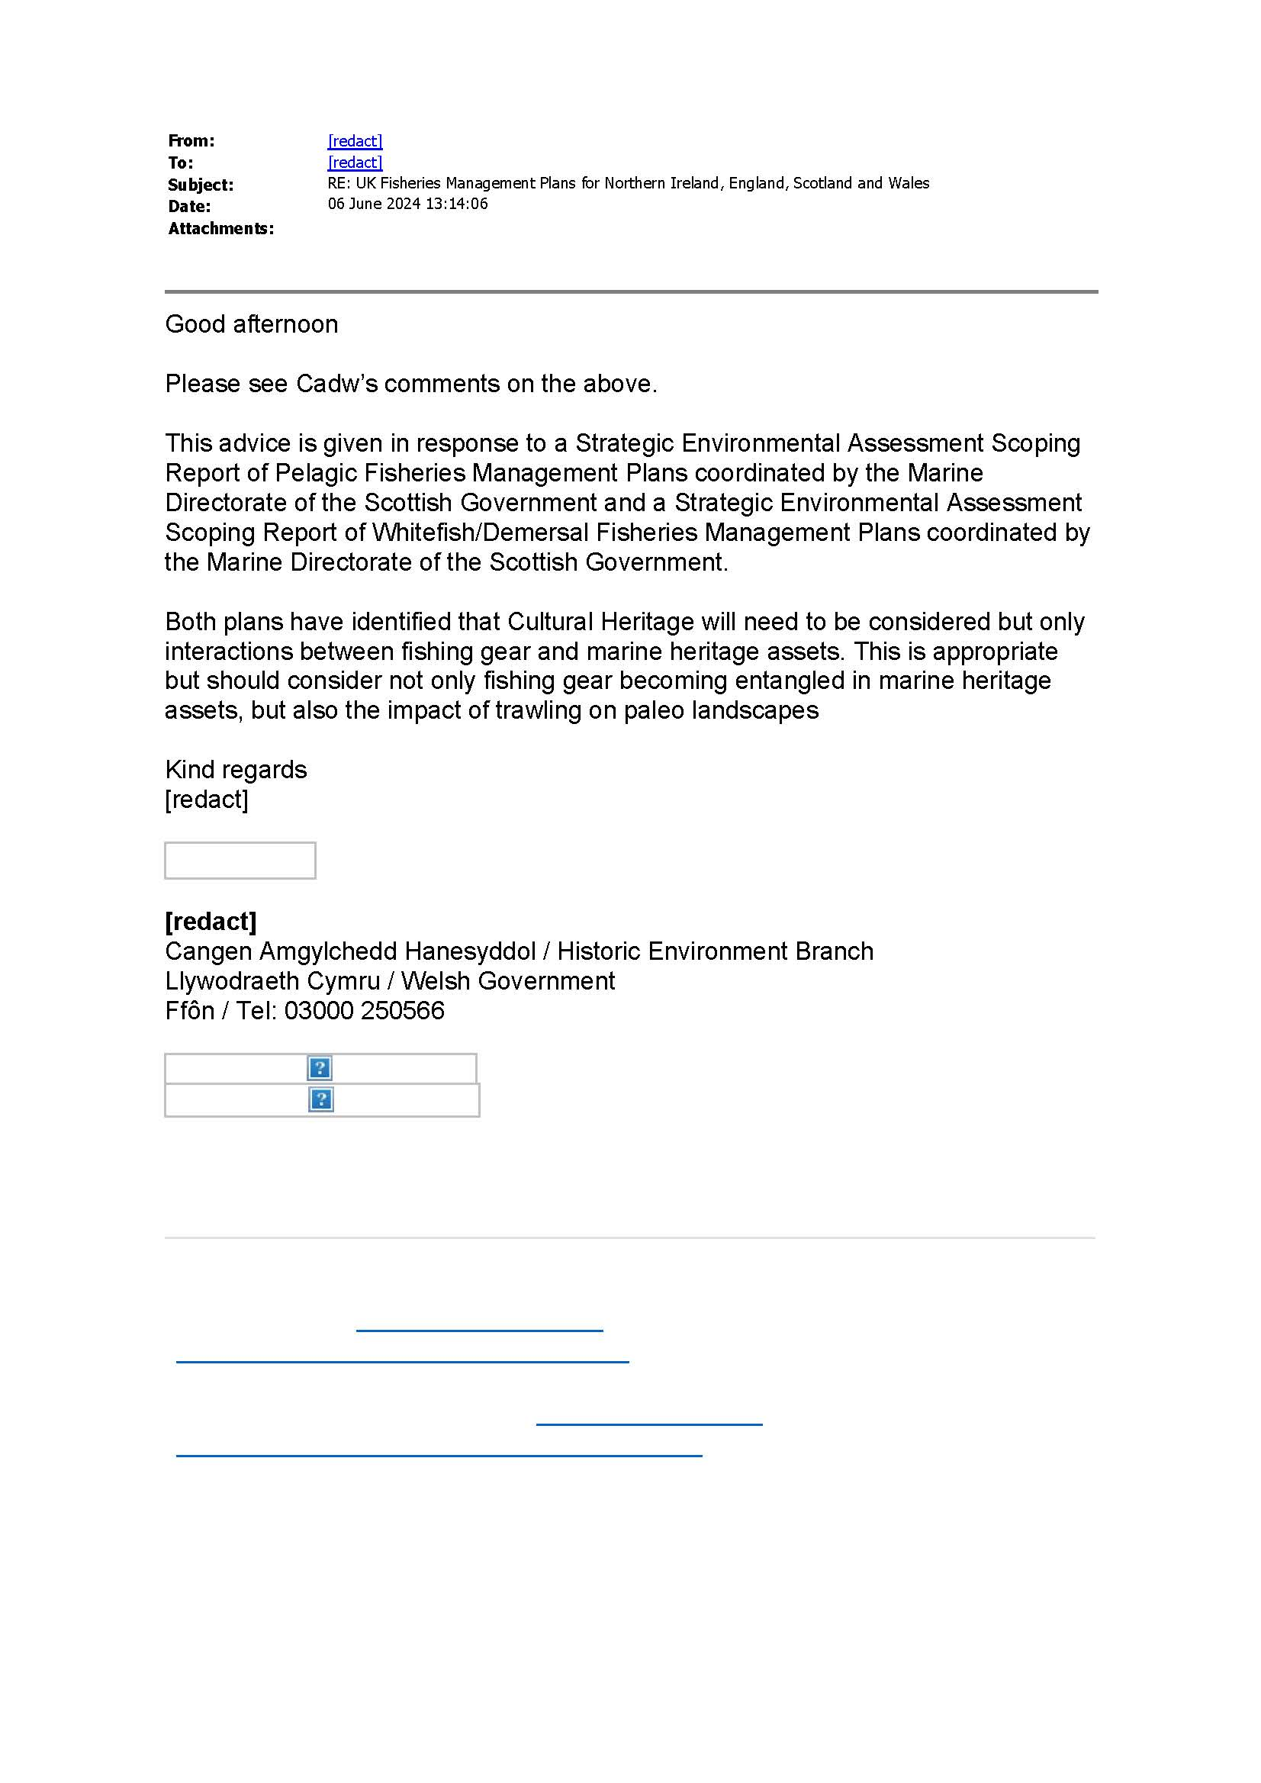

How the consultation response was considered
Point # | How point was considered
- The pelagic plans have identified that Cultural Heritage will need to be considered but only interactions between fishing gear and marine heritage assets. This is appropriate but should consider not only fishing gear becoming entangled in marine heritage assets, but also the impact of trawling on paleo landscapes. | Point noted. Given the limited interaction expected between Pelagic gears and the seafloor, and limited use of bottom contacting gears in these fisheries, we believe the impacts to paleo landscapes are unlikely to be significant and have therefore been screened out of this assessment.

Northern Ireland Environment Agency Response
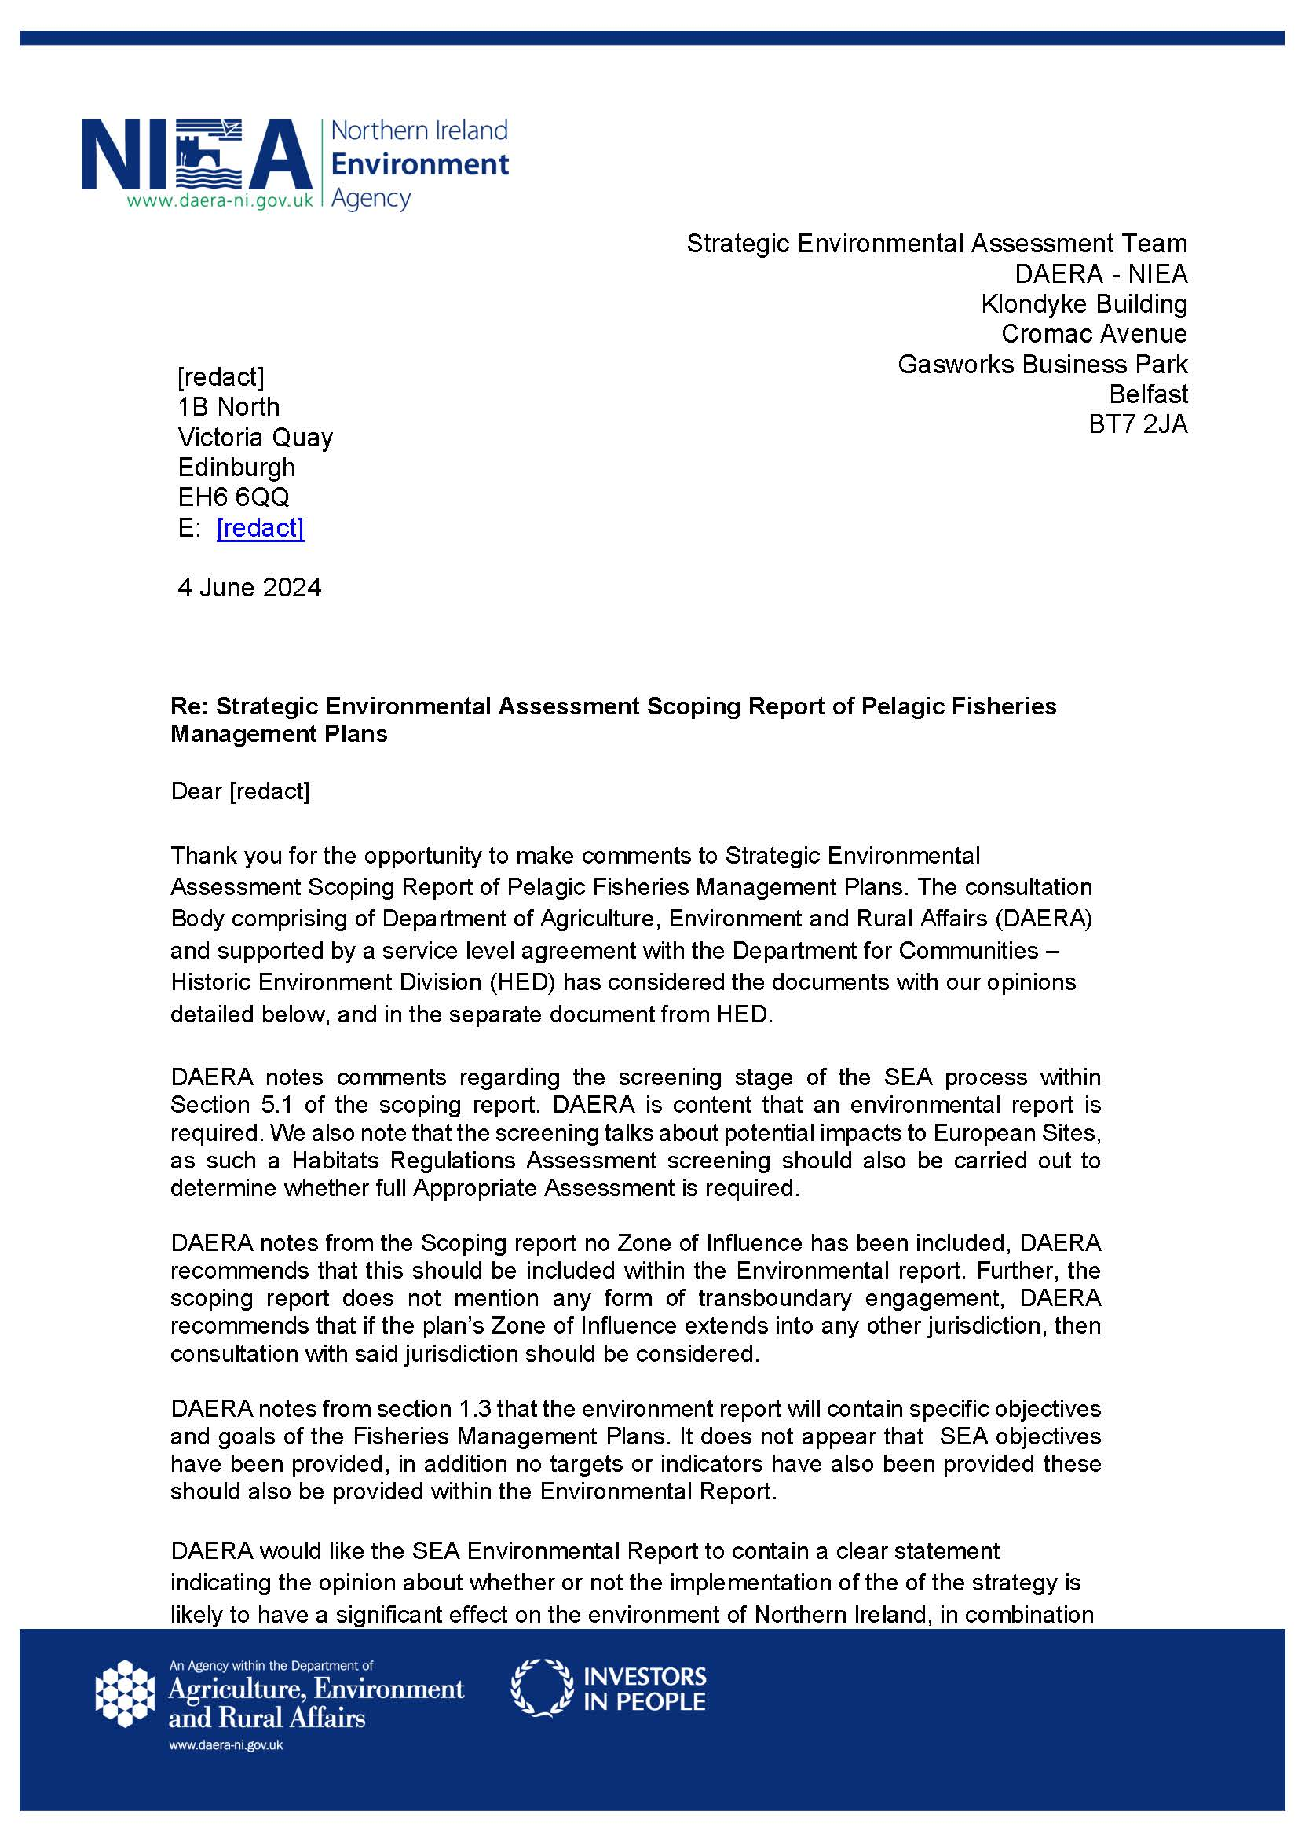
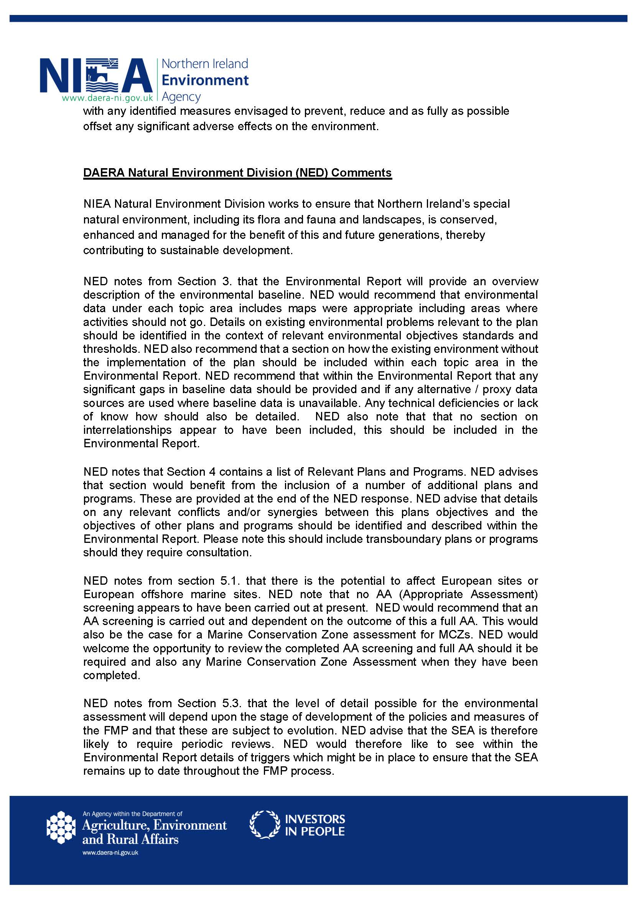
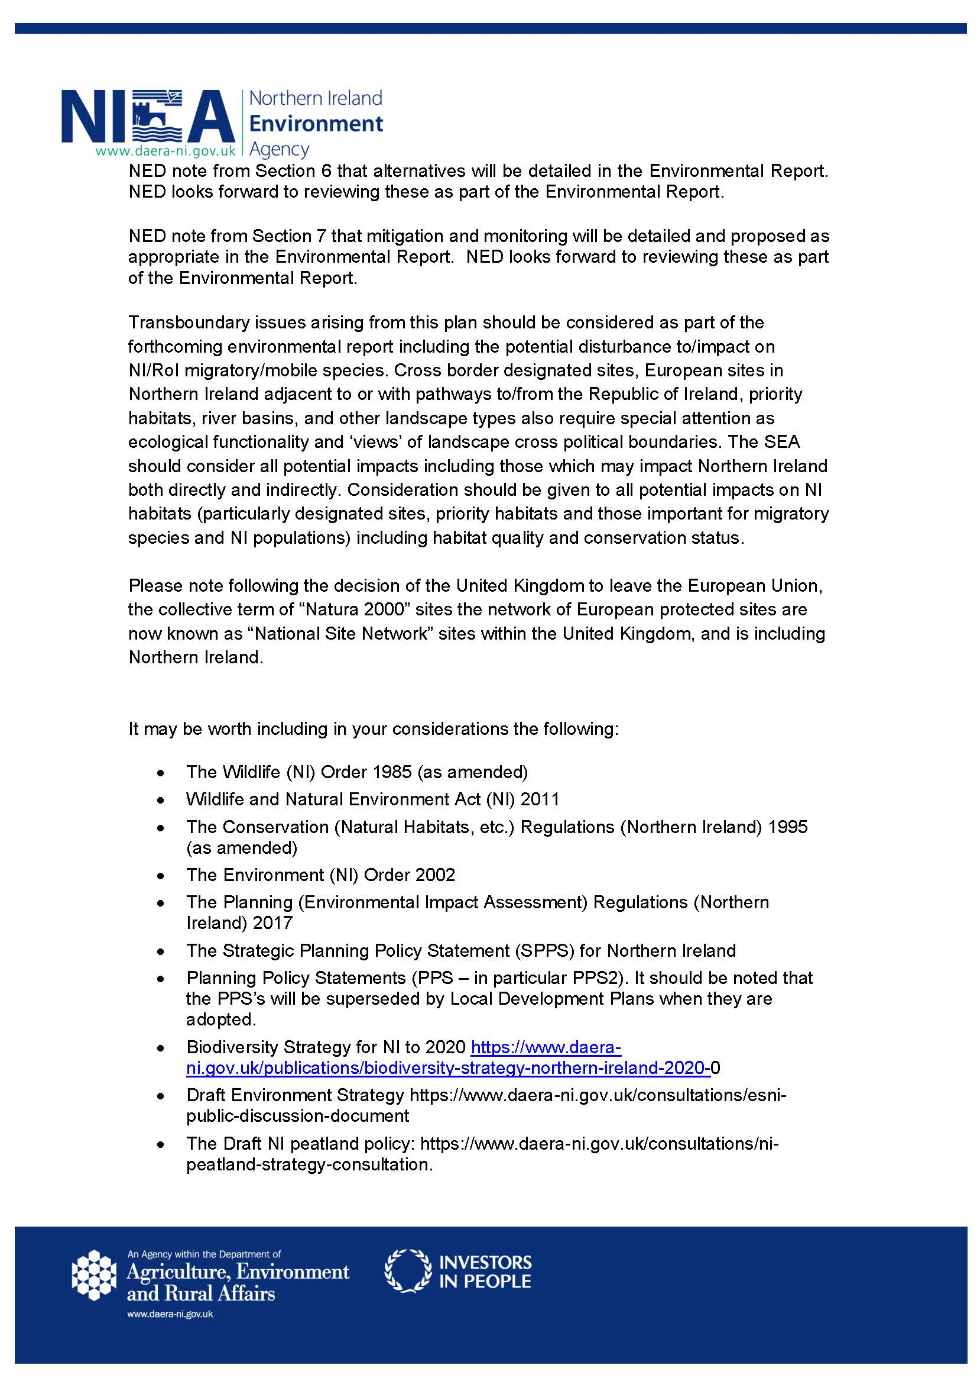
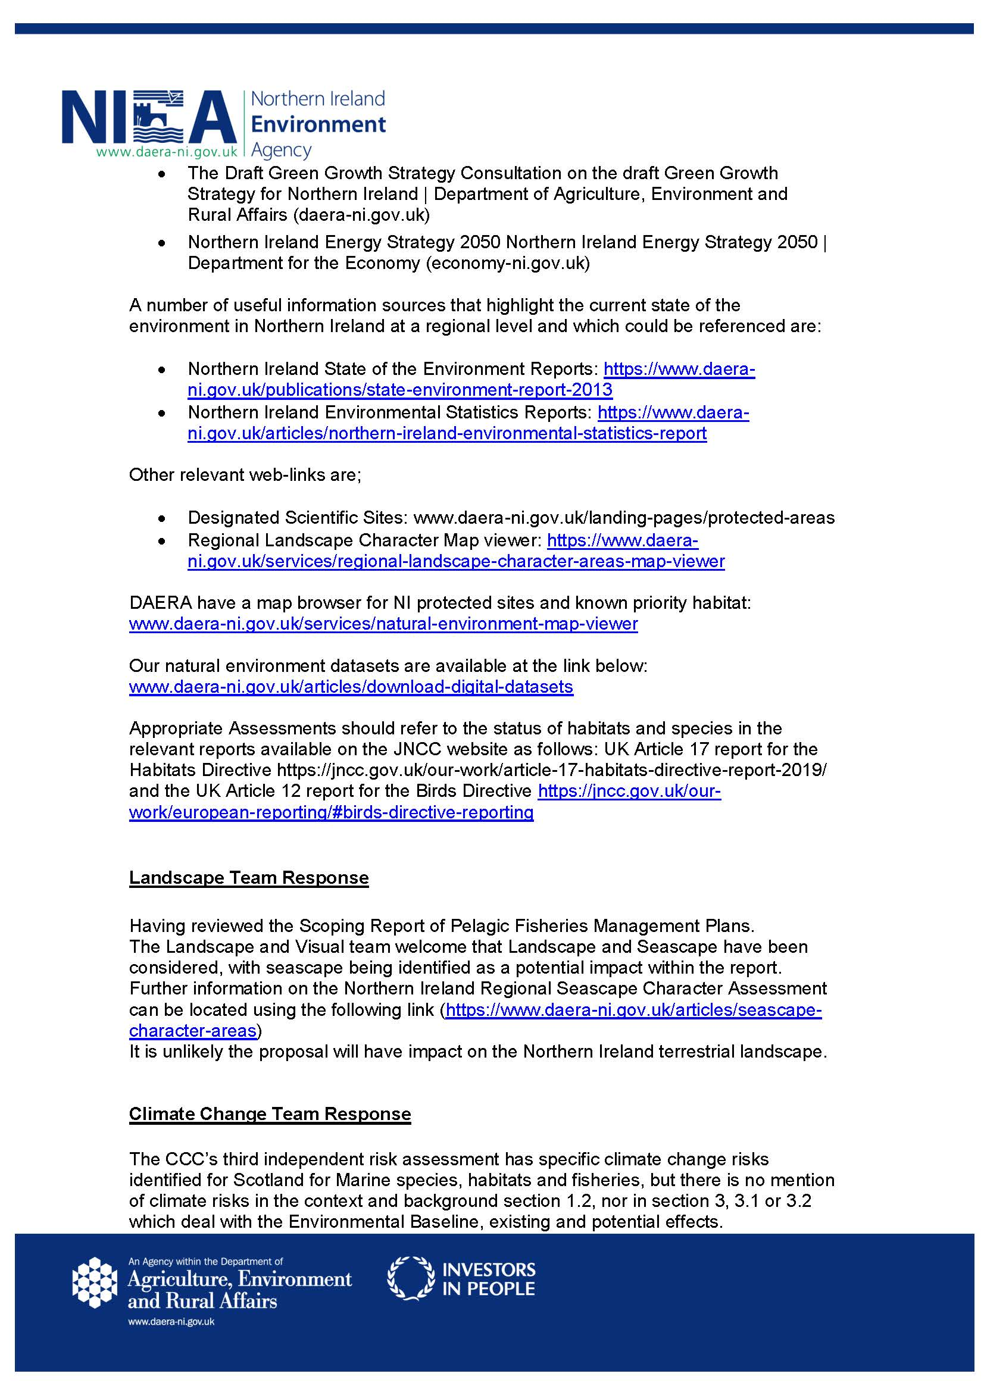


How the consultation response was considered
Point # | How point was considered
- DAERA notes from the Scoping report no Zone of Influence has been included, DAERA recommends that this should be included within the Environmental report. Further, the scoping report does not mention any form of transboundary engagement, DAERA recommends that if the plans Zone of Influence extends into any other jurisdiction, then consultation with said jurisdiction should be considered. | Point noted. The FMPs cover stocks in UK waters only and include actions specifically related to engagement with Coastal State partners.
- DAERA notes that no SEA objectives have been provided, in addition no targets or indicators have also been provided. Alongside SEA objectives, targets and indicators should also be provided within the Environmental Report. | The Environmental Report will examine how the policies and actions in the FMPs may result in both significant positive and negative environmental effects. Further details will be outlined in Section 2, Approach to Strategic Environmental Assessment. Additionally, the report will provide information on relevant indicators for the SEA.
- DAERA would like the SEA Environmental Report to contain a clear statement indicating the opinion about whether or not the implementation of the of the strategy is likely to have a significant effect on the environment of Northern Ireland, in combination with any identified actions envisaged to prevent, reduce and as fully as possible offset any significant adverse effects on the environment. | The Environmental Report will examine how the policies and actions in the FMPs may result in both significant positive and negative environmental effects. Further details will be outlined in Section 2, Approach to Strategic Environmental Assessment. Additionally, the report will provide information on in-combination effects under Section 5, Assessment of Environmental Effects.  Before any changes to fisheries management are made as a result of the draft Pelagic FMPs, new actions where necessary, will undergo Habitats Regulations Assessments and Marine Conservation Zone assessments. These assessments will consider potential in-combination effects with other plans and projects within an MPA and will identify any specific interactions.
- NED notes from Section 3 that the Environmental Report will provide an overview description of the environmental baseline. NED would recommend that environmental data under each topic area includes maps were appropriate including areas where activities should not go. Details on existing environmental problems relevant to the plan should be identified in the context of relevant environmental objectives standards and thresholds. NED also recommend that a section on how the existing environment without the implementation of the plan should be included within each topic area in the Environmental Report. NED recommend that within the Environmental Report that any significant gaps in baseline data should be provided and if any alternative / proxy data sources are used where baseline data is unavailable. Any technical deficiencies or lack of know how should also be detailed. NED also note that that no section on interrelationships appear to have been included, this should be included in the Environmental Report. | Some recommendations will be included as part of the development process of the Environmental Report. The environmental baseline and the impacts on UK MS, MPA features, and PMFs will be informed by advice from SNCBs. Due to the high-level nature of FMP policies and actions, as well as their early stage of development, assessing the impact of area-specific management measures is unlikely to be possible at this stage.  Before any changes to fisheries management are made as a result of the draft Pelagic FMPs, new actions, where necessary, will undergo Habitats Regulations Assessments and Marine Conservation Zone assessments. These assessments will consider potential in-combination effects with other plans and projects within an MPA and will identify any specific interactions.
- NED notes that Section 4 contains a list of Relevant Plans and Programs and Environmental Protection Objectives. NED advises that section would benefit from the inclusion of a number of additional plans and programs. These are provided at the end of the NED response. NED advise that details on any relevant conflicts and/or synergies between this plan’s objectives and the objectives of other plans and programs should be identified and described within the Environmental Report. Please note this should include transboundary plans or programs should they require consultation. | Point noted. Additional plans/programmes will be considered as appropriate in the Environmental Report.
- NED notes from section 5.1 that there is the potential to affect European sites or European offshore marine sites. NED note that no AA (Appropriate Assessment) screening appears to have been carried out at present. NED would recommend that an AA screening is carried out and dependent on the outcome of this a full AA. This would also be the case for a Marine Conservation Zone assessment for MCZs. NED would welcome the opportunity to review the completed AA screening and full AA should it be required and any Marine Conservation Zone Assessment when they have been completed. | Point noted. Before any changes to fisheries management are made as a result of the draft Pelagic FMPs, new actions, where necessary, will undergo Habitats Regulations Assessments and Marine Conservation Zone assessments.
- NED notes from Section 5.3 that the level of detail possible for the environmental assessment will depend upon the stage of development of the policies and actions of the FMP and that these are subject to evolution. NED advise that the SEA is therefore likely to require periodic reviews. NED would therefore like to see within the Environmental Report details of triggers which might be in place to ensure that the SEA remains up to date throughout the FMP process. | The Environmental Report will include more detailed information in Section 8, "Monitoring and Review."
- NED note from Section 6 that alternatives will be detailed in the Environmental Report. NED looks forward to reviewing these as part of the Environmental Report. | Point noted.
- NED note from Section 7 that mitigation and monitoring will be detailed and proposed as appropriate in the Environmental Report. NED looks forward to reviewing these as part of the Environmental Report. | The Environmental Report will include more detailed information in Section 8, "Monitoring and Review."
- Transboundary issues arising from this plan should be considered as part of the forthcoming environmental report including the potential disturbance to/impact on NI/RoI migratory/mobile species. Cross border designated sites, European sites in Northern Ireland adjacent to or with pathways to/from the Republic of Ireland, priority habitats, river basins, and other landscape types also require special attention as ecological functionality and ‘views’ of landscape cross political boundaries. The SEA should consider all potential impacts including those which may impact Northern Ireland both directly and indirectly. Consideration should be given to all potential impacts on NI habitats (particularly designated sites, priority habitats and those important for migratory species and NI populations) including habitat quality and conservation status. | Point noted. The FMPs cover a number of transboundary stocks and include actions specifically related to engagement with Coastal State partners.  The SEA has been developed in collaboration with DAERA, Welsh Government, Defra to ensure transboundary and country-specific issues are captured.  The FMPs and SEA are also consider Conservation Advice from Natural England, JNCC, NatureScot and Natural Resources Wales, which have highlighted a number of transboundary impacts from bycatch and prey reduction – this has been discussed and assessed in the Environmental Report
- Please note following the decision of the United Kingdom to leave the European Union, the collective term of “Natura 2000” sites the network of European protected sites are now known as “National Site Network” sites within the United Kingdom, and is including Northern Ireland. | Point noted and wording updated.
- Landscape and Visual Team Comment  The Landscape and Visual team welcome that Landscape and Seascape have been considered, with seascape being identified as a potential impact within the report. Further information is available in the Northern Ireland Regional Seascape Character Assessment. It is unlikely the proposal will have impact on the Northern Ireland terrestrial landscape. | Point noted.
- Climate Change Team Comments  The CCC’s third independent risk assessment has specific climate change risks identified for Scotland for Marine species, habitats and fisheries, but there is no mention of climate risks in the context and background section 1.2, nor in section 3, 3.1 or 3.2 which deal with the Environmental Baseline, existing and potential effects. | Point noted. Climatic factors have been scoped into the Environmental Report.

Historic Environment Division Response (Northern Ireland)
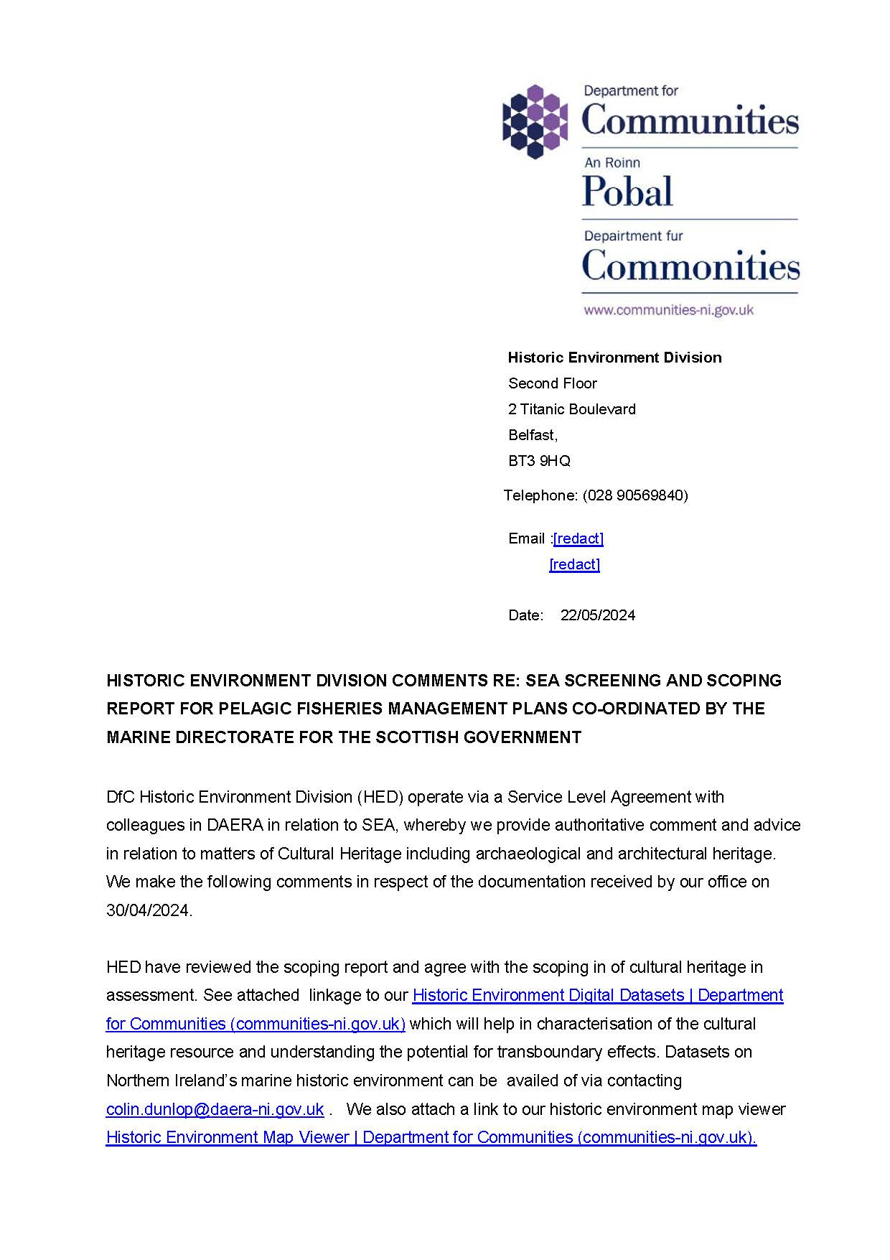
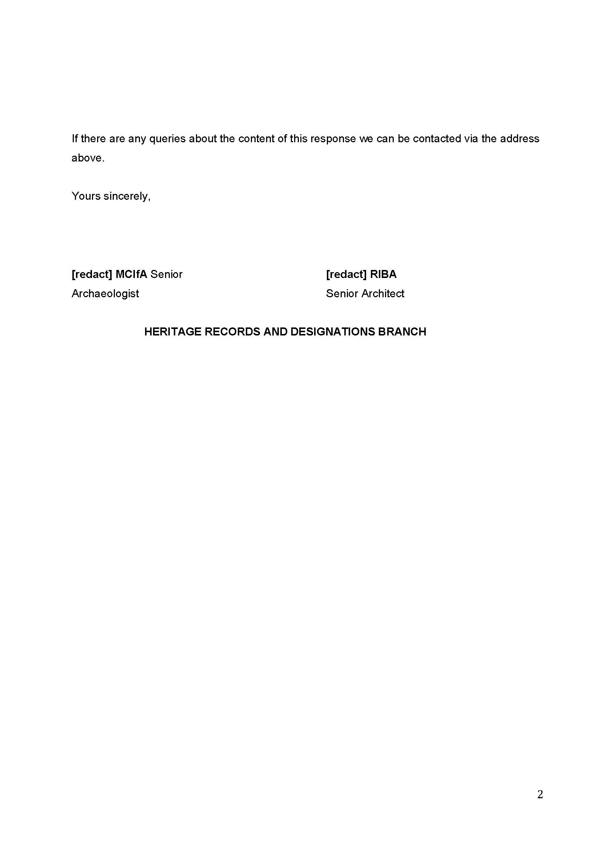

How the consultation response was considered
Point # | How point was considered
- HED have reviewed the scoping report and agree with the scoping in of cultural heritage in assessment. Although we consider the transboundary risk to cultural heritage to be low, we nonetheless provide linkage to our Historic Environment Digital Datasets | Department for Communities (communities-ni.gov.uk) which will help in characterisation of the cultural heritage resource and understanding the potential for transboundary effects. Datasets on Northern Ireland’s marine historic environment can be availed of via contacting [redact]. We also attach a link to our historic environment map viewer Historic Environment Map Viewer | Department for Communities (communities-ni.gov.uk). | Point noted.

Historic Environment Scotland Response (Scotland)
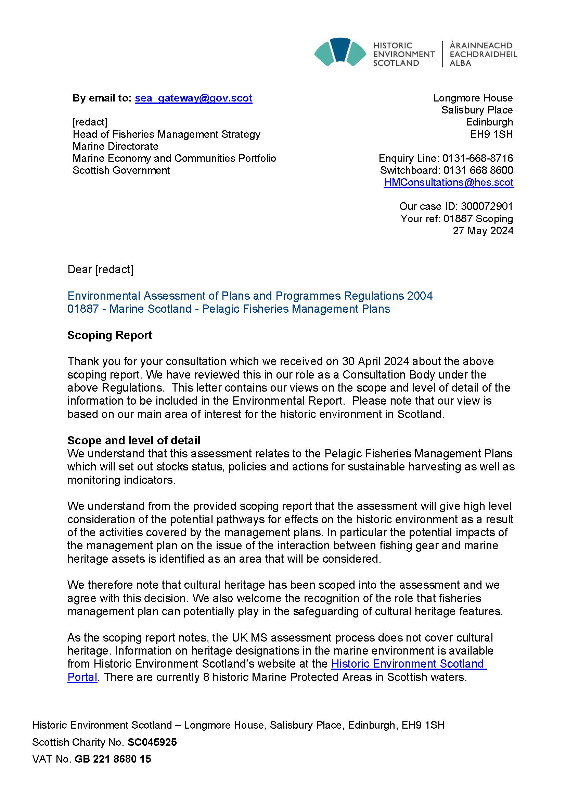
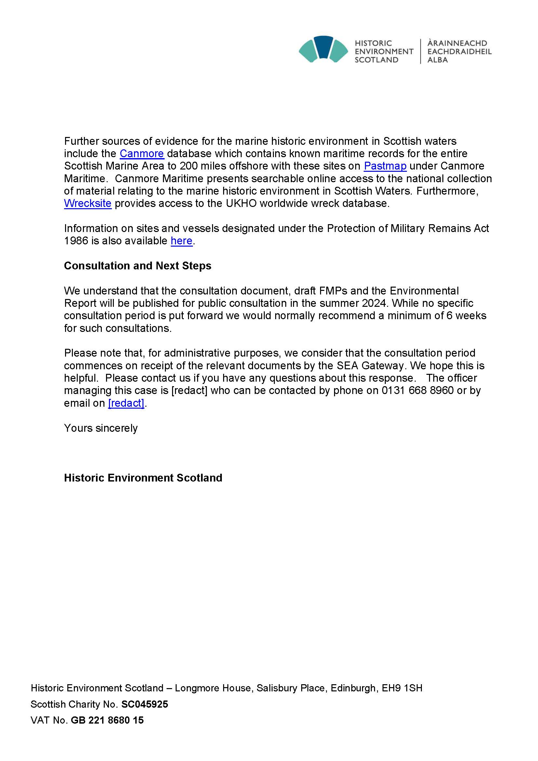

How the consultation response was considered
Point # | How point was considered
- We understand from the provided scoping report that the assessment will give high level consideration of the potential pathways for effects on the historic environment as a result of the activities covered by the management plans. In particular the potential impacts of the management plan on the issue of the interaction between fishing gear and marine heritage assets is identified as an area that will be considered.  We therefore note that cultural heritage has been scoped into the assessment and we agree with this decision. We also welcome the recognition of the role that fisheries management plan can potentially play in the safeguarding of cultural heritage features. | Point noted.
- As the scoping report notes, the UK MS assessment process does not cover cultural heritage. Information on heritage designations in the marine environment is available from Historic Environment Scotland’s website at the Historic Environment Scotland Portal. There are currently 8 historic Marine Protected Areas in Scottish waters.  Further sources of evidence for the marine historic environment in Scottish waters include the Canmore database which contains known maritime records for the entire Scottish Marine Area to 200 miles offshore with these sites on Pastmap under Canmore Maritime. Canmore Maritime presents searchable online access to the national collection of material relating to the marine historic environment in Scottish Waters. Furthermore, Wrecksite provides access to the UKHO worldwide wreck database.  Information on sites and vessels designated under the Protection of Military Remains Act 1986 is also available here. | Point noted.

Historic England Response
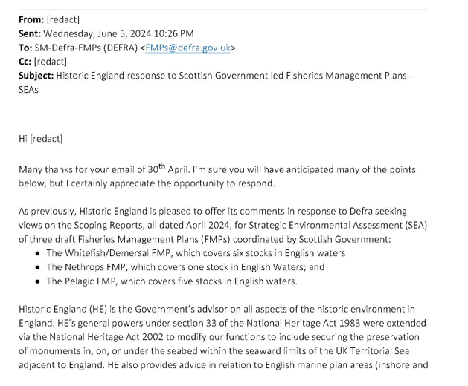
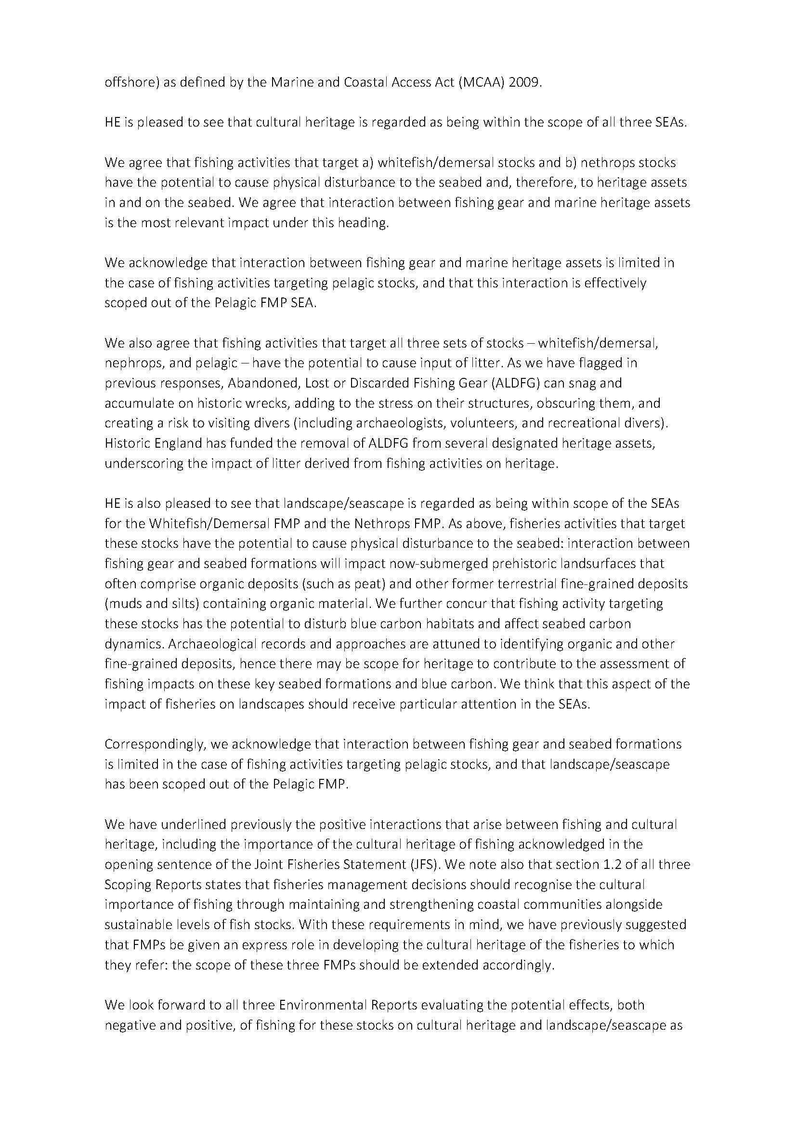
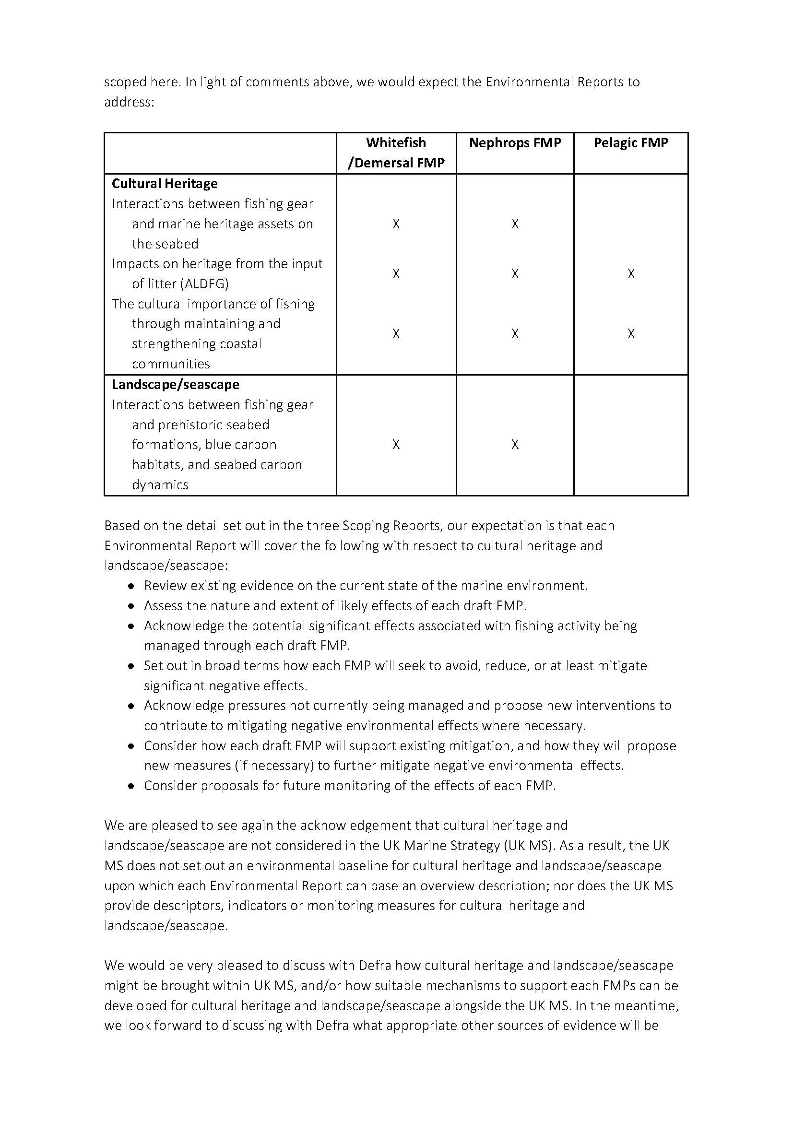
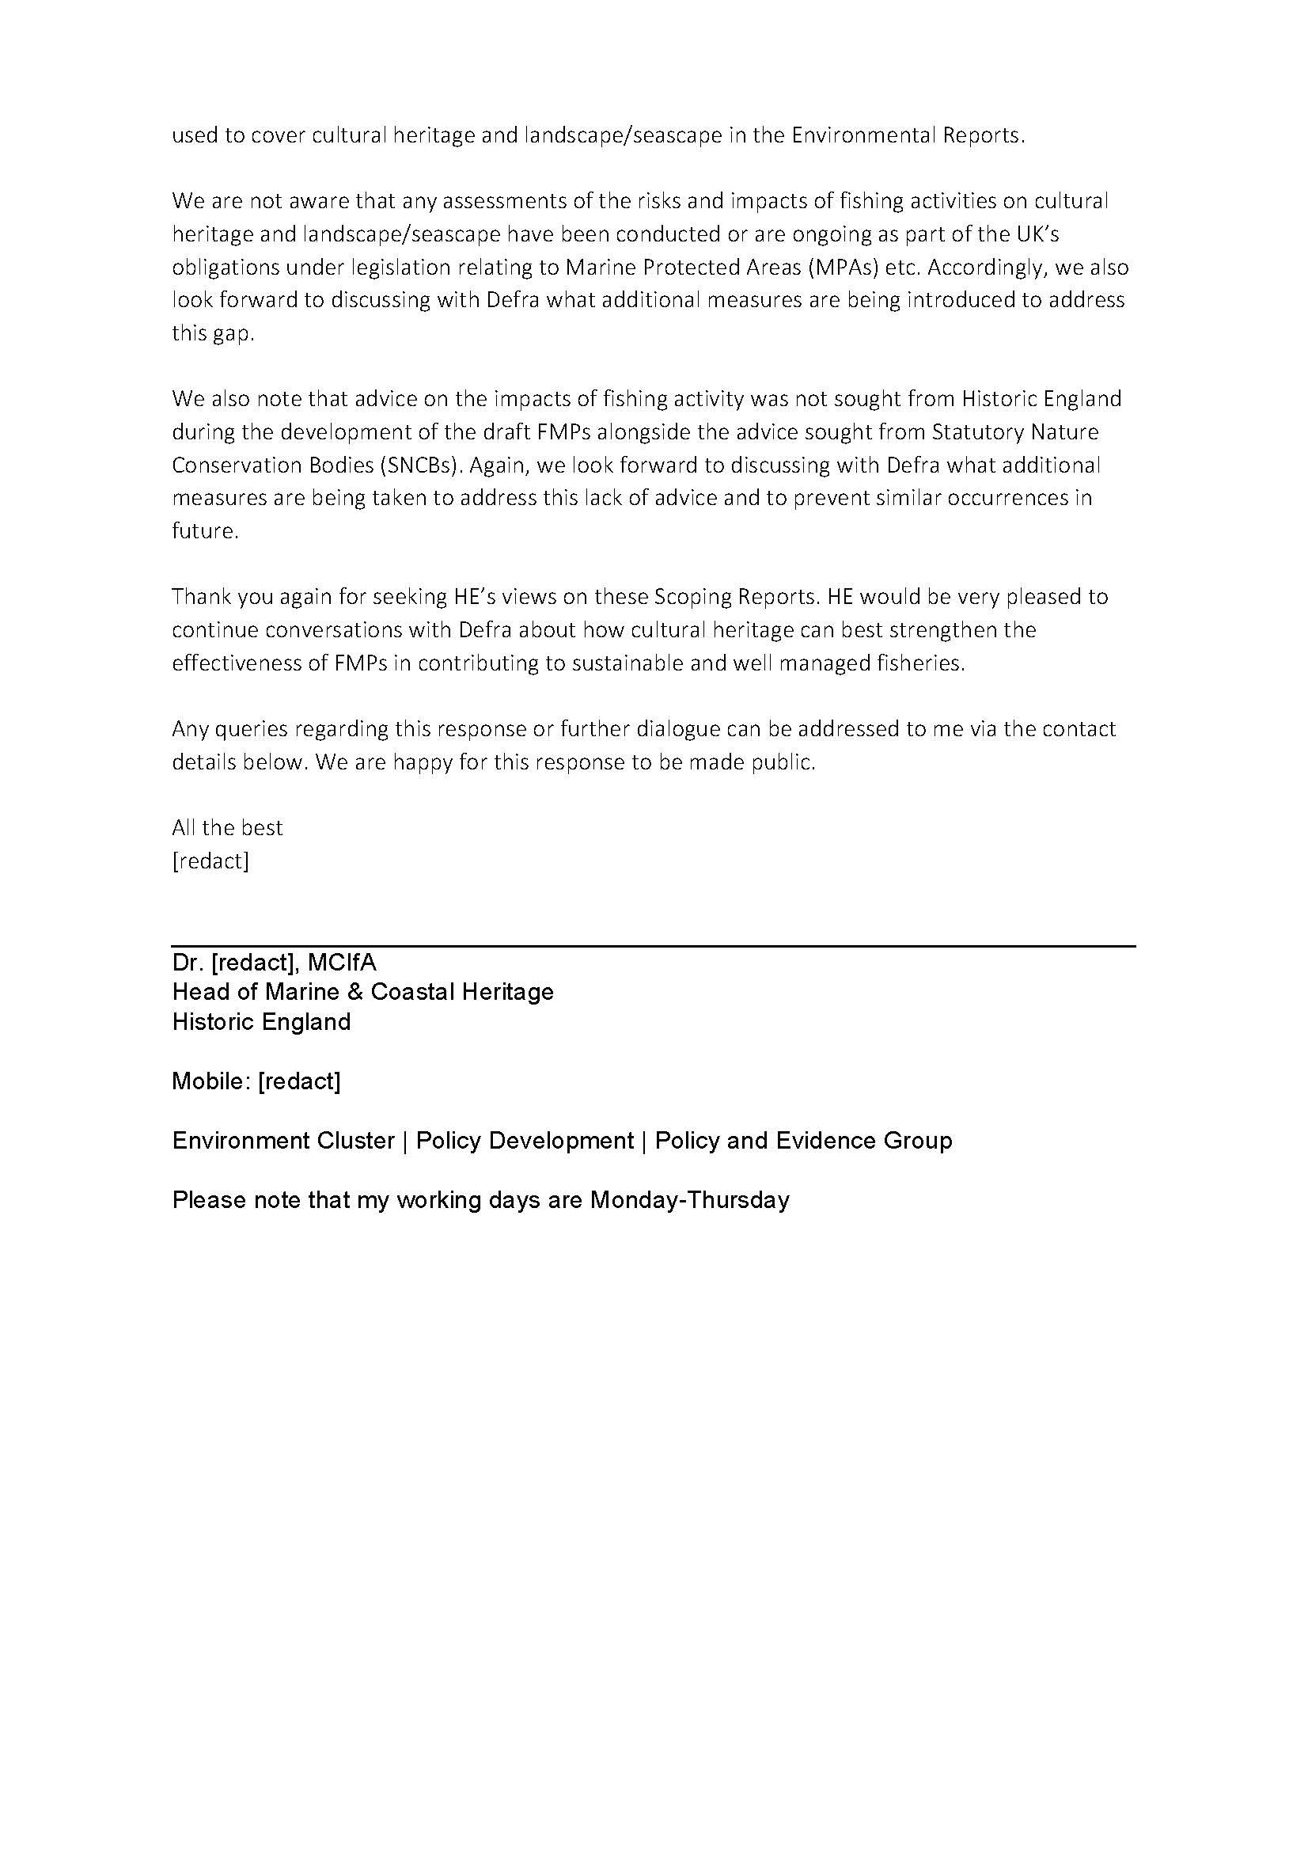

How the consultation response was considered
Point # | How point was considered
- HE is pleased to see that cultural heritage is regarded as being within the scope of all three SEAs. | Point noted.
- We acknowledge that interaction between fishing gear and marine heritage assets is limited in the case of fishing activities targeting pelagic stocks, and that this interaction is effectively scoped out of the Pelagic FMP SEA. | Point noted.
- We also agree that fishing activities that target all three sets of stocks – whitefish/demersal, nephrops, and pelagic – have the potential to cause input of litter. As we have flagged in previous responses, Abandoned, Lost or Discarded Fishing Gear (ALDFG) can snag and accumulate on historic wrecks, adding to the stress on their structures, obscuring them, and creating a risk to visiting divers (including archaeologists, volunteers, and recreational divers). Historic England has funded the removal of ALDFG from several designated heritage assets, underscoring the impact of litter derived from fishing activities on heritage. | Point noted. The impact of litter will be considered through UK MS descriptor D10.
- We acknowledge that interaction between fishing gear and seabed formations is limited in the case of fishing activities targeting pelagic stocks, and that landscape/seascape has been scoped out of the Pelagic FMP. | Point noted.
- We have underlined previously the positive interactions that arise between fishing and cultural heritage, including the importance of the cultural heritage of fishing acknowledged in the opening sentence of the Joint Fisheries Statement (JFS). We note also that section 1.2 of all three Scoping Reports states that fisheries management decisions should recognise the cultural importance of fishing through maintaining and strengthening coastal communities alongside sustainable levels of fish stocks. With these requirements in mind, we have previously suggested that FMPs be given an express role in developing the cultural heritage of the fisheries to which they refer: the scope of these three FMPs should be extended accordingly. | Point noted. The policies and actions related to cultural heritage will be addressed in the Environmental Reports.
- We look forward to all three Environmental Reports evaluating the potential effects, both negative and positive, of fishing for these stocks on cultural heritage and landscape/seascape as scoped here. In light of comments above, we would expect the Environmental Reports to address these. | The Environmental Reports focuses on how the policies and actions in the FMPs could give rise to both significant positive and negative environmental effects.  However, the Environmental Reports also acknowledge existing environmental effects of fishing activity and set out policies and actions to address them, where appropriate.
- Based on the detail set out in the three Scoping Reports, our expectation is that each Environmental Report will cover the following with respect to cultural heritage and landscape/seascape:  - Review existing evidence on the current state of the marine environment.  - Assess the nature and extent of likely effects of each draft FMP.  - Acknowledge the potential significant effects associated with fishing activity being managed through each draft FMP.  - Set out in broad terms how each FMP will seek to avoid, reduce, or at least mitigate significant negative effects.  - Acknowledge pressures not currently being managed and propose new interventions to contribute to mitigating negative environmental effects where necessary.  - Consider how each draft FMP will support existing mitigation, and how they will propose new actions (if necessary) to further mitigate negative environmental effects.  - Consider proposals for future monitoring of the effects of each FMP. | Point noted. Environmental Reports (ER) will provide recommendations on how FMPs could consider fishing, cultural heritage and landscape/seascape
- We are pleased to see again the acknowledgement that cultural heritage and landscape/seascape are not considered in the UK Marine Strategy (UK MS). As a result, the UK MS does not set out an environmental baseline for cultural heritage and landscape/seascape upon which each Environmental Report can base an overview description; nor does the UK MS provide descriptors, indicators or monitoring measures for cultural heritage and landscape/seascape. | Point noted.
- We would be very pleased to discuss with Defra how cultural heritage and landscape/seascape might be brought within UK MS, and/or how suitable mechanisms to support each FMPs can be developed for cultural heritage and landscape/seascape alongside the UK MS. In the meantime, we look forward to discussing with Defra what appropriate other sources of evidence will be used to cover cultural heritage and landscape/seascape in the Environmental Reports. | Point noted. Defra would welcome further discussions with HE to consider this point.
- We are not aware that any assessments of the risks and impacts of fishing activities on cultural heritage and landscape/seascape have been conducted or are ongoing as part of the UK’s obligations under legislation relating to Marine Protected Areas (MPAs) etc. Accordingly, we also look forward to discussing with Defra what additional measures are being introduced to address this gap. | Point noted. Defra would welcome further discussions with HE to consider this point.
- We also note that advice on the impacts of fishing activity was not sought from Historic England during the development of the draft FMPs alongside the advice sought from Statutory Nature Conservation Bodies (SNCBs). Again, we look forward to discussing with Defra what additional measures are being taken to address this lack of advice and to prevent similar occurrences in future. | Point noted.

JNCC Response
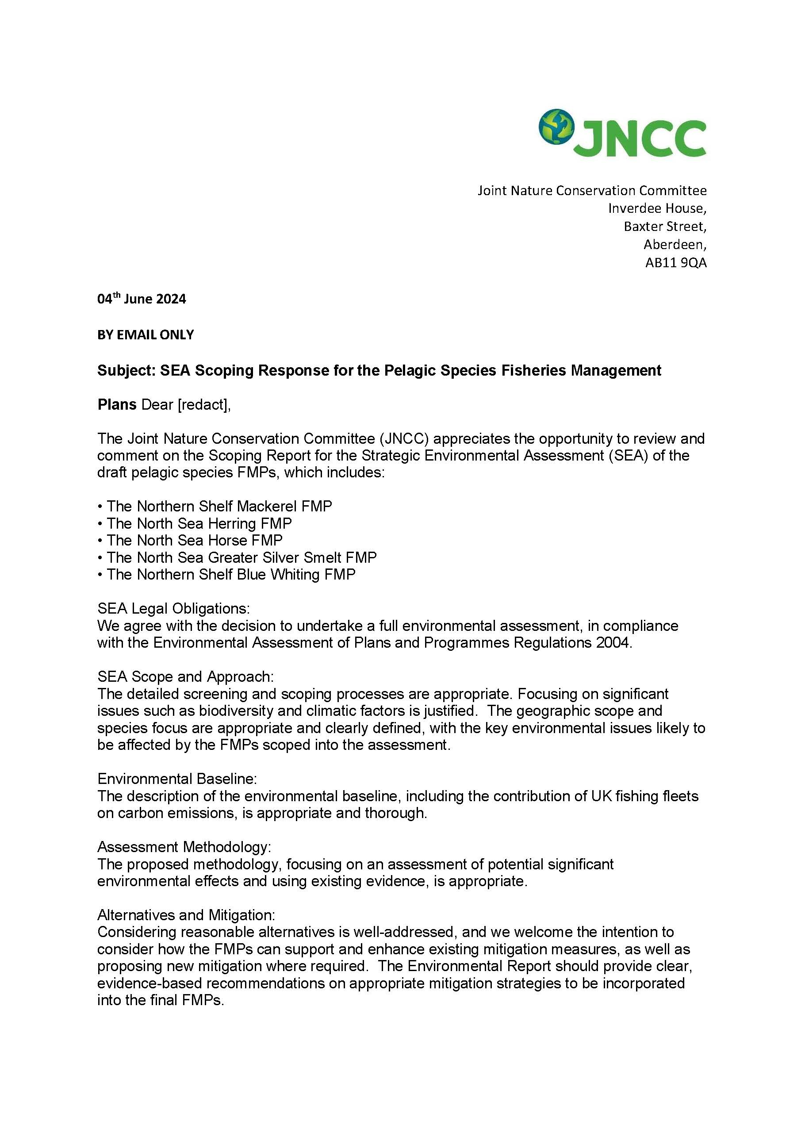
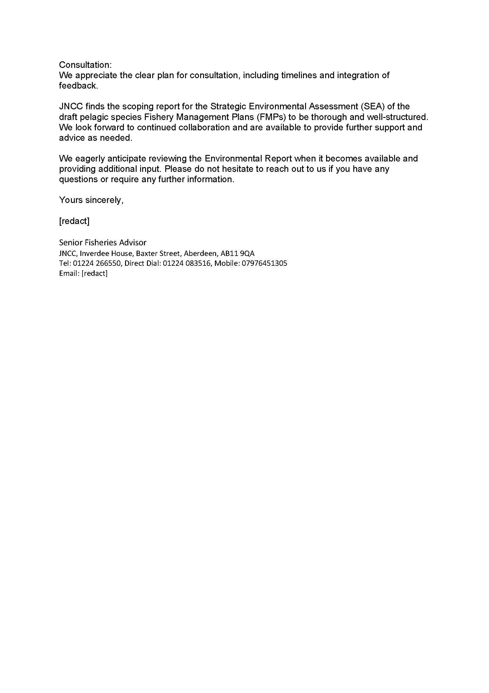

How the consultation response was considered
Point # | How point was considered
- We agree with the decision to undertake a full environmental assessment, in compliance with the Environmental Assessment of Plans and Programmes Regulations 2004. | Point noted.
- The detailed screening and scoping processes are appropriate. Focusing on significant issues such as biodiversity and climatic factors is justified. The geographic scope and species focus are appropriate and clearly defined, with the key environmental issues likely to be affected by the FMPs scoped into the assessment. | Point noted.
- The description of the environmental baseline, including the contribution of UK fishing fleets on carbon emissions, is appropriate and thorough. | Point noted.
- The proposed methodology, focusing on an assessment of potential significant environmental effects and using existing evidence, is appropriate. | Point noted.
- Considering reasonable alternatives is well-addressed, and we welcome the intention to consider how the FMPs can support and enhance existing mitigation measures, as well as proposing new mitigation where required. The Environmental Report should provide clear, evidence-based recommendations on appropriate mitigation strategies to be incorporated into the final FMPs. | Point noted. Recommendations will be included in the Environmental Report.
- We appreciate the clear plan for consultation, including timelines and integration of feedback. | Point noted.
- JNCC finds the scoping report for the Strategic Environmental Assessment (SEA) of the draft pelagic Fishery Management Plans (FMPs) to be thorough and well-structured. We look forward to continued collaboration and are available to provide further support and advice as needed. | Point noted.
- We eagerly anticipate reviewing the Environmental Report when it becomes available and providing additional input. Please do not hesitate to reach out to us if you have any questions or require any further information. | Point noted.

Natural England Response

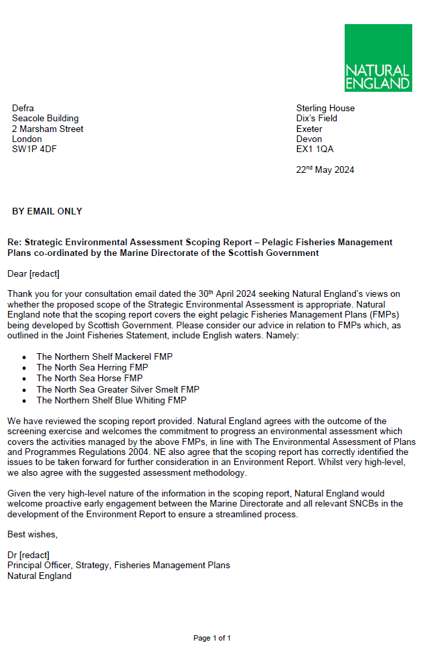

How the consultation response was considered
Point # | How point was considered
- We have reviewed the scoping report provided. Natural England agrees with the outcome of the screening exercise and welcomes the commitment to an environmental assessment which covers the activities managed by the above FMPs, in line with The Environmental Assessment of Plans and Programmes Regulations 2004. NE also agree that the scoping report has correctly identified the issues to be taken forward for further consideration in an Environment Report. Whilst very high-level, we also agree with the suggested assessment methodology. | Point noted.
- Given the very high-level nature of the information in the scoping report, Natural England would welcome proactive early engagement between the Marine Directorate and all relevant SNCBs in the development of the Environment Report to ensure a streamlined process. | Point noted.

NatureScot Response
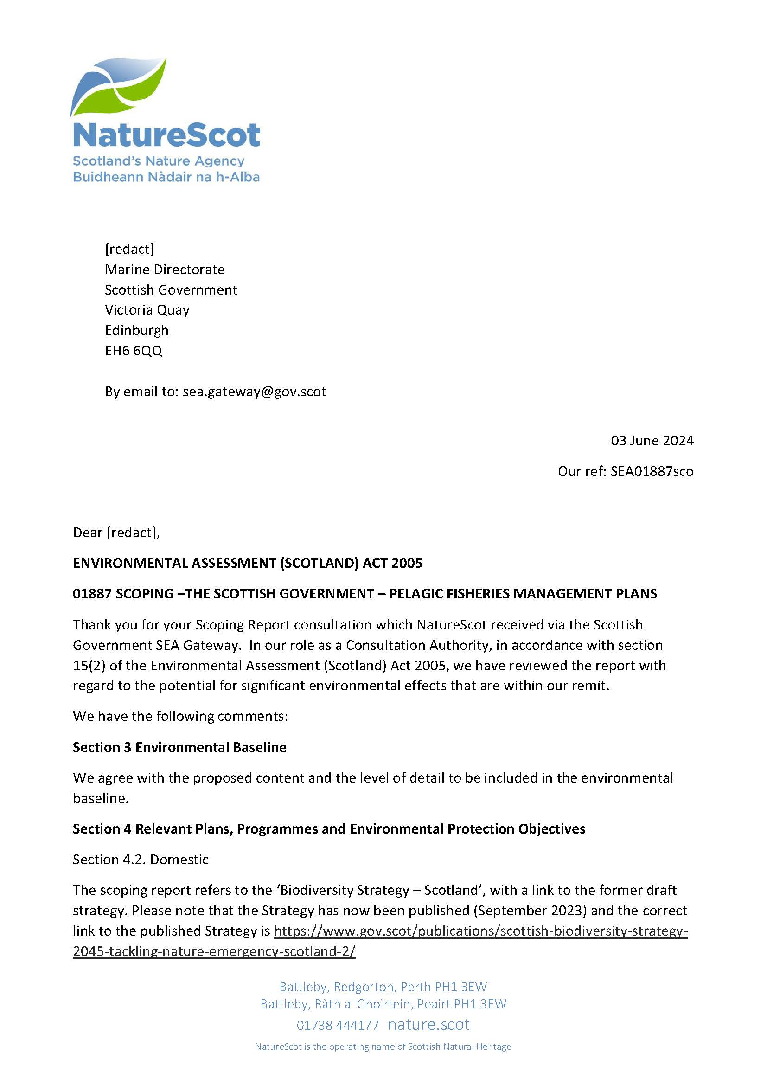
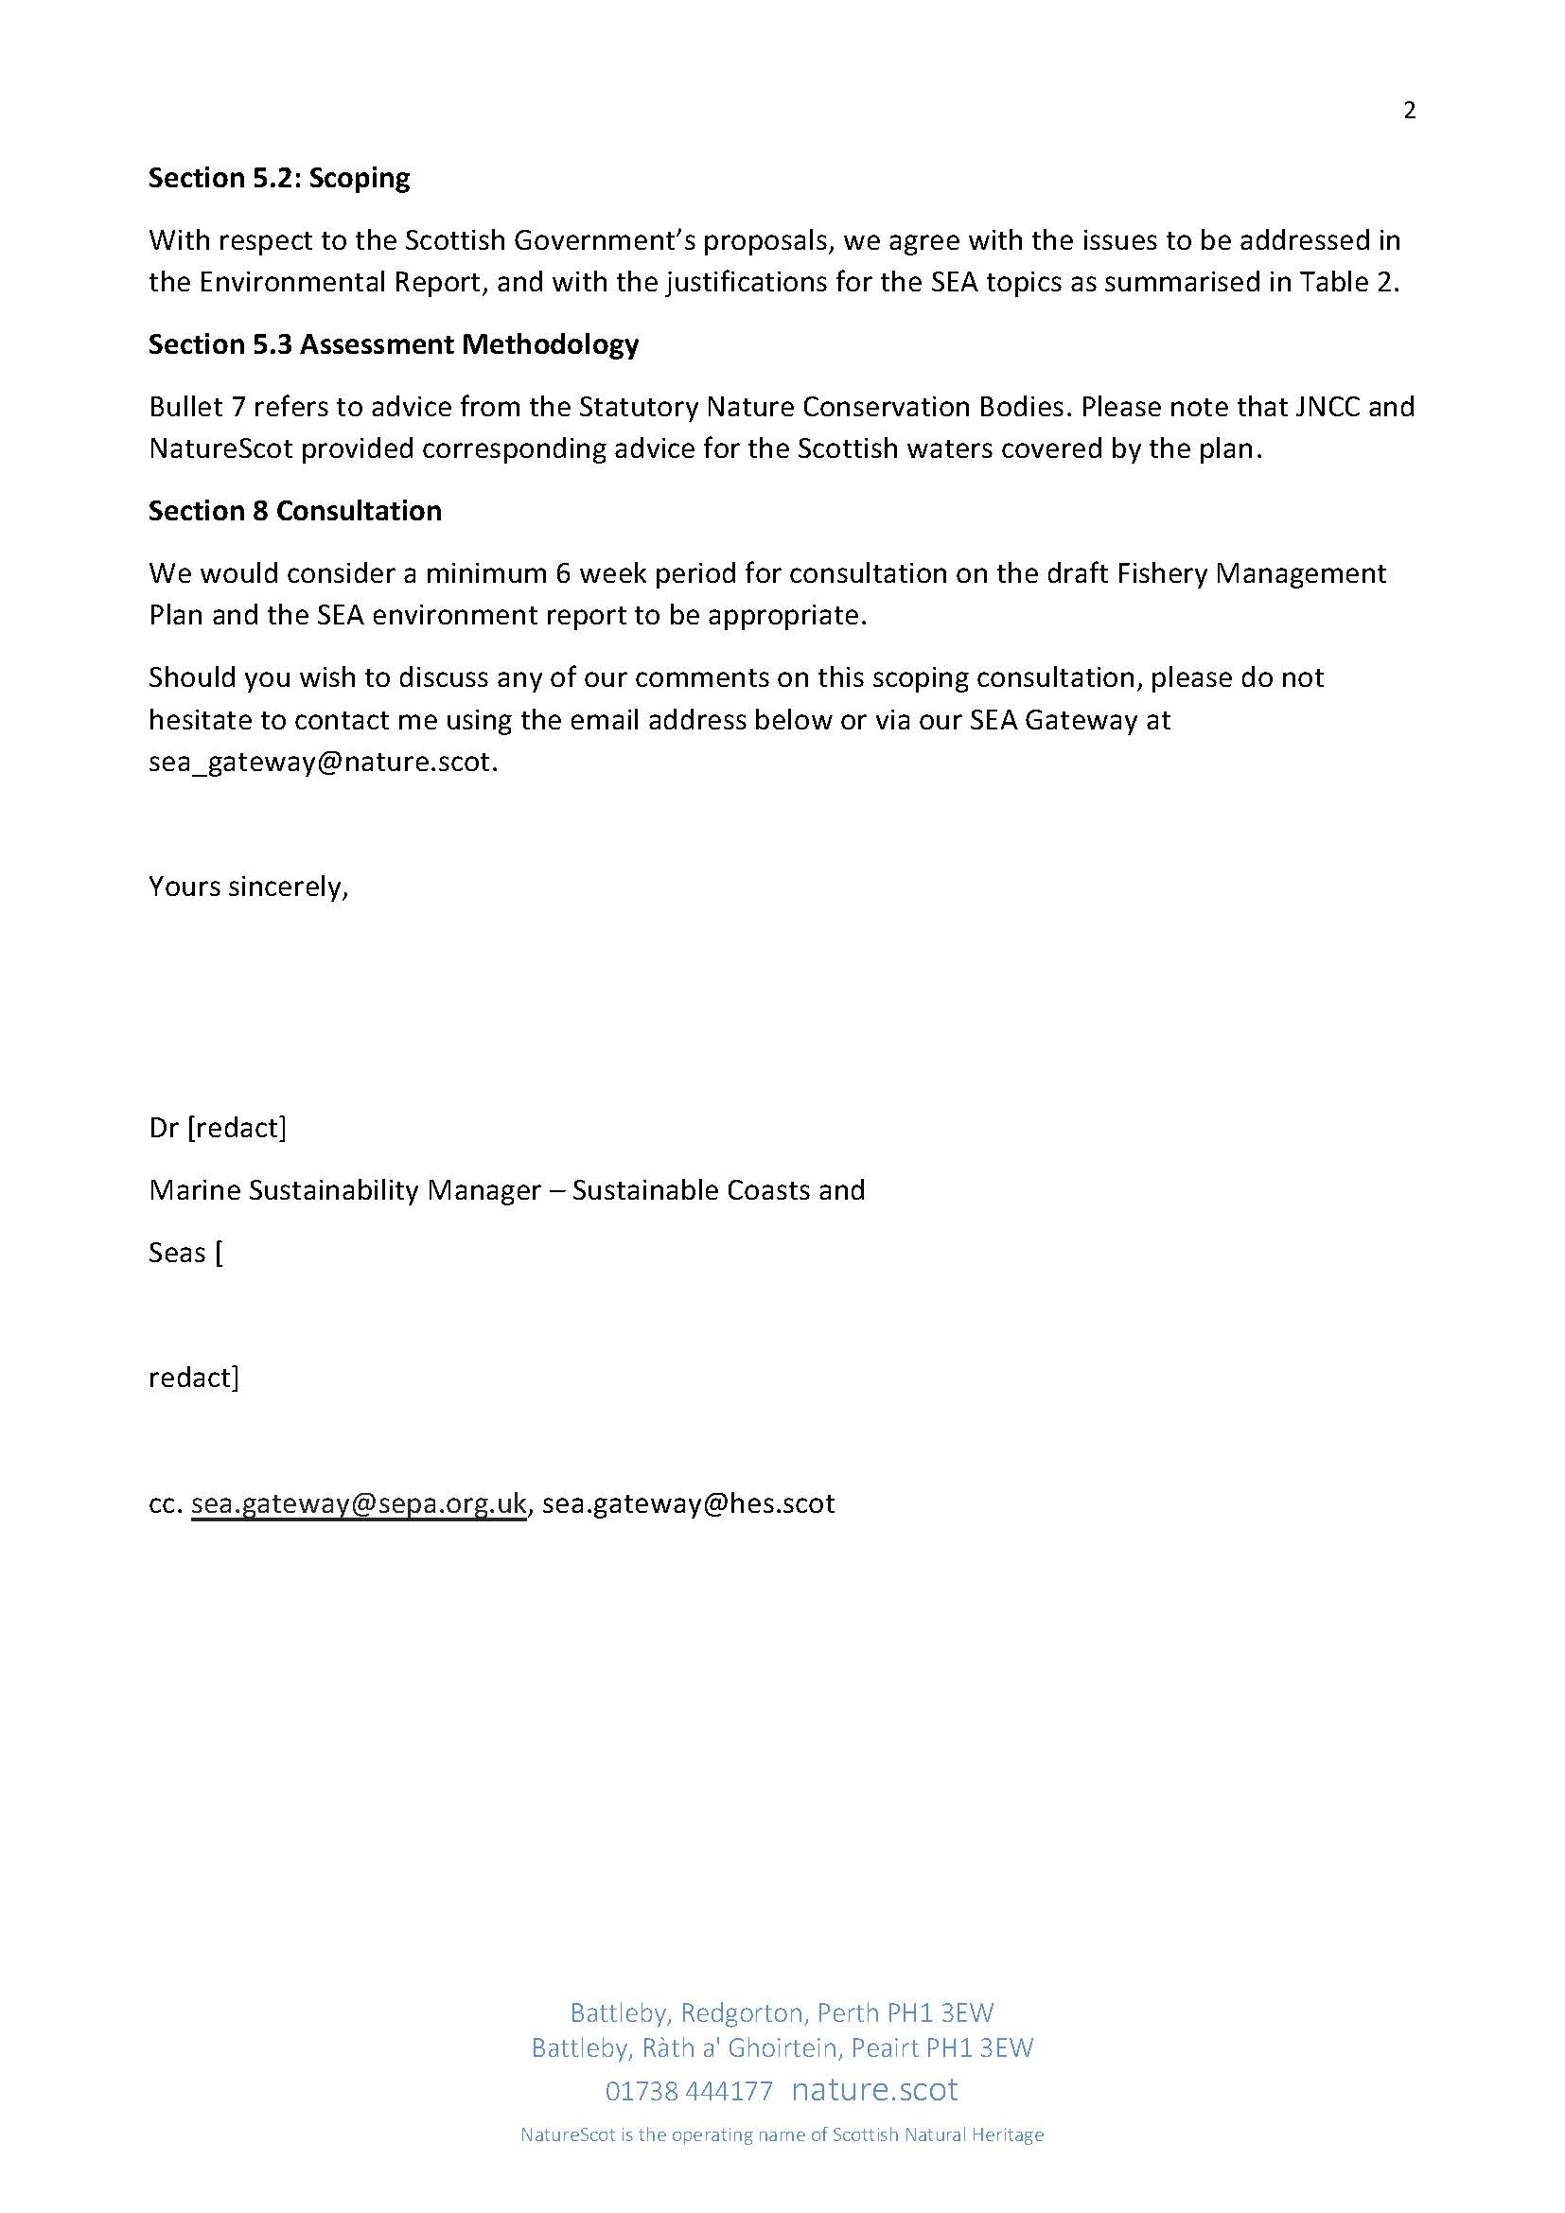

How the consultation response was considered
Point # | How point was considered
- Section 3 Environmental Baseline  We agree with the proposed content and the level of detail to be included in the environmental baseline. | Point noted.
- Section 4 Relevant Plans, Programmes and Environmental Protection Objectives  Section 4.2. Domestic  The scoping report refers to the ‘Biodiversity Strategy – Scotland’, with a link to the former draft strategy. Please note that the Strategy has now been published (September 2023) and the correct link to the published Strategy is Scottish Biodiversity Strategy to 2045 Tackling the Nature Emergency in Scotland | Point noted. Updated link will be used.
- Section 5.2: Scoping  With respect to the Scottish Government’s proposals, we agree with the issues to be addressed in the Environmental Report, and with the justifications for the SEA topics as summarised in Table 2. | Point noted.
- Section 5.3 Assessment Methodology  Bullet 7 refers to advice from the Statutory Nature Conservation Bodies. Please note that JNCC and NatureScot provided corresponding advice for the Scottish waters covered by the plan. | Point noted. Advice commissioned by the Marine Directorate will be included.
- Section 8 Consultation  We would consider a minimum 6-week period for consultation on the draft Fishery Management Plans and the SEA environment report to be appropriate. | Point noted.

NRW Response
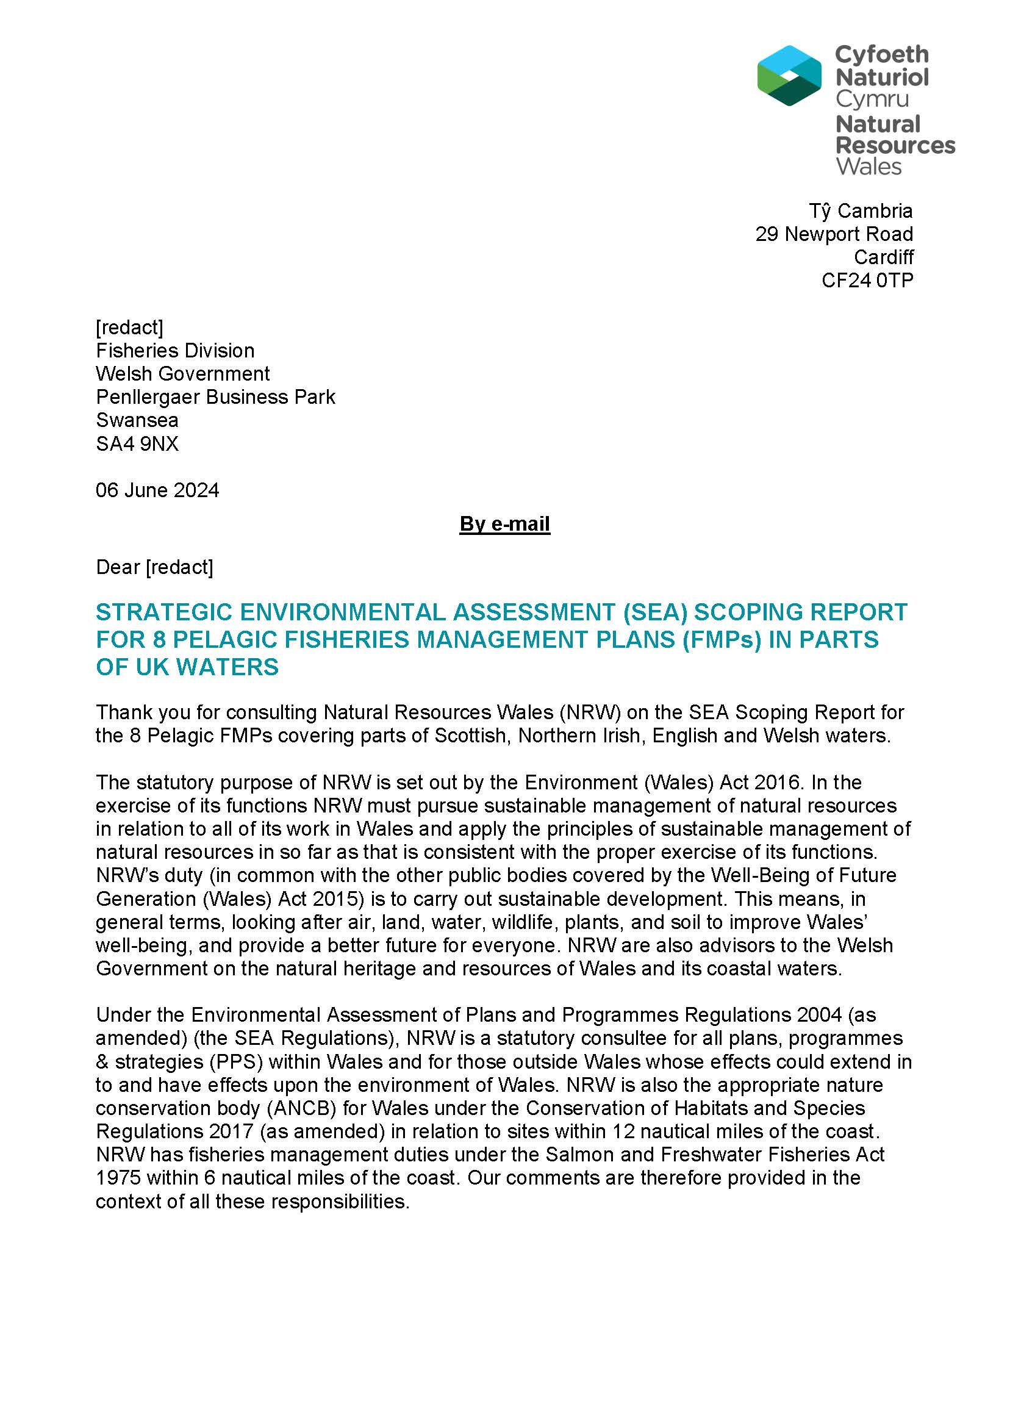
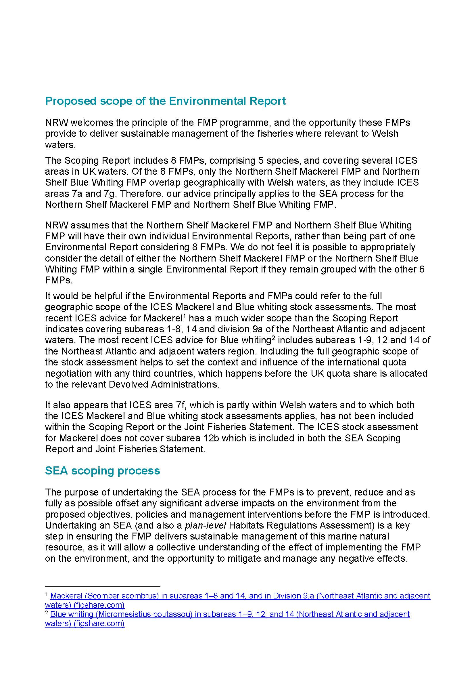
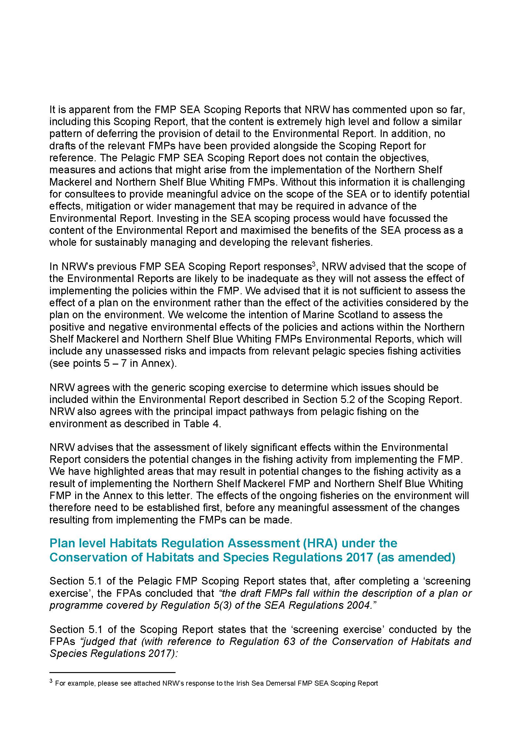
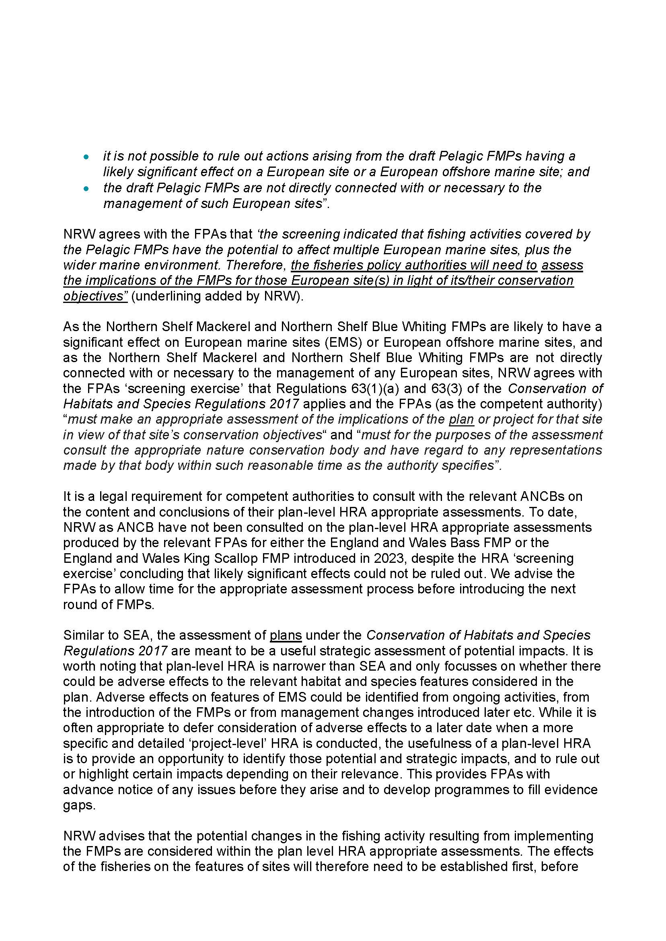
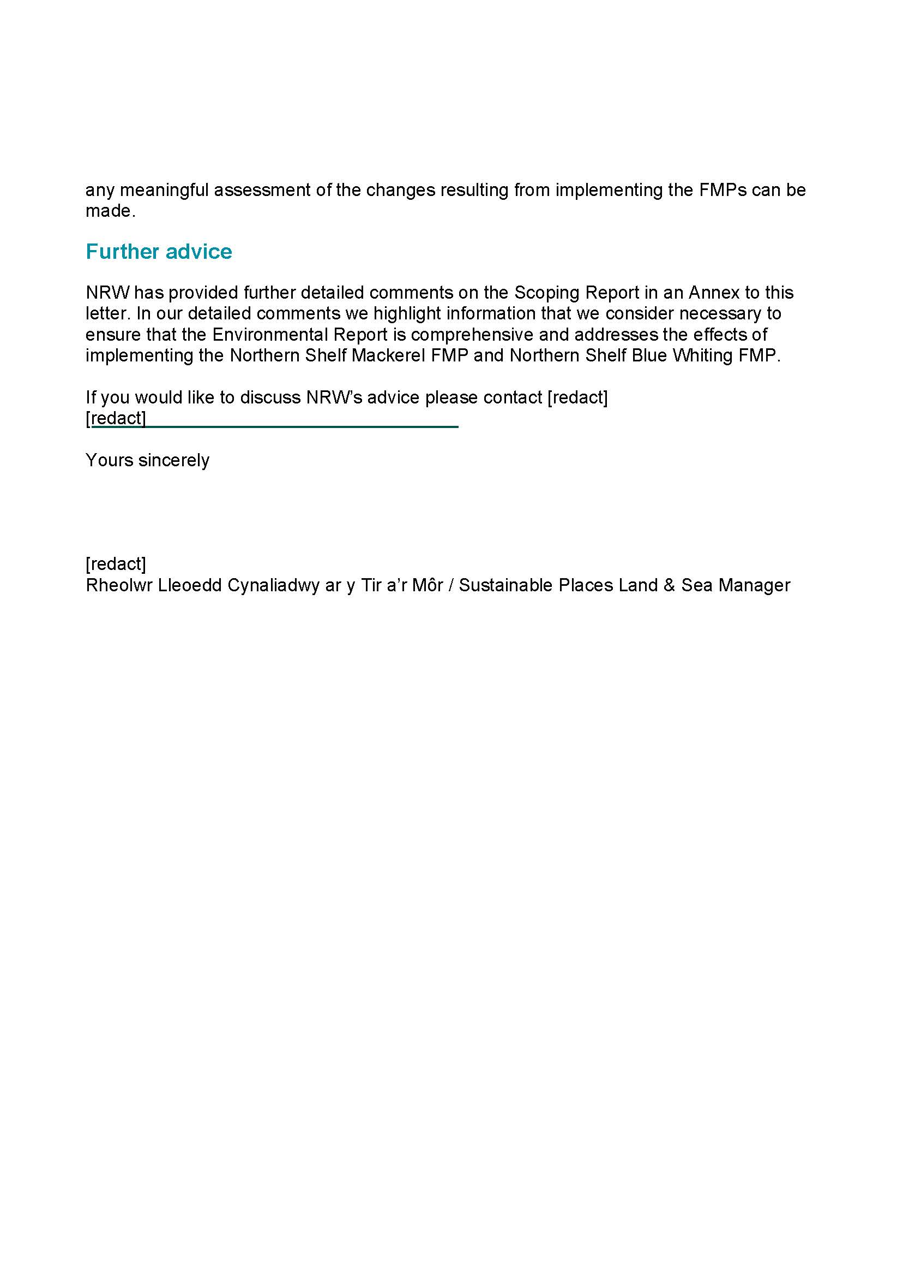

How the consultation response was considered
The fisheries policy authorities have consulted with statutory nature conservation advisors, including Natural Resources Wales (NRW), regarding the scope and level of detail for the Pelagic SEA Environmental Report (ER). The Welsh Government acts as a joint authority for the Northern Shelf Mackerel FMP and the Northern Shelf Blue Whiting FMP. The authorities have agreed to combine the UK Pelagic FMPs into a single environmental report, the Pelagic SEA.
Some comments from NRW, provided during the consultation process for the ER, have already been addressed, taking into account the updated version of Annex A of the Joint Fisheries Statement (JFS), published in December 2024. Outstanding comments and advice, including those related to the timing of Habitats Regulations Assessments (HRA), are discussed below.
The FMPs follow a high-level strategic assessment framework, using UK MS indicators as benchmarks for environmental assessment. The policies and actions of the FMPs are outlined in Tables 3 and 4. Some actions may lead to recommendations for subsequent management measures, which could change fisheries characteristics. A summary of potential positive and negative effects is provided, noting that these changes could be spatial, temporal, or effort based.
However, it is important to distinguish between the potential effects of meeting high-level strategic policies and any resulting management measures that may be adopted. Conducting an in-combination assessment at this stage of the FMPs’ development cycle is challenging due to the high-level nature of the policies and actions and their stage of development.
Before any changes to fisheries management are made as a result of the draft Pelagic FMPs, new actions will, where necessary, undergo Habitats Regulations Assessments and Marine Conservation Zone (MCZ) assessments. Any new management interventions proposed in the draft FMPs will be screened for potential significant effects on European sites or European offshore marine sites within the measure’s geographical scope. If necessary, a further appropriate assessment will be carried out in accordance with the Conservation of Habitats and Species Regulations 2017 or the Conservation of Offshore Habitats and Species Regulations 2017. In accordance with the Marine and Coastal Access Act 2009 (MaCAA), an MCZ Assessment will also be conducted before any new management measures are implemented that could significantly affect the conservation objectives of an MCZ. Additionally, Nature Conservation Marine Protected Areas (NCMPAs), designated under the Marine and Coastal Access Act 2009, will be assessed as needed to ensure that any proposed actions or measures do not adversely affect their integrity.
Until suitable management actions are identified, it is not possible to assess the type or scale of potential impacts on relevant MPAs and their associated protected habitats and species. Any recommended management changes would require legislative amendments to fisheries regulations, providing the opportunity for a full assessment of potential impacts in line with the Conservation of Habitats and Species Regulations 2017. This would also address any outstanding advice from NRW.
Until such legislative changes are made, no real-world changes, such as those that could trigger an HRA for protected Welsh MPAs, habitats, or species, can be implemented, as the FMPs themselves do not propose any management changes or new actions.

SEPA Response
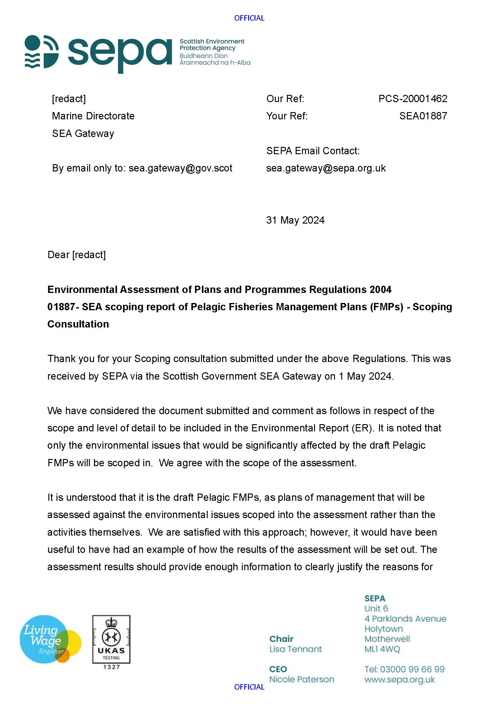
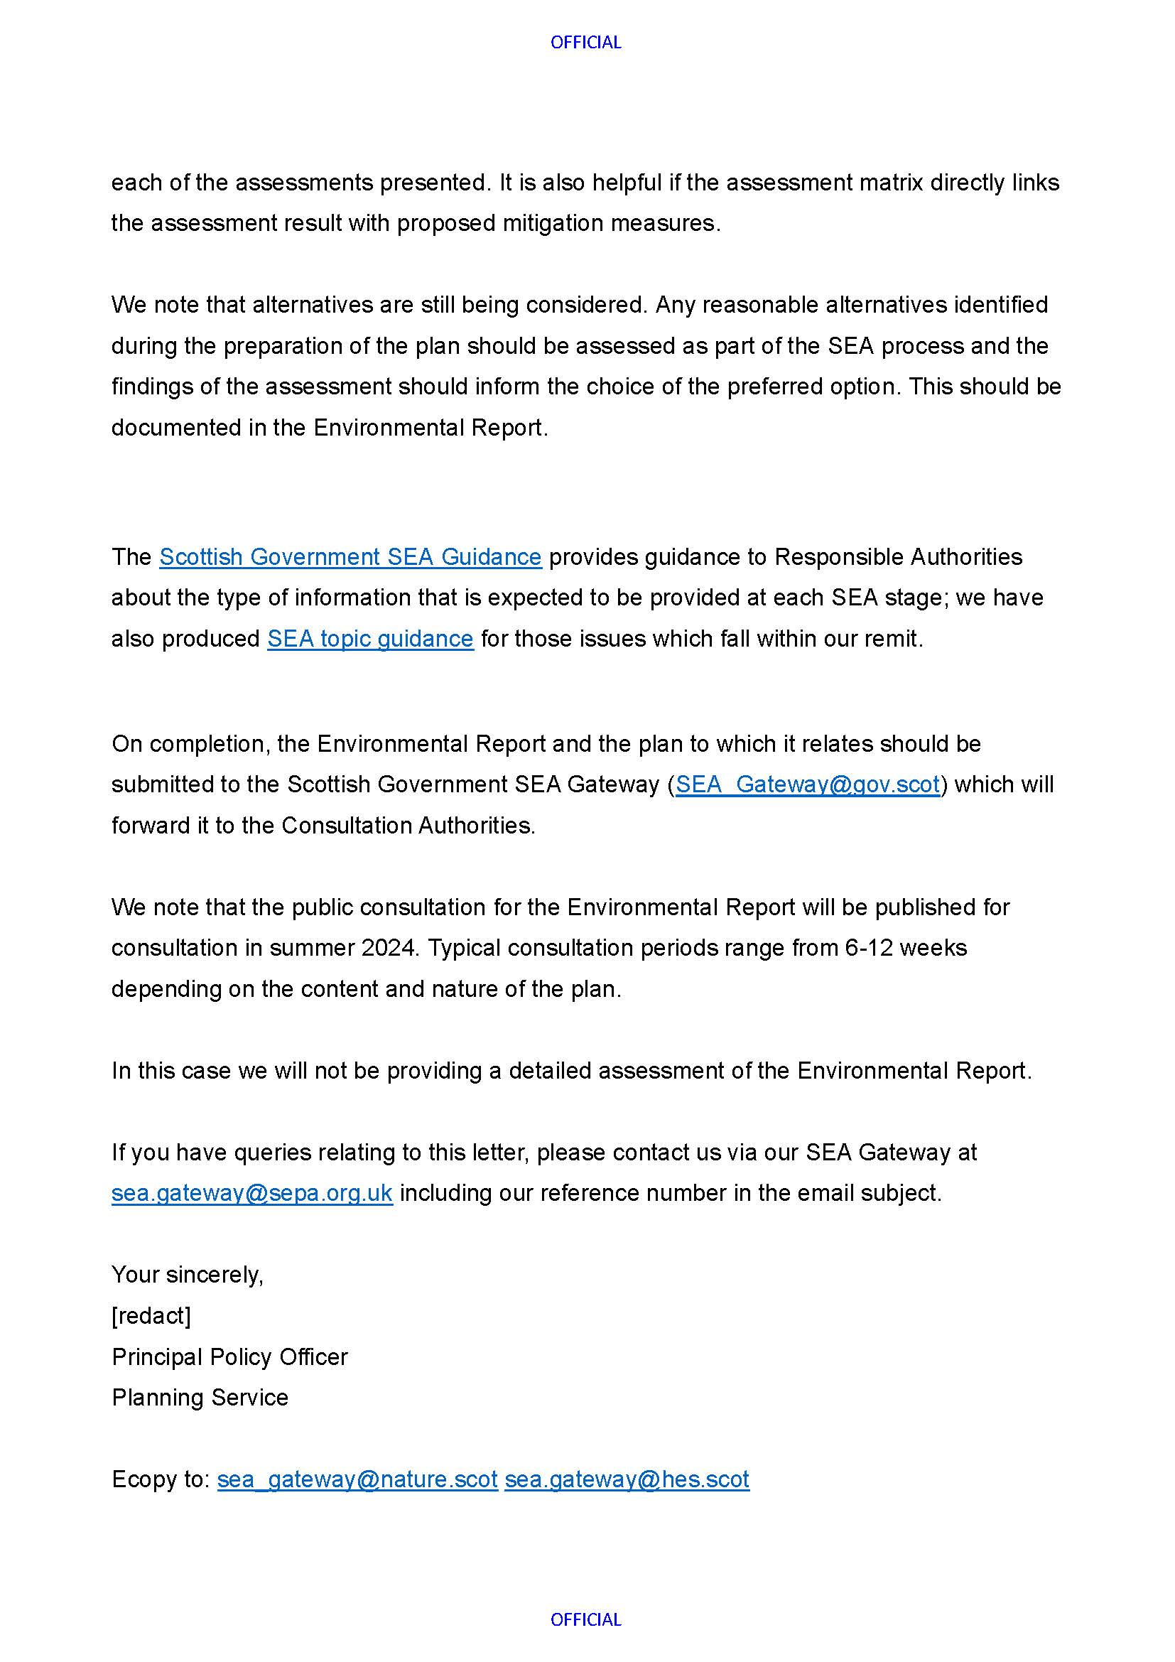
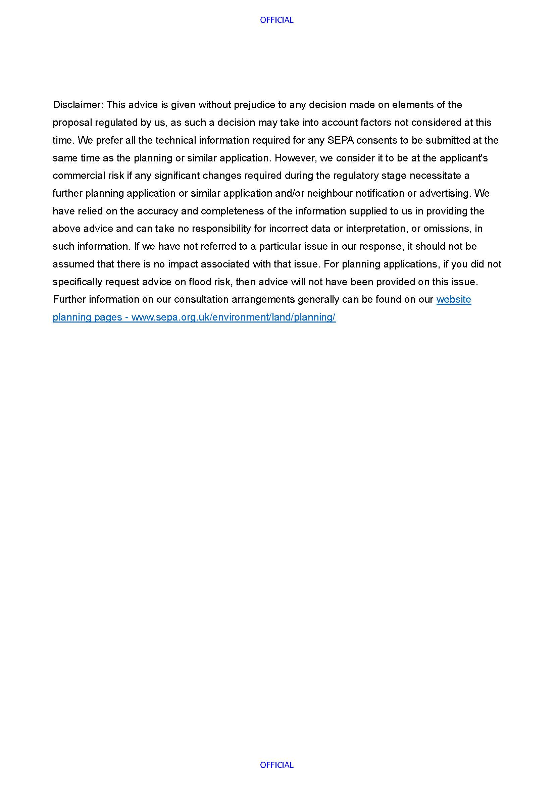

How the consultation response was considered
Point # | How point was considered
- It is noted that only the environmental issues that would be significantly affected by the draft Pelagic FMPs will be scoped in. We agree with the proposed scope of the assessment. | Point noted.
- It is understood that it is the draft Pelagic FMPs, as plans of management that will be assessed against the environmental issues scoped into the assessment rather than the activities themselves. We are satisfied with this approach; however, it would have been useful to have had an example of how the results of the assessment will be set out. The assessment results should provide enough information to clearly justify the reasons for each of the assessments presented. It is also helpful if the assessment matrix directly links the assessment result with proposed mitigation measures. | Point noted.
- We note that alternatives are still being considered. Any reasonable alternatives identified during the preparation of the plan should be assessed as part of the SEA process and the findings of the assessment should inform the choice of the preferred option. This should be documented in the Environmental Report. | Point noted. Assessment of alternatives will be incorporated into the final Environmental Report of the SEA.
- The Scottish Government SEA Guidance provides guidance to Responsible Authorities about the type of information that is expected to be provided at each SEA stage; we have also produced SEA topic guidance for those issues which fall within our remit. | Point noted.
- On completion, the Environmental Report and the plan to which it relates should be submitted to the Scottish Government SEA Gateway (SEA_Gateway@gov.scot) which will forward it to the Consultation Authorities. | Point noted.
- We note that the Environmental Report will be published for consultation in summer 2024. Typical consultation periods range from 6-12 weeks depending on the content and nature of the plan. | Point noted.
- In this case we will not be providing a detailed assessment of the Environmental Report. | Point noted.

Scottish waters refer to the Scottish inshore and Scottish offshore regions as set out in section 322 of the Marine and Coastal Access Act 2009.
English waters refer to the English inshore and English offshore regions as set out in section 322 of the Marine and Coastal Access Act 2009.
Northern Irish waters refer to the Northern Irish inshore and Northern Irish offshore regions as set out in section 322 of the Marine and Coastal Access Act 2009.
Welsh waters refer to the Welsh inshore and Welsh offshore regions as set out in Section 322 of the Marine and Coastal Access Act 2009.
Carbon emissions in UK fisheries: recent trends, current levels, and pathways to Net Zero. Opens a report analysing carbon emissions in UK fisheries and potential pathways to net zero.
The environmental impacts of pelagic fish caught by Scottish vessels. Opens a study assessing the environmental impacts of pelagic fisheries in Scotland.
Assessing greenhouse gas emissions from Scotland's fishing fleet. Opens a report evaluating greenhouse gas emissions from Scotland’s fishing fleet.
Scottish Government Sea Fisheries Statistics 2024: Table 47. Opens official statistics on sea fisheries from the Scottish Government.
Changes in fish distribution in the eastern North Atlantic ICES 2023. Opens a report on observed changes in fish distribution in the eastern North Atlantic based on ICES scientific analysis.
Climate change risk adaptation for wild capture seafood. Opens guidance on adapting wild capture fisheries to risks associated with climate change.
Changing fish distributions challenge the effective management of European Fisheries. Opens an article discussing how shifting fish distributions affect fisheries management in Europe.
Climate change projections of commercial fish distribution and suitable habitat around north western Europe. Opens a study presenting projected changes in fish distribution and habitats under climate change scenarios.
Warming shelf seas drive the subtropicalization of European pelagic fish communities. Opens a scientific study on how warming seas are shifting fish communities toward warmer-water species.
Geographical expansion of Northeast Atlantic mackerel (Scomber scombrus) in the Nordic Seas. Opens a study describing the expansion of mackerel into northern waters.
Impacts on Commercial and Recreational Fisheries Relevant to the UK and Ireland. Opens a report assessing climate change impacts on commercial and recreational fisheries.
Impacts of climate change on the complex life cycles of fish. Opens a study examining how climate change affects different stages of fish life cycles.
Wasp-waist populations and marine ecosystem dynamics: Navigating the “predator pit” topographies. A research article explaining how some marine ecosystems are shaped by a few key mid-level fish species that strongly influence both their predators and their prey.
Forage fish, their fisheries, and their predators: who drives whom? A research article exploring how small “forage fish” link the marine food web, supporting predators like seabirds and larger fish.
Interaction between top-down and bottom-up control in marine food webs. A study explaining how marine ecosystems are shaped both by “top-down” forces (predators and fishing) and “bottom-up” forces (climate and food availability).
The 11 descriptors include: biodiversity; non-indigenous species; commercial fish; food webs; eutrophication; sea-floor integrity; hydrographical conditions; contaminants; contaminants in seafood; marine litter and underwater noise. For more information, see Introduction to UK Marine Strategy (cefas.co.uk)
Key issues are: impact of the removal of targeted species on the status of fish stocks; benthic disturbance related pressures associated with towed demersal gear; impact of the removal of targeted fish stocks on other species / wider environment; impact of bycatch (bird / mammal / fish) on biodiversity, food webs or stocks; fishing related sources contributing to marine litter; noise from pingers / acoustic deterrents contributing to marine noise.
Good ecological status (GES) is a metric for assessing the health of the water environment. It is assigned using various water flow, habitat and biological quality tests. Failure to meet any one individual test means that the whole water body fails to achieve good ecological status. Source: Department for Environment, Food and Rural Affairs (DEFRA) (WQR0028)
Marine litter strategy - gov.scot
Reasonable alternatives definition
An explanation of a MSY approach to fishing is provided in Advice published by ICES
Sustainability of Fish Stocks | National Performance Framework
Where relevant, the relationship between the issue and the UK MS descriptor of GES is shown as ‘D#’ where # represents the number of the descriptor, as shown in Appendix A.
Kingston, A., Thomas, l. and Northridge, S. (2021) UK Bycatch Monitoring Programme Report for 2019. Sea Mammal Research Unit. Available at Science Search (defra.gov.uk)
7 Northridge, S., Kingston, A. and Thomas, l. (2019) Annual report on the implementation of Council Regulation (EC) No 812/2004 during 2018. Sea Mammal Research Unit. Available at Science Search (defra.gov.uk)
Kingston, A., Thomas, l. and Northridge, S. (2021) UK Bycatch Monitoring Programme Report for 2019. Sea Mammal Research Unit. Available at Science Search (defra.gov.uk)
Marine Mammal By-catch Assessment
Kittiwake breeding success has only been achieved for the English mainland colonies. GES for Kittiwake breeding success has not been achieved for the entire North Sea region due to breeding failures in Orkney and Shetland.
Anderson, O.R.J., Thompson, D. & Parsons, M. (2022). Seabird bycatch mitigation: evidence base for possible UK application and research. . JNCC Report no. 717 , JNCC, Peterborough. ISSN 0963-8091
Northridge. S., Kinston. A. and Coram. A. (2020). Preliminary estimates of seabird bycatch by UK vessels in UK and adjacent waters. Scottish Ocean Institute, University of St Andrews. Final report to JNCC
Miles, J., Parsons, M. and O’Brien, S. (2020). Preliminary assessment of seabird population response to potential bycatch mitigation in the UK-registered fishing fleet. Report prepared for the Department for Environment Food and Rural Affairs (Project Code ME6024).
Bell ED, Nash RMD, Garnacho E, De Oliveira J, Hanin M, Gilmour F, O’Brien CM 2023. Assessing the sustainability of negotiated fisheries catch limits by the UK for 2023. Cefas project report for Defra.

