
Some questions for you to answer about our ideas about treating everyone fairly

Please tell us what you think of our ideas by Thursday 6 February 2020.

1
Idea 1

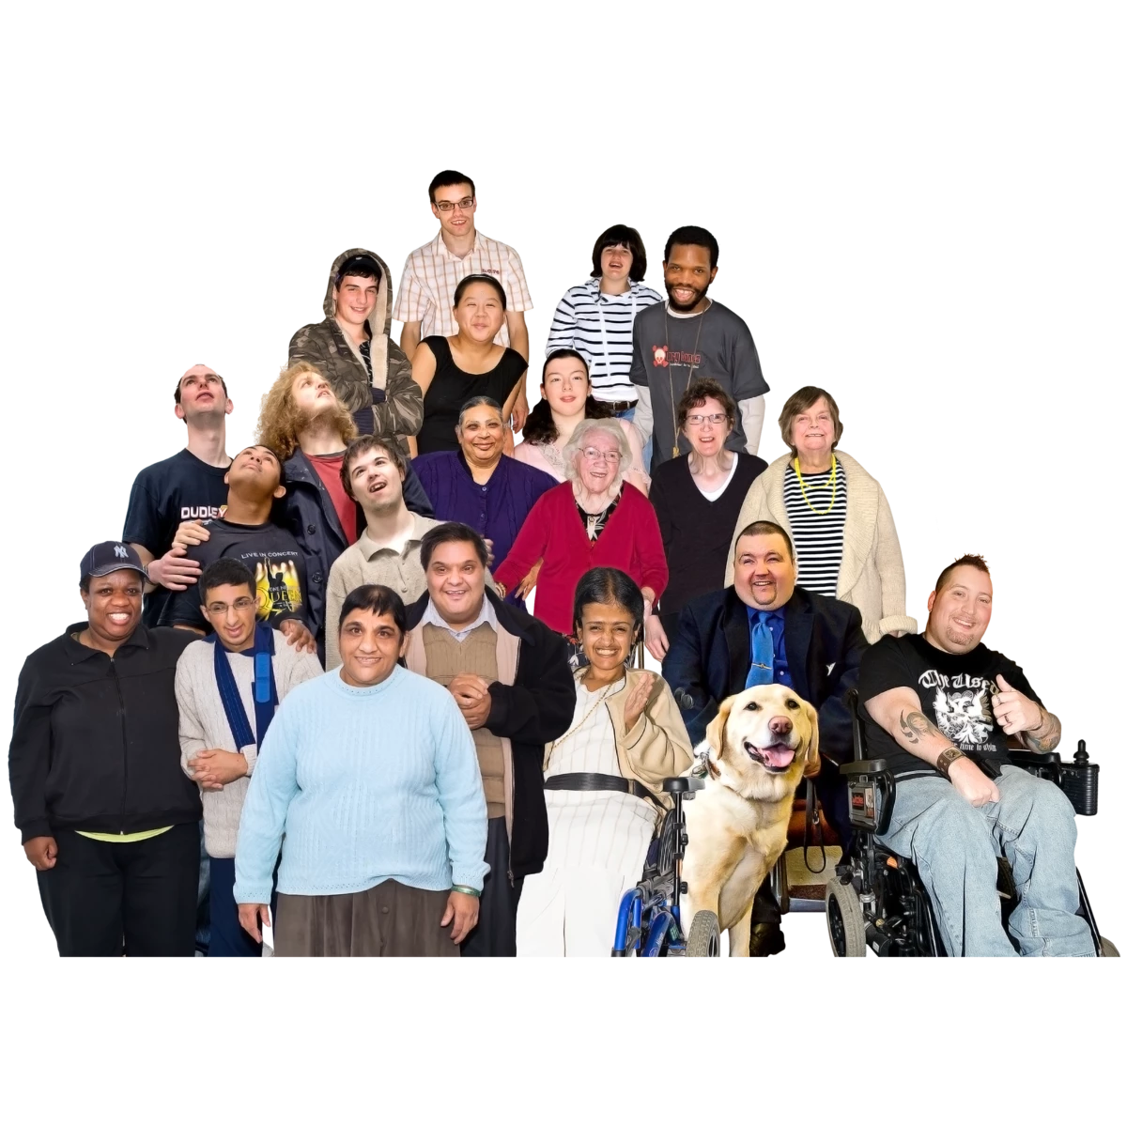
Our benefits service will work well for everyone.

People who use the service will be able to get the support they need

There is more information about Idea 1 starting on page 6 of the document called: Our ideas for making sure everyone is treated fairly.


Do you think Idea 1 and the things we could do to make it happen is fair for all groups of people and will give them what they need?




Yes No Don’t know
?



If not, how could we make this idea fair for all groups of people? Write in here:

Idea 2
2

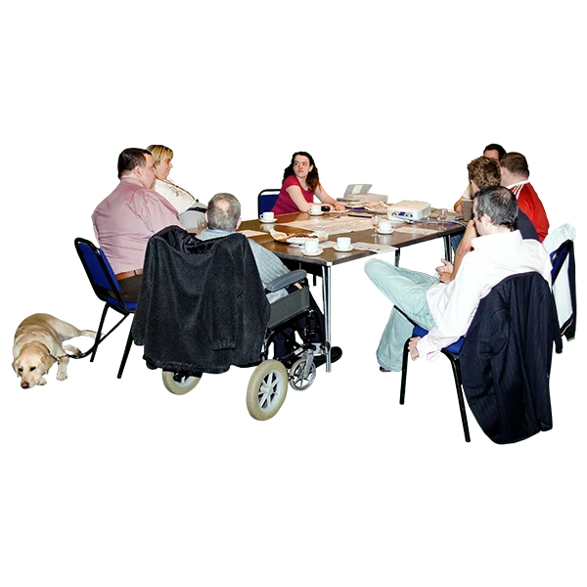
We will help make sure that all different groups of people are part of our work and no one is left out.

We will do our best for all our staff and make sure they can do the best they can.

There is more information about Idea 2 starting on page 9 of the document called Our ideas for making sure everyone is treated fairly.

Do you think Idea 2 and the things we could do to make it happen is fair for all groups of people and will give them what they need?

Yes No Don’t know
?

If not, how could we make this idea fair for all groups of people? Write in here:

Idea 3
3


People will want to work for Social Security Scotland. We will have many different groups of people working for us

There is more information about Idea 3 starting on page 13 of the document called:
Our ideas for making sure everyone is treated fairly.
Do you think Idea 3 and the things we could do to make it happen is fair for all groups of people and will give them what they need?

Yes No Don’t know
?

If not, how could we make this idea fair for all groups of people? Write in here:

Idea 4
4


We will use the information that people give us to keep making our service better for everyone.

There is more information about Idea 4 starting on page 16 of the document called:
Our ideas for making sure everyone is treated fairly.

Do you think Idea 4 and the things we could do to make it happen is fair for all groups of people and will give them what they need?

Yes No Don’t know
?

If not, how could we make this idea fair for all groups of people? Write in here:

Idea 5
5
We will work with other organisations to make sure that everyone can get advice about benefits that is right for them and their lives

There is more information about Idea 5 starting on page 19 of the document called:

Our ideas for making sure everyone is treated fairly.

Do you think Idea 5 and the things we could do to make it happen is fair for all groups of people and will give them what they need?

Yes No Don’t know
?

If not, how could we make this idea fair for all groups of people? Write in here:

Other questions

Is there anything unfair about the way people get benefits at the moment?

For example, are some groups of people treated less fairly than others? Please write in here


Is there anything else you want to say about how we can make our work fair for everyone? Please write in here


Are you giving us your answers:

On your own

As part of an organisation

Please tell us your name or the name of your organisation if you can

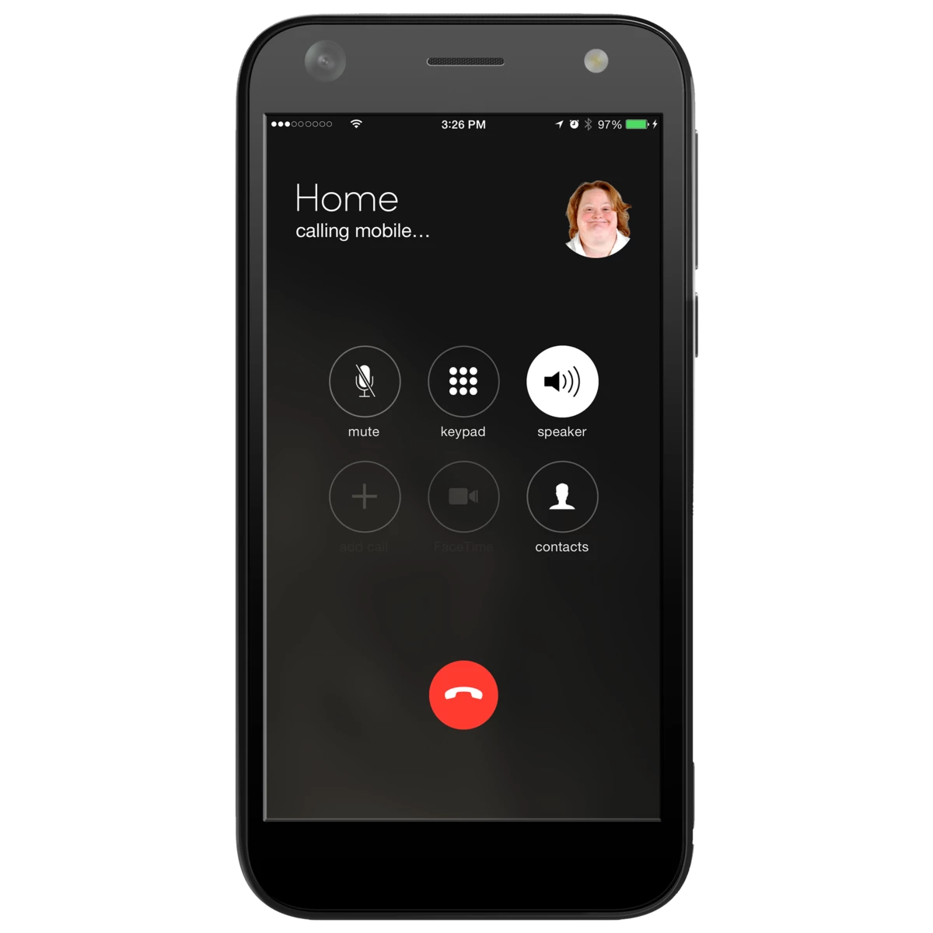

Your phone number


Your address and postcode



Your email address

Are you happy for us to share what you say with the public?

Yes. You can say my name as well

Yes. But don’t use my name

No. Please don’t share what I say

(We may still use your name if you are an organisation)


Can we get in touch with you again about what you tell us?

Yes No

How to tell us what you think

Please tell us what you think of our ideas by Thursday 6 February 2020.



You can tell us on this website:

https://consult.gov.scot/social-security/mainstreaming-equality

Or you can send your answers using this easy read form. Send it by email to:

consultations@socialsecurity.gov.scot

Or by post to:

Social Security Scotland
Corporate Assurance Team
50 North Lindsay Street
Dundee
DD1 1QE


Events

We will also have some events.

You can come to the events to find out more and say what you think of our ideas.

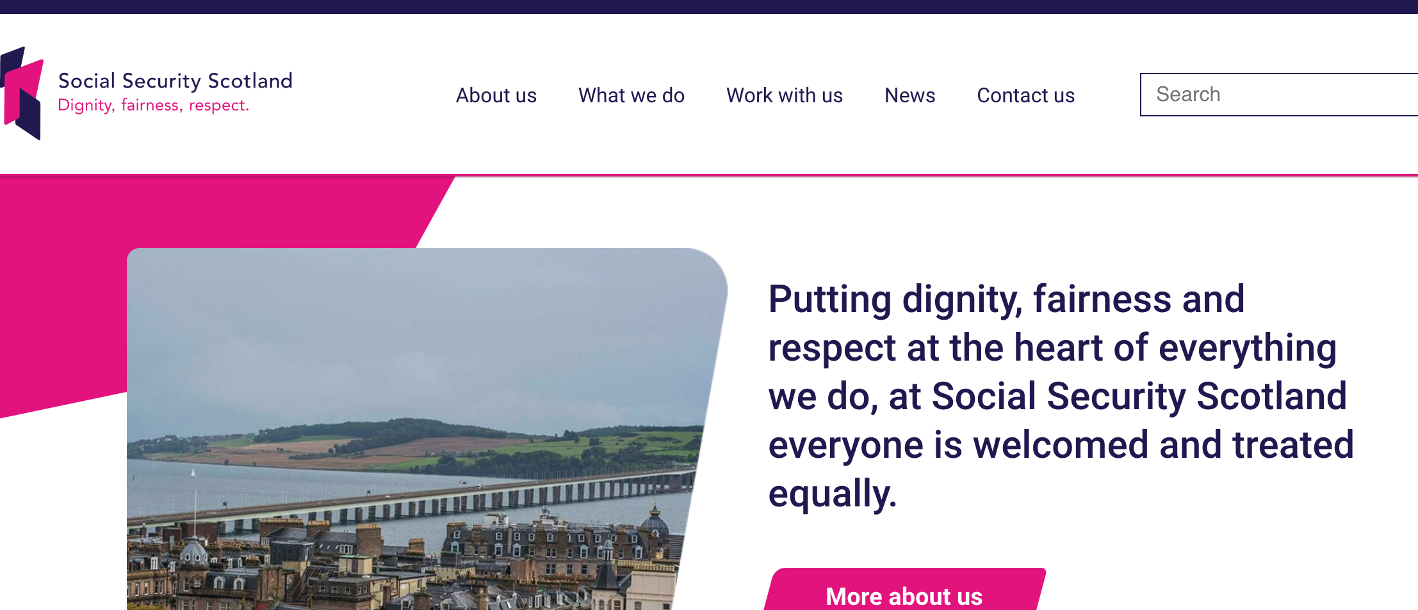
There is more information on our website at:

www.socialsecurity.gov.scot



