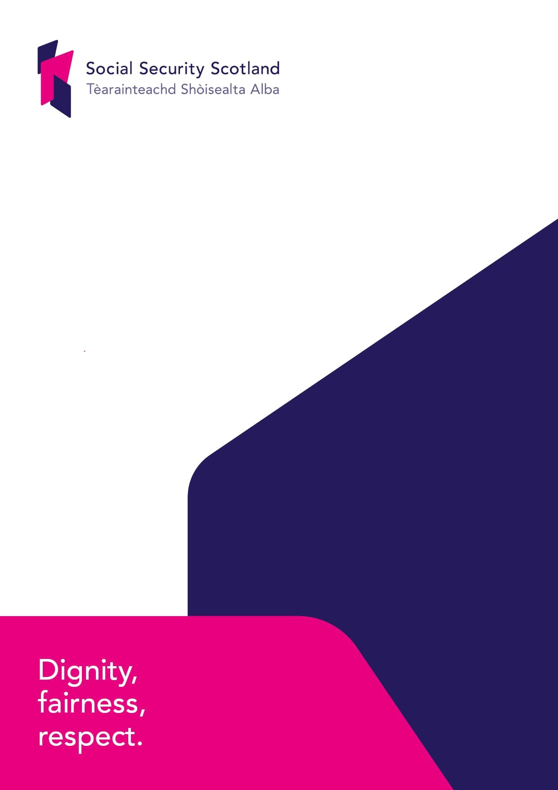

Mainstreaming Equality
Draft Equality Outcomes
Consultation
Contents

Page
Welcome Page 3
Responding to this Consultation Page 3
Events Page 4

About Social Security Scotland Page 5
Social Security Scotland – the Executive Agency Page 5
The Social Security Programme Page 6
Our Principles Page 6
Our Strategic Objectives Page 7

Consultation context Page 8
Equality legislation Page 8
Social Security (Scotland) Act 2018 Page 8
Taking a strategic approach Page 9

Draft Mainstreaming Equality Outcomes Page 10
Draft outcomes Page 10
Equality Outcome 1 Page 11
Equality Outcome 2 Page 13
Equality Outcome 3 Page 15
Equality Outcome 4 Page 16
Equality Outcome 5 Page 17

Consultation questions Page 18
How were the outcomes developed? Page 19
Review and report Page19

Annex A Page 20
Mainstreaming Equality – Draft Equality Outcomes Consultation Page 20
Respondent Information Form Page 20
Information for organisations: Page 21

Annex B Page 22
Consultation Questions Page 22

Welcome

Social Security Scotland is working to develop its first Equality Strategy. This strategy will ensure equality is at the centre of all that we do. It will be the main driver to ensure we meet, and wherever possible, exceed the public expectations of us as a public body under both the Equality Act 2010 and the Social Security (Scotland) Act 2018.

The strategy will set out our commitment to mainstreaming equality, and this will be underpinned by a set of strong mainstreaming equality outcomes. These outcomes are the focus of this important consultation we are running. We are seeking views from clients and stakeholders to make sure these are:
- The right outcomes for a new growing organisation.
- Focused rightly towards making practical improvements and on addressing inequality.
- Clear on what we aim to achieve and how we can measure and demonstrate this.

Your input on these outcomes will make sure we deliver an Equality Strategy that achieves the practical improvements for those who experience discrimination and disadvantage, and are reflective of what our stakeholders needs’ are.

Responding to this Consultation
We are inviting responses to this consultation by Thursday 30 January 2020. Please respond to this using the Scottish Government’s consultation hub, Citizen Space https://consult.gov.scot/social-security/mainstreaming-equality . You can save and return to your responses while the consultation is still open, but please ensure that consultation responses are submitted before the closing date of Thursday 30 January 2020.

If you respond using the consultation hub, you will be directed to the About You page
before submitting your response. Please indicate how you wish your response to be
handled and, in particular, whether you are content for your response to published. If
you ask for your response not to be published, we will regard it as confidential, and
we will treat it accordingly.

We want our consultation to be accessible, and welcome a diverse range of responses. If, for any reason, you are unable to submit your response through our online form, please contact us by emailing consultations@socialsecurity.gov.scot to arrange responding in an alternative format.

If you are unable to respond using our consultation hub, you can also do so by completing the consultation questionnaire (provided at Annex C) and Respondent Information Form at the end of the document and send it with your response either by email to consultations@socialsecurity.gov.scot or written responses can be sent to:

Social Security Scotland
Corporate Assurance Team
50 North Lindsay Street
Dundee
DD1 1QE

We would be grateful however if you choose to respond in a different format to
clearly indicate in your response which questions you are responding to as this will aid our analysis of the responses received.

All respondents should be aware that Social Security Scotland is subject to the
provisions of the Freedom of Information (Scotland) Act 2002 and would therefore
have to consider any request made to it under the Act for information relating to
responses made to this consultation exercise.

Where respondents have given permission for their response to be made public, and
after we have checked that they contain no potentially defamatory material, responses will be made available to the public at http://consult.gov.scot. If you use
the consultation hub to respond, you will receive a copy of your response via email.

To find out how we handle your personal data, please see our privacy policy: https://www.socialsecurity.gov.scot/privacy-statement

Following the closing date, all responses will be analysed and considered along with
any other available evidence. Responses will be published where we have been
given permission to do so. An analysis report will also be made available.

We aim to publish the final Equality Strategy in early 2020.

If you have any comments about how this consultation exercise has been conducted,
please send them to the contact address above or to consultations@socialsecurity.gov.scot

Events
Social Security Scotland will be holding a series of events to run alongside and compliment this consultation. The sessions will provide stakeholders with the opportunity to find out more information on the consultation, participate in group discussions and provide feedback.

For more information on venues, dates and times, and to book a place at one of the
events, please visit our website www.socialsecurity.gov.scot.

During the consultation period our staff will also be attending various other events and roadshows. Although many will not be directly related to this consultation, staff will be actively promoting the consultation and seeking views on our draft outcomes based on the consultation questions.

About Social Security Scotland

Social Security Scotland – the Executive Agency
Social Security Scotland is an Executive Agency of the Scottish Government. We are a new public service that will administer benefits on behalf of the Scottish Government. This will include benefits that were previously delivered by the UK Government, and a number of new benefits created by The Scottish Government. It is Social Security Scotland’s responsibility to ensure that these benefits are managed efficiently, correctly and fairly.

How we administer these benefits is directed by the Principles in the Social Security (Scotland) Act 2018 and Our Charter..

Why
Aim
Contribute to the creation of a fairer society

Vision
Provide support to each of us when we need it

What
Purpose
Administer the Scottish social security system effectivly and in accordance with the principles in the Act and the Charter

Promise
We will deliver support built around you when and where you need it

Values
Dignity, fairness and respect

How
Strategic objectives
Delivering a service with dignity, fairness and respect at its core
Promoting equality and tackling poverty
Ensuring efficency and aligning our activities with wider public sector for the benefit of the people we serve
Contributing to our economy, society and protection of our environment

The Social Security Programme
Working alongside us is the Social Security Programme. The Social Security Programme is separate from Social Security Scotland, and refers to the way that the Scottish Government is managing its work to design, build and implement the new Scottish social security system. For example the Social Security Programme has designed, built and tested all of the systems, processes and other requirements to deliver the new Carer’s Allowance Supplement, and Best Start Grant benefits, they then hand these over to Social Security Scotland to deliver. This will continue on for all benefits and both us and Social Security Programme will learn from experience and feed this into the next benefit.

Our Principles
As outlined in Our Charter, we are determined to do things differently and deliver these benefits in a more positive and supportive way – placing dignity, fairness and respect at the heart of all we do. This approach is underpinned by the following eight Principles:

- social security is an investment in the people of Scotland,
- social security is itself a human right and essential to the realisation of other human rights,
- the delivery of social security is a public service,
- respect for the dignity of individuals is to be at the heart of the Scottish social security system,
- the Scottish social security system is to contribute to reducing poverty in Scotland,
  - the Scottish social security system is to be designed with the people of Scotland on the basis of evidence,
  - opportunities are to be sought to continuously improve the Scottish social security system in ways which—
  - put the needs of those who require assistance first, and
  - advance equality and non-discrimination,

- the Scottish social security system is to be efficient and deliver value for money.

We exist in order to administer the newly devolved social security powers and we are focused on taking a rights based approach while doing so. Social security is a human right – it is an investment in ourselves and each other, it is an investment in the people of Scotland, and it is designed to ensure that people can play a full and active part in society - which will make a positive difference in all our lives.

‘How’ we do our work is just as important as ‘what’ we do. With that in mind, the Scottish Government (through the Social Security Programme) is designing the services that we will deliver in partnership with the people who will use them. We will continue this approach encouraging feedback. We are committed to listening, learning and improving in order to deliver the best service possible.

Our Strategic Objectives
Our Strategic Objectives are aligned with the Scottish Government National Performance Framework. Specifically, our rights-based approach supports progress of the human rights outcome. If we fulfil our strategic objectives, we will help to build a fairer Scotland and a service which redefines the way in which people engage with social security.

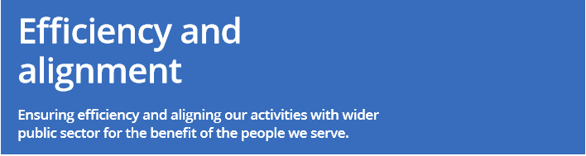

Consultation context

Equality legislation
Understanding both the statutory and national context is important to defining our approach.

As an Executive Agency we are subject to the Equality Act 2010 Public Sector General Equality Duty, and the various equality specific duties. This means we need to have due regard to the need:
- to eliminate unlawful discrimination, harassment, victimisation and any other conduct prohibited by the Act
- to advance equality of opportunity between people who share a protected characteristic and people who do not share it
- to foster good relations between people who share a protected characteristic and people who do not share it.

Having due regard means consciously thinking about the three aims of the Equality Duty as part of our decision making process, and ensuring equality sits at the heart of our culture and operational delivery.

There are also other equality related legislative obligations and national agenda’s that we will seek to input into as appropriate, and make links with, to ensure our overall approach is representative of the wider needs’ of Scotland. This will all be set out clearly within our final Equality Strategy.

Social Security (Scotland) Act 2018
Social Security is a specific outcome within the Scottish Government Mainstreaming Equality outcomes. The outcome states ‘Equality is at the heart of the development and creation of a devolved social security system for Scotland and we will design this in partnership with the people of Scotland’. The Social Security Programme within Scottish Government has been leading on embedding this as they have been developing the service and products that Social Security Scotland will administer.

Within the Social Security (Scotland) Act 2018 legislation there are also references to themes of equality.

- Section 3 Promotion of benefit take-up
- Section 4 Recognition of importance of inclusive communication
- Section Recognition of importance of accessible information
- Section 20 Annual Report - Ministers must provide an assessment of how the Scottish social security system has affected the circumstances of persons living in households whose income is adversely affected, or whose expenditure is increased, because a member of the household has one or more protected characteristics.

These legislative commitments demonstrate the importance of making sure equality is at the centre of all that we do, and that with the Social Security Programme we deliver a service based on the principle that social security is a human right.

Taking a strategic approach
Taking account of our legislative obligations and our overall commitment to equality this is why we have chosen to develop an Equality Strategy for Social Security Scotland. This will be framed around mainstreaming equality outcomes, as required by the specific equality duties legislation, and once complete will provide an overarching framework and enable us to co-ordinate all activity under this theme. It will also make sure we are held accountable for what we set out to achieve, and allow us to take a more targeted approach to tackling equality.

Draft Mainstreaming Equality Outcomes

Draft outcomes
We have five draft Equality Outcomes that we are seeking comment on:

- Social Security Scotland will deliver a seamless service that is inclusive and where our clients are able to access the support they need.

- Social Security Scotland will have a culture built on inclusivity where differences are supported, our people feel valued and they have opportunities to reach their full potential.

- Social Security Scotland will be an employer of choice and through our recruitment process we will look to build a workforce that is representative of the population of Scotland.

- Social Security Scotland uses the equality data (evidence) collected from clients, our people and other sources to respond to feedback and continually improve the service provided to all clients.

- Social Security Scotland’s service is delivered through having established partnerships with relevant public sector, third sector and community bodies providing clients person centred advice no matter their circumstances.

Equality Outcome 1
Social Security Scotland will deliver a seamless service that is inclusive and where our clients are able to access the support they need.

HOW DOES IT MEET THE GENERAL DUTY?
- Eliminate discrimination
- Advance equality of opportunity
- Foster good relations.

IMPACTED PROTECTED CHARACTERISTICS
This outcome cuts across all the protected characteristics

LINK TO STRATEGIC OBJECTIVES
- Delivering a service with dignity, fairness and respect at its core
- Promoting equality and tackling poverty
- Ensuring efficiency and aligning our services with the wider public sector for the benefit of the people we serve.

HOW WILL WE MEASURE SUCCESS?
- Client Insights Research
- Equality and Feedback Monitoring Form
- Client experience data
- Application journey measures (e.g. Number of applications measured against projections, application drop off’s)
- Measurements associated with Social Security Charter
- Feedback from representative groups
- Requests for information in other forms
- Published Equality Impact Assessments.

ACTIVITIES THAT COULD SUPPORT ACHIEVING THIS OUTCOME
- Inclusive communication project – key client materials and publications provided in various formats at the same time (e.g. BSL, Easy Read and various languages)
- Engagement with equality groups to inform decisions on physical environment for Social Security Scotland locations
- Ensuring feedback from delivery feeds back into service design being led by Social Security programme
- Roll out of the Social Security Scotland’s Equality Impact Assessment process, with assurance checking to ensure recommendations are followed up
- Delivery of the Social Security Charter
- Tailored pre-application support delivered throughout local
delivery areas
- Creation and delivery of Equality and Diversity training, ensuring every contact with our clients aligns to the strategic objectives.

Equality Outcome 2
Social Security Scotland will have a culture built on inclusivity where differences are supported, our people feel valued and they have opportunities to reach their full potential.

HOW DOES IT MEET THE GENERAL DUTY?
- Eliminate discrimination
- Advance equality of opportunity
- Foster good relations.

IMPACTED PROTECTED CHARACTERISTICS
This outcome cuts across all the protected characteristics

LINK TO STRATEGIC OBJECTIVES
- Delivering a service with dignity, fairness and respect at its core
- Promoting equality and tackling poverty.

HOW WILL WE MEASURE SUCCESS?
- Staff survey
- Analysis across protected characteristics
- Staff Insights research
- Self-declaration (eHR data on protected characteristics)
- Retention rates
- Number of grievances
- Analysis of Human Resource data
- Organisational rewards
- Success of staff networks
- Reporting supporting specific equality duties
- Board member information.

ACTIVITIES THAT COULD SUPPORT ACHIEVING THIS OUTCOME
- Creation of staff networks focused on equality
- Training and development opportunities that go further than mandatory e-learning e.g. staff awareness sessions. (Learning and Development to develop a programme of training)
- Overall culture work
- Communications - specific awareness weeks to highlight issues, raise awareness and engage staff
- Proactive outreach work targeting groups with protected characteristics
- Promotion of e-hr self-declaration
- Mental health first aiders
- Human Resource policies in place to support staff in attending religious commitments, medical appointments etc.
- Consideration given within estates facilities e.g. – prayer room, equipment for expressing mothers
- Reasonable adjustment process
- Inclusive communications
- Use Scottish Government Board reporting information to inform recruitment of Executive Advisory Body members.

Equality Outcome 3
Social Security Scotland will be an employer of choice and through our recruitment process we will look to build a workforce that is representative of the population of Scotland.

HOW DOES IT MEET THE GENERAL DUTY?
- Eliminate discrimination
- Advance equality of opportunity
- Foster good relations.

IMPACTED PROTECTED CHARACTERISTICS
This outcome cuts across all the protected characteristics

LINK TO STRATEGIC OBJECTIVES
- Delivering a service with dignity, fairness and respect at its core
- Promoting equality and tackling poverty

HOW WILL WE MEASURE SUCCESS?
- Analysis of Human Resource data across protected characteristics
- Staff Insights research
- Feedback on recruitment process
- Recruitment research.

ACTIVITIES THAT COULD SUPPORT ACHIEVING THIS OUTCOME
- Social Security Scotland recruitment policy
- Stakeholder input into recruitment materials
- Targeted workshops/roadshows with under-represented groups
- Insights research investigating experiences with the recruitment process specifically
- Mentoring opportunities
- Targeted Internships supporting equality groups
- Fair assessment process
- Representative workforce
- Early identification and actioning of possible reasonable adjustments required to improve employee’s journey and experiences following recruitment.

Equality Outcome 4
Social Security Scotland uses the equality data (evidence) collected from clients, our people and other sources to respond to feedback and continually improve the service provided to all clients.

HOW DOES IT MEET THE GENERAL DUTY?
- Eliminate discrimination
- Advance equality of opportunity
- Foster good relations.

IMPACTED PROTECTED CHARACTERISTICS
This outcome cuts across all the protected characteristics

LINK TO STRATEGIC OBJECTIVES
- Delivering a service with dignity, fairness and respect at its core
- Promoting equality and tackling poverty.

HOW WILL WE MEASURE SUCCESS?
- Equality Monitoring and Feedback Form
- Human Resource data
- Client and Staff Insights research
- Benefit take up rates
- Client experience data.

ACTIVITIES THAT COULD SUPPORT ACHIEVING THIS OUTCOME
- Development and application of the Clients Insights Research programme.
- Development of accessible client surveys on individual interactions and overall experience when engaging with Social Security Scotland.
- Social Security Scotland reporting on Specific duties (Workforce/Gender/Disability Pay Gap)
- Workforce data analysis – using this to support specific reviews of staff polices
- Implementation of ‘All ideas matters’ staff suggestion scheme
- Supporting Scottish Government analysts to design and measure benefit take up
- Developing and embedding a continuous improvement culture
- Action plan following staff survey results
- Quality checks in place and performance improvement action plans for staff not achieving the desired standard.

Equality Outcome 5
Social Security Scotland service is delivered through having established partnerships with relevant public sector, third sector and community bodies providing clients person centred advice no matter their circumstances.

HOW DOES IT MEET THE GENERAL DUTY?
- Eliminate discrimination
- Advance equality of opportunity
- Foster good relations.

IMPACTED PROTECTED CHARACTERISTICS
This outcome cuts across all the protected characteristics

LINK TO STRATEGIC OBJECTIVES
- Delivering a service with dignity, fairness and respect at its core
- Promoting equality and tackling poverty
- Ensuring efficiency and aligning our services with the wider public sector for the benefit of the people we serve.

HOW WILL WE MEASURE SUCCESS?
- Feedback from organisations
- Client experience feedback
- Equality and Feedback Monitoring Form
- Stakeholder consultations.

ACTIVITIES THAT COULD SUPPORT ACHIEVING THIS OUTCOME
- Local delivery partnerships established – developing Social Security Scotland’s services in close partnership with stakeholders and those with direct lived in experience
- Delivery of our Engagement and Relationships Strategy
- Tailored pre-application support based on local needs
- Developing clients referral arrangements with a range of other advice and support services
- Appropriate design, analysis and reporting of stakeholder consultations
- Providing enough resources to support people
- Ensure support systems and person centred advice.

Consultation questions
For each of the outcomes we are asking the following questions. A submission template with all the questions is provided at Annex B.

- Do you feel this outcome meets the needs of protected groups? (Yes/No)
If you answered No, can you please outline how the outcome could be improved to meet their needs? (If appropriate, please make clear, which protected characteristic you are referring to?)

- Do you feel that the supporting activities stated will help achieve the stated outcome (Yes/No)
If you answered No, what types of activity are missing that we could do to make an impact on delivery of this outcome?

- Do you feel that the measures of success stated will help Social Security Scotland measure the progress of this outcome? (Yes/No)?
If you answered No, what are your concerns, and can you identify any further measures we should use?

More generally to inform the wider development of the Equality Strategy we are asking:
- Do the outcomes stated target the areas of most relevance for Social Security Scotland (Yes/No)
If you answered No, what further outcomes would you suggest and why?

- Are there any specific inequalities that you would wish to highlight that are relevant to the delivery of social security benefits? Any information or evidence you can provide or signpost us to will be greatly appreciated.

- Do you have any other comments or suggestions on our approach to equality?

How were the outcomes developed?
These draft outcomes have not been developed by Social Security Scotland in isolation. They have been already informed through a variety of evidence and stakeholder input.

- Internal feedback - we have an Internal Working Group who helped map existing activity in Social Security Scotland, and considered ‘What would best look like’. Outcomes from their meetings were communicated to staff and feedback sought.
- We undertook analysis of feedback from Experience Panels – the purpose of the Experience Panels is to inform the development of the new social security system and is made up of more than 2,400 people in Scotland with experience of the current system as it relates to the benefits being devolved to Scotland. This includes individuals who claimed on their own behalf, as well as those who have helped or cared for others.
- Equality workshop – in January 2019 we held a workshop attended by over 30 equality organisations. Here we discussed our approach and gathered input on what we should focus on and how stakeholders should continue to be involved.
- Equality Impact Assessments – we reviewed existing equality impact assessments already completed to inform the implementation of the Social Security (Scotland) Act 2018, and individual benefits including Best Start Grant and Funeral Expenses.

Together the input we have received so far on the outcomes has been positive and helped shape what we believe are strong mainstreaming outcomes. We however want to involve our clients, the public and other stakeholders in shaping these further and make sure we get input from people who share a protected characteristic. This is not just an opportunity to get your input, but also to start an ongoing conversation and build relationships to shape our delivery.

Review and report
Finally aligning with the Equality Specific Duties legislation our intention is to report on progress every two years and refresh our outcomes every four. We will continue to report as part of the Scottish Government wider Mainstreaming Equality Report, and will review the specific reporting requirements to identify how best we achieve these and report on them.

Leadership and governance will be important in making sure the strategy and outcomes are delivered. Our Chief Executive and Senior Leadership Team are fully committed to our approach and we intend to report annually on progress to our Executive Advisory Body.

We are considering the development of specific ‘equality groups’ across the Social Security Scotland to help progress our work and a Equalities Steering Group will be established with possible external membership to oversee implementation.

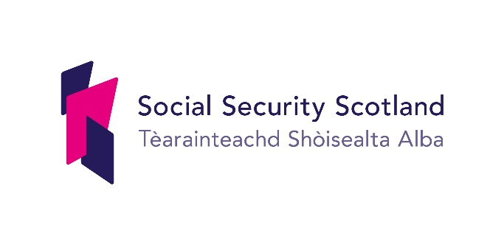
Annex A

Mainstreaming Equality –
Draft Equality Outcomes Consultation

Respondent Information Form

Please Note this form must be completed and returned with your response.
To find out how we handle your personal data, please see our privacy policy: www.socialsecurity.gov.scot/privacy-statement

Are you responding as an individual or an organisation?
☐ Individual
☐ Organisation
Full name or organisation’s name

Phone number

Address

Postcode

Email

Social Security Scotland would like your permission to publish your consultation
response. Please indicate your publishing preference:

☐ Publish response with name
☐ Publish response only (without name)
☐ Do not publish response
We will share your response internally with other Social Security and Scottish Government policy teams who may be addressing the issues you discuss. They may wish to contact you again in the future, but we require your permission to do so. Are you content for Social Security Scotland and/or Scottish Government to contact you again in relation to this consultation exercise?
☐ Yes
☐ No
Information for organisations:
The option 'Publish response only (without name)’ is available for individual respondents only. If this option is selected, the organisation name will still be published.
If you choose the option 'Do not publish response', your organisation name may still be listed as having responded to the consultation in, for example, the analysis report.

Annex B

Consultation Questions
Outcome 1 Social Security Scotland will deliver a seamless service that is inclusive and where our clients are able to access the support they need.

Question 1 Do you feel this outcome meets the needs of protected groups?
Yes ☐ No ☐

If you answered No, can you please outline how the outcome could be improved to meet their needs

Question 2. Do you feel that the supporting activities stated will help achieve the stated outcome?
Yes ☐ No ☐

If you answered No, what types of activity are missing that we could do to make an impact on delivery of this outcome?

Question 3. Do you feel that the measures of success stated will help Social Security Scotland measure the progress of this outcome?
Yes ☐ No ☐

If you answered No, what are your concerns, and can you identify any further measures we should use?

Outcome 2 Social Security Scotland will have a culture built on inclusivity where differences are supported, our people feel valued and they have opportunities to reach their full potential.

Question 4 Do you feel this outcome meets the needs of protected groups?
Yes ☐ No ☐

If you answered No, can you please outline how the outcome could be improved to meet their needs

Question 5. Do you feel that the supporting activities stated will help achieve the stated outcome?
Yes ☐ No ☐

If you answered No, what types of activity are missing that we could do to make an impact on delivery of this outcome?

Question 6. Do you feel that the measures of success stated will help Social Security Scotland measure the progress of this outcome?
Yes ☐ No ☐

If you answered No, what are your concerns, and can you identify any further measures we should use?

Outcome 3 Social Security Scotland will be an employer of choice and through our recruitment process we will look to build a workforce that is representative of the population of Scotland.

Question 7. Do you feel this outcome meets the needs of protected groups?
Yes ☐ No ☐

If you answered No, can you please outline how the outcome could be improved to meet their needs

Question 8.
Do you feel that the supporting activities stated will help achieve the stated outcome?
Yes ☐ No ☐

If you answered No, what types of activity are missing that we could do to make an impact on delivery of this outcome?

Question 9 Do you feel that the measures of success stated will help Social Security Scotland measure the progress of this outcome?
Yes ☐ No ☐

If you answered No, what are your concerns, and can you identify any further measures we should use?

Outcome Social Security Scotland uses the equality data (evidence) collected from clients, our people and other sources to respond to feedback and continually improve the service provided to all clients.

Question 10 Do you feel this outcome meets the needs of protected groups?
Yes ☐ No ☐

If you answered No, can you please outline how the outcome could be improved to meet their needs

Question 11 Do you feel that the supporting activities stated will help achieve the stated outcome?
Yes ☐ No ☐

If you answered No, what types of activity are missing that we could do to make an impact on delivery of this outcome?

Question 12 Do you feel that the measures of success stated will help Social Security Scotland measure the progress of this outcome?

Yes ☐ No ☐

If you answered No, what are your concerns, and can you identify any further measures we should use?

Outcome 5 Social Security Scotland’s service is delivered through having established partnerships with relevant public sector, third sector and community bodies providing clients person centred advice no matter their circumstances.

Question 13 Do you feel this outcome meets the needs of protected groups?

Yes ☐ No ☐

If you answered No, can you please outline how the outcome could be improved to meet their needs

Question 14 Do you feel that the supporting activities stated will help achieve the stated outcome?

Yes ☐ No ☐

If you answered No, what types of activity are missing that we could do to make an impact on delivery of this outcome?

Question 15 Do you feel that the measures of success stated will help Social Security Scotland measure the progress of this outcome?

Yes ☐ No ☐

If you answered No, what are your concerns, and can you identify any further measures we should use?

General Questions

Question 16 Do the outcomes stated target the areas of most relevance for Social Security Scotland

Yes ☐ No ☐

If you answered No, what further outcomes would you suggest and why?

Question 17 Are there any specific inequalities that you would wish to highlight that are relevant to the delivery of social security benefits? Any information or evidence you can provide or signpost us to will be greatly appreciated.

Question 18 Do you have any other comments or suggestions on our approach to equality?

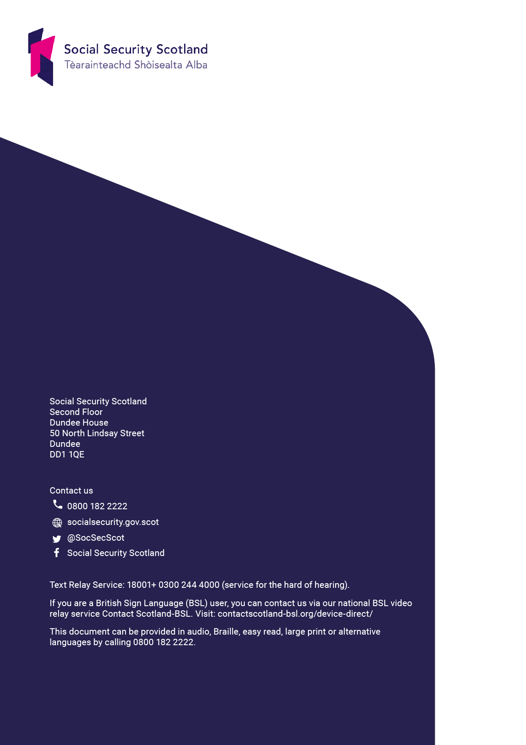

http://www.legislation.gov.uk/asp/2018/9/enacted
https://www.socialsecurity.gov.scot/about-us/our-charter

