Tribunals (Scotland) Act 2014 - Consultation on Draft Regulations regarding:
- the Transfer of Functions and Members of the Scottish Charity Appeals Panel to the Scottish Tribunals;

- the rules of procedure for the First-tier Tribunal for Scotland General Regulatory Chamber

- the Composition of the First-tier and Upper Tribunals for Scotland and

(4) Eligibility criteria for ordinary members

Analysis of Responses

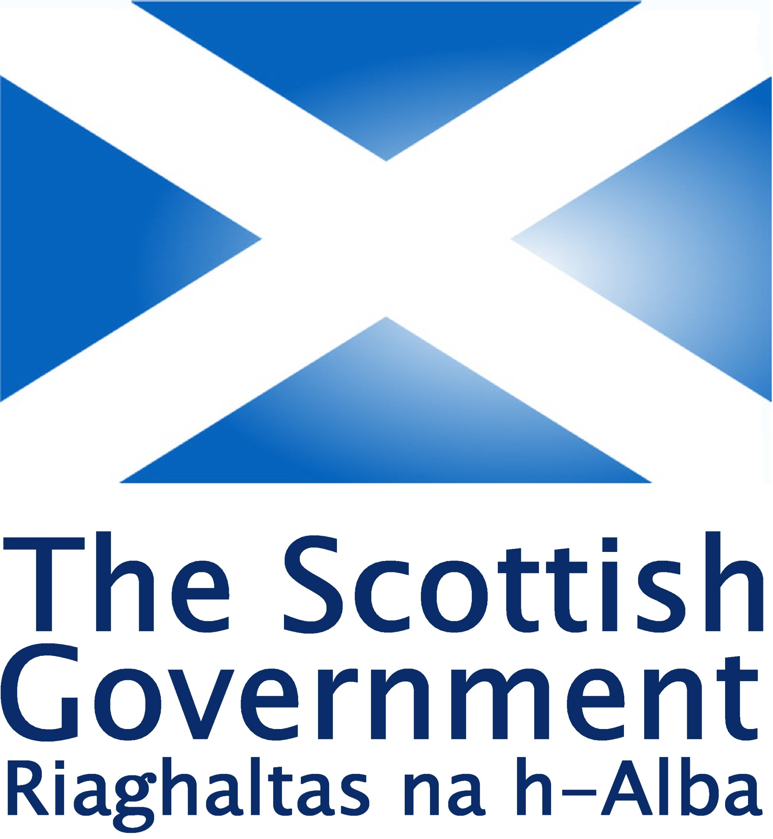

November 2017

Table of Contents

Background page 3
Consultation responses page 4
Analysis of responses page 4
Next steps page 4
Annex A: Consultation responses page 5

ANALYSIS OF RESPONSES TO THE CONSULTATION ON DRAFT REGULATIONS FOR:
- THE TRANSFER OF FUNCTIONS AND MEMBERS OF THE SCOTTISH CHARITY APPEALS PANEL TO THE SCOTTISH TRIBUNALS,
- THE RULES OF PROCEDURE FOR THE FIRST-TIER TRIBUNAL FOR SCOTLAND GENERAL REGULATORY CHAMBER
- THE COMPOSITION OF THE SCOTTISH TRIBUNALS WHEN HEARING CHARITY APPEALS IN AND FROM THE FIRST-TIER TRIBUNAL FOR SCOTLAND GENERAL REGULATORY CHAMBER
- ELIGIBILITY CRITERIA FOR ORDINARY MEMBERS OF THE FIRST-TIER TRIBUNAL WITH CHARITY REGULATORY EXPERIENCE
Background
- The Scottish Government is in the process of implementing the Tribunals (Scotland) Act 2014 (the 2014 Act) which creates a new, simplified statutory framework for tribunals in Scotland, bringing existing tribunal jurisdictions together and providing an organised structure for new jurisdictions.

- The 2014 Act creates two tribunals, the First-tier Tribunal for Scotland (First-tier Tribunal) and the Upper Tribunal for Scotland (Upper Tribunal), known collectively as the Scottish Tribunals. In due course all of the devolved tribunal jurisdictions will transfer-in to the Scottish Tribunals. The first tribunals (the private rented housing panel, the homeowner housing panel and their respective committees) transferred into the Scottish Tribunals in December 2016. The Scottish Tax Tribunals transferred into the Scottish Tribunals in April 2017.

- The Scottish Charity Appeals Panel (SCAP) was established by the Charities and Trustee Investment (Scotland) Act 2005 (the 2005 Act), in order to hear appeals against certain decisions of the Office of the Scottish Charity Regulator.

- The Scottish Government ran a consultation between 22 May and 1 August 2017 on the suite of draft regulations required to transfer the SCAP into the Scottish Tribunals..

Consultation responses
- We received a response from the Office of the Scottish Charity Regulator (OSCR) and the Scottish Council for Voluntary Organisations.

- Due to the small number of responses this analysis relies on consideration of the key points raised in the responses relating to each set of regulations rather than an in-depth statistical analysis of the responses.

Analysis of responses
- We received responses in relation to each of the regulations and the main comments and the Scottish Government response are listed below.
Transfer of functions of SCAP

- By repealing the whole of section 78 of the Charities and Trustee Investment (Scotland) Act 2005 this is removing the right of an individual who has been suspended by OSCR under section 31(4) of that Act to appeal directly to the Court of Session.

- The transfer regulations have now been amended to only remove the right of appeal to decisions of the SCAP to the Court of Session. This has been removed as decisions of the First-tier Tribunal will be appealed to the Upper Tribunal and are covered by the Tribunals (Scotland) Act 2014.

General Regulatory Chamber Rules of Procedure

- We have summarised the comments received about the General Regulatory Chamber Rules of Procedure and the Scottish Government response in the table below.
Title of Rule 5 should be Confirmation of appeal BY the FTT not TO the FTT | Retained original as it is the process of confirmation of the appeal to the Tribunal.
Rule 7 (Withdrawal of Appeal) - final sentence stating that "where an appeal is withdrawn, no further appeal may be made in relation to the same decision" should be reinstated | Agreed - have reinstated
Rule 9 (Evidence and Submissions) - not fully reflected in Rule 20 (Orders) | We have separated these rules out and have ensured that there is no overlap.
Rule 14 (Absence of member of the FTT) - doesn't reflect rule 24 (Decisions of the FTT) | Have replaced text with "the appeal may, with the consent of the parties, be heard by the other two members and, in that event, the FTT shall be deemed to be properly constituted."
Rule 24 (Decisions of the FTT) reference to when the tribunal is constituted of two members does not fit with the composition regulations. | We have clarified this in the composition regulations
Rule 31 (Review) - what is nature of review, can we specify grounds of review. The use of the term review could lead to confusion as the 2005 Act allows OSCR's decision to be reviewed. Concern that the review would be undertaken by the same members as conducted the original case. | The rule says that it refers to an application for a review under section 43(2)(b) of the 2014 Act which differentiates it from the review provision mentioned in the 2005 Act. This is a generic provision across the Scottish Tribunals. We have sought to keep the review process tight and allow the flexibility for the tribunal to refuse reviews if they are frivalous/ without merit. The reason for having the same members is that they have an understanding of the case - however, there is flexibility for someone else to deal with a review. If there is to be a wholsale reconsideration of a case then this would be done by the appeal process.

Eligibility for Appointment | Eligibility criteria should be rephrased to say a person must have "knowledge and experience in accounting or governance of the charity sector and its operation in Scotland" | Seeking confirmation from Charity Law Policy team but our initial view is to retain existing definition as the proposal is quite restrictive and may exclude a couple of existing SCAP members from transferring into the Scottish Tribunals.
Composition | Requirement that the FTT must consist of three members goes against rules where a panel member may be absent. | Will seek advice on this and will amend as necessary.

Composition of the First-tier Tribunal General Regulatory Chamber and Upper Tribunal

- The concern was raised that the requirement that the First-tier Tribunal must consist of three members goes against rules where a panel member may be absent. We have clarified that the provisions in the composition regulations do not go against the rule which specifies a hearing may go ahead with two panel members (at least one of them being a legal member).
Eligibility for membership of First-tier Tribunal as ordinary member with Charity Regulatory Experience

- Three comments were raised in relation to these regulations. Firstly, if an ordinary member is eligible if they have experience of law then this could lead to the tribunal being overly dominated by lawyers. Secondly, the eligibility criteria does not include experience of charities. Finally, the experience should be Scots based.

- We have taken the first two comments on board and have revised the criteria to remove reference to experience of charity law and have added in experience of accounting or governance of charities as well as public and private bodies. We have not specified that experience must be based in Scotland as we feel this would be over restrictive and could exclude good candidates if a recruitment for these members were to be undertaken.

Next Steps

- The draft regulations have been amended as considered appropriate, in light of respondents’ comments. The regulations setting out the eligibility criteria for ordinary members of the First-tier Tribunal with health and education experience were laid in the Scottish Parliament on 4 September 2017 and came into force on 2 October 2017. This was to allow the Judicial Appointments Board for Scotland to undertake a recruitment exercise for ordinary and legal members of the First-tier Tribunal assigned to the Health and Education Chamber.

- The remaining regulations were laid in the Scottish Parliament on 30 October 2017 and are due to come into force on 12 January 2018.

https://consult.scotland.gov.uk/tribunals-administrative-justice-policy/tribunals-scotland-act-2014-draft-regulations/

