Tribunals (Scotland) Act 2014 - Consultation on Draft Regulations regarding:
(1) the Transfer of Functions and Members of the Scottish Tax Tribunals to the Scottish Tribunals;
(2) the rules of procedure for the First-tier Tribunal for Scotland Tax Chamber and
(3) the Composition of the First-tier and Upper Tribunals for Scotland

Analysis of responses

Analysis of Responses

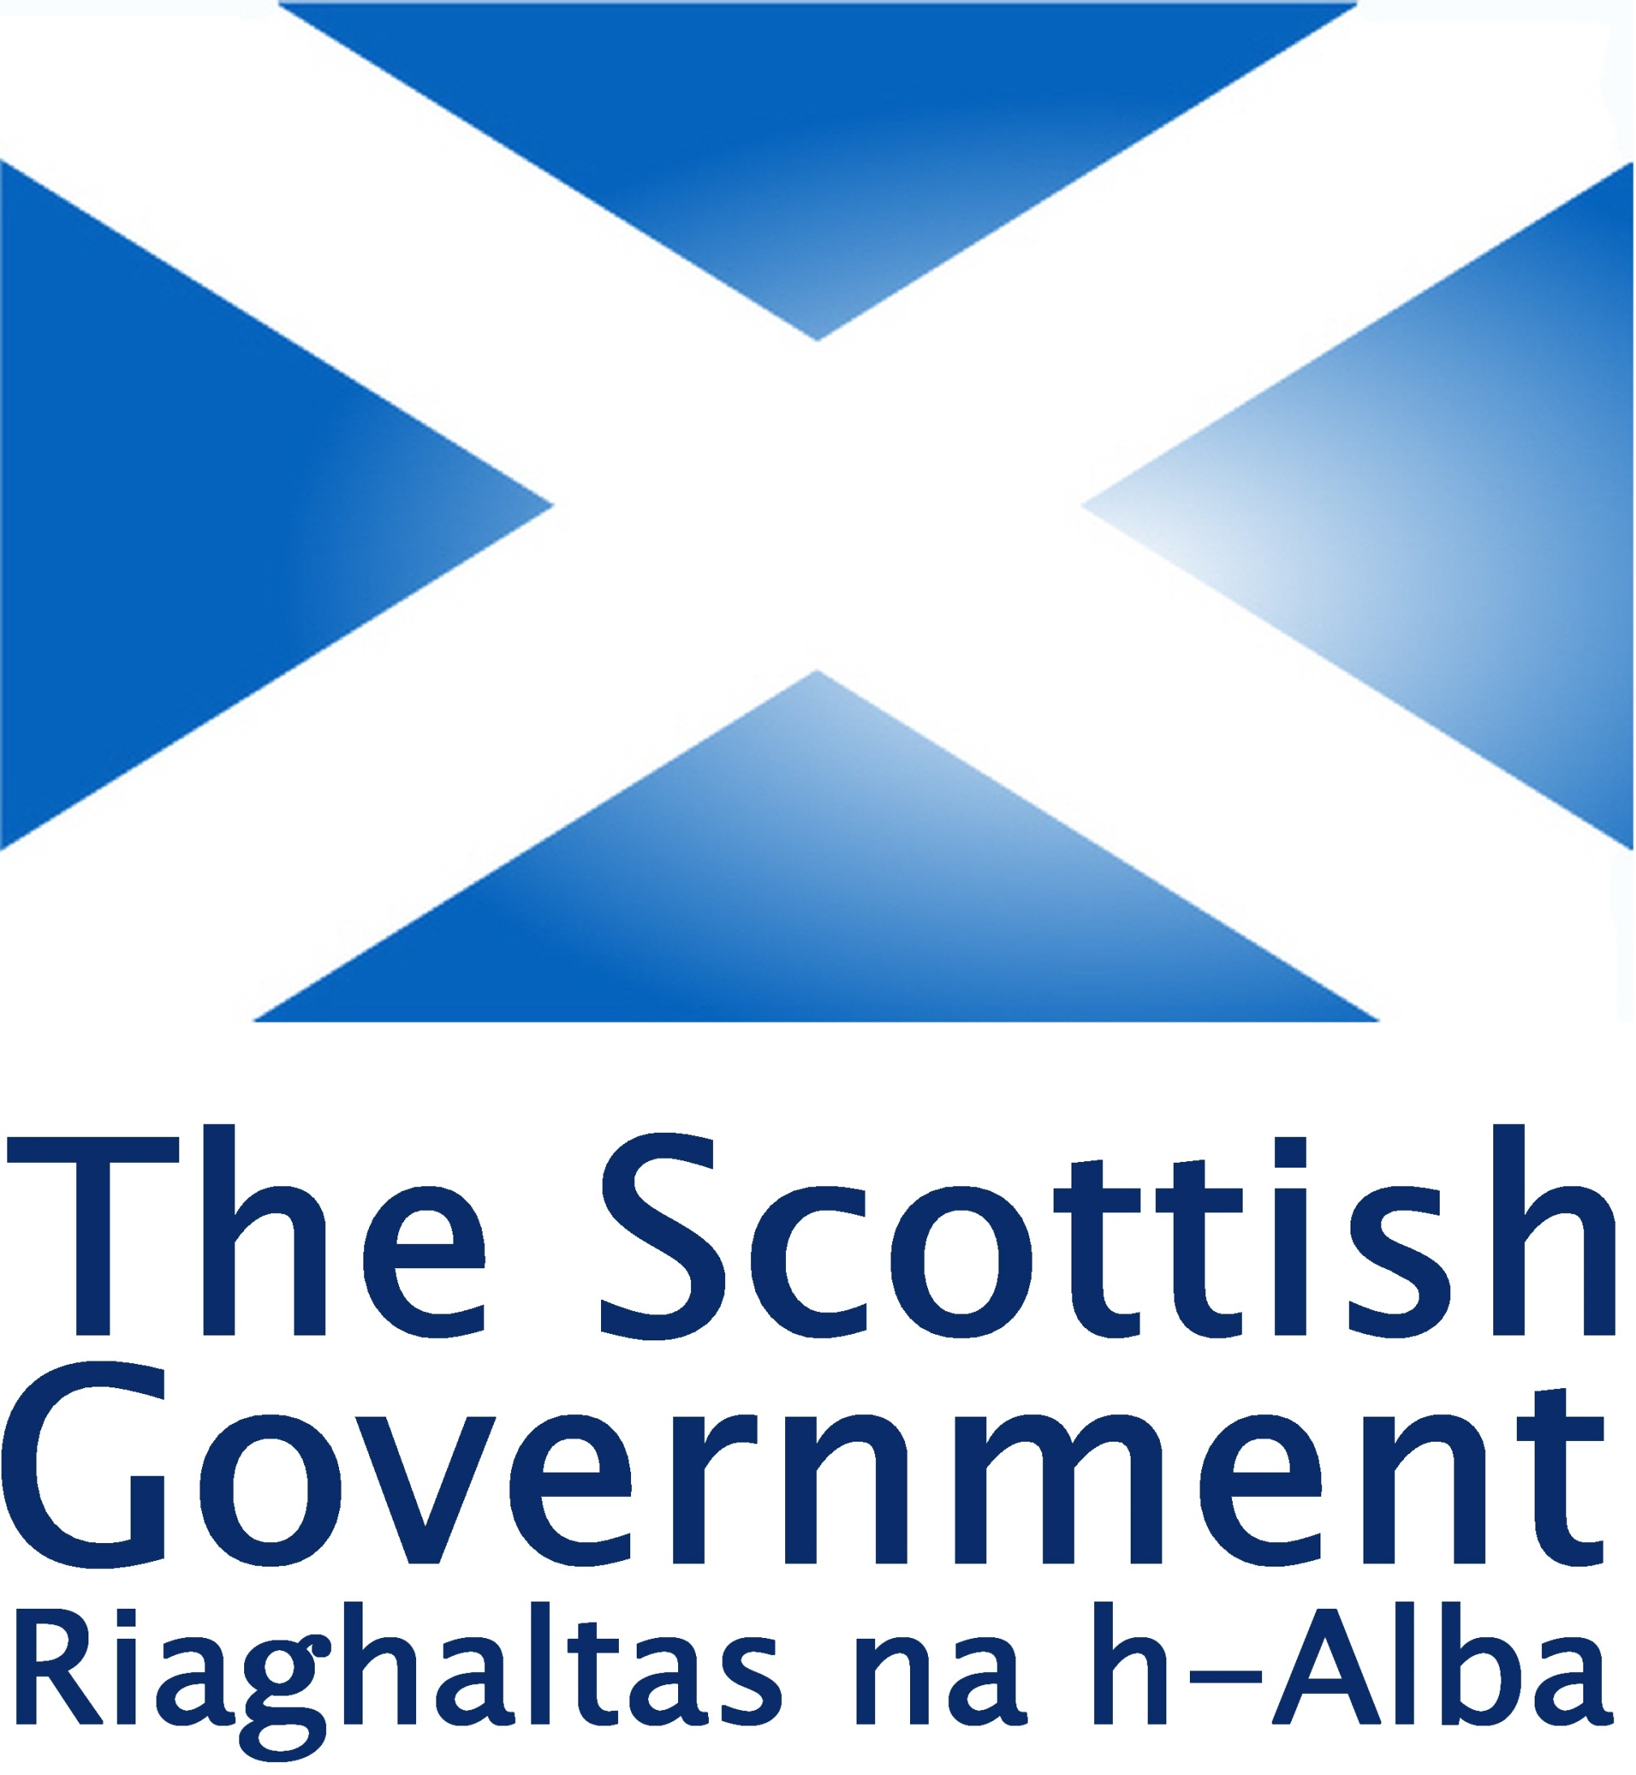

January 2017

Table of Contents

Background page 3
Consultation Responses page 3
Analysis of responses page 4
Next Steps page 6

ANALYSIS OF RESPONSES TO THE CONSULTATION ON DRAFT REGULATIONS FOR:
- THE TRANSFER OF FUNCTIONS AND MEMBERS OF THE SCOTTISH TAX TRIBUNALS TO THE SCOTTISH TRIBUNALS,
- THE RULES OF PROCEDURE FOR THE FIRST-TIER TRIBUNAL FOR SCOTLAND TAX CHAMBER
- THE COMPOSITION OF THE SCOTTISH TRIBUNALS WHEN HEARING APPEALS AND REFERRALS IN AND FROM THE FIRST-TIER TRIBUNAL FOR SCOTLAND TAX CHAMBER
Background
- The Scottish Government is in the process of implementing the Tribunals (Scotland) Act 2014 (the 2014 Act) which creates a new, simplified statutory framework for tribunals in Scotland, bringing existing tribunal jurisdictions together and providing an organised structure for new jurisdictions.

- The 2014 Act creates two tribunals, the First-tier Tribunal for Scotland (First-tier Tribunal) and the Upper Tribunal for Scotland (Upper Tribunal), known collectively as the Scottish Tribunals. In due course all of the devolved tribunal jurisdictions will transfer-in to the Scottish Tribunals. The first tribunals (the private rented housing panel, the homeowner housing panel and their respective committees) transferred into the Scottish Tribunals in December 2016.

- The First-tier Tax Tribunal for Scotland and the Upper Tax Tribunal for Scotland were established by the Revenue Scotland and Tax Powers Act 2014 and are known collectively as the Scottish Tax Tribunals. The Scottish Tax Tribunals are due to transfer into the Scottish Tribunals in April 2017.

- The Scottish Government ran a consultation between 20 October and 4 December 2016 on draft regulations covering the transfer of functions and members of the Scottish Tax Tribunals, composition of the First-tier Tribunal and Upper Tribunal when hearing cases to and from the Tax Chamber of the Scottish Tribunals and the Rules of Procedure for the First-tier Tribunal Tax Chamber.
Consultation responses
- There were three responses to the consultation all of whom were organisations. The three organisations were:
Chartered Institute of Taxation and Low Incomes Tax Reform Group
Faculty of Advocates
Institute of Chartered Accountants of Scotland

- Due to the small number of responses this analysis relies on consideration of the key points raised in the responses relating to each set of regulations rather than an in-depth statistical analysis of the responses.

Analysis of responses

Transfer of functions and members of Scottish Tax Tribunals

- One organisation sought clarification on whether members have to consent to new terms of appointment being offered. The Scottish Government’s interpretation of these provisions is that it is implicit that if members do not accept the offer of terms and conditions they do not transfer in.

Ancillary Provisions

- There were no comments on the draft regulations that repeal part 4 and schedule 2 of the Revenue Scotland and Tax Powers Act 2014.

First-tier Tribunal Tax Chamber Rules of Procedure

- One respondent commented that the power to delegate to staff should be limited to case management decisions. This regulation gives the First-tier Tribunal Chamber President flexibility to use Scottish Courts and Tribunals staff if required. Therefore, to maintain this flexibility we propose to retain the text of the regulation.

- One respondent suggested that the First-tier Tribunal should take into account the circumstances of the party when considering the reasons for failing to comply with rules. This rule does not force the First-tier Tribunal to take action and we consider that by specifying that the First-tier Tribunal may take such action as it considers just this would include taking into account the circumstances of the party. One respondent noted that the action for failing to comply with rules of restricting a party’s participation in proceedings was removed from the draft regulations. This was done to ensure consistency with the Upper Tribunal Rules of Procedure. The First-tier Tribunal will still be able to exclude a person who is disrupting proceedings.

- One respondent questioned why the current sub paragraphs (8) and (9) of the rule relating to the dismissal of a party’s case were omitted. These paragraphs allowed the First-tier Tribunal to bar a respondent from further participating in hearings and set out the procedure for parties who wished to have a case reinstated. These provisions were removed to ensure consistency with the Upper Tribunal Rules of Procedure and in other tribunals in Scotland.

- Two organisations commented on the expenses provision as this has been significantly amended. The policy intention is for the First-tier Tribunal to only be able to award expenses if a party’s act, omission or other conduct has caused the other party to incur an expense that it would be unreasonable for them to pay.

- Two organisations made suggestions on the regulation regarding sending and delivery of documents. One organisation suggested that the First-tier Tribunal should expressly permit documents to be sent by email. The First-tier Tribunal may direct that documents should be delivered by email which gives the tribunal the flexibility to direct documents be sent by email if this is the most appropriate format in the case in question. Another organisation suggested that the option for parties to indicate a communication method they do not wish to be used should be highlighted to parties. This will be done in guidance on applying to the First-tier Tribunal.

- There were a number of comments regarding the allocation of cases to categories. These regulations are aiming to replicate existing Scottish Tax Tribunal procedure and these suggestions would require a change in policy. We therefore propose to retain the existing rules regarding allocation of cases to categories.

- There were a few comments regarding time limits. One organisation wished the time limit for seeking permission to appeal to be extended to 54 days. We propose to maintain the 30 day time limit as this reflects the current procedure in other Scottish Tribunals. This will also allow a quicker resolution of cases. The time limits are specified in regulation 2016/231 and therefore we do not propose to replicate them in the Tribunal Rules.

- One respondent queried why the reference to national security was removed in relation to Public and Private Hearings. This was removed as it is highly unlikely cases that concern national security will be heard in the tribunal.

- One respondent noted that the sections in relation to lead cases, consent orders, clerical mistakes, setting aside a decision and power to treat an application as a different type of application have been removed from the existing Scottish Tax Tribunals Rules. The provision relating to lead cases was replaced by references in the rule concerning case management powers to lead cases and giving the tribunal the power to conjoin cases and specify one or more cases as a lead case. The provision relating to consent orders was removed to ensure consistency with procedure in other Scottish tribunals.

- The provisions regarding correction of clerical errors and setting aside a decision have been reintroduced as part of the revised part 4 on reviewing and appealing a decision. The review provision has been substantially revised as a result of comments from organisations. We propose to tie the review in with the permission to appeal stage.

Composition of the Scottish Tribunals when hearing cases to and from the Tax Chamber

- One organisation suggested that the word “ordinary” should be supplemented with “or legal” in regulation 2(b) which sets out how many members may hear cases in the First-tier Tribunal Tax Chamber. We have amended the regulation to allow a legal member and one ordinary or legal member to hear a case. This maintains the status quo.

- One organisation suggested that to maintain the status quo the judiciary sitting in the Upper Tribunal should be limited to Court of Session judges. This would exclude sheriffs and the Chairman of the Scottish Land Court from being able to sit on cases. We have amended the regulations to reflect this and the President of Tribunals will now be able to choose a legal member of the Upper Tribunal, a Court of Session Judge, the Chamber President of the First-tier Tax Chamber, the Lord President or the President of Tribunals to hear appeals or referrals in the Upper Tribunal.

Next Steps

- The draft regulations have been amended as considered appropriate, in light of respondents’ comments. We propose to lay these regulations in the Scottish Parliament in early 2017. The intention is for these regulations to come into force in April 2017.

https://consult.scotland.gov.uk/tribunals-administrative-justice-policy/tribunals-scotland-act-2014-draft-regulations/
https://consult.scotland.gov.uk/tribunals-administrative-justice-policy/tribunals-scotland-act-2014-draft-regulations/consultation/published_select_respondent
http://www.legislation.gov.uk/ssi/2016/231/regulation/2/made#regulation-2-4-a-i

