Wild Fisheries Reform
Draft provisions for a Wild Fisheries (Scotland) Bill/ Draft Wild Fisheries Strategy

Strategic Environmental Assessment
Environmental Report
Non-Technical Summary

February 2016



Introduction
- Scottish Ministers are currently consulting on draft provisions for inclusion in a future Wild Fisheries (Scotland) Bill and on an outline draft Wild Fisheries Strategy (the “draft policy instruments”).
What is Strategic Environmental Assessment?
- Strategic environmental assessment (SEA) identifies the likely significant environmental impacts of plans and policies, and alternatives to them. Taking place at an early stage in the plan or policy preparation process, it ensures that decision-making is informed by relevant environmental information. SEA provides opportunities for the public to consider this information and use it to inform their views on a draft plan or policy.
- This report summarises the findings from the SEA of the draft policy instruments. This is required by the Environmental Assessment (Scotland) Act 2005 because they have the potential to give rise to significant environmental effects. Screening and scoping were carried out in December 2015.
What are the draft policy instruments?
- The report of the independent Review of Wild Fisheries, published in October 2014, made 53 recommendations for change which, taken together, would result in a fundamental re-design of the existing fishery management system. Broad policy options for a new management system were consulted on between May and August 2015. Over 200 written responses to the consultation were received, alongside feedback from numerous public and stakeholder meetings.
- The next step was to prepare the draft Bill provisions and national strategy, building on the contents of and responses to the summer 2015 consultation, together with the results of work with stakeholders. A consultation document was published on 8 February 2016.
- The draft provisions of the Wild Fisheries (Scotland) Bill cover the following:
- administration and management of wild fisheries (Part 1). This part sets out national and local arrangements, including: Scottish Ministers’ powers and responsibilities; the process for establishing Fisheries Management Organisations (FMOs); a series of good governance requirements; and provision for a wild fisheries levy.
- regulation of wild fishing and fisheries (Part 2). This part establishes the regulatory framework, including: prescribing the methods of fishing which are allowable; powers to create conservation measures for all species of freshwater fish; control on fishing; and a power to create a licensing scheme.
- enforcement (Part 3). This part sets out measures to enforce legislation, in terms of the appointment process and powers of water bailiffs and fishery wardens.
- general matters (Part 4). This part defines certain terms for the purposes of the provisions.
- The draft provisions do not represent a draft Bill in its entirety. Further work will be undertaken to explore the funding of freshwater fisheries management, including an online dialogue. Provisions relating to technical issues, such as offences and authorisations for introductions and activities which would otherwise be illegal (such as electrofishing), are still under development (Part 2), as are those relating to the powers of enforcement officers (Part 3). Transitional arrangements (moving from the current to the future system), will be developed.
- The draft national strategy aims to provide:
- a long-term vision for managing and developing wild freshwater fisheries in Scotland, and key overarching objectives;
- an outline methodology for achieving the vision (in the form of a Governance and Accountability Framework); and
- a structure for greater stakeholder involvement in the development and management of wild fisheries in Scotland.
- The policy and plan hierarchy will be as follows:
- the Wild Fisheries Strategy, providing overarching national priorities;
- a comprehensive national management plan, setting out clear and time-limited nationally prioritised actions;
- local fisheries management plans, setting out clear and time-limited regionally prioritised actions.
- This hierarchy is not intended to act as a “top down” system; rather, there would be interaction and sharing of information between all levels in the preparation of strategies and plans, and in monitoring and evaluating their implementation.
How was the SEA undertaken?
- A series of key questions (‘strategic environmental assessment objectives’) is used to structure this strategic-level appraisal. Information about the existing freshwater environment has been used to inform the appraisal and define these SEA objectives. The appraisal identifies the positive and negative effects of the draft policy instruments on biodiversity, flora and fauna; the ecological status of water bodies; and human health. The significant impacts are described in detail in the Environmental Report.
Which reasonable alternatives have been assessed?
- No reasonable alternatives to the contents or wording of the draft Bill provisions were identified as mitigation measures by the SEA. Some alternative wording for the contents of the draft national strategy has been suggested as part of the identification of mitigation measures.
What is the current state of the environment?
Freshwater Fish
- Scotland has a small number of native freshwater species that, even now, have a limited distribution; these include lamprey, Atlantic salmon, trout, Arctic charr, powan, vendace, smelt (sparling), shad and eels. Many of the other freshwater species found in Scotland occur only as a result of accidental or deliberate introduction by human activity, e.g. pike, perch, rainbow trout and roach.

- Riverine habitats are also used by other species:
- Those that are legally protected, e.g. otters, freshwater pearl mussels. The flow of clean, well-oxygenated water through river gravels is an important habitat for freshwater pearl mussels.
- Exposed gravels are used by many protected Red List invertebrates. More silted bars are colonised by aquatic macrophytes and invertebrates.
- Rivers and lochs support a wide range of bird species, e.g. kingfisher, grey heron, coot, dipper, and moorhen. Some areas are used by over-wintering ducks and geese or for breeding e.g. by red-throated diver.
- River banks are particularly important for species such as water voles and sand martins.
Designations
- Atlantic salmon are protected at both international and European levels, as are other species of freshwater fish native to Scotland. For example, there are 17 Special Areas of Conservation (SACs) for Atlantic salmon in Scotland (Figure NTS1).
- Other species using freshwater habitat are also protected. For example, otters are classed as European Protected Species under the Conservation (Natural Habitats etc) (Scotland) Regulations 1994 as amended; these protect both otters and their resting places. All wild birds in the UK are protected under the Wildlife and Countryside Act 1981 (as amended). Special Protection Areas also provide protection for some of the species using freshwater habitat for breeding and/or overwintering. Water vole are protected under the Wildlife and Countryside Act 1981 (as amended). Freshwater pearl mussels are also protected in this way; in addition, their habitat is protected by Special Areas of Conservation, of which there are 19 in Scotland. Seven of these overlap with SACs for salmon.
Water
- Scotland has a high quality water environment which is important for health and well-being; supports a rich diversity of wildlife; attracts visitors; and provides for the sustainable growth of our economy.
- The Water Framework Directive (WFD), implemented through the Water Environment and Water Services (Scotland) Act 2003 (WEWS), requires the introduction of a holistic source-to-sea approach for the management of the water environment. The Scottish Government has extended this principle of integration to its policy and legislative framework, by taking steps to ensure that WFD aims and principles are embedded in all relevant policy and regulatory areas.
- Some areas of the water environment are under considerable pressure from human activity. The WFD and the WEWS Act introduced a system of river basin management planning to identify and address these pressures. The process involves defining specific environmental objectives for each water body in the river basin districts and identifying and implementing a programme of measures to deliver those objectives. The Scotland and Solway and Tweed River Basin Management Plans were updated in 2015.
- The ecological status of surface waters is an expression of the quality of the structure and functioning of surface water ecosystems, indicated by the condition of biological quality (water plants and animals); chemical and physicochemical quality, e.g. oxygen and nutrient levels; and hydromorphological quality, e.g. water flows and levels; condition of beds, banks and shores; and the continuity of rivers for fish migration. Five classes of ecological status (high, good, moderate, poor or bad) define how much ecological quality deviates from natural conditions.
Figure NTS1. Locations of SACs designated for Atlantic Salmon
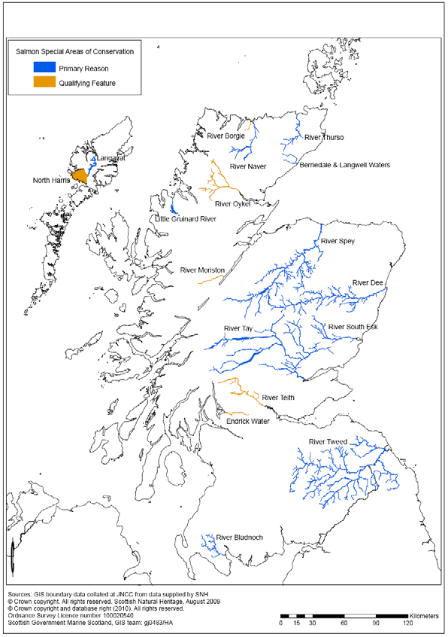
- More than half of Scotland’s rivers and lochs are of good or higher ecological status (Figure NTS2). Just under one-quarter are moderate; approximately one-fifth are poor or worse. About 85% of estuaries are of high or good ecological status. The pressures underlying this status are summarised, for all surface waters, in Figure NTS3.
Human Health
- A key goal of the Scottish Government is to tackle health inequalities, while also seeking to improve diet, increase physical activity and support people to achieve and maintain a healthy weight (Scottish Government, 2008 and 2010). Some key facts about Scotland’s population include:
- The population in 2014 was estimated at 5,347,600. Most people live in central Scotland; the lowest population density is in the Highlands and Western Isles.
Figure NTS2. Ecological status of Scottish surface waters (2014)
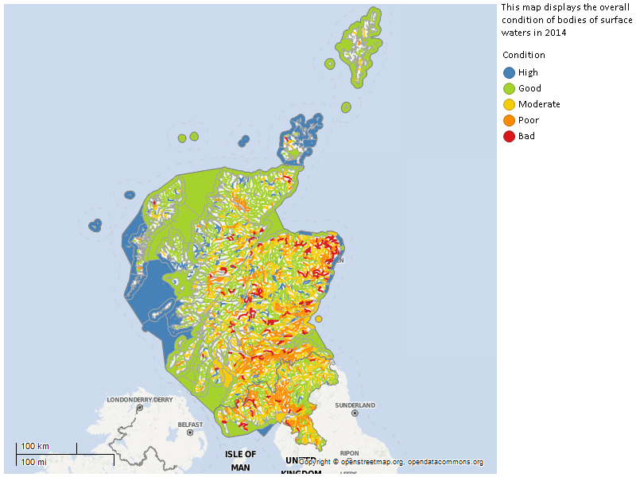

Figure NTS3. Pressures Affecting Scotland’s Surface Waters (2014)
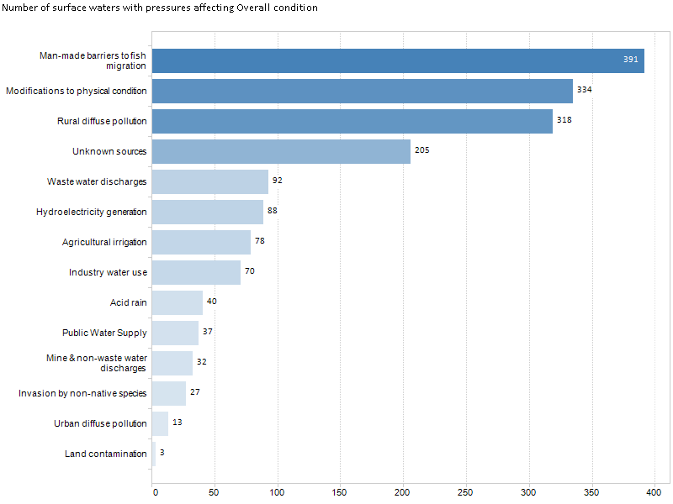
- The most disadvantaged populations in Scotland are concentrated in urban areas (based on indicators of income, employment, health, education, skills and training, housing, geographic access and crime). Some rural areas are disadvantaged by poor access to services.
- The mental well-being of adults in Scotland averaged a score of 50 between 2006 and 2011 (the score can range between 14 and 70, with a higher score indicating better wellbeing).
- In Scotland, sports participation statistics show that around 3% of adults (16+ years) and 3% of children (8-15 years) took part in angling during the most popular two months of each year (these figures are for 2006-2008). Based on 2008 population figures, this equates to 155,055 participants.
- Recent research in England and Scotland on the contribution of angling to health and well-being has identified the following benefits:
- Contributions to physical health, through increasing levels of physical activity and through assisting in recovery from illness and/or injury.
- Contributions to mental health, through promoting positive mental health and through assisting treatment and recovery from mental illness.
- Contributions to improved social well-being, through more time spent with family and friends, and contributing to the wider community through volunteering.
- Green space provides a key opportunity for direct contact with the natural environment, particularly in urban areas, and this has measurable physical and psychological benefits.
Existing Environmental Pressures
- There are many pressures on freshwater fish, including Atlantic salmon and sea trout, and non-migratory salmonids and coarse fish species.. Some are natural and some are the result of human activities. These are summarised in Figure NTS4.
What are the likely significant environmental effects of the draft policy instruments?
- This SEA has undertaken a high-level assessment of the draft policy instruments. A summary is provided in Tables NTS1 and NTS2.
Draft Bill Provisions
Will the draft policy instruments safeguard aquatic ecosystems, including species and habitats, and their interactions? Will they maintain or work towards good ecological status?
- Many fisheries management practices, including habitat management, may provide benefits for species other than freshwater fish. The draft provisions relating to promotion of the conservation of freshwater fish in wild fisheries and their habitats, and best practice in the management of wild fisheries (Sections 1 and 9), would therefore have benefits for the wider environment, in terms of biodiversity and the ecological status of water bodies

Figure NTS4. Existing Pressures on Freshwater Fish in Scotland
salmon only
- A key benefit for freshwater fish is the extension of freshwater fisheries management to include all freshwater fish species, across the whole of Scotland. Why is this a benefit? Mainly because the extension of management to cover all of Scotland should lead to a consistency of management, including of all species, across the whole country. The focus of management would change from being predominantly salmon- and sea trout-centred to ensure that the interests of all freshwater species and their habitats are taken into account. Management would therefore be provided to relieve the pressures on non-migratory salmonids and coarse fish, as well as those affecting migratory salmon and sea trout. It would also regulate management practices that benefit one species to the detriment of another without due consideration. Such management would include (and thereby benefit) aquatic species that are of conservation rather than commercial value, such as lamprey (sea, river and brook) and eels.
- The overarching duty for Scottish Ministers would be progressed in the context of existing environmental legislation and policy, particularly that relating to biodiversity and the ecological status of water bodies. Accordingly, any actions progressed to further this overarching duty would necessarily take these wider issues into account e.g. during the strategy and/or national plan development. In consequence, it was considered unnecessary to add wording to the draft provisions to capture these issues. Recognition of these issues could also be made explicit in the wording of the draft national strategy.
- Like Scottish Ministers, FMOs would be required to consider the implications of their activities for the good ecological status of water bodies, through the requirements of the Water Environment and Water Services (Scotland) Act 2003. However, FMOs would not be public bodies, as defined by the Scottish Government. In consequence, the biodiversity duty is not directly applicable to their activities. However, Scottish Ministers are empowered to provide guidance to FMOs, and the need to take wider biodiversity into consideration would be emphasised in this guidance, for example, when developing local fisheries management plans required by Section 10 of the draft provisions. These plans require Scottish Ministers’ approval.
- The requirement for Scottish Ministers to prepare a national strategy would provide similar biodiversity benefits, since the national strategy would set out Ministers’ objectives, priorities and policies for achieving their overarching duty – to set the framework for management planning by both national and local management bodies. The requirement to regularly review the strategy would assist its updating if monitoring identified unanticipated or adverse environmental effects, or benefits that could be enhanced. The same biodiversity benefit would ensue from the requirement for FMOs to prepare local fisheries management plans (Section 10).
- The powers for regulation set out in Sections 23, 24, 27 and 28, taken together, could be of benefit to freshwater fish populations which in turn could have wider biodiversity benefits. The provisions for enforcement (Section 36) would have similar benefits, as enforcement supports regulations whose objective is to protect and/or conserve freshwater fish.
- Section 25 would provide for Scottish Ministers to make conservation regulations about activities that exert pressure on freshwater fish. This would be of biodiversity benefit, as it would contribute to the resolution of catchment-wide pressures on freshwater fish and their habitats, with consequent wider biodiversity benefits.
- Section 26 would provide powers for Scottish Ministers to require, through regulations, data collection and evaluation. Data collection would support the evidence base needed for appropriate fisheries management strategies and practices. This would also be of biodiversity benefit, for the reasons cited in preceding paragraphs.
- Given that many fisheries management practices, including habitat management, may provide benefits for species other than freshwater fish, these would support water bodies in attaining good or higher ecological status, in line with Scottish Government objectives and the requirements of legislation. This would likely include stream substrates, given their importance for spawning and the provision of shelter in early life cycle stages. However, some management practices may adversely affect the wider environment. It is envisaged that these effects would be identified and mitigated as part of the development of national and local fisheries management plans.

Will the draft policy instruments provide opportunities for physical activity, to the benefit of human health?
- The duty to promote conservation would only be of indirect benefit to human health, through ensuring maintenance of the resource upon which angling depends
- The framework for a wild fisheries levy, set out in Section 22, has the potential for adverse effects on human health. Stakeholders have expressed concerns about the potential for the levy to result in new and/or increased costs to fishery owners, and that these would be passed on to anglers. There are fears that these costs would be such that anglers would leave the sport, which would work against objectives to increase participation in angling, with the benefits that such participation could bring. However, these effects may be offset by the actions within the draft strategy to promote access to and opportunities for angling.

Draft National Strategy
- The SEA has considered the elements of the draft strategy: the vision; the overarching objectives; and the strategic framework.
- The draft vision focuses on the social and economic benefits of fishing, including those arising from increased access to and participation in angling. A prerequisite for the success of the vision is a fishery that is sustainable in the long-term – the goal of the duties set out in Sections 1 and 9 of the draft Bill provisions. However, the vision is silent on this point, despite the remainder of the draft strategy including objectives, themes and indicators which set out to achieve this.

Draft Vision: To protect, develop and enhance social and economic benefit from Scotland’s freshwater fish and fisheries; and to promote access to fishing opportunities and participation.
- On that basis, this could be mitigated by amending the wording of the vision to explicitly include reference to the wider environment. For example, the wording could read “to protect, develop and enhance environmental, social and economic benefit …”. This would provide the “green thread” to run through the remainder of the policy and planning hierarchy, including at the FMO level.
- The key overarching objectives build on the vision and set the scene for the strategic framework. As with the vision, it is important for the objectives to make clear that environmental quality should be a key consideration within the policy and planning hierarchy. In consequence, the wording of the objectives could be amended to explicitly include environment. A suggestion would be:
- Providing comprehensive protection and improvement of Scottish freshwater fish and the habitats they depend on, in a sustainable manner.
- Promoting effective, evidence-based fishery management through integrated data gathering, research and dissemination.
- Identifying and maximising societal benefits from sustainable fisheries, and the promotion of sustainable angling as a recreational and tourism activity.
- The strategic framework builds on the vision and overarching objectives, and identifies four themes for action:
- protecting and growing the resource
- science and research
- partnership and engagement
- promotion
- A key action is to identify pressures on fish, their habitats and species and to prioritise and take pragmatic action where sensible. These actions would be integrated with existing processes, including for example river basin management planning. They would therefore reflect other catchment-level national priorities, including: achieving good or higher ecological status in water bodies; the control of non-native invasive species; and the removal of physical obstacles to fish movement.
- At this stage we envisage that the “pragmatic actions” would be progressed through inclusion in the national management plan and/or local fisheries management plans. Management practices are likely to be beneficial for aquatic ecosystems, as well as for freshwater fish species. However, some may adversely affect other aspects of aquatic and terrestrial ecosystems. The consequences to the wider environment of the actions in these plans would be subject to SEA at both the national and local level. Any environmental effects would be identified and appropriate mitigation measures identified through this process.
- The indicators for national enforcement (1.3) and data collection (2.1, 2.2, 2.3) would have benefits for both biodiversity and the ecological status of water bodies since, taken together, they are intended to address gaps in the evidence base that supports fisheries management practices, as well as supporting regulations whose objective is to protect and/or conserve freshwater fish.
- The indicators for partnership and engagement (3.1 and 3.2) would normally be considered to be procedural and therefore screened out of the SEA. However, the nature of the pressures on freshwater fisheries and the need for communication and coordination between the many stakeholders involved, means that continuing and building on partnership working at the national and local levels would be of benefit both to freshwater fisheries and the wider environment. These are therefore considered to be of benefit for both biodiversity associated with these indicators are essential to achieve national strategy would set out Scottish Ministers’ objectives, priorities and policies for achieving their overarching duty (i.e. the conservation of freshwater fish in wild fisheries and their habitats, and the management of wild fisheries).
- The promotion of angling, including improved access to and participation in angling, would have benefits for human health, as increased physical activity has potential benefits for both physical and mental health. Participation in angling is also considered to have wider social and community benefits in terms of improved engagement by family and community members, which in turn is positive for mental health.

Table NTS1. Draft Bill Provisions: SEA Results
SEA Objectives | Key: environmental effects
Obj 1 – Biodiversity | Work against SEA objective
Obj 2 – To maintain or work towards good ecological and environmental status | No change
Obj 3 – To safeguard human health | Mixed effects
 | Promote SEA objective
 | Uncertain

Draft bill provisions |  | Biodiversity | Human health | Ecological status | Comments
1 | overarching duty SM |  |  |  | Management practices are likely to be beneficial for aquatic ecosystems, as well as freshwater fish species. However, some may adversely affect other aspects of aquatic and terrestrial ecosystems. See Section 6 of this report and paragraph 7.2.4.
2 | national strategy
3 | strategy review |  |  |  | Would assist updating if monitoring identified environmental effects.
6 | FMAs |  |  |  | Extends fisheries management to all of Scotland, as well as to all freshwater fish species.
9 | overarching duty FMOs |  |  |  | Management practices are likely to be beneficial for aquatic ecosystems, as well as freshwater fish species. However, some may adversely affect other aspects of aquatic and terrestrial ecosystems. See Section 6 of this report and paragraph 7.2.5.
10 | local fisheries management plan
22 | wild fisheries levy |  |  |  | Stakeholders have raised concerns about costs being passed on to anglers, with potential adverse effects on human health. However see also paragraph 7.3.10 re the national strategy.
23 | conservation regulations |  |  |  | Would continue powers to make certain fisheries management practices statutory, e.g. close times, equipment types.
24
25 | structures/obstructions etc |  |  |  | Would contribute to the resolution of catchment-wide pressures.
26 | data collection |  |  |  | Data collection would support the evidence base needed for appropriate fisheries management strategies and practices.
27 | tagging |  |  |  | Controls taking and killing of freshwater fish – important for rivers where population levels are not sustainable.
28 | licensing
36 | enforcement |  |  |  | Supports enforcement of regulations whose objective is to protect and/or conserve freshwater fish.

Table NTS2. Draft National Strategy: SEA Results
SEA Objectives | Key: environmental effects
Obj 1 – Biodiversity | Work against SEA objective
Obj 2 – To maintain or work towards good ecological and environmental status | No change
Obj 3 – To safeguard human health | Mixed effects
 | Promote SEA objective
 | Uncertain

Draft national strategy |  | Biodiversity | Human health | Ecological status | Comments
1.1 | habitat protection/restoration |  |  |  | Management practices are likely to be beneficial for aquatic ecosystems, as well as freshwater fish species. However, some may adversely affect other aspects of aquatic and terrestrial ecosystems.
1.2 | national and local priorities and plans |  |  |  | Management practices are likely to be beneficial for aquatic ecosystems, as well as freshwater fish species. However, some may adversely affect other aspects of aquatic and terrestrial ecosystems.
1.3 | national enforcement |  |  |  | Mostly procedural but enforcement officer role includes specific responsibilities and accountability for ensuring compliance.
2.1 | coordination/planning of research projects and priorities |  |  |  | Data collection would support the evidence base needed for appropriate fisheries management strategies and practices.
2.2 | establish research and data collection priorities |  |  |  | Data collection would support the evidence base needed for appropriate fisheries management strategies and practices.
2.3 | national data standards |  |  |  | Data collection would support the evidence base needed for appropriate fisheries management strategies and practices.
3.1 | partnership working |  |  |  | Integrated working likely to be more effective in taking forward catchment-level planning and ensuring consistency of management across species and rivers/water bodies.
3.2 | policy development - interactions |  |  |  | Integrated working likely to be more effective in taking forward catchment-level planning and ensuring consistency of management across species and rivers/water bodies.
4.1 | promotion of angling |  |  |  | Increased physical activity has potential benefits for physical and mental health and well-being and social/community engagement.

What happens next?
- The consultation document and the Environmental Report have been published for public consultation. Views on the Environmental Report, and the draft policy instruments, are invited. The consultation period will close on 2 May 2016.
- Following the consultation period, the responses received will be analysed, and the findings from this analysis will be taken into account in the drafting of the Bill and the national strategy before they are submitted to the Scottish Parliament. Assuming their successful passage, once the Bill comes into force and the strategy is adopted, a Post-Adoption Statement will be prepared, explaining how issues raised in the SEA, and associated views in response to the consultation, have been addressed.
How do I respond to the consultation?
- Please respond to this consultation online (via Citizen Space) at: https://consult.scotland.gov.uk/wild-fisheries-reform-team/draft-wild-fisheriesstrategy.
You can save and return to your responses while the consultation is still open.
- If you are unable to respond online, please complete the Respondent Information Form (see “Handling your Response” below) to:
Wild Fisheries Reform
Area 1-B North, Victoria Quay, Edinburgh, EH6 6QQ
Or alternatively email:

wildfisheriesreform@gov.scot
- Please send your response, by 2 May 2016, to:
By email to salmonandrecreationalfisheries@scotland.gsi.gov.uk or
By post, to: Jackie McDonald
Scottish Government
Area 1-B North
Victoria Quay
Edinburgh EH6 6QQ

The Stakeholder Reference Group and the Strategy Development Group. More information is available on http://www.gov.scot/Topics/marine/Salmon-Trout-Coarse/fishreform).
Source: Malcolm et al (2010), p.4.
In addition, it is not considered good practice to repeat existing legislative requirements in new legislation.
Bodies which have a role in the processes of national Government, but are not a Government department or part of one, and which accordingly operate to a greater or lesser extent at arm’s length from Ministers.

